An investigation into the toxicity, bioconcentration, and risk of perfluoroalkyl substances in aquatic taxa

By

Adric Delray Olson, B.S., M.S.

A Dissertation

In

Environmental Toxicology

Submitted to the Graduate Faculty

of Texas Tech University in

Partial Fulfillment of

the Requirements for

the Degree of

Doctor of Philosophy

Approved by

Dr. Todd Anderson

Chair of Committee

Dr. Christopher J. Salice

Dr. Philip N. Smith

Dr. Jonathan Maul

Mark Sheridan

Dean of the Graduate School

May, 2017

Copyright 2017, Adric D. Olson

# ACKNOWLEDGMENTS

I first need to thank my advisor and mentor in this work, Dr. Christopher Salice, for his help throughout this work. Without his guidance, knowledge, and tutelage, this work would not have been completed with the quality you see here. Dr. Todd Anderson was also instrumental in completing this work. I appreciate him for stepping in to serve as my advisor at TTU and also for his input on this work and general joie de vivre. Additionally, I’d like to thank Dr. Phil Smith for his advice and feedback on this manuscript and for helping me discover an enjoyment of risk assessment. I’d also like to thank Dr. Jonathan Maul for his input on this work, particularly due to his knowledge of aquatic toxicology work.

This work would not have been possible without the aid of the entire staff, faculty, and student body of The Institute of Environmental and Human Health. I learned from and utilized the resources of many faculty, including Dr. Greg Mayer, Dr. Céline Godard-Codding, Dr. Weimin Gao, Dr. Jaclyn Cañas-Carrell, and Dr. David Klein. Furthermore, the coordination and assistance of the staff, including Allyson Smith, Mike Wages, and Dr. Seenivasan Subbiah, was instrumental in this work. Without the assistance of many of my peers, this work would not have been completed, including: Heather Lanza, Becca Cochran, Dr. Dan Dawson, Tommy Bilbo, Bridgette Fidder, Dr. Evelyn Reátegui-Zirena, Dr. Nick Dunham, Dr. Scott Weir, Dr. Kim Wooten, Dr. Brett Blackwell, Meghan Funkhouser, Jessica Mauricio, Steve Lasee, Dr. Dave Kimberly, Dr. Joe Mudge, and Dr. Stephanie Plautz.

I must acknowledge those who provided funding for this work. The Texas Tech University Graduate School and TIEHH both provided funding for my schoolwork. I received additional funding from the U.S. Air Force Civil Engineer Center, and thanks are also due to Dr. Hunter Anderson of AFCEC for assistance in the field. Finally, several groups provided me financial assistance through the form of scholarships, without with I would not have been able to travel to conferences during my time at TIEHH, including the TTU Graduate School, the Society of Environmental Toxicology and Chemistry, the South Central chapter of SETAC, LE-SETAC, and the Terracon Foundation.

I also need to thank my family. My parents, Dr. James Olson and Dr. Pamela Ferris-Olson, instilled a love of learning in me from a young age. My brother, Jeremy Olson, has always set a high bar of intellectual thought and maturity for me to try to reach. Finally, and most importantly, to my wife, Jessica, who went from my girlfriend to my fiancée to my wife during my time in Lubbock, who has always supported and encouraged me, without whom I can’t imagine having done any of this work, thank you, you are my everything.

TABLE OF CONTENTS

**ACKNOWLEDGMENTS ii**

**ABSTRACT vi**

**LIST OF TABLES viii**

**LIST OF FIGURES x**

**I.** **INTRODUCTION 1**

**II.** **GOOD DATA ARE IN THE DETAILS: AERATION METHOD INFLUENCES PERFLUOROOCTANE SULFONATE (PFOS) CONCENTRATION IN AQUATIC TOXICITY TESTS 6**

**III.** **DEVELOPING A PERFLUOROOCTANE SULFONATE (PFOS) UPTAKE AND DEPURATION MODEL FOR FISH USING DATA DEVELOPED IN THE LABORATORY AND FIELD 19**

**IV.** **AGE-SPECIFIC EFFECTS OF SUB-CHRONIC EXPOSURE TO PERFLUOROOCTANE SULFONATE (PFOS) IN THE GREAT POND SNAIL (LYMNAEA STAGNALIS) 64**

**V.** **THE TOXICITY OF TWO PERFLUORINATED ALKYL SUBSTANCES TO A POTENTIALLY SENSITIVE INVERTEBRATE, THE YELLOW FEVER MOSQUITO (AEDES AEGYPTI) 109**

**VI.** **REVISITING PERFLUOROOCTANE SULFONATE (PFOS) CONCENTRATION IN THE EASTERN OYSTER, CRASSOTREA VIRGINICA, IN THE GULF OF MEXICO EIGHTEEN YEARS LATER 135**

**VII.** **An assessment of chronic ecological risk from exposure to perfluorooctane sulfonate (PFOS) at Mack’s Bayou, Barksdale Air Force Base, Shreveport, LA 158**

**VIII.** **CONCLUSION 195**

**APPENDICES**

**A.** **CODE TO PRODUCE THE BIOACCUMULATION MODELS FOR UPTAKE AND DEPURATION IN PROGRAM R 200**

**B.** **CODE TO PRODUCE THE SPATIALLY-EXPLICIT BIOCONCENTRATION MODEL IN NETLOGO 204**

**ABSTRACT**

Perfluorinated compounds (PFASs) such as perfluorooctane sulfonate (PFOS) and pefluorohexane sulfonate (PFHxS) are surfactants that were discovered to be persistent and potentially toxic in the environment and to humans. They were used in Aqueous Film Forming Foams (AFFFs) and in some household products due to their flame-retardant nature. As part of AFFF formulations they were used to fight fires, but the large volume required and their mobility as a liquid led them to be detected in a large number of waterways and animal tissues. They were voluntarily phased out by the manufacturer between 2000 and 2002 over concerns about their persistence and health effects. These same concerns have led to them being listed as a contaminant of emerging concern by the U.S. Environmental Protection Agency (US EPA) and the Organisation for Economic Co-operation and Development (OECD).

This project presents work with PFOS, and to a lesser extent PFHxS, on a variety of aquatic taxa, spanning a large section of the food web. Initially, my work involved figuring out an experimental setup to use with these chemicals, as they have been shown to sorb to glass. In the second chapter, I report a study using the Western mosquitofish (*Gambusia affinis*) in the laboratory, field collection of other fish species, and a literature review to develop a physiologically based pharmacokinetic (PBPK) model to predict the uptake of and depuration of PFOS into and out of several fish tissues. In that chapter, I also developed a spatially-explicit bioconcentration model that can be used to simulate the variability inherent in environmental exposures. Then, I present the result of toxicity tests over both an acute and sub-chronic exposure period with a snail, the great pond snail (*Lymnaea stagnalis*), and an insect, the yellow fever mosquito (*Aedes aegypti*). These tests are crucial for improving scientific understanding for a variety of reasons: acute toxicity tests are generally used by risk assessors to estimate the risk due to a chemical while chronic tests more closely approximate the environmentally relevant exposure length, due to the persistence of the chemicals. I found that none of the species evaluated exhibited toxic effects at environmentally relevant concentrations of PFOS. However, different life stages of *L. stagnalis* were affected differently by exposure. Further, I discovered that combining PFOS and PFHxS into a mixture increased the toxicity to *A. aegypti* in a manner greater than would be predicted by additivity. Finally, I present an analysis of the PFOS burdens of a marine invertebrate, the Eastern oyster (*Crassostrea virginica*), collected along the Texas coastline. The amount of PFOS found in these samples suggest that the phase-out of PFASs has been successful in decreasing environmental concentrations found worldwide. These results provide further insight for the scientific community about the behavior of PFOS and may allow risk managers to make more informed decisions relating to PFASs.

# LIST OF TABLES

III-1. Inputs for liver from Martin et al. (2003) used to parameterize static bioaccumulation models in order to select a model for continued use and development 53

III-2. Relevant statistics relating to the liver burdens of fish with different home ranges in ng/g after 1000 time-steps using the spatially-explicit behavior model 54

III-3. Minimum, average, and maximum liver burdens of fish in ng/mL after 250 time-steps using the spatially-explicit behavior model 55

IV‑1. No-observed effect concentrations (NOECs) and associated lowest-observed effect concentrations (LOECs) for snails exposed to PFOS for a variety of endpoints 97

VI‑1. Site names and latitude and longitude coordinates for potential Texas coast oyster sampling sites 155

VI‑2. Concentration of PFOS in Crassotrea virginica and sediment at field sites along the Texas coast where oysters could be collected by hand in this study 156

VII-1. Benchmarks from the literature and calculated HC5 and HC10 values for chronic exposure to organisms 187

VII-2. Chronic endpoints used for creating a species sensitivity distribution for PFOS exposure 188

VII-3. The probabilities of PFOS water concentrations from Mack’s and Cooper’s Bayou, BAFB, exceeding protective benchmarks 189

VII-4. The probabilities of the 75th and 95th percentile PFOS water concentrations from Mack’s and Cooper’s Bayou, BAFB, exceeding the calculated HC5 for aquatic organisms, of 4750 ng/L 190

**LIST OF FIGURES**

II‑1. Example exposure chamber for experiments with PFASs, made of an HDPE carboy, drain, and standpipe, and a PEX water inflow tube 17

II-2. The change in PFOS concentration in differently aerated containers over time 18

III-1. The whole-body concentration of PFOS in *Gambusia affinis* 56

III-2. The models generated by using the inputs from Martin et al. (2003) versus the data generated by Martin et al. (2003) in the livers of *Oncorhynchus mykiss* 57

III-3. The projected PFOS-tissue concentration for fish after an accidental spill into Etobicoke creek using water concentrations measured by Moody et al. (2002) 58

III-4. The liver concentrations for several species of fish collected at Barksdale AFB in Shreveport, LA 59

III-5. A graphical representation of the spatially-explicit behavior model with the “river” setup to test the effect of a varied home range 60

III-6. Representative graphs of fish liver burden across each trial by time-step (ticks) using the spatially-explicit behavior model 61

III-7. Graphical representation of the spatially-explicit behavior model with exposure concentrations chosen from Cochran (2015) 62

III-8. The graphs of the minimum, average, and maximum fish liver burdens across a representative trial by time-step (ticks) using the spatially-explicit behavior model 63

IV‑1. Kaplan-meier curves for survival of 0-3 week-old snails exposed to PFOS 98

IV‑2. Kaplan-meier curves for survival of 3-6 week-old snails exposed to PFOS 99

IV‑3. Average final mass of 3-6 week snails exposed to PFOS 100

IV‑4. The average carbohydrate concentration in the 0-3 week-old, 3-6 week-old, and 6-9 week-old snail age-classes at the conclusion of 21-day trials 101

IV‑5. Kaplan-meier curves for survival of 6-9 week-old snails exposed to PFOS 102

IV‑6. Kaplan-meier curves for survival of 9-12 week-old snails exposed to PFOS 103

IV‑7. Average final length of 9-12 week snails exposed to PFOS 104

IV‑8. Kaplan-meier curves for survival of adult snails exposed to PFOS 105

IV‑9. Mass of raw organic lettuce consumed by adult snails 106

IV‑10. Final body burden of adult *L. stagnalis* exposed to different concentrations of PFOS for 21 days 107

IV‑11. The average number of eggs laid per egg mass per day by snails exposed to PFOS 108

V‑1. Survival of mosquitoes across one life-stage when exposed to PFOS 129

V‑2. Mass of emerged mosquitoes as a function of time to emergence 130

V‑3. Time to emergence for mosquitoes exposed to PFOS 131

V‑4. Survival of mosquitoes through development when exposed to a mixture of 1 part PFOS to 4.5 parts PFHxS 132

V‑5. Comparison of the results of multiple mortality studies conducted at different times 133

V‑6. An important subset of the toxic results of *A. aegypti* after exposure to only PFOS, only PFHxS, or a mixture of those two chemicals 134

VI‑1. Means and standard deviations of PFOS concentrations in *C. virginica* collected on the Texas coast 157

VII-1. Species-sensitivity distribution generated from no-observed effect concentrations (NOECs) for chronic exposure of aquatic species to perfluorooctane sulfonate (PFOS) 191

VII-2. A cumulative distribution function for water concentrations of perfluorooctane sulfonate (PFOS) in the downstream reach of Mack’s Bayou, Barksdale Air Force Base (BAFB), Shreveport, LA, as collected by Cochran (2015) 192

VII-3. The modeled maximum exposure concentration for fish downstream of the Weapon’s Bridge site at BAFB for August, 2013 (data from Cochran, 2015) 193

VII-4. Cumulative distribution functions for water concentrations of perfluorooctane sulfonate (PFOS) 194

**CHAPTER I**

# INTRODUCTION

Per- and polyfluoroalkyl substances (PFASs) are a class of chemicals historically used for their surfactant properties. They were ingredients in flame-resistant fabrics, anti-stick coatings, and Aqueous Film Forming Foams (AFFFs), among other uses (Beach, et al. 2006). However, due to concerns regarding their persistence and bioaccumulation potential, the manufacturer agreed to cease production of several long-chain chemicals of this class, such as perfluorooctane sulfonate (PFOS), perfluorooctanoic acid (PFOA), and perfluorohexane sulfonate (PFHxS) by 2002. The persistence of the longer-chain PFASs in the environment is due to their structure – namely a backbone of carbon atoms tightly bound to fluorine atoms. No rapid breakdown processes have been identified in the environment, either from abiotic or biotic mechanisms (Beach, et al. 2006). In organisms, these chemicals predominantly accumulate in blood-rich tissues such as the liver. Once in an animal, they can cause a variety of adverse effects, including the activation of peroxisome proliferator-activated receptor alpha in the liver, disruption of the endocrine system, tumor proliferation, and the suppression of immune response (Fang, et al. 2013, Jensen and Leffers 2008, Wolf, et al. 2008). In the aquatic environment, PFASs are commonly found as mixtures, especially at those locations where their initial introduction to aquatic environments was through the use of AFFFs (Houtz, et al. 2013). The research in this dissertation focused on PFOS, one of the most consistently detected PFASs in environmental samples, and the frequently co-occurring PFHxS. PFOS has received considerable research attention although many data gaps remain while PFHxS has been infrequently studied.

To properly understand the potential ecotoxicity of a chemical, it is important to complete testing with a variety of species (Van den Brink, et al. 2006). These data can then be used to develop a species sensitivity distribution (SSD) that then can, in turn, be used to predict the risk a chemical may represent in the environment (Suter 2006). Therefore, in this dissertation, the toxicity of PFOS was assessed among aquatic species representing a variety of taxa, including a mosquito (*Aedes aegypti*), a snail (*Lymnaea stagnalis*), and a fish (*Gambusia affinis*). The toxicity of PFHxS to *A. aegypti* was also assessed. Although the primary method of assessing the toxicity of a chemical is through the use of an acute toxicity test (Cairns 1983), because PFOS is persistent, assays of longer duration are necessary to represent probable exposure in the field. As such, testing in this dissertation was completed at both an acute and, for *L. stagnalis* and *A. aegypti*, chronic duration. The chronic toxicity test results were then combined with published testing of similarly long-term durations to generate an SSD for PFOS. This was then combined with water concentrations collected in another study (Cochran 2015) and studies from the literature to complete a risk assessment of the potential for adverse effects to be observed in the environmentally relevant concentrations of PFOS. As PFASs commonly occur in the aquatic environment in mixtures, a chronic toxicity test for *A. aegypti* was also completed in this study utilizing a mixture of PFOS and PFHxS at a ratio observed in the environment.

However, methods other than toxicity testing can also be utilized to develop an understanding of the risk and fate of a chemical. Two of these methods include the development of models that can predict the bioconcentration of the chemical in target organisms and the monitoring of sentinel species in the field. Accurate modeling allows researchers to make estimates of the potential concentration of the chemical in animal tissues, the time to reach maximum concentration, and to include processes such as animal movement or varied chemical exposure concentration, among other benefits (De Laender, et al. 2009). Sentinel species are important for ecotoxicology as they can provide information about the present amount, bioavailable fraction, and effects of pollutants (Basu, et al. 2007). This study also presents work related to these important concepts in ecotoxicology by developing a spatially-explicit bioaccumulation model for fish and updating an almost-two-decade-old study using an oyster, *Crassotrea virginica*, as a sentinel species.

This study will expand knowledge of the toxicity of PFOS and, to a lesser extent, PFHxS, through a combination of testing methods, model development, and field research. The main question of this study was: What is the toxicity, accumulation potential, and risk of several perfluoroalkyl substances to a variety of aquatic taxa? The specific objectives of the study are addressed in the following chapters and were to:

1. Develop a laboratory testing setup that will maintain nominal exposure concentrations;
2. Determine the accumulation potential of PFOS to a ubiquitous, warm-water fish, *G. affinis*, and then develop a model that can predict accumulation into different tissues from water concentrations;
3. Determine the chronic toxicity to, and most sensitive life stages for a variety of important endpoints of, a freshwater snail, *L. stagnalis*;
4. Determine the chronic toxicity of PFOS, PFHxS, and a mixture of the two chemicals to the aquatic life-stage of a sensitive Dipteran, *A. aegypti*;
5. Determine the current body burden of PFOS in a sentinel species, the oyster *C. virginica*, found along the Texas coast; and
6. Complete an aquatic risk assessment for a bayou in Louisiana that is in proximity to former fire training areas and for which PFASs have been measured at high concentrations (ng/ml).

**REFERENCES**

Basu, N., A.M. Scheuhammer, S.J. Bursian, J. Elliott, K. Rouvinen-Watt, and H.M. Chan. 2007. Mink as a sentinel species in environmental health. *Environmental Research* 103: 130-144.

Beach, S.A., J.L. Newsted, K. Coady, and J.P. Giesy. 2006. Ecotoxicological evaluation of perfluorooctanesulfonate (PFOS). *Reviews of Environmental Contamination and Toxicology* 186: 133-174.

Cairns, J. 1983. Are single species toxicity tests alone adequate for estimating environmental hazard? *Hydrobiologia* 100: 47-57.

Cochran, R.S. 2015. *Evaluation of perfluorinated compounds in the sediment, water, and passive samplers collected from the Barksdale Air Force Base.* Ph.D. Dissertation, Lubbock, TX: Texas Tech University.

De Laender, F., D. Van Oevelen, J.J. Middelburg, and K. Soetaert. 2009. Incorporating ecological data and assoicated uncertainty in bioaccumulation modeling: methodology development and case study. *Environmental Science & Technology* 43: 2620-2626.

Fang, C., Q. Huang, T. Ye, Y. Chen, L. Liu, M. Kang, Y. Lin, H. Shen, and S. Dong. 2013. Embryonic exposure to PFOS induces immunosuppression in the fish larvae of marine medaka. *Ecotoxicology and Environmental Safety* 92: 104-111.

Houtz, E.F., C.P. Higgins, J.A. Field, and D.L. Sedlak. 2013. Persistence of perfluoroalkyl acid precursors in AFFF-impacted groundwater and soil. *Environmental Science & Technology* 47: 8187-8195.

Jensen, A.A., and H. Leffers. 2008. Emerging endocrine disrupters: perfluoroalkylated substances. *International Journal of Andrology* 31: 161-169.

Suter, G.W. 2006. *Ecological Risk Assessment, Second Edition.* Boca Raton, FL: CRC Press.

Van den Brink, P.J., N. Blake, T.C.M. Brock, and L. Maltby. 2006. Predictive value of species sensitivity distributions for effects of herbicides in freshwater ecosystems. *Human and Ecological Risk Assessment* 12: 645-674.

Wolf, C.J., M.L. Takacs, J.E. Schmid, C. Lau, and B.D. Abbott. 2008. Activation of mouse and human peroxisome proliferator-activated receptor alpha by perfluoroalkyl acids of different functional groups and chain lengths. *Toxicological Sciences* 106: 162-171.

**CHAPTER II**

# GOOD DATA ARE IN THE DETAILS: AERATION METHOD INFLUENCES PERFLUOROOCTANE SULFONATE (PFOS) CONCENTRATION IN AQUATIC TOXICITY TESTS

**ABSTRACT**

Per- and polyfluoroalkyl substances (PFASs) are a class of anthropogenic chemicals that were used widely for their surfactant properties. Perfluorooctane sulfonate (PFOS) is an example of one of these chemicals that has been found in biota and abiotic samples worldwide. It has recently been listed as a contaminant of emerging concern and therefore has been a focus of toxicological and environmental research. However, consistent PFOS exposure concentrations can be difficult to maintain in laboratory experiments, precluding accurate assessments of toxicity thresholds. In this study, I examined the effect that three types of aeration have on measured concentrations in exposure containers specifically designed for experiments with PFOS. A key finding was that aerating exposure tanks with standard aquarium sandstones contributed to a dramatic decrease in observed exposure concentrations while the use of pipette tips did not cause any changes in PFOS exposure concentrations. Additionally, observed exposure concentrations appear to start to vary, although not significantly, after four days of experimentation. Therefore, I recommend standardization in (1) the aeration methods of these experiments, (2) the frequency of water changes during these experiments, and (3) the details provided for how experiments are conducted.

**INTRODUCTION**

Laboratory-based ecotoxicological studies provide a means to assess chemical toxicity that would otherwise be difficult or impossible to explore in the field (Kohler 2002). Laboratory toxicity testing ostensibly provides researchers with the opportunity to control many aspects of experimental exposure conditions, thereby reducing the influence of unexplained variation (Falk and Heckman 2009). For this reason, it is of critical importance that researchers are cognizant of as many experimental details as possible, including those factors easily overlooked or assumed to be unimportant (Macleod, et al. 2009, Festing and Altman 2002). Experimental design elements such as food quantity and quality, the composition of the dosing and habitat media, and aeration method may have the potential to influence the nature of exposure and/or expression of toxicity. Aeration, however, has not been well studied with regard to its influence on chemical exposure and is primarily thought to be a concern only for very volatile chemicals.

Perfluoroalkyl substances such as perfluorooctane sulfonate (PFOS) have had a variety of uses since their discovery (Clara, et al. 2008). However, they were found to be persistent and potentially toxic and so production was ceased (US EPA 2009a). Due to their relatively recent listing as a contaminant of concern (Sauve and Desrosiers 2014), laboratory experimental practices for these chemicals have not been standardized or even fully explored. Despite the knowledge that PFOS sorbs to carbon (Rayne and Forest 2009), many researchers do not specify experimental details in their methods. This is particularly important because using glass aquaria in experiments with PFOS can cause the actual exposure concentration of PFOS to be significantly lower than expected (Hansen, et al. 2001). In fact, water analysis guidelines specifically indicate the importance of using polypropylene or polyethylene plastic to reduce interactions with PFOS (US EPA 2009b).

While conducting aquatic toxicity experiments with PFOS in the laboratory, decreasing PFOS concentrations were observed despite the use of exposure chambers made of polyethylene – a material that limits PFOS sorption. Therefore, I sought to determine whether aeration method was the cause of the decreased experimental concentrations. This work will establish a precedent for reporting the experimental procedures necessary for researchers working with PFOS and potentially other similar acting chemicals.

**MATERIALS AND METHODS**

Experimental units were designed and built to conduct toxicity experiments with PFOS on a variety of aquatic organisms including fish and invertebrates. In the experiment reported here, no organisms were used as the focus was on characterizing PFOS concentration profiles through time. The experimental design was static-renewal including the use of a controlled, uni-directional-flow system to minimize disturbance during water changes, however, for the purposes of this experiment, no renewal of exposure media was conducted. Because of known problems with PFOS exposures in glass aquaria (US EPA 2009b), exposure water was housed in 5-gallon high-density polyethylene (HDPE) chambers (Figure II-1). These exposure chambers were constructed from large carboys with the tops removed to facilitate access. Aquaria constructed of HDPE were not commercially available. A polyethylene drainpipe was added and covered with a metal screen to prevent experimental individuals from swimming into the drain hole. A cross-linked polyethylene (PEX) tube was secured to one end of the exposure chamber so that input water would be forced to flow to the bottom of the container, thereby creating a flow to the drain that would span the entire container and theoretically force older water out of the drain during water changes. Water was added to the container from a HDPE header tank that drained through a flow-regulating valve attached to an HDPE tube, which was in turn fed into the PEX in the main exposure chamber. For this experiment, each tank was filled with 5 gallons of 1.0 µg/mL PFOS in moderately hard water.

For the purpose of this experiment, six replicates of three different aeration types were evaluated. The aeration types were: no aeration, sandstone aeration, and pipette tip aeration. For the two conditions featuring aeration, air hoses were connected to a central aeration line. The aeration mechanism was then held in place by the tie used to hold the PEX tube in the tank such that the aeration (sandstone or pipette tip) was submerged in the tank. The entire sandstone bubbler was submerged while the pipette tip was placed approximately 1 cm below the water line, such that the chambers were aerated at an approximately equal rate, assessed visually. A 1 mL water sample was collected from each container approximately 5 cm below the water level in the middle of each tank every day of the 7-day trial.

For analysis of PFOS water concentrations, methods followed EPA guidelines for PFOS analysis (US EPA 2009a). Briefly, water samples were filtered using 0.2 µm regenerated cellulose filters into polypropylene LC vials. Each vial was also spiked with a small volume (100 µg/L) of internal standard (13C4-PFOS) to determine instrumental ion suppression. A Thermo Fisher Scientific Triple Stage Quadrupole Quantum liquid chromatography tandem mass spectrometer (LC-MS/MS) was used to quantify PFOS residue (as in US EPA 2009a). Separation was accomplished using a Gemini-NX C18 column (150 mm x 2.0 mm, 3 µm; Phenomenex), with gradient elution. The mobile phase consisted of methanol and 20 mM ammonium acetate in water, with a flow rate of 0.3 mL/min. Blanks of milliQ water and QC samples were run after half of the samples were complete and at the end of the run to check for instrumental error and matrix effects. The lowest calibration standard, 100 ng/mL, was used to determine the limit of detection (LOD).

The data did not meet the assumptions of parametric statistical tests, despite transformation. Therefore, Kruskal-Wallis rank sum tests were used to test for effects of aeration type on PFOS concentrations. Wilcoxon signed-rank tests were used to statistically compare aeration types on each day. For all statistical tests alpha = 0.05.

**RESULTS**

Initial (time = 0) PFOS concentrations for the three aeration treatments were not significantly different from each other (*p* = 1.0 for all comparisons). Non-aerated tanks did not have a significant concentration change during the 7-d experiment (*p* = 0.7403). Tanks aerated with pipette tips did not have significant concentration change during the experiment (*p* = 0.3608). Tanks aerated by sandstones had significant concentration decrease during the 7-d experiment (*p* = 0.01076). Aeration with pipette tips resulted in an average final water concentration 91% of the initial after 7 days, while no aeration resulted in an average final water concentration 118% of the initial after 7 days.

A significant change in the concentration of PFOS in exposure chambers was not observed until day 3, at which point the sandstone-aerated containers were significantly different from non-aerated containers. On days 4, 6, and 7, sandstone-aerated containers were significantly different from both non-aerated and pipette tip-aerated containers. On day 5, sandstone-aerated containers were only significantly different from non-aerated containers. Figure II-2 shows PFOS concentrations over time.

**DISCUSSION**

My results show that PFOS concentrations can vary dramatically depending on how air is delivered to the testing setup. For organisms that require aeration, these results suggest that very different exposure profiles may result depending on the aeration methods utilized. The observed decrease in concentration due to aeration with sandstones would be partially mitigated by frequent water changes but the concentration to which organisms would be exposed may still be below the nominal concentration. Because observed exposure concentrations decrease significantly below nominal concentrations when aerated with sandstones, I recommend the use of pipette tips when aeration is necessary for the test organism. Neither pipette-tip aerated or non-aerated tanks had significantly different concentrations from the initial concentrations at any time during the study. Therefore, depending on the organism used for the experiment, either of these methods may be appropriate for toxicity testing with PFOS.

The reason for the significant drop in water concentration from sandstone aeration is unclear. However, two potential explanations seem most probable: extra volatilization of PFOS from sandstone-aerated tanks or that PFOS bound to the sandstone aerators. The vapor pressure of PFOS is very low (0.000331 Pa @ 20º C, Giesy, et al. 2010), so volatilization of the compound is not expected to occur. More likely is that the decrease in PFOS concentration was observed due to the sorption of the chemical to the sandstone aerator. This may have occurred in a similar fashion as has been observed in experiments with glass aquaria (Hansen, et al. 2001), as sandstone and glass may both contain large amounts of silica (Suttner and Dutta 1986, Bansal and Doremus 1986). Sandstone grains are likely glued together in bubblers in a manner that may result in a large amount of interstitial space and therefore a large surface area within the bubbler. Research has shown that up to 6.0 µg of PFOS may sorb per square meter of silica (Tang, et al. 2010). Therefore, the large surface area of grains in a bubbler present PFOS with a large surface area for sorption and may be the cause of the observed decrease in experimental concentrations.

Failure to appropriately characterize exposure conditions with PFOS could result in significantly inaccurate estimations of effect thresholds and therefore an understanding of the risk posed by the chemical. Based on the error acceptable within the EPA method (US EPA 2009a) and the decrease in observed concentrations in sandstone-aerated containers in this study, nominal exposure concentrations may be up to two times greater than observed. Although risk assessments have generally concluded minimal risk due to PFOS exposure (Zushi, et al. 2012), poorly derived thresholds may be contributing to this conclusion. Crucially, the authors of the study reporting the most sensitive species evaluated (MacDonald, et al. 2004) characterized their exposure methods appropriately, including aeration method and water-change regime. Therefore, assessments based off of this most-sensitive endpoint are likely valid.

A search for the term “PFOS” in the journal *Environmental Toxicology and Chemistry* returned 122 results (up to March 2017), of which 14 were studies that involved research with aquatic organisms requiring water changes or aeration. Of these 14 studies, ten did not specify one or more of these method details: whether their tanks were aerated, how often the exposure water was changed, or what type of container comprised their exposure tanks. A search of other journals, including *Archives of Environmental Contamination and Toxicology* and *Environmental Toxicology and Chemistry*, for similar experiments uncovered six additional manuscripts published in peer-reviewed journals between 2003 and 2013 that were missing one or more of the experimental details given above. Additionally, of the 20 total studies, four mentioned using glass aquaria in their experiments, which should be avoided according to EPA guidelines (US EPA 2009b).

Several of the manuscripts that were evaluated reported measuring PFOS concentrations at the end of their experiment only. It is important to verify exposure concentrations but the analytical method for PFOS may not always return accurate results (US EPA 2009a). Therefore, solely relying on analytical verification of nominal concentrations for PFOS is potentially problematic. This is because verifying observed concentration at the end of an exposure period does not provide any context for the initial concentration or the exposure profile during the experiment. For these reasons, I suggest that reporting research involving PFOS should include important methodological details, including the listing of the material from which exposure tanks are constructed, how the exposure media was aerated, how often the exposure concentration was verified, and how frequently exposure water was changed. Some of these recommendations fall within expected reporting for published manuscripts but I note that, in general, details regarding aeration are often limited to simply stating that exposure chambers were or were not aerated.

**REFERENCES**

Bansal, N.P., and R.H. Doremus. 1986. *Handbook of Glass Properties.* Orlando, FL: Academic Press, Inc.

Clara, M., C. Scheffknecht, S. Scharf, S. Weiss, and O. Gans. 2008. Emissions of perfluorinated alkylated substances (PFAS) from point sources - identification of relevant branches. *Water Science & Technology* 58: 59-66.

Falk, A., and J.J. Heckman. 2009. Lab experiments are a major source of knowledge in the social sciences. *Science* 326: 535-538.

Festing, M.F.W., and D.G. Altman. 2002. Guidelines for the design and statistical analysis of experiments using laboratory animals. *Institute for Laboratory Animal Research* 40: 244-258.

Giesy, J.P., J.E. Naile, J.S. Khim, P.D. Jones, and J.L. Newsted. 2010. Aquatic toxicology of perfluorinated chemicals. In *Reviews of Environmental Contamination and Toxicology*, 1-52. Springer Science.

Hansen, K.J., L.A. Clemen, M.E. Ellefson, and H.O. Johnson. 2001. Compound specific quantitative characterization of organic fluorochemicals in biological matrices. *Environmental Science and Technology* 35: 766-770.

Kohler, R.E. 2002. *Landscapes and labscapes; exploring the lab-field border in biology.* Chicago, IL: The University of Chicago Press.

Macleod, M.R., M. Fisher, V. O'Collins, E.S. Sena, U. Dirnagl, P.M.W. Bath, A. Buchan, H.B. van der Worp, R. Traystman, K. Minematsu, G.A. Donnan, and D.W. Howells. 2009. Good laboratory practice: preventing introduction of bias at the bench. *Stroke* 40: e50-e52.

Rayne, S., and K. Forest. 2009. Congener-specific organic carbon-normalized soil and sediment-water partitioning coefficients for the C1 through C8 perfluoroalkyl carboxylic and sulfonic acids. *Journal of Environmental Science and Health, Part A* 44: 1374-1387.

Sauve, S., and M. Desrosiers. 2014. A review of what is an emerging contaminant. *Chemistry Central Journal* 8: 15.

Suttner, L.J., and P.K. Dutta. 1986. Alluvial sandstone composition and paleoclimate, I. Framework mineralogy. *Journal of Sedimentary Petrology* 56: 329-345.

Tang, C.Y., Q.S. Fu, D. Gao, C.S. Criddle, and J.O. Leckie. 2010. Effect of solution chemistry on the adsorption of perfluorooctane sulfonate onto mineral surfaces. *Water Research* 44: 2654-2662.

US EPA. 2009a. *Method 537. Determination of selected perfluorinated alkyl acids in drinking water by solid phase extraction and liquid chromatography/ tandem mass spectrometry (LC/MS/MS). Version 1.1.* Washington, D.C.: U.S. Environmental Protection Agency.

US EPA. 2009b. *Long-chain perfluorinated chemicals (PFCs) action plan.* Washington, D.C.: U.S. Environmental Protection Agency.

Zushi, Y., J.N. Hogarh, and S. Masunaga. 2012. Progress and perspective of perfluorinated compound risk assessment and management in various countries and institutes. *Clean Technologies and Environmental Policy* 14: 9-20.

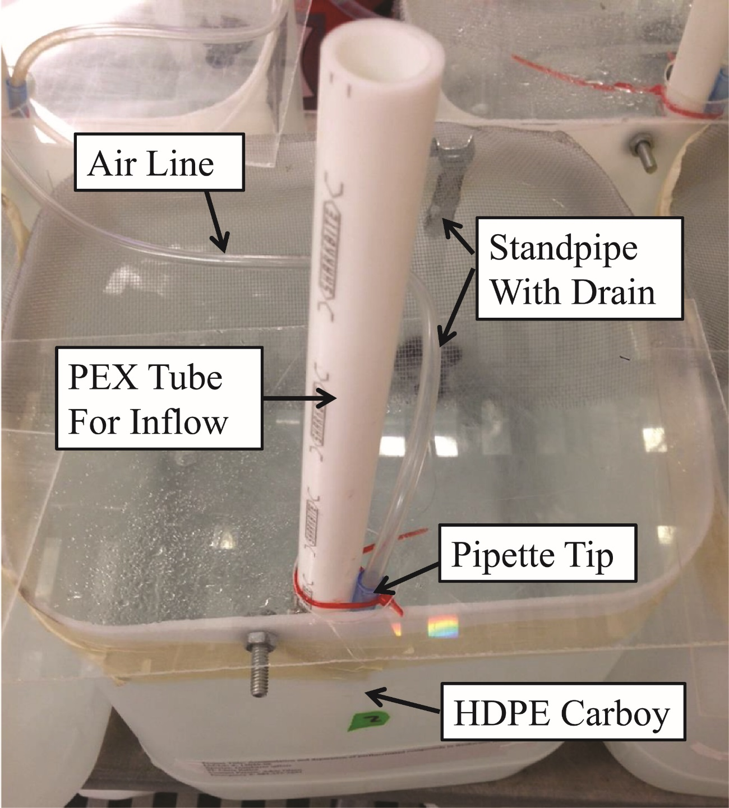

Figure II‑1. Example exposure chamber for experiments with PFASs, made of an HDPE carboy, drain, and standpipe, and a PEX water inflow tube. This image shows the pipette tip aeration method.

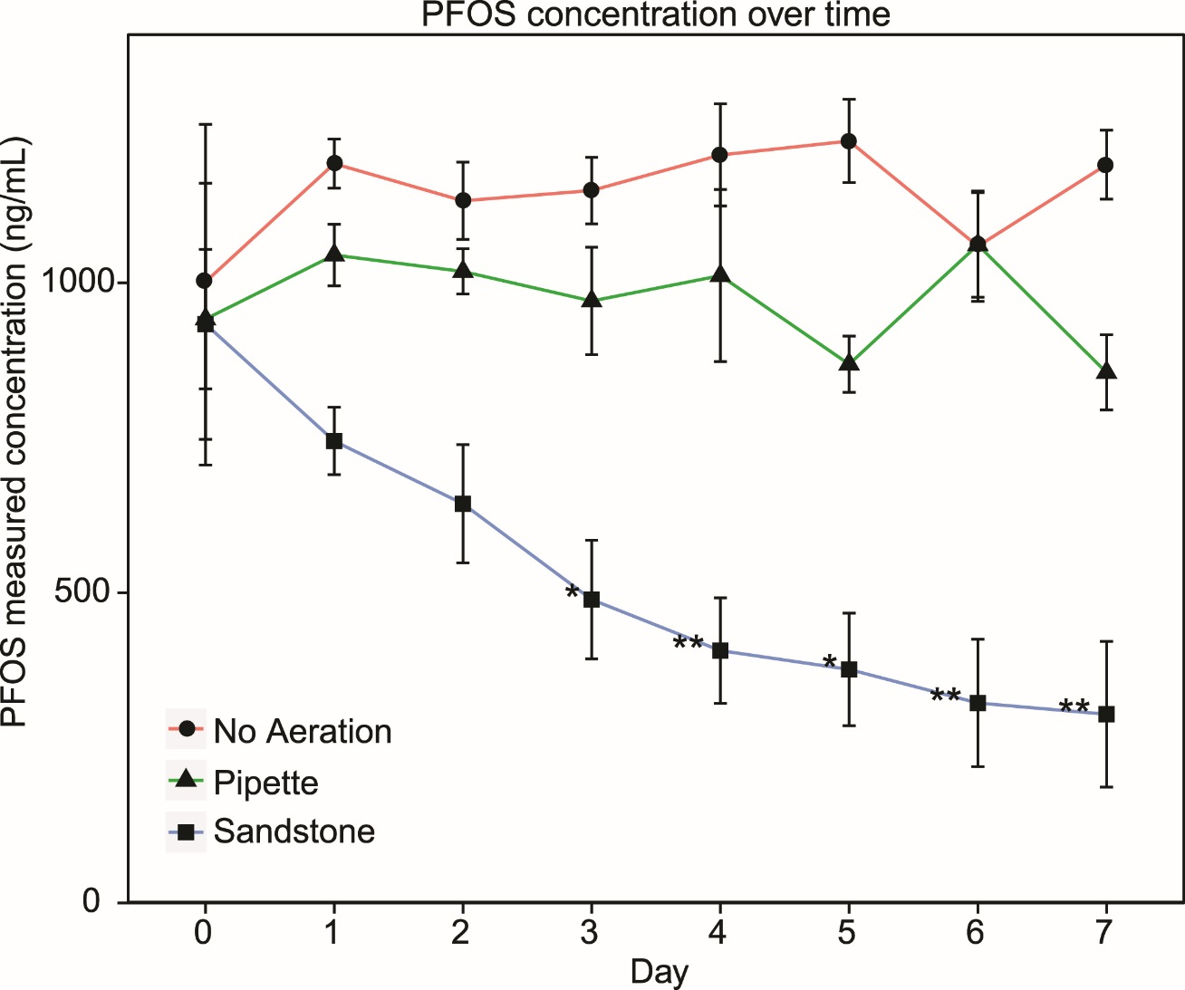

Figure II-2. The change in PFOS concentration in differently aerated containers over time. Sandstones containers marked with a single asterisk were significantly different from only the non-aerated containers, while those with double asterisks were significantly different from both containers on that day. Pipette and non-aerated containers were never significantly different from each other. Error bars represent the standard error.

**CHAPTER III**

# DEVELOPING A PERFLUOROOCTANE SULFONATE (PFOS) UPTAKE AND DEPURATION MODEL FOR FISH USING DATA DEVELOPED IN THE LABORATORY AND FIELD

**Abstract**

Perfluorooctane sulfonate (PFOS) is a perfluoroalkyl substance that continues to receive considerable research. Aquatic organisms are of particular interest with regard to the ecotoxicology and fate of perfluorooctane sulfonate (PFOS) because these organisms have two potential pathways for PFOS exposure – via diet and water. Fish are especially important in aquatic systems because many represent higher trophic levels within the aquatic food web and serve as a potential exposure pathway to humans. However, considerable uncertainties remain regarding the extent that PFOS accumulates and depurates in different fish species. This project presents three, one-compartment bioconcentration models using a kinetic bioconcentration factor for uptake and depuration over time for PFOS in fish. The three individual compartments represented different tissues including muscle, blood, and liver. The uptake and depuration kinetics data used in the model were obtained from peer-reviewed sources as well as a study conducted in the laboratory. Field data on water and fish PFOS concentrations were also obtained from the literature and from studies at Barksdale Air Force Base, LA and used to assess model performance. The model predicts a hyperbolic accumulation of PFOS over time that matches patterns observed in uptake studies and indicates that accumulation in the blood and liver is approximately five times greater than accumulation in the carcass. The model also suggests that exposure to contaminated water is of greater importance to accumulation than from contaminated diet. However, the factors derived from the data for rainbow trout (*Oncorhynchus mykiss*) do not predict the observed uptake and depuration rates for Western mosquitofish (*Gambusia affinis*). This discrepancy indicates that the rates are different for different fish species. I further developed a spatially-explicit bioconcentration model to account for exposure variability and tested this model with field-derived data. This model provided a range of final tissue concentrations instead of a single value and therefore may provide a better approximation of exposures in the environment. When parameterized with bioconcentration kinetics factors derived from *O. mykiss*, the model closely approximated observed concentrations in many fish species collected in the field. In this study, the derived kd was 0.0003696

hr1, Ku equaled 70.4 L/kg/hr, and the BCF was 250 L/kg for *G. affinis*.

**Introduction**

Ecological risk assessment is used in environmental management to aid in determining the hazards posed by manufactured chemicals (Suter 2006). Risk assessment is a comprehensive process that involves three major steps – problem formulation, analysis, and risk characterization (Suter 2006). As part of the analysis step, an understanding of the bioconcentration and the associated rates of chemical uptake and depuration of an animal provides valuable insight into chemical exposure and toxicity. These rates, once determined, can then be used to estimate the concentration of chemical that is expected to be found within an organism after exposure by collecting environmental concentration samples (McGeer, et al. 2003, Pan, et al. 2014, Burkhard 2003). Bioconcentration factors (BCF) represent perhaps the simplest method for relating environmental sample concentration to organism tissue concentrations (Barron 1990). A more sophisticated approach is the use of bioconcentration models that require uptake and depuration rates (Landrum, et al. 1992). Collectively, these models allow for the prediction of individual tissue concentrations based on the degree and route of exposure of an organism (McGeer, et al. 2003). In turn, this allows assessors to estimate the bioavailability of contaminants in the environment and their fate relative to organisms (van der Oost, et al. 2003). This information can also be used to predict exposure for organisms throughout the food chain indirectly exposed to the chemical via consuming exposed food items (Kannan, et al. 2005). These estimates also have importance for human health assessments because dietary intake may represent an important portion of the total exposure to a chemical for humans (D'Hollander, et al. 2010).

For chemicals in which a large body of research has been conducted, the information necessary to conduct risk assessments, including the parameters necessary for bioconcentration models, are commonly available in the peer-reviewed literature for a variety of species including fish (Arnot and Gobas 2006). However, for chemicals that have either recently been developed or are considered “contaminants of emerging concern,” such as perfluoroalkyl substances (PFASs), there is little to no information available to help risk assessors. Perfluoroalkyl substances are of particular concern as these chemicals have been found widely in various tissues of both humans (Olsen, et al. 2003, Kannan, et al. 2004) and wildlife (Giesy and Kannan 2001, Senthilkumar, et al. 2007). Moreover, there is concern regarding their toxicity: perfluorooctane sulfonate can cause a variety of adverse effects including tumor proliferation (Hoff, et al. 2003), decreased immune system function (Keil, et al. 2008), and lowered body weight (Seacat, et al. 2002), among others. Although a number of studies have failed to find significant adverse effects to humans exposed to PFAS (Fei, et al. 2007, So, et al. 2006, Eriksen, et al. 2010), other studies have indicated that the potential for adverse effects exists for human exposure (Washino, et al. 2009, Fei, et al. 2009). Due to this uncertainty, building and validating bioconcentration models that accurately estimate the rates of uptake and depuration of these chemicals in organisms is an important step in furthering scientific understanding of PFASs (Suter 2006) and may be used to streamline or focus site-specific risk assessments.

Perfluorooctane sulfonate (PFOS) is a member of the PFAS class of chemicals. It is commonly detected in surface waters worldwide (Loos, et al. 2007, Boulanger, et al. 2004) and is also environmentally stable, with a photolytic half-life of at least 3.7 years and a hydrolytic half-life of at least 40 years (Beach, et al. 2006). Additionally, PFOS has a large BCF in fish, potentially as great as 125,000 (Moody, et al. 2002). Unlike many other bioconcentrating chemicals that tend to be lipophilic, PFOS preferentially partitions to serum and blood-rich tissues such as the liver (Martin, et al. 2003). However, PFOS additionally accumulates in muscle tissue (Stahl, et al. 2012). Therefore, PFOS and potentially other PFASs present novel challenges in terms of understanding and predicting bioconcentration.

Some of the uncertainty in predicting the fate and partitioning of PFOS can be reduced by the development of robust bioconcentration models. A successfully parameterized and vetted bioconcentration model will provide risk assessors with the ability to estimate organism concentrations with reasonable accuracy across a variety of water concentrations and organism taxa (Arnot and Gobas 2004).These models can be somewhat limited if a single exposure concentration is assumed but may be further refined by the inclusion of varying exposure concentrations, either spatially or temporally (Linkov, et al. 2002). One method of including multiple exposure concentrations is to develop a spatially-explicit model that simulates organism movement within landscape in which pollutant concentrations are heterogeneous. In this type of bioconcentration model, the organism is exposed to different concentrations of a chemical as it moves, thereby altering its burden and potentially yielding a more representative estimate of exposure and uptake. Spatially-explicit models have the benefit of reducing the number of variables that must otherwise be assumed to be constant or non-existent, such as animal movement and variation in contaminant concentration by location (Woodbury 2003), thereby adding to the realism of exposure estimates (Wickwire, et al. 2011). Further, these models allow for robust sensitivity analyses to determine the most important variables in the simulation (Schmolke, et al. 2010).

Several field studies have shown elevated concentrations of PFOS and PFASs in surface waters and aquatic biota (Boulanger, et al. 2004, Giesy and Kannan 2001, Kannan, et al. 2005) but few efforts have been made to directly relate PFOS concentrations in these different system components. As part of a large, multi-objective study, several sampling events were conducted at Barksdale Air Force Base (BAFB) in which PFAS concentrations were determined in both water and fish samples (Lanza, et al. In press, Cochran 2015). At that site, sampling was completed along the length of Cooper’s bayou which is the surface water body adjacent to two former fire training areas. The concentration of PFOS in water at these sites ranged from 0.466 to 0.958 ng/mL, while the concentration in fish collected at the same area peaked at 6632 ng/g.

The ultimate objective of this research was to develop a fish bioconcentration model that can accurately predict the concentration of PFOS in different fish tissues. I first conducted an uptake experiment with Western mosquitofish (*Gambusia affinis*), a warm-water species common to BAFB to yield additional PFOS uptake and depuration rates. I also reviewed literature to find several models with input variables for which I could find peer-reviewed data. I then tested these models for accuracy against published uptake data, uptake data from the *G. affinis* work in this study, field studies that included both fish concentrations and water concentrations of PFOS, and fish and water concentrations collected from BAFB. Finally, I generated a spatially-explicit model and explored whether the inclusion of spatial variation in PFOS concentration and a behavioral component altered model predictions. I discuss the results in light of the current literature, variation among species and habitats, and future research needs.

**Methods**

*Uptake Experiment*

Study Species:Western mosquitofish (*Gambusia affinis*)

*Gambusia affinis* is a small, live-bearing fish of the family Poeciliidae. Importantly for this study, this species is found in warm-water habitats, and is generally found in great numbers at BAFB. It is well suited for laboratory studies due to its small size and ease of maintenance. Additionally, uptake data for PFOS for adults of warm-water species does not exist in the literature.

Study fish were purchased from Carolina Biological Supply. They were maintained in the laboratory in glass aquaria such that there was no less than 0.5 L of moderately hard water per fish. Aeration was supplied constantly and fish were fed *ad libitum* with TetraMin fish food twice daily, with care taken to not over feed. Half-volume water changes were completed on each tank twice per week, at which time the sides of the tanks were scrubbed and accumulated waste matter was removed using an aquarium net. Water quality parameters (DO, pH, ammonium, salinity, temperature) were monitored daily and dead fish were removed at that time.

*Uptake Experiment Methods*

A similar study to Martin, et al. (2003) was conducted to replicate their experimental conditions with a warm water species common to BAFB. For this purpose, *G. affinis* were exposed to 300 ng/mL PFOS for up to 288 hours, the same duration and similar concentration to Martin, et al. (2003). Exposure concentrations were verified for the first four days of the study only, after which time it was reasonable to assume that nominal concentrations were similar to expected without further testing. Experimental containers (for more information on the setup of these, see Chapter II of this dissertation) contained approximately 18.9 L of water and ten individual fish. As in maintenance tanks, aeration was supplied constantly, water quality was monitored daily, and fish were fed *ad libitum* twice daily, again, being careful to not over feed. Water changes were completed by slowly adding 18.9 L of water to the bottom of tank. The intent of this method was to cause the newly added water to force the aged water out through the drain, which was located at the water line on the other side of the tank. In this way, the expectation was that the majority of the volume of “old water” in the tank would be replaced during the water change. The speed at which water was added was variable between tanks and dependent on the size of the drain. The room in which the experiment was housed was on a 16:8 light:dark cycle and the water temperature during the experiment was recorded as 25 ± 2 º C. In addition to the PFOS-exposed fish, some fish were maintained in moderately hard water for use as controls. At each time point; 4.5, 9, 18, 36, 72, 144, and 288 hours; three replicates of PFOS-exposed fish containing 6 fish each were sacrificed in 1.5 g/L MS-222 buffered with sodium bicarbonate to a pH of 7 while one replicate of 6 control fish was also sacrificed at the same time. Fish were then rinsed with distilled water and blotted dry. They were then transferred to a -25º Celsius freezer for storage. After 288 hours, all remaining fish were transferred to moderately hard water, with exposed and control fish kept separate. They were then sacrificed in the same manner as above, including a control replicate consisting of fish that had not been exposed to PFOS, at the following time points: 292.5, 297, 306, 324, 360, 432, and 576 hours. After the conclusion of the experiment, fish were air dried for 48 hours and total dry mass was measured.

Perfluorooctane sulfonate was extracted from whole fish using the QuECheRS method. Briefly, each sample of 6 fish was cut into pieces to increase surface area and then were added to a tube containing 4 g anhydrous magnesium sulfate and 1 g sodium chloride. Ten mL of acetonitrile and 2 mL of milliQ water were each added to the tube which was then closed, vortexed, and left on a shake table overnight. The tubes were then vortexed before being centrifuged at 0º C for 15 minutes. The supernatant was collected and transferred to a second tube containing 900 mg anhydrous magnesium sulfate, 300 mg PSA, and 150 mg C18. These new tubes were vortexed and centrifuged for 15 minutes. They were then placed in a -20º C freezer for at least three hours and the supernatant was filtered into a new tube through a 0.2 µm cellulose acetate syringe filter. Recovered volumes were recorded and the samples were evaporated to dryness. They were then reconstituted to 0.5 mL using methanol before being filtered using syringes attached to 0.2 µm cellulose acetate filters. The remaining liquid was transferred to polypropylene LC vials.

Each vial was also spiked with 100 µg/L of internal standard (13C4-PFOS) to determine instrumental ion suppression. A Thermo Fisher Scientific Triple Stage Quadrupole Quantum liquid chromatography tandem mass spectrometer (LC-MS/MS) was used to quantify PFOS residue (as in US EPA 2009). Separation was accomplished using a Gemini-NX C18 column (150 mm x 2.0 mm, 3 µm; Phenomenex), with gradient elution. The mobile phase consisted of methanol and 20 mM ammonium acetate in water, with a flow rate of 0.3 mL/min. Blanks of milliQ water and QC samples were run after half of the samples were complete and at the end of the run to check for instrumental error and matrix effects. The lowest calibration standard, 10 ng/mL, was used to determine the limit of detection (LOD), which was below the lowest sample concentration.

Uptake rate, depuration rate and bioconcentration factor were then determined using generalized linear modeling (GLM). The body burden and exposure concentration were the parameters used as inputs to the GLM and uptake and depuration rates, and bioconcentration factors, were determined from these. The intercept was set to 0 to provide a regression formula with the desired interaction between variables. The values determined this way were used directly in bioconcentration models in this manuscript (Liu, et al. 2011, Newman 2012; described below). All statistics and calculations were conducted using the R statistical software package (R Core Team 2016).

*Bioconcentration Model*   
 I conducted a literature review to identify the simplest fish bioconcentration models that would be suitable given the data commonly or likely to be available for PFOS. The data commonly available are generally limited to co-collected water concentrations and fish body burden at a single time point (e.g., Taniyasu, et al. 2003, Moody, et al. 2002, Labadie and Chevreuil 2011). There are few studies in which uptake and depuration have been determined for PFOS, however, a laboratory study published by Martin, et al. (2003) contains these data and calculated uptake and depuration rates, and a bioconcentration factor. I identified two uptake models that were suitable for the available data and that would address overall objectives (eq. 1 and eq. 2). Both models are one-compartment models that can be parameterized using the uptake and depuration rates from other compartments of the organism and then combined to make more complex models representative of the whole-body of the organism. The use of more complex, multi-compartment models was not available as the data necessary to derive the inputs for these models do not exist in the literature. Of the identified models, one predicts the concentration in the organism from both an uptake rate from water and a depuration rate in each tissue, both in mL/g/hr. The other model is based on both of those variables in addition to a bioconcentration factor that synthesizes a number of other rates, including respiratory exchange, fecal egestion, and metabolic biotransformation, into a single factor (Arnot and Gobas 2006). Both models also utilize a calculated half-life for PFOS in organisms, determined to be 288 hours (in rainbow trout, from Martin, et al., 2003). Each model provides a time course of tissue concentration estimates in mg/kg PFOS.

The equations for the models are presented below:

Model from Newman (2012):



Where Cf is the concentration in fish, Ku is the uptake rate, Cw is the water concentration, Kd is the depuration rate, Ci is the initial concentration in the fish, and t is time.

Model from Liu, et al. (2011):



Where BCF is the bioconcentration factor and other variables are as above.

During the course of the study, these models were parameterized with both data generated by Martin, et al. (2003) and by the *G. affinis* uptake experiment described above. The code for these models appears in Appendix A.

*Model Comparison to Data*

In order to streamline additional modeling efforts, I was interested in identifying which of the above models best approximated the data from Martin, et al. (2003). To accomplish this, the time series data from Martin, et al. (2003) were compared to the model output at each time point and the sum of squares were calculated. The model with the lowest value was used as the primary model moving forward.

I reviewed the literature to locate manuscripts in which both fish tissue concentrations and surface water concentrations were available. The water values for these data sets were used as model inputs and their output was compared to the published fish tissue concentrations. This served as an initial means of exploring the utility of the model. Here, I assumed that fish were exposed to constant PFOS concentrations for the duration of the exposure, as specified by the individual manuscript. For studies where samples were collected in the environment, I assumed constant exposure unless a time series of exposure concentrations was provided, and increased the duration time to a value well past what was necessary to reach an asymptote to estimate final PFOS tissue concentrations. Other values necessary to parameterize the model were chosen based on the organ for which burdens were reported, commonly the liver. For the comparison of the model to the data from Moody, et al. (2002), simulations were completed using the data generated in Martin, et al. (2003) and from the work with *G. affinis* in this study.

Additionally, I conducted a similar exercise with fish collected at Barksdale Air Force Base, Shreveport, LA, USA, along with co-located water samples (Cochran 2015). The measured PFOS water concentrations were used as the model inputs for water concentration and the model was run until output values reached an asymptote. The model output value for liver concentration was compared with body concentrations from fish collected at the field site. However, this approach assumes that exposure concentrations were constant, which is unlikely to be the case in the field.

*Spatially Explicit Model*

The spatially-explicit bioconcentration model was generated in the freeware program NetLogo (Wilensky 1999), which is an individual-based modeling (IBM) platform. The purpose of the bioconcentration-IBM was to incorporate spatial (and temporal) variability in PFOS exposure concentrations and fish behavior. The model allows a variety of useful parameters to be easily changed, including the number of distinct concentration patches, the concentration mean and standard deviation of each patch, the number and behavior of animals, and the accumulation and depuration equations. The model also allows the user to specify a variety of output parameters, such as the average and maximum burdens accumulated by exposed animals. For simulations, I specified a number of fish that were randomly placed within the river and then moved randomly at each time-step, with the restrictions that they could not leave or “wrap around” the river and that they could not move more than than a specified number of patches from their initial patch. If their random movement path would have violated these rules, they were turned 180 degrees from their current trajectory and moved one patch in that direction. Although the size of an individual fish is similar to the size of a patch graphically in this model, the implication was not intended to be that the fish was the size of a patch. Therefore, fish were not prevented from occupying the same patch as other fish. A patch may represent any size as defined by the user but for the purposes of this modeling exercise represented approximately 30 m2. The time-step could also represent any length of time but in this exercise represented 1 hr. To calculate burden at each time-step, the bioconcentration equation generated from the data in Martin, et al. (2003) for uptake of PFOS into fish liver was used.

For the purpose of this work, two sets of experimental simulations were utilized. First, to evaluate the sensitivity of the model to changes in home range size, the model was initialized with a single fish in a river of five equally-sized patches, each with a different PFOS concentration. The concentrations chosen for these trials were 1, 2, 3, 4, and 5 ng/mL, in order from the top of the stream to the bottom (Figure III-5), with a standard deviation for all patches of 0.25 ng/mL. The movement range of the fish was altered, from the lowest range of 10 patches to the highest range of 50 patches. This upper range allowed the fish to traverse the entire stream during exposure. For each of these trials, the average exposure curve and the final liver burden, after 1000 time-steps, were recorded. Each home range size was simulated ten times. The code for this model appears in Appendix B.

For the second set of simulations, I sought to replicate the observed fish PFOS data from Lanza, et al. (In press) by basing the average and standard deviation of PFOS water concentrations on those determined during a single sampling event on Mack’s Bayou (see Cochran 2015 and Figure III-4). The bayou reaches chosen were contiguous and connected. Each of these reaches were given the same total fraction of area of river, and the patches within a section were chosen from a distribution defined by the mean and standard deviation of that river stretch (Figure III-7). Two subsets of these simulations were completed, one with the model parameterized with the data from Martin, et al. (2003) and the other with the model parameterized with the data generated by experiments with *G. affinis* from this study.

To test the effect the spatially-explicit behavior model had on predicted PFOS liver burden of fish, the model was run several times while varying the number of fish present. I did this to observe the effect that changing the number of fish would have on the smoothness of burden over time figures and the final variability in burdens. The population size was set at either one, ten, or one-hundred fish, and three trials were used for each, with a limit of 2500 time-steps. Additionally, these trials utilized a home range limit of 10 patches equal to the length and width of each reach in the model. At the conclusion of each simulation, the final average liver burden and standard deviation of the distribution of burdens were noted. Further, these data were used to test the validitiy of the model, by comparing observed burdens from the field (Lanza, In press) with those predicted by the model using a Welch’s t-test.

**Results**

*PFOS Uptake Experiment*

*Gambusia affinis* were exposed for 576 hours instead of the longer duration as in Martin, et al. (2003), which was unlikely to have impacted depuration rate estimates because that study found that depuration rate was constant over time. Perfluorooctane sulfonate body concentration for *G. affinis* was approximately 10 times less than predicted for the same experiment conducted by Martin, et al. (2003) with rainbow trout (Figure III-1) with a similar exposure concentration. Whole body concentration also apparently increased after the fish were moved to clean water although only the concentrations at 297 and 360 hours were significantly greater than the body concentration in the fish at 288 hours, determined by using a post hoc one-tailed Student’s t-test. The calculated kd was 0.0003696 hr-1, the half-life was 1875 hours, Ku equaled 2.93 L/kg/hr, and the BCF was 250 L/kg. The equation that most closely approximated the observed uptake was:

Where concentration is in ng/g, time is in hours, and with r2 = 0.5339.

*Model Comparison to Published Data*

When compared to the data from Martin, et al. (2003) on PFOS in rainbow trout livers, the average sum of square of the difference between predicted values and the data of the bioconcentration factor-based model was 0.012, half as much as the difference of the rate-based model, 0.253 (Figure III-2, model inputs in Table III-1). Therefore, the BCF-based model based on Liu, et al. (2011) will be used throughout the rest of this paper for analyses. Both models provided very good estimates of PFOS bioconcentration and any insights obtained from the BCF-based model by Liu, et al. (2011) likely apply to the traditional, one-compartment bioconcentration model (e.g., Newman, 2012).

After an accidental release of PFOS into Etobicoke creek, Moody, et al. (2002) collected water concentration data across a period of 21 days in addition to fish samples after 21 days. Using these data, I plotted the concentration change over time to generate best-fit equations for each of the major curve shapes to represent the instantaneous water concentration at any given time. These water concentrations were then input into the BCF-based model, using the rates derived by Martin, et al. (2003) for rainbow trout or those calculated from the *G. affinis* exposure of the current study, and the expected liver burden at the end of 21 days was compared to the sample values collected by Moody, et al. (2002). The concentrations predicted by the model parameterized with values from Martin, et al. (2003) and with the data generated with *G. affinis* in the current study were 95.6 µg/g and 47.4 µg/g, respectively. The samples collected by Moody, et al. (2002) had concentrations between 2 and 72.9 µg/g (mean ± s.d. = 26.5 ± 25.6 µg/g, see Figure III-3).

Fish were collected at Barksdale Air Force Base in Shreveport, LA, USA in August 2013. In addition to collecting fish, a water sample was collected from the overlying water at each location at the same time. These water concentrations, analyzed in triplicate, provided a range of values that were used as variable inputs into the BCF-based accumulation model parameterized with data from Martin, et al. (2003) or derived from the exposure of *G. affinis* in the current study to provide a range of potential values including 95% confidence intervals (for the data from Martin, et al. 2003 only). To predict the body burden after chronic exposure, the model was run for enough time-steps so that burdens reached an asymptote. The projected concentrations for the fish using the data from Martin, et al. (2003), 125-298 ng/g with 95% confidence intervals of 89-380 ng/g, were within the range of those observed in fish that are more benthic and at a lower trophic level, such as redear sunfish (148-321 ng/g) and yellow bullhead (144 ng/g) while under-representing the concentrations found in other fish such as longear sunfish (269-624 ng/g) and bluegill (415-750 ng/g) (Figure III-4). The range of concentrations projected using the data from *G. affinis* was 20.3 ng/g to 51.5 ng/g, below those of the fish previously mentioned. No *G. affinis* were reported for the August 2013 collection at Weapons Bridge by Lanza, et al. (In press), however, samples of the fish were collected at a different site (Upstream). Use of the water concentrations for this site from Cochran (2015) with the *G. affinis* rates developed in this study predicted a burden of 3.7-5.3 ng/g, compared to the observed concentrations from Lanza, et al. (In press) of 32.23-33.93 ng/g.

*Spatially Explicit Model*

The statistics pertaining to the final liver burdens of the fish in the varied home range simulation experiments are presented in Table III-2. The fish with the largest home range had the lowest average final liver burden and standard deviation (mean ± s.d. = 218 ± 74 ng/g). The average and standard deviation of burdens increased with decreasing home range size (mean ± s.d. = 328 ± 154 ng/g for the medium range, 414 ± 178 ng/g for the smaller range).

For the results of the simulation experiments to explore fish bioconcentration from exposure concentrations representative of those measured at BAFB, the average and maximum liver burdens of fish for each of the trial runs parameterized with liver data from Martin, et al. (2003) are presented in Table III-3. The average values for all trials were similar (2703 – 2821 ng/g),. Figures showing minimum, average, and maximum liver burdens over the course of representative trials are presented in Figure III-8. When compared to the fish collected at BAFB by Lanza, et al. (In press), no significant difference was observed between the burdens estimated by the model for 100 fish and those observed in the field (*p* = 0.84) suggesting that the model may be used to predict receptor burdens in the environment with reasonable accuracy. When the spatially-explicit model was parameterized with the values generated by the current study with *G. affinis*, the final concentration was approximately 4 times less (658 ng/g with 100 fish).

**Discussion**

In this chapter, I developed both a static accumulation and a spatially-explicit accumulation model to estimate the burden of PFOS in several fish tissues based on surface water concentrations. In general, the model outputs from all bioconcentration models developed and used were similar to body burdens observed in both laboratory and field studies. When using the same uptake and depuration parameters, both models provided equivalent outputs. However, the spatially-explicit model allows the user to vary multiple parameters with greater ease, including those that more accurately represent the realities of environmental exposure including different behavioral attributes. Therefore, the spatially-explicit model can simply be viewed as a more flexible model that more directly accounts for some environmental and ecological variability when estimating PFOS accumulation in fish tissues.

The rate at which fish uptake PFOS is described using a second-order exponential curve and the rate at which fish depurate PFOS is described using a first-order curve dependent on the half-life of PFOS in the fish tissue. Bioconcentration factor, uptake rate, depuration rate, and the half-life of PFOS are dependent on the species of fish and also differ between tissues within a fish. Martin, et al. (2003) provided uptake and depuration results for a variety of organs. For each of these organs, using the BCF-based model more accurately predicted the data, justifying its use as the model for the prediction of burdens in the current study.

The toxicokinetic parameters derived by experimentation with *G. affinis* in the current study differed from those calculated for *O. mykiss* by Martin, et al. (2003). However, the tissues for which these parameters were determined differed between the two studies, and it would be expected that the burden in a whole-body sample would be less than that for tissues containing blood, as in Martin, et al. (2003). Many of the comparisons made in this study were of predicted values to those observed in livers, and therefore, for the majority of these predictions, use of the parameters for uptake into liver from Martin, et al. (2003) more accurately predicted final burdens than did the values generated in the current study. The exception to this was when the static-uptake model was compared to the data for a spill of PFOS (Moody, et al. 2002), and potential explanations for this difference will be discussed in the next section.

*Model Comparison to Data*

The static-exposure bioconcentration model, parameterized with data from Martin, et al. (2003), closely approximated the upper-value for PFOS in fish livers after the Etobicoke Creek spill, but most of the liver concentrations found by Moody, et al. (2002) were half of the predicted value or less. It is possible that this was due to three main reasons: 1) the fish for which the model successfully predicted the liver concentration represented a worse-case scenario, where the individual remained in the most concentrated section of the plume until collection, and/or 2) the BCF for the fish collected was less than what Martin, et al. (2003) found for *O. mykiss*, and/or 3) the BCF for the fish appearing lower when exposed to a very large concentration of PFOS. The first of these explanations appears less likely because, in some cases, fish are likely to express avoidance behavior when exposed to high concentrations of toxicants (Sprague and Drury 1969). Furthermore, the concentration of PFOS measured after the spill was greater than the LC50 for many species, indicating that any organisms exposed to the undiluted concentration were likely killed. However, the BCFs for different species are almost certainly different, as has been shown by a number of studies including this one (Franke 1996, Arnot and Gobas 2006). If the BCF for the species of fish captured by Moody, et al. (2002) was known, it’s possible that the model would have more accurately predicted the values seen after collection.

The prediction for body burden made by the static model parameterized with the data generated by experimentation with *G. affinis* from this study were closer to what was observed by Moody, et al. (2002). However, the body burdens from that study represent the concentration of PFOS in the liver of fish while the parameters generated in this study estimate the whole-body burden. Caution must be exercised when making comparisons between these tissues, since it has been shown that PFOS tends to concentrate in specific tissues, such as the liver (Martin, et al. 2003). If the model is assumed to predict burdens accurately, these results suggest that the majority of the fish collected by Moody, et al. (2002) likely did not receive peak possible exposure, because the estimates of whole-body burden are greater than those observed livers, for which the burden would be expected to be high. This might be due to a quirk of bioconcentration, in which the apparent BCF decreases as concentration increases (Franke 1996). This effect may be caused by adsorption binding sites being rapidly filled at high water concentrations, limiting the total amount of a chemical that may be bound during a short exposure period (Liu, et al. 2011).

Further evidence pointing to a different BCF, and therefore different equilibrium body burdens of PFOS, in different fishes comes from the field collections of Lanza, et al. (In press). The model predicted liver concentrations of PFOS in livers accurately for both redear sunfish and yellow bullhead but not for largemouth bass, longear sunfish, or bluegill. This could be due to BCFs that varied by the niche of the organism. Stable isotope analysis has shown that fishes such as those which were not estimated accurately by the model are generally found at a higher trophic level than those that were (Fry, et al. 1999). This is because these higher trophic level predators are accumulating PFOS both from their prey items as well as from the surrounding environment, and their prey items have a greater concentration of PFOS than do the prey items of organisms at a lower trophic level. This would also imply that the BCF of rainbow trout found by Martin, et al. (2003) likely underestimates burdens that would be seen in the environment, because the rainbow trout in that study were fed uncontaminated food items instead of their normal prey, which would increase PFOS intake. However, the whole-body burden predicted by the static model for *G. affinis* was a factor of 6-10 less than what was observed in the field by Lanza, et al. (In press). This difference suggests that more factors influence the burden in the field than simply a variation in the BCF of an organism (for example, see Borga, et al. 2004).

*Uptake Experiment*

The uptake and depuration of PFOS seen by *G. affinis* followed the same reaction orders as seen by Martin, et al. (2003) However, the calculated BCF for carcasses of *G. affinis* was four times less and the half-life was approximately five times longer than for *O. mykiss*. This is potentially due to one or more factors: different metabolism among species, the different body sizes of the species, different blood volumes, or different serum binding affinities for PFOS, among others. Therefore, it appears that bioconcentration models developed for a specific species may only be applicable for that species or closely related species, and perhaps only in the specific sampling conditions in which it was developed (Franke 1996, Arnot and Gobas 2006). Because of this potential for limited application of the model, it is important to test the model with other species and/or conditions to compare the functionality of the model across various conditions. By conducting additional experimentation, the model may be made more robust and universal and areas in which the model is lacking can be identified so future research can be done to address these issues. The scientific literature remains remarkably sparse with useful studies where fish burdens and water concentration were collected at the same time at the same location for PFASs. For example, Pan, et al. (2014), reports the average PFOS concentrations at each of 11 sites along contiguous river sections over several hundred km, but do not report the range for each of those collections. When the spatially-explicit model was initialized with water values from Tokyo Bay, collected by Taniyasu, et al. (2003), predicted liver burdens from the model ranged from 15 to 288 ng/g, comparable to the 38-558 ng/g collected in the field. This variation suggests that refining the model parameters, such as including avoidance behavior or including different BCF values, could further increase the predictive power of the model.

Interestingly, PFOS concentrations in *G. affinis* appeared to continue to increase for the first 18 hours after the individuals were moved to clean water. This pattern also appeared, but to a lesser extent, in the manuscript by Martin, et al. (2003) Since this was not due to continued exposure, some other factor must have been the cause. Potentially, this was due to a metabolic process by which fish were binding PFOS into a moiety while exposed and then reversing that binding once exposure ceased. A process of this type was noted by Jones, et al. (2003) who observed that PFOS has the potential to displace hormones from binding globulins within the serum of fish. However, Jones, et al. (2003) noted that this effect would only occur at relatively high concentration levels (i.e. greater than 100 mg/L). The exposure concentration for this experiment was less than that critical effect value, however, a similar effect may still have occurred in this instance.

*Spatially Explicit Model*

Changing the home range of a single fish had several interesting effects on the liver burden uptake curve and final burden. A fish limited to moving no more than 10 patches was generally limited to a similar exposure concentration throughout the trial. Therefore, their uptake curves were generally logarithmic in shape. Fish with a greater range were more likely to reach a concentration much different from their initial exposure concentration. This was noted more for fish allowed to range throughout the entire river than it was for those with the middle-size range, as these were the only uptake curves in which burden noticeably dropped for an extended period of time (for example, see trial 2 of home range 50 in Figure III-6). The potential within the model to modify the home range indicates that this model can be utilized for both fish and water bodies of different sizes, because altering the home range can have the effect of either making the water body seem bigger or the fish seem smaller.

Importantly, the spatially-explicit bioconcentration model predicted body burdens after exposure that were within the values observed in fish collected at sites receiving exposure at BAFB (Lanza, et al. In press). For example, a single model simulation with 100 fish yielded liver burdens from 2021 to 4678 ng/g with an average value of 2816 ng/g, while fish livers collected at BAFB during the sampling period on which the water values were based had burdens ranging from 182.48 to 16,887.37 ng/g with an average value of 3347 ng/g. Importantly, a statistical comparison of these data indicated that they were not from significantly different distributions, although this is likely due to the large variability in burdens in collected fish. However, the spatially-explicit model generates an estimate of burden that is close to the average of those seen in the field. This suggests that the addition of varying exposure due to both spatial and behavioral processes improves upon the basic, static uptake model. Moreover, that variability exists within body burdens using the spatially explicit model is more representative of the reality of environmental exposure. Commonly, fish collected at a single site during a single sampling effort do not have the same chemical burden (for example, see Figure III-4 or Moody, et al. 2002). A key limitation to exploring the full utility of a spatially-explicit PFOS uptake model is that water concentration data may not be available in sufficient spatial and temporal detail. The study conducted at BAFB, for example, is the only one to my knowledge in which samples were repeatedly obtained from the same sites.

The number of fish used to populate the spatially-explicit model had an impact on the results. The use of 1, 10, or 100 fish yielded a similar average body burden across all trials. However, the maximum burdens observed for the trials using 100 fish were greater than those with 10 fish and minimum burdens were less. These results indicate that the likelihood of a fish remaining in the patches with higher (or lower) exposure concentrations increases with an increase in the number of individuals in the trial. However, if fish were to express avoidance behavior towards PFOS, lower burdens than what are predicted by this model would be expected. Another benefit of the spatially-explicit model is the ability to include more parameters, such as habitat quality or population size, that improve the estimates of exposure for an organism (Hope 2000). However, as evidenced by the underestimation of exposure when only one individual was modeled, and discussed by Woodbury (2003), care must be taken when using spatially-exlicit modeling to ensure that the scenario modeled is representative of the reality of exposure and interpreted correctly in the face of uncertainty.

With further validation regarding the predictive power for a variety of species, the bioconcentration model could be a boon for human health risk assessments of PFASs. By developing a model that can predict the concentration of PFOS in fish muscle tissues with reasonable accuracy, estimates of potential human consumption can be made (for example, see Berger, et al. 2009). A useful model can cut out a potentially difficult and time-consuming step of the assessment process, collecting fish, and allow for a prediction of human exposure from a few water samples.

*Summary*

This study presents a method by which PFOS concentrations in several organs of fish can be estimated from surface water concentrations and duration of exposure. The bioconcentration model and variants presented herein allow for changing the concentration and duration of exposure to a single individual over time. By verifying the model with both peer-reviewed data and my own field and laboratory experiments, I determined that BCF, and therefore equilibrium PFOS concentration, tends to be determined by an organism’s life history traits. Fish at a higher trophic level will have greater body burdens of PFOS. Further, I noticed that the concentration of PFOS in an organism may appear to increase after exposure is ended, and hypothesized that this may be due to the termination of PFOS binding to globulins in serum. Further research to validate the model with different fish species is important to determine the BCFs for a variety of trophic levels and to further elucidate the pattern of increasing PFOS body burden after exposure ceases. Additionally, the determination of fish tissue burdens at a single site over time would provide insight into the variability of exposure, uptake, and the heterogeneity of environmental PFOS concentrations in water bodies. Given that PFASs often occur in mixtures in the environment (Cochran 2015, Liu and Avendano 2013), research investigating the bioconcentration rate of PFAS mixtures would also provide valuable information necessary to predict organismal burdens. Although it may currently be used to approximate exposure in real-world scenarios with some accuracy, with these refinements, the spatially-explicit model may be utilized to predict exposures across a wider range of exposure concentrations and fish species.

**REFERENCES**

Arnot, J.A., and F.A.P.C. Gobas. 2004. A food web bioaccumulation model for organic chemicals in aquatic ecosystems. *Environmental Toxicology and Chemistry* 23: 2343-2355.

Arnot, J.A., and F.A.P.C. Gobas. 2006. A review of bioconcentration factor (BCF) and bioaccumulation factor (BAF) assessments for organic chemicals in aquatic organisms. *Environmental Reviews* 14: 257-297.

Barron, M.G. 1990. Bioconcentration. *Environmental Science and Technology* 24: 1612-1618.

Beach, S.A., J.L. Newsted, K. Coady, and J.P. Giesy. 2006. Ecotoxicological evaluation of perfluorooctanesulfonate (PFOS). *Reviews of Environmental Contamination and Toxicology* 186: 133-174.

Berger, U., A. Glynn, K.E. Holmstrom, M. Berglund, E.H. Ankarberg, and A. Tornkvist. 2009. Fish consumption as a source of human exposure to perfluorinated alkyl substances in Sweden - analysis of edible fish from Lake Vattern and the Baltic Sea. *Chemosphere* 76: 799-804.

Borga, K., A.T. Fisk, P.F. Hoekstra, and D.C.G. Muir. 2004. Biological and chemical factors of importance in the bioaccumulation and trophic transfer of persistent organochlorine contaminants in arctic marine food webs. *Environmental Toxicology and Chemistry* 23: 2367-2385.

Boulanger, B., J. Vargo, J.L. Schnoor, and K.C. Hornbuckle. 2004. Detection of perfluorooctane surfactants in Great Lakes water. *Environmental Science and Technology* 38: 4064-4070.

Burkhard, L.P. 2003. Factors influencing the design of bioaccumulation factor and biota-sediment accumulation factor field studies. *Environmental Toxicology and Chemistry* 22: 351-360.

Cochran, R.S. 2015. *Evaluation of perfluorinated compounds in the sediment, water, and passive samplers collected from the Barksdale Air Force Base.* Ph.D. Dissertation, Lubbock, TX: Texas Tech University.

D'Hollander, W., P. de Voogt, W. De Coen, and L. Bervoets. 2010. Perfluorinated substances in human food and other sources of human exposure. In *Perfluorinated alkyl substances*, edited by P. de Voogt, 179-215. New York, NY: Springer NY.

Eriksen, K.T., O. Raaschou-Nielsen, M. Sorensen, M. Roursgaard, S. Loft, and P. Moller. 2010. Genotoxic potential of the perfluorinated chemicals PFOA, PFOS, PFBS, PFNA and PFHxA in human HepG2 cells. *Mutation Research/Genetic Toxicology and Environmental Mutagenesis* 700: 39-43.

Fei, C., J.K. McLaughlin, R.E. Tarone, and J. Olsen. 2007. Perfluorinated chemicals and fetal growth: a study within the Danish national birth cohort. *Environmental Health Perspectives* 115: 1677-1682.

Fei, C., J.K. McLaughlin, L. Lipworth, and J. Olsen. 2009. Maternal levels of perfluorinated chemicals and subfecundity. *Human reproduction* 24: 1200-1205.

Franke, C. 1996. How meaningful is the bioconcentration factor for risk assessment? *Chemosphere* 32: 1897-1905.

Fry, B., P.L. Mumford, F. Tam, D.D. Fox, G.L. Warren, K.E. Havens, and A.D. Steinman. 1999. Trophic position and individual feeding histories of fish from Lake Okeechobee, Florida. *Canadian Journal of Fisheries and Aquatic Sciences* 56: 590-600.

Giesy, J.P., and K. Kannan. 2001. Global distribution of perfluorooctane sulfonate in wildlife. *Environmental Science & Technology* 35: 1339-1342.

Hoff, P.T., W. Van Dongen, E.L. Esmans, R. Blust, and W.M. De Coen. 2003. Evaluation of the toxicological effects of perfluorooctane sulfonic acid in the common carp (Cyprinus carpio). *Aquatic Toxicology* 62: 349-359.

Hope, B.K. 2000. Generating probabilistic spatially-explicit individual and population exposure estimates for ecological risk assessments. *Risk Analysis* 20: 573-590.

Jones, P.D., W. Hu, W. De Coen, J.L. Newsted, and J.P. Giesy. 2003. Binding of perfluorinated fatty acids to serum proteins. *Environmental Toxicology and Chemistry* 22: 2639-2649.

Kannan, K., S. Corsolini, J. Falandysz, G. Fillmann, K.S. Kumar, B.G. Loganathan, M.A. Mohd, J. Oliero, N. Van Wouwe, J.H. Yang, and K.M. Aldous. 2004. Perfluorooctanesulfonate and related fluorochemicals in human blood from several countries. *Environmental Science & Technology* 38: 4489-4495.

Kannan, K., L. Tao, S.D. Pastva, D.J. Jude, and J.P. Giesy. 2005. Perfluorinated compounds in aquatic organisms at various trophic levels in a Great Lakes food chain. *Archives of Environmental Contamination and Toxicology* 48: 559-566.

Keil, D.E., T. Mehlmann, L. Butterworth, and M.M. Peden-Adams. 2008. Getstational exposure to perfluorooctane sulfonate suppresses immune function in B6C3F1 mice. *Toxicological Sciences* 103: 77-85.

Labadie, P., and M. Chevreuil. 2011. Partitioning behaviour of perfluorinated alkyl contaminants between water, sediment and fish in the Orge River (nearby Paris, France). *Environmental Pollution* 159: 391-397.

Landrum, P.F., H. Lee II, and M.J. Lydy. 1992. Toxicokinetics in aquatic systems: model comparisons and use in hazard assessment. *Environmental Toxicology and Chemistry* 11: 1709-1725.

Lanza, H.A., R.S. Cochran, J.F. Mudge, A.D. Olson, B.R. Blackwell, J.D. Maul, C.J. Salice, and T.A. Anderson. In press. Temporal monitoring of PFOS accumulation in aquatic biota downstream of historical aqueous film forming foam use area. *Environmental Toxicology and Chemistry.* doi:10.1002/etc.3726.

Linkov, I., D. Burmistrov, J. Cura, and T.S. Bridges. 2002. Risk-based management of contaminated sediments: consideration of spatial and temporal patterns in exposure modeling. *Environmental Science & Technology* 36: 238-246.

Liu, C., K.Y.H. Gin, V.W.C. Change, B.P.L. Goh, and M. Reinhard. 2011. Novel perspectives on the bioaccumulation of PFCs - the concentration dependency. *Environmental Science & Technology* 45: 9758-9764.

Liu, J., and S.M. Avendano. 2013. Microbial degradation of polyfluoroalkyl chemicals in the environment: a review. *Environment International* 61: 98-114.

Loos, R., J. Wollgast, T. Huber, and G. Hanke. 2007. Polar herbicides, pharmaceutical products, perfluorooctane sulfonate (PFOS), perfluorooctanoate (PFOA), and nonylphenol and its carboxylates and ethoxylates in surface and tap waters around Lake Maggiore in Northern Italy. *Analytical and Bioanalytical Chemistry* 387: 1469-1478.

Martin, J.W., S.A. Mabury, K.R. Solomon, and D.C.G. Muir. 2003. Bioconcentration and tissue distribution of perfluorinated acids in rainbow trout (*Oncorhynchus mykiss).* *Environmental Toxicology and Chemistry* 22: 196-204.

McGeer, J.C., K.V. Brix, J.M. Skeaff, D.K. DeForest, S.I. Brigham, W.J. Adams, and A. Green. 2003. Inverse relationship between bioconcentration factor and exposure concentration for metals: implications for hazard assessment of metals in the aquatic environment. *Environmental Toxicology and Chemistry* 22: 1017-1037.

Moody, C.A., J.W. Martin, W.C. Kwan, D.C.G. Muir, and S.A. Mabury. 2002. Monitoring perfluorinated surfactants in biota and surface water samples following an accidental release of fire-fighting foam in Etobicoke Creek. *Envionmental Science & Technology* 36: 545-551.

Newman, M.C. 2012. *Quantitative Ecotoxicology.* Second. CRC Press.

Olsen, G.W., K.J. Hansen, L.A. Stevenson, J.M. Burris, and J.H. Mandel. 2003. Human donor liver and serum concentrations of perfluorooctanesulfonate and other perfluorochemicals. *Environmental Science & Technology* 37: 888-891.

Pan, C.-G., J.-L. Zhao, Y.-S. Liu, Q.-Q. Zhang, Z.-F. Chen, H.-J. Lai, F.-J. Peng, S.-S. Liu, and G.-G. Ying. 2014. Bioaccumulation and risk assessment of per- and polyfluoroalkyl substances in wild freshwater fish from rivers in the Pearl River Delta region, South China. *Ecotoxicology and Environmental Safety* 107: 192-199.

R Core Team. 2016. R: A language and environment for statistical computing. Vienna, Austria: R Foundation for Statistical Computing. https://www.R-project.org.

Schmolke, A., P. Thorbek, D.L. DeAngelis, and V. Grimm. 2010. Ecological models supporting environmental decision making: a strategy for the future. *Trends in Ecology & Evolution* 25: 479-486.

Seacat, A.M., P.J. Thomford, K.J. Hansen, G.W. Olsen, M.T. Case, and J.L. Butenhoff. 2002. Subchronic toxicity stuides on perfluorooctanesulfonate potassium salt in Cynomolgus monkeys. *Toxicological Sciences* 68: 249-264.

Senthilkumar, K., E. Ohi, K. Sajwan, T. Takasuga, and K. Kannan. 2007. Perfluorinated compounds in river water, river sediment, market fish, and wildlife samples from Japan. *Bulletin of Environmental Contamination and Toxicology* 79: 427-431.

So, M.K., N. Yamashita, S. Taniyasu, Q. Jiang, J.P. Giesy, K. Chen, and P.K.S. Lam. 2006. Health risks in infants associated with exposure to perfluorinated compounds in human breast milk from Zhoushan, China. *Environmental Science & Technology* 40: 2924-2929.

Sprague, J.B., and D.E. Drury. 1969. Avoidance reactions of salmonid fish to representative pollutants. In *Advances in Water Pollution Research: Proceedings of the Fourth International Conference held in Prague*, edited by S.H. Jenkins, 169-179. Oxford, England: Pergamon Press.

Stahl, T., S. Falk, K. Failing, J. Berger, S. Georgii, and H. Brunn. 2012. Perfluorooctanoic acid and perfluorooctane sulfonate in liver and muscle tissue from Wild Board in Hesse, Germany. *Environmental Contamination and Toxicology* 62: 696-703.

Suter, G.W. 2006. *Ecological Risk Assessment, Second Edition.* Boca Raton, FL: CRC Press.

Taniyasu, S., K. Kannan, Y. Horii, N. Hanari, and N. Yamashita. 2003. A survey of perfluorooctane sulfonate and related perfluorinated organic compounds in water, fish, birds, and humans from Japan. *Environmental Science & Technology* 2634-2639: 37.

U.S. EPA. 2009. *Determination of selected perfluorinated alkyl acids in drinking water by solid phase extraction and liquid chromatography/tandem mass spectrometry (LC/MS/MS).* Cincinnati, OH: U.S. Environmental Protection Agency National Exposure Research Laboratory Office of Research and Development.

van der Oost, R., J. Beyer, and N.P.E. Vermeulen. 2003. Fish bioaccumulation and biomarkers in environmental risk assessment: a review. *Environmental Toxicology and Pharmacology* 13: 57-149.

Washino, N., Y. Saijo, S. Sasaki, S. Kato, S. Ban, K. Konishi, R. Ito,A. Nakata, Y. Iwasaki, K. Saito, H. Nakazawa, and R. Kishi. 2009. Correlations between prenatal exposure to perfluorinated chemicals and reduced fetal growth. *Environmental Health Perspectives* 117: 660-667.

Wickwire, T., M.S. Johnson, B.K. Hope, and M.S. Greenberg. 2011. Spatially explicit ecological exposure models: a rationale for and path toward their increased acceptance and use. *Integrated Environmental Assessment and Management* 7: 158-168.

Wilensky, U. 1999. NetLogo. Center for Connected Learning and Computer-Based Modeling, Northwestern University, Evanston, IL. https://ccl.northwestern.edu/netlogo/.

Woodbury, P.B. 2003. Dos and don'ts of spatially explicit ecological risk assessments. *Environmental Toxicology and Chemistry* 22: 977-982.

Table III-1. Inputs for liver from Martin et al. (2003) used to parameterize static bioaccumulation models in order to select a model for continued use and development.

|  |  |  |  |  |  |  |  |
| --- | --- | --- | --- | --- | --- | --- | --- |
| Variable | Time steps (hr) | PFOS water concentration (mg/mL) | Uptake rate (L/kg/d) | Elimination rate (1/d) | Exposure time (hr) | BAF (L/kg) | Half-life in tissue (hr) |
| Value | 1080 | 0.00035 | 260 | 0.05 | 288 | 5400 | 336 |

Table III-2. Relevant statistics relating to the liver burdens of fish with different home ranges in ng/g after 1000 time-steps using the spatially-explicit behavior model.

|  |  |  |  |  |
| --- | --- | --- | --- | --- |
| Home range size (patches) | Minimum trial liver concentration | Average trial liver concentration | Maximum trial liver concentration | Standard deviation of trial burdens |
| 10 | 113 | 414 | 585 | 178 |
| 30 | 186 | 328 | 582 | 154 |
| 50 | 145 | 311 | 592 | 133 |

Table III-3. Minimum, average, and maximum liver burdens of fish in ng/g after 2500 time-steps using the spatially-explicit behavior model. The final column shows the smallest minimum and largest maximum of all trials. Only one value is presented for the single-fish trials as all values were the same. See Figure III-7 for the inputs chosen for the model.

|  |  |  |  |  |
| --- | --- | --- | --- | --- |
| Number of fish in trial | Trial 1 average (minimum – maximum) | Trial 2 average (minimum – maximum) | Trial 3 average (minimum – maximum) | Mean of all trials – average (minimum – maximum) |
| 1 | 2572 | 3041 | 2865 | 2826 |
| 10 | 2656 (1821 – 3340) | 2914 (2278 – 3671) | 2538 (1883 – 3345) | 2703 (1821 – 3671) |
| 100 | 2628 (2049 – 3911) | 2690 (1799 –4143) | 2816 (2021 – 4678) | 2711 (1799 – 4678) |

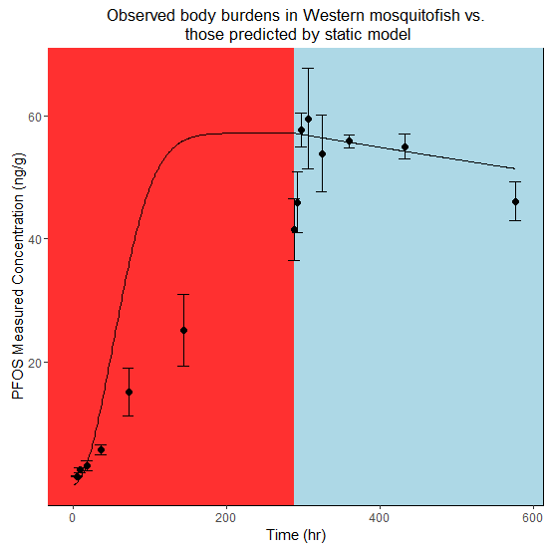

Figure III-1. The whole-body concentration of PFOS in *Gambusia affinis*. The fish were dosed with 300 ng/mL PFOS for 288 hours, at which point they were moved to un-dosed water. The left side of the figure, shaded red, represents the time period during which fish were in dosed water, while the right side, shaded blue, represents the time period during which fish were not in dosed water. The solid line represents the curve of best-fit, derived by generalized linear modeling.

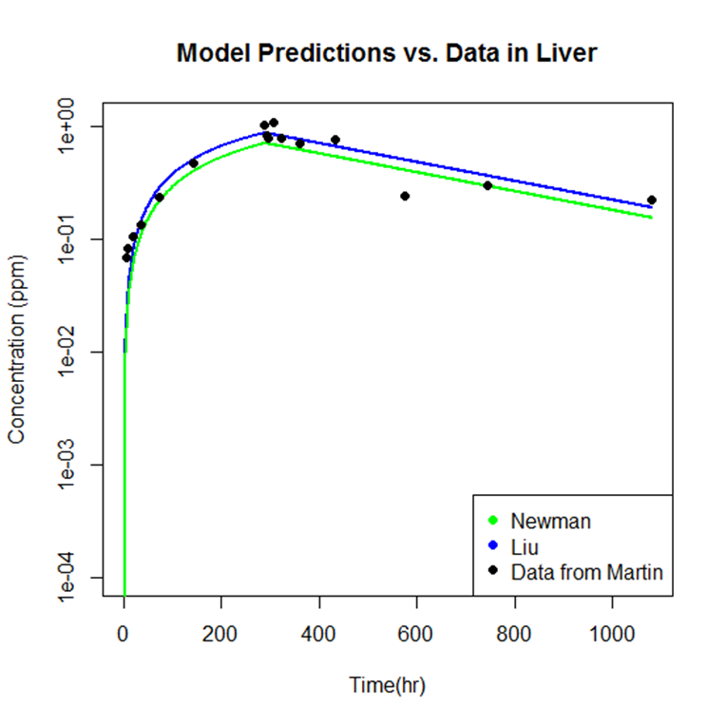

Figure III-2. The models generated by using the inputs from Martin et al. (2003) versus the data generated by Martin et al. (2003) in the livers of *Oncorhynchus mykiss*. The rate-based model is shown in green and the bioconcentration factor-based model is shown in blue. The sum-of-square difference between the model prediction and the data is less for the bioconcentration factor-based model. In this example, fish were given a constant exposure until 288 hours, at which point they were transferred to un-dosed water.

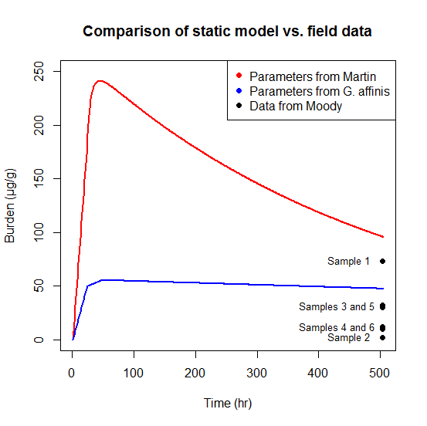

Figure III-3. The projected PFOS-tissue concentration for fish after an accidental spill into Etobicoke creek using water concentrations measured by Moody et al. (2002). The projected tissue concentration was generated using a bioconcentration factor-based model. Samples were collected 21 days after the spill. The red curve is the output for the model parameterized with data from Martin, et al. (2003) for uptake into the liver of *Oncorhynchus mykiss*. The blue curve is the output for the model parameterized with data generated by the current study for uptake in the whole carcass of *Gambusia affinis*.

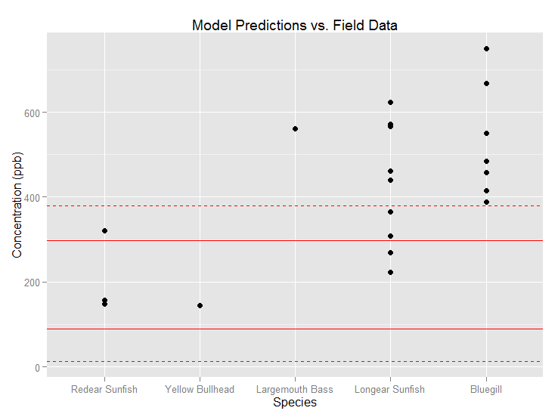

Figure III-4. The liver concentrations for several species of fish collected at Barksdale AFB in Shreveport, LA. All fish in this plot were collected during an individual sampling effort in August, 2013 at a single location, the Weapons Bridge site. The solid horizontal lines are the upper and lower bounds for concentration predicted by a bioconcentration factor-based model and the dashed horizontal lines are the 95% confidence intervals for the upper and lower bounds.



Figure III-5. A graphical representation of the spatially-explicit behavior model with the “river” setup to test the effect of a varied home range. The water concentration values are represented here by the shade of blue, with a darker blue representing a greater concentration of PFOS.

|  |
| --- |
|  |
| Home range sizes | | |
| 10 | 30 | 50 |
|  |  |  |
|  |  |  |  |

Figure III-6. Representative graphs of fish liver burden across each trial by time-step (ticks) using the spatially-explicit behavior model. Each set of trials used different home ranges, and for each trial the starting location of each fish was randomly assigned.



Mean:

0.466 ng/mL

S.D.:

0.795 ng/mL

Mean:

0.782 ng/mL

S.D.:

1.008 ng/mL

Mean:

0.821 ng/mL

S.D.:

1.266 ng/mL

Mean:

0.433 ng/mL

S.D.:

0.437 ng/mL

Mean:

0.958 ng/mL

S.D.:

1.508 ng/mL

Figure III-7. Graphical representation of the spatially-explicit behavior model with exposure concentrations chosen from Cochran (2015). Each panel shows a setup for one of the trial runs, containing either one, ten, or one hundred fish (here, from left to right). Each “river” is divided into five sections of equal length, visually separated by thick black lines. The water concentration values are given to the right of the figure, and represented here by the shade of blue, with a darker blue representing a greater concentration of PFOS.

|  |
| --- |
|  |
| Number of fish in simulation | 1 |  |  |  |
| 10 |  |  |  |
| 100 |  |  |  |

Figure III-8. The graphs of the minimum, average, and maximum fish liver burdens across a representative trial by time-step (ticks) using the spatially-explicit behavior model. Each trial used randomly selected water concentrations for each patch from a distribution for that river section (see Figure III-5), and for each trial the starting location of each fish was randomly assigned.

**CHAPTER IV**

# AGE-SPECIFIC EFFECTS OF SUB-CHRONIC EXPOSURE TO PERFLUOROOCTANE SULFONATE (PFOS) IN THE GREAT POND SNAIL (*LYMNAEA STAGNALIS*)

**ABSTRACT**

Per- and polyfluoroalkyl substances (PFASs) are emerging as important aquatic pollutants and a benthic oligochaete has been identified as the most sensitive species to a particularly common PFAS, perfluorooctane sulfonate (PFOS). Benthic invertebrates are a crucial component of the food web of freshwater aquatic communities. However, few benthic species are traditionally used in toxicity testing leaving an important knowledge gap in understanding effects of chemical stressors on aquatic systems. The great pond snail, *Lymnaea stagnalis*, is an example of a benthic invertebrate that was not commonly used in toxicity tests but is emerging as a candidate species for use in toxicity testing. Because the species is relatively long-lived, identifying critically sensitive life stages may facilitate future testing with this species. To address these data gaps, I exposed each of five different age classes of *L. stagnalis* to PFOS for 21 days and measured multiple endpoints, including growth, food consumption, survival, reproduction, PFOS uptake, and metabolism. The 96-hr LC50 for adults was 196 µg/mL (ppm), indicating that snails are one of the less sensitive organisms. However, the sub-lethal endpoints for many age classes were significantly altered by PFOS at concentrations well below the 96-hr LC50. For example, the 3-6 week age-class had significantly different masses, lengths, and carbohydrate concentrations after three weeks of exposure. Other significant effects were observed in pre-adult snails, including mortality in the 6-9 week age-class and total length in the 9-12 week age-class. The survival and number of eggs produced per egg mass of adults were also significantly altered by PFOS. Bioconcentration of PFOS within the adult age class was concentration dependent and increased logarithmically with increasing concentration. The accumulation results suggest that bioconcentration factors are concentration-dependent, as has been suggested elsewhere, perhaps due to a limited number of binding sites for PFOS within an organism. This study provides evidence that sub-chronic, age-class specific toxicity testing with *L. stagnalis* can provide important toxicological information.

**INTRODUCTION**

Per- and polyfluorinated compounds (PFASs) have been classified as contaminants of emerging concern due to their potential to cause adverse effects to human health or the environment (Dodder, et al. 2014). The potential for PFASs to cause adverse effects is, in part, due to their persistence in the environment and resistance to biodegradation processes (Beach, et al. 2006). A particular PFAS that has received considerable attention in the scientific community is perfluorooctane sulfonate (PFOS). This compound was used in a variety of products, including textiles, metals, and Aqueous Film Forming Foams (Xie, et al. 2013). Due to concerns about the toxicity of the chemical, production of PFOS was voluntarily ceased by 2002 by the main producer, 3M (Olsen, et al. 2007). Despite the phase-out, PFOS continues to be detected and measured in environmental samples, including in areas geographically distant from those in which it was used (Martin, et al. 2004). Perfluorooctane sulfonate has also been detected in wildlife (Giesy and Kannan 2001, Senthilkumar, et al. 2007) and humans (Inoue, et al. 2004, Joensen, et al. 2009), adding to the concerns that this chemical may cause adverse effects. Since its emergence as a chemical of concern, much research has been conducted on the potential toxicity of PFOS, however, considerable uncertainty remains. For example, little work has been conducted evaluating the chronic toxicity of PFOS to aquatic species which are among the most likely to be exposed.

While the vast majority of toxicological data for PFOS is focused on human health, a reasonable amount of ecotoxicological data is available. Currently, the most sensitive aquatic species to PFOS is *Chironomus tentans*. An acute EC50 for growth was established as 87.2 µg/L and a chronic NOEC for survival and growth of 2.3 µg/L was also identified (MacDonald, et al. 2004). Other studies (Boudreau, et al. 2003, Hagenaars, et al. 2008, Li 2009, among others) evaluated the sensitivity of a number of aquatic taxa to acute exposures of PFOS but the lowest effect level from these studies was a 48-hr NOEC for immobility of 0.8 mg/L in *Daphnia magna*. Additionally, some studies have evaluated the toxicity of PFOS to aquatic organisms over chronic exposure durations (Du, et al. 2009, Wang, et al. 2011, Ji, et al. 2008). Some of the acute thresholds identified by these studies are below observed extreme environmental concentrations such as those following an accidental spill of Aqueous Film Forming Foam (AFFF), which had PFOS as a key ingredient (i.e., a maximum of 2.21 mg/L from Moody, et al. 2002). However, extreme water concentrations like those found as a result of a spill are not maintained for long in moving bodies of water and so exposure over a longer term is more representative of what might be seen for the majority of potentially exposed aquatic organisms. Water concentrations maintained in the environment are generally in the range of 10 pg/L to 200 ng/L but may occasionally be as high as 10 µg/L (Ahrens, et al. 2010, Hansen, et al. 2002, Harada, et al. 2003, Jin, et al. 2009, Cochran 2015). To date, few studies have identified chronic toxic effects at what might be considered environmentally relevant concentrations (particularly for benthic macroinvertebrates as in MacDonald, et al. 2004, Van Gossum, et al. 2009, Bots, et al. 2010), while many more have not (Zhang, et al. 2014, Boudreau, et al. 2003, Li 2010, Drottar and Krueger 2000, Cui, et al. 2016, Wang, et al. 2011, Ankley, et al. 2004, among others). Hence, available toxicity and environmental monitoring data suggest a potential overlap of exposure and effects thresholds and therefore risk, but more data and approaches would allow refined risk estimates.

Chronic toxicity studies are particularly relevant for PFASs like PFOS because the chemical is not easily degraded by environmental or biological processes (Hekster, et al. 2003). There are a general lack of studies evaluating chronic toxicity for PFOS that must be addressed in order to increase our understanding of the risk the chemical poses for a number of species (Giesy, et al. 2010). The lack of toxicity data for PFOS requires risk assessors to calculate screening reference values using conservative methodology that necessitates a variety of assumptions (Beach, et al. 2006). However, the conservativism of these values can be decreased, and therefore the accuracy of these values increased, through the inclusion of toxicity data for more species (US EPA 1995). Further, due to the persistence of PFOS, it is important to complete toxicity studies using multiple life stages of organisms, such as in Wang, et al. (2011). This is especially important for PFOS, because exposure to PFOS may result in different effects depending on organismal life stage at exposure (Bots, et al. 2010).

Benthic invertebrates, such as gastropods, are often crucial to the ecosystems in which they live. They contribute to necessary processes such as cycling nutrients and may occupy a number of niches within the food web (Covich, et al. 1999). For this reason, although snails are not traditionally studied in toxicity testing (but see Ducrot, et al. 2014 and new guidelines: OECD 242 and 243 (OECD 2016a, OECD 2016b)), toxicity data for these animals can provide important information about the effects a chemical may have on the aquatic community. In this study, a representative species of gastropods, the great pond snail (*Lymnaea stagnalis*), was chosen as the test organism. *Lymnaea stagnalis* were used for several reasons, including that their habitat range includes Canada and Europe, areas in which PFAS-containing AFFFs were used, and that they are easily maintained in a laboratory setting. Furthermore, experiments may be carried out across a set of defined life-stages (Ducrot, et al. 2010b) and for a variety of endpoints, including reproduction, food consumption, growth, metabolism, and toxicant uptake (Coutellec and Lagadic 2006, Barsi, et al. 2014, Ducrot, et al. 2010a). It is likely important to identify the most sensitive life stage for continued toxicity testing with *L. stagnalis* because the species has a relatively long lifespan (up to 2 years in the field) with distinct life stages (Ducrot, et al. 2014).

The objectives of this research were twofold: 1) to determine the toxicological effect of PFOS on *L. stagnalis* by evaluating multiple endpoints including growth, food consumption, total reproduction, reproductive viability, and metabolism (as expressed by the amount of carbohydrates, proteins, and lipids within the organism) across five separate life stages (0-3 weeks old, 3-6 weeks old, 6-9 weeks old, 9-12 weeks, old, and adult (>12 weeks old)); and 2) to calculate the total uptake of PFOS by adult *L. stagnalis*. I hypothesized that toxicological effects would not be observed at environmentally relevant concentrations and that the youngest age-class would be the most sensitive. These data can be used to inform future experiments with *L. stagnalis* while also contributing to our understanding of PFOS toxicity to an additional aquatic invertebrate species.

**METHODS**

*Organism Culture*

*Lymnaea stagnalis* used in this experiment were randomly selected from the appropriate age group from a snail culture maintained at Texas Tech University. The original snails for the culture were received from the University of Miami in 2013. The culture was maintained in 20 L glass aquaria, in aerated synthetic fresh water (hereafter referred to as lab water, 13.38 g CaSO4, 5.6 g MgSO4, 0.25 g KCl, and 2.95 g NaHCO3 to 50 L deionized water (US EPA 2002)) that was changed several times per week using the static-renewal method. Cultures were fed raw organic romaine lettuce *ad libitum*.

*Toxicity Testing*

Acute toxicity tests were initially completed to determine the concentrations used for longer duration tests. Exposures during the acute tests were 96-hours while sub-chronic tests were of a 21-day duration. The procedure for the longer tests were based off of a tiered toxicity testing strategy modified from Ducrot, et al. (2010b). The snails used by Ducrot, et al. (2010b) took 21 days to grow between life stages in their laboratory and reached adulthood and began reproductive activity at 8 weeks. However, observation of *L. stagnalis* in our laboratory showed that snails took approximately 12 weeks to become reproductively active. Therefore, in order to follow the methods of Ducrot, et al. (2010b) as closely as possible, I kept the experimental length of 21 days per test but utilized five age classes instead of four. As such, the experimental animals were divided into four pre-adult groups of ages equal to the length of the experiment (i.e., 0-3 weeks, 3-6 weeks, etc.) rather than dividing *L. stagnalis* by length as in Ducrot, et al. (2010b). In this way, snails of all ages leading to and including adulthood were used in testing.

*Range-Finding Tests*

Stock solutions of PFOS were prepared by dissolving between 0.2000 and 0.2010 g of the chemical powder in 1.00-L of lab water, which is well below the solubility limit of 498 mg/L (Beach, et al. 2006), and placing the HDPE bottles on a shaker overnight. This stock solution was then diluted as necessary to obtain the final exposure concentrations. Exposure concentrations were measured initially and after three days for verification (see Chapter II). For these acute exposures, tests were completed using adult and 0-3 week-old snails, fed raw organic lettuce *ad libitum*, maintained in incubators at 20º C, and covered with plexiglass. The test with adults was initiated by placing five individuals in each of two replicates in each of seven exposure concentrations (0, 15, 30, 60, 125, 200, and 250 µg/mL (ppm) PFOS in 1-L total of exposure water and deionized water). The test with 0-3 week old snails included 10 individuals in each replicate and concentrations of 0, 12.5, 25, 50, 100, 150, and 200 µg/mL PFOS. Dead individuals were removed daily. After 96 hours, the remaining living snails were counted.

*Life-Stage Experimental Procedure*

Stock solutions of PFOS were prepared as in the range-finding tests. As the goal of these experiments was not immediate mortality for most of the individuals in any treatments, the maximum concentration was set equal to half of the NOEC from the range-finding tests, and was, therefore, 50 µg/mL. To ensure minimal variation between concentrations, the same stock solution bottle was used for the lowest concentrations (1.5, 3, and 6 µg/mL). During the initial life-stage experiment, nominal concentrations (0.0, 1.5, 3, 6, 12.5, 25, and 50 µg/mL) were verified by collecting a 1-mL sample of exposure media at experiment initiation, before and after a water change at 3 days, and before and after the water change at 7 days. These were verified using instrumental analysis, as described at the end of the next section. However, this method permits accepting observed concentrations within a factor of 2 as being equivalent to nominal concentrations (US EPA 2009). Due to the lack of precision inherent in this method, the nominal concentrations of experiments will be referenced in this document rather than measured values.

Experiments were conducted in incubators set to 20º C, which did not vary more than 1º C during the course of the studies. For each study, individuals of the appropriate age group were randomly selected from the culture tanks, impartially assigned to treatment groups, and then weighed and either photographed on top of millimetric paper for the purpose of measuring their length or measured with calipers. They were then placed into their exposure containers, which were 1-L tripour polyethylene beakers. Once all snails were processed in this manner, all experimental units were amended with the appropriate PFOS amount, to bring the total volume of liquid in each container to 1-L. This volume was slightly below the top of the container, so spillage was not a concern. Finally, each replicate received lettuce that had been soaking in lab water overnight. The extra step of soaking overnight was taken to ensure that lettuce removed and weighed at the end of a feeding period had similar proportion water compared to lettuce initially added. Containers with adults received approximately 2.5 g of lettuce, while other age-classes received 2 cm2 (2 cm x 1 cm) pieces. Prior to being placed in an experimental unit, each piece of lettuce was blotted dry and then weighed. The exposure containers were randomly assigned to a shelf in the incubator and also randomly assigned a place on that shelf. To decrease evaporation and prevent snail escape, containers were covered with plexiglass which was held in place using wooden blocks.

Each life-stage experiment was monitored daily at 1600 hours, except for the days during which the water change occurred at 1100 hours. Water changes occurred every 3.5 days, at which time the snails would be observed as normal before the exposure water was poured through a net. Exposure containers were then cleaned with a KimWipe before the snails were returned. The appropriate amount of water, PFOS, and lettuce was then added to each container. Care was taken to avoid as much stress as possible for the snails during this period, as well as to avoid leaving snails in non-treatment water for longer than necessary (less than 30 minutes per change). At each monitoring period, the number of snails alive and the number of egg masses (for relevant life stages) were observed in each container. Additionally, the lettuce was replaced with an amount similar to the initiation of the experiment daily (for adults) or every other day (for the other age-classes). Removed lettuce was blotted dry and weighed. The first three egg masses from each container and the first three collected on or after the fifteenth day of the trial were counted under a dissecting microscope to determine the total number of eggs, placed in lab water, and returned to the incubators to assess hatching success. Subsequent, additional egg masses were counted to determine the total number of eggs in each mass and then discarded. At the conclusion of the experiment, the remaining snails were again weighed and either photographed on top of millimetric paper for the purpose of measuring with the exception that adults were directly measured with calipers. They were then placed in storage containers and frozen at -80º C until processing for macronutrient or PFOS content. Shell length from digital images was measured using the free program, imageJ.

*PFOS Uptake Analysis*

Adult specimens were used for PFOS uptake testing, accomplished through a multi-stage process. First, samples were dried for 48 hours at room temperature in a laboratory hood. Their dry weight was obtained and, if enough mass did not exist for the extraction method, snails were combined into samples of approximately equal mass. If this step was necessary, snails were grouped with others from their exposure concentration. Otherwise, snails were kept with the other individuals from their initial replicate. All samples were at least 1 g-dw. They were then processed via the QuEChERS method. Briefly, the dried samples were cut using laboratory scissors to increase surface area and then were added to a tube containing 4 g anhydrous magnesium sulfate and 1 g sodium chloride. Ten mL of acetonitrile and 2 mL of milliQ water were each added to the tube which was then closed, vortexed, and left on a shaker table overnight. The tubes were then vortexed before being centrifuged at 0º C for 15 minutes. The supernatant was collected and transferred to a second tube containing 900 mg anhydrous magnesium sulfate, 300 mg PSA, and 150 mg C18. These new tubes were vortexed and centrifuged for 15 minutes. They were then placed in a -20º C freezer for at least three hours and the supernatant was filtered into a new tube through a 0.2 µm cellulose acetate syringe filter. Recovered volumes were recorded and the samples were evaporated to dryness. They were then reconstituted to 0.5 mL using methanol before being transferred to microcentrifuge tubes containing 0.2 µm cellulose acetate filters. These were spun for 2 minutes at 4500 rpm and the remaining liquid was transferred to polypropylene LC vials.

Each vial was also spiked with 100 µg/L of internal standard (13C4-PFOS) to determine instrumental ion suppression. A Thermo Fisher Scientific Triple Stage Quadrupole Quantum liquid chromatography tandem mass spectrometer (LC-MS/MS) was used to quantify PFOS residue. Separation was accomplished using a Gemini-NX C18 column (150 mm x 2.0 mm, 3 µm; Phenomenex), with gradient elution. The mobile phase consisted of methanol and 20 mM ammonium acetate in water, with a flow rate of 0.3 mL/min. Blanks of milliQ water and QC samples were run after half of the samples were complete and at the end of the run to check for instrumental error and matrix effects. The lowest calibration standard, 10 µg/L, was used to determine the limit of detection (LOD).

*Bioenergetic Endpoints – Macronutrients*

Sub-adult snails were used for macronutrient analysis using a method modified from De Coen and Janssen (2003). Macronutrient analysis provides insight into the stress experienced by an organism as stress may result in a change in feeding activity or use of energetic reserves (Sokolova, et al. 2012). Immediately prior to analysis, snails of each replicate were thawed, pureed, and homogenized in 200 µL of deionized water using a Dremel tool. Samples were then extracted using 100 µL of 15% trichloroacetic acid. Samples were then centrifuged for 10 minutes at 3500 rpm at 4º C. Of this, 250 µL of the supernatant, in triplicate, was added to 250 µL of 5% phenol and 1 mL sulfuric acid. This represented the carbohydrate fraction, for which glucose was used as a standard. The precipitate was resuspended in 500 µL sodium hydroxide, incubated at 60º C for 30 minutes, and then added to 300 µL hydrochloric acid. This represented the protein fraction, for which bovine serum albumin was used as a standard. All samples were added to a 96-well plate in triplicate, and then read using a spectrophotometer (Bio Tek, Synergy 4).

Due to the number of samples, two instrument runs were necessary for each age class for all bioenergetic tests. A regression line was developed for each set of controls, and the best-fit equation for this line was then used to calculate the value for each replicate in the plates.

*Statistical Analysis*

All statistics were completed in program R (R Core Team 2016) with an alpha of 0.05. For range finding tests, LC50 values were calculated using logistic regression available in the library “MASS” (Venables and Ripley 2002). Treatment effects on mortality were analyzed using a Kaplan-Meier estimator (Kaplan and Meier 1958), available in the library “Survival” (Therneau 2015). If significant effects were observed using this test, Dunnett’s Test was used in post hoc testing to determine which concentrations were different than the control. Food consumption was analyzeed using a one-way ANOVA with concentration means as the factor and mg of lettuce consumed per snail-day as the response variable. For these tests, the first sampling period was excluded to accommodate acclimation of snails to the experimental environment.

Effects of PFOS exposure concentration on mass and length were analyzed using a one-way ANOVA. The dependent variable in this case was the final size of the snails that survived to the termination of the study. This was used after a one-way ANOVA to verify that no significant differences existed with regard to size among exposure concentrations at the initiation of the study.

One-way ANOVAs were also used to test for differences in bioenergetic endpoints and PFOS uptake. If significant differences were noted using an ANOVA, Dunnett’s Test was used post hoc to determine which concentrations were significantly different from the controls.

**RESULTS**

For all tests, survival in the controls was at least 90%.

*Range-Finding Tests*

Complete mortality was observed at 250 µg/mL (ppm) in the adult test. No concentration in the 0-3 week age-class test caused complete mortality, however, the highest concentration resulted in 10% survival in both replicates. The 96-hr LC50 for adults was 196 µg/mL (± 11.8 µg/mL standard error) and for 0-3 week-old snails was 150 µg/mL (± 12.4 µg/mL standard error).

*0-3 Week Age-Class*

Fifteen individuals of this age-class died during the study (Figure IV-1). There were no significant mortality effects due to PFOS (*p =* 0.277). There were no significant effects from PFOS on food consumption (*p =* 0.237).

No significant differences existed between snail masses (*p =* 0.605) or lengths (*p =* 0.81) at the beginning of the study. Mass did not differ between concentrations at the end of the study (*p =* 0.81). Similarly, length did not differ between concentrations at the termination of the study (*p =* 0.93). Additionally, significant differences did not exist for the measurable bioenergetic endpoint (carbohydrate *p =* 0.287, Figure IV‑4). Statistical analysis for protein concentration was impossible due to the large percentage of concentrations below the instrument limit of detection (91 of 126). However, a large percentage of these values below the LOD came from the three higher concentrations (50 of 54 of these concentrations).

*3-6 Week Age-Class*

Fifteen individuals of this age-class died during the study (Figure IV‑2). There were no significant mortality effects due to PFOS (*p =* 0.27). There were no significant effects from PFOS on food consumption (*p =* 0.22).

No significant differences existed between snail masses (*p =* 0.683) or lengths (*p =* 0.557) at the beginning of the study. However, PFOS exposure significantly altered both the mass of the snails by the end of the study (*p =* 0.006, Figure IV‑3) and the length of the snails (*p* < 0.001).

Carbohydrate concentration was significantly altered by exposure to PFOS (*p =* 0.004, Figure IV‑4). The significant trend for this age-class was a decrease in carbohydrate concentration with an increase in PFOS concentration. However, no individual concentration was significantly different from the controls (lowest *p =* 0.101). Statistical analysis for protein concentration was impossible due to the large percentage of concentrations below the instrument limit of detection (112 of 126). Only three samples out of 54 from the three highest concentrations were above the LOD.

*6-9 Week Age-Class*

Thirty-seven individuals of this age-class died during the study (Figure IV‑5). Significant mortality effects due to PFOS were observed (*p =* 0.025). However, only snails expsoed to 12.5 µg/mL had decreased survival compared to the controls (*p* = 0.0316; other *p* > 0.077). Food consumption effects were not statistically compared for this age-class due to my inability to feed the snails enough lettuce so that they wouldn’t consume the entire amount. This occurred despite increasing the amount of lettuce fed to the replicates throughout the study.

No significant differences existed between snail masses (*p =* 0.354) or lengths (*p =* 0.418) at the beginning of the study. Neither mass nor length differed between concentrations at the end of the study (*p =* 0.105 and 0.203, respectively).

Carbohydrate concentration was not significantly altered by exposure to PFOS (*p =* 0.13, Figure IV‑4). For this age-class, 42 of the 126 protein bioenergetic samples were below the limit of detection. Statistical analyses were completed in two ways using these data – both with samples below the LOD set to equal 0 ng/mL and also excluding those samples. Neither set of analyses showed a significant effect of PFOS on protein concentration (*p =* 0.12 and 0.103, respectively).

*9-12 Week Age-Class*

Seven individuals of this age-class died during the study (Figure IV‑6). There were no significant mortality effects due to PFOS (*p =* 0.659). There were no significant effects from PFOS on food consumption (*p =* 0.45).

No significant differences existed between snail masses (*p =* 0.297) or lengths (*p =* 0.935) at the beginning of the study. Mass did not differ between concentrations at the end of the study (*p =* 0.156). However, length was significantly altered by exposure to PFOS (*p =* 0.0237, Figure IV‑7).

Carbohydrate concentration data was not calculable for this age-class due to the samples being highly concentrated and therefore unable to be read by the instrument. Protein concentration was not affected by exposure to PFOS (*p =* 0.702).

*Adult Age-Class*

All exposure levels other than the controls had mortality of at least 7 individuals in this age-class (Figure IV‑8). In total, 80 of the 210 snails involved in this study died. Mortailty was significantly altered by PFOS (*p* < 0.001). Snails in the 6 (*p =* 0.0112), 25 (*p* < 0.001), and 50 (*p =* 0.0111) µg/mL concentrations had significantly decreased survival when compared to the controls. There were no significant effects of PFOS on food consumption (*p =* 0.744, Figure IV-9).

No significant differences existed among treatments for snail masses (*p =* 0.596) or lengths (*p =* 0.915) at the beginning of the study. Mass did not differ between concentrations at the end of the study (*p =* 0.949). Length also did not differ at the end of the study between concentrations (*p =* 0.723).

The final concentration of PFOS in the snails was significantly affected by the exposure concentration of PFOS (*p <* 0.001). The three highest exposure concentrations had significantly greater PFOS body burdens at the end of the study than did the controls and other low exposure concentrations (Figure IV‑10).

The adult age-class was the only life stage to produce enough eggs for statistical analyses. Exposure to PFOS had a significant effect on the number of eggs produced per egg mass (*p* < 0.001), however, none of the PFOS concentrations were significantly different from the controls (lowest *p* = 0.437). Additionally, when standardized for the number of snail-days (the sum of the number of days each snail was alive during the trial), the total production of eggs (the units in this case being eggs per snail-day) was not significantly altered by exposure to PFOS (*p =* 0.139). Furthermore, neither the total number of egg masses laid nor the number of masses per snail-day were significantly altered by PFOS exposure (*p =* 0.389 and 0.627, respectively). Finally, neither the number of eggs laid per day (*p =* 0.150, Figure IV‑11) nor the percent of eggs successfully hatched from observed masses (*p =* 0.832) were significantly altered by exposure to PFOS.

**DISCUSSION**

As is the case with the majority of species used in PFOS toxicity tests, *L. stagnalis* was not found to be particularly sensitive to PFOS exposure at environmentally relevant concentrations. In this study, this was true for both lethal and sub-lethal endpoints. The lowest individual concentration at which significant effects due to PFOS were noted was 6 µg/mL (ppm), for survival of adult snails (Table IV-1). Further, unexpectedly, the exposure concentrations for which sub-lethal endpoints were significantly different from controls were higher than for the threshold for survival, if effects were noted. The threshold of effects from this study is greater than surface water concentrations commonly observed in the environment (< 10 ng/mL) except for in extreme spill events, indicating that adverse effects of PFOS exposure to *L. stagnalis* are not expected.

*Survival*

Of the endpoints measured, survival after exposure to PFOS was the one for which significance was observed in the greatest number of age-classes. This result is counterintuitive, because in general, mortality generally results from a rather large stress response, sometimes comprised of effects on multiple different endpoints (i.e., Lin and Beal 2006, Portner, et al. 2005). Therefore, we would expect to see significant results in other endpoints at lower concentrations before we would see significant mortality differences due to chemical exposure. Toxic effects for sub-lethal endpoints at thresholds below those that cause mortality have also been observed for a number of species in aquatic toxicity tests with PFOS (Boudreau, et al. 2003, MacDonald, et al. 2004). These results suggest that toxic effects may be observed at a lower concentration than in this study for *L. stagnalis* for other endpoints, such as developmental deformities or at the cellular level (see Cheung and Lam 1998, Finnegan, et al. 2009).

Another unexpected result of mortality testing was that the most sensitive life stages were not the youngest. In the case of *L. stagnalis*, the most sensitive age-classes were the 6-9 week-olds and the adults. This was not the hypothesized result because previous studies have shown that juveniles are generally the most sensitive age-class (McCahon and Pascoe 1988, Hutchinson, et al. 1998). Early-life-stage sensitivity may be due to a number of factors, including that detoxification pathways may use energetic resources that otherwise would be used for growth and development (de Chavez and de Lara, 2003) and that early life-stage organs are less developed and therefore are less capable of detoxification (Bentivegna and Piatkowski 1998). Therefore, for this study, I expected that the 0-3 week age-class would be the most sensitive, followed by the 3-6 week age-class.

In general, stressors have been shown to alter the feeding activity, energy reserves, growth, and reproduction of organisms (Sokolova, et al. 2011). Therefore, a possible explanation for why the 3-66 week age-class was one of the most sensitive is that the snails may have been investing a large amount of energy in maturation during that life stage. Therefore, they may have been less prepared to process toxicants (Zooneveld and Kooijman 1989). A possible explanation for the unusually high sensitivity of adults to PFOS could be that the internal shift to reproduction also decreased the ability of individuals to successfully detoxify the chemical. Organisms may respond to stressors by increasing reproduction at the expense of other internal pathways (Nicholson 1954). The increase in reproduction can also have an effect on macronutrient usage, as nutrients are necessary to provide eggs with energy (Heras, et al. 1998).

*Food Consumption and Bioenergetics*

No age-classes showed different food consumption due to PFOS exposure. Similarly, the vast majority of metabolic endpoints measured were not significantly altered by PFOS exposure. This suggests that exposure to these high levels of PFOS does not necessarily alter internal energy reserves or allocation patterns of *L. stagnalis*. However, carbohydrate concentrations were altered for a single age-class, the 3-6 week-olds (Figure IV‑4). This result is important because the carbohydrate concentration decreased with an increase in PFOS exposure. Other research has shown that carbohydrate content can be used as an indicator of respiration rate, i.e., increased respiration will lead to decreased carbohydrate concentration (Dwivedi 2000). Furthermore, it has been suggested that toxicity due to perflurooctanoic species is caused by a shift in lipid metabolism that leads to weight loss (Kennedy, et al. 2004). Therefore, it is possible that the significant difference in carbohydrates in this age class are indicative of a metabolic shift due to PFOS exposure that is most prominent in 3-6 week-old snails. This type of response may also explain some of the effects described in the previous section. Importantly, as mentioned previously, it is likely that there are endpoints not evaluated here for which effects would have been observed at a more sensitive threshold. For example, MacDonald, et al. (2004) observed abnormal behavior in exposed *C. tentans* which they hypothesized might have resulted from respiratory distress or a change in energetic pathways.

*Growth*

Importantly, no snail sizes were significantly different within age classes at the beginning of the studies, meaning that final masses and lengths may be used to compare growth over the course of the study. Significant differences in mass and length of snails at the end of the studies were noted for a few age classes, namely the 3-6 week-old snails and the 9-12 week-old snails. For both of these groups, the trend was a decreased size at the higher PFOS concentrations. For 3-6 week-olds, the only concentration for which significant differences were noted was for 50 µg/mL, for both mass and length. This result indicates that exposure to PFOS at this concentration could have significant effects on the future success of snails, especially when relating to reproductive success, as studies have shown that smaller animals tend to have less reproductive success than do larger animals of the same species (Ellis 1995).

The two highest exposure concentrations, 25 and 50 µg/mL, caused significantly decreased length in 9-12 week-old snails. However, the mass of these animals was not significantly affected by PFOS exposure. These results may also be explained by altered metabolic priorities, in this case prioritizing internal development over adding to shell length. This may or may not cause a long-term effect, dependent on the successful development of reproductive organs and if the smaller snails were able to re-allocate energy toward shell growth later in development. This may be possible because animals with indeterminate growth, such as snails, may exhibit “compensatory growth” once stressors are eased (Hector and Nakagawa 2012).

*Reproduction*

Only the adult age-group produced enough egg masses for analysis. An ANOVA indicated that exposure to PFOS had an effect on the number of eggs produced per egg mass, with the number of eggs per mass increasing with increasing exposure concentration. This result may be explained by the shift, observed in other species, towards increasing reproductive activity in the face of a stressor (Nicholson 1954). However, none of the other endpoints examined for reproductive activity were significantly altered by PFOS exposure. These endpoints include some that may be more appropriate for explaining the data, including standardizing the number of eggs to the number of days that snails were alive during the period to produce those masses. Additionally, no significance differences were observed in the successful hatching of egg masses that were collected. Together, these results suggest that the reproduction of *L. stagnalis* may not have been affected by exposure to PFOS and, additionally, the effects of PFOS that were observed will not cause population-level effects at commonly occurring environmental concentrations.

*Uptake of PFOS by Adults*

As expected, snails exposed to higher concentrations of PFOS had greater body burdens of PFOS at the end of the experiment. The snails in the three highest concentrations of PFOS exposure had significantly greater concentrations of PFOS at the end of the study than did the controls and even the lowest exposure concentration. When viewed on a logarithmic scale, the curve generated by plotting the final concentration by the exposure concentration appeared to follow an asymptotic logarithmic curve (see Figure IV‑10). These results seem to corroborate the work by Liu, et al. (2011), which indicated that the PFOS bioaccumulation factor (BAF) decreases with an increase in exposure concentration. This means that body burden will asymptotically increase as exposure concentration increases. Put another way, as exposure concentration increases, the ratio of organism concentration to exposure concentration decreases. Liu, et al. (2011) hypothesized that this effect is observed due to a limited number of globulin binding sites for the chemical within an organism.

*Relevance*

Perhaps most importantly, this research has shown that PFOS does not appear to pose a significant risk to the aquatic snails used in this study. The endpoints evaluated, including survival, suggest that PFOS concentrations would need to be significantly greater than those currently observed in the environment to pose a realistic threat to the survival of these species, or to contribute negatively to the health of this component of the food web. However, as survival was the most sensitive endpoint observed in this study, it is probable that there exist endpoints for which greater sensitivity would have been observed. Furthermore, there is still value in completing toxicity studies such as this one even when effects are observed at concentrations higher than expected in the environment. Risk assessments, especially at the Stage I screening level, are inherently conservative (Beach, et al. 2006). This is necessary because, although useful, laboratory toxicity tests are not representative of the multiple stressors and exposure regimes that occur *in situ*. Furthermore, risk assessments are often concerned with extrapolating toxicity information from species that have been used for experiments to species that may not be commonly used in toxicity tests (Forbes and Calow 2002a). Therefore, it is important to add toxicity information about species across a variety of taxonomic groups in order to decrease the conservativism necessary for risk assessments (Brix, et al. 2001).

An interesting outcome of this research was the observation of significant results across several snail age-classes but for different endpoints. Toxicity testing is generally completed using either adult individuals or the most juvenile group, depending on the endpoint of interest and the expected toxicity. For *L. stagnalis*, the age-classes for which the greatest effects were observed were the adults and the 3-6 week-old snails. Similar differences in life-stage sensitivities were also observed in another study with *L. stagnalis* (Ducrot, et al. 2010b). In that study, snails were exposed to vinclozolin for the same duration as in this study and varied results were observed wherein biological responses differed between concentrations and age-class. These results suggest that multiple ages should be considered when using *L. stagnalis* as a model species, particularly because significance was observed for some of the endpoints for 3-6 week-old snails and not for the adults.

The experiments completed in this study were of a sub-chronic duration. Studies, like this one and of an even longer duration, are important when testing the toxicity of PFASs. This is because these chemicals are very persistent in the environment and exposure may occur across multiple generations at approximately equal concentrations for some species. Furthermore, testing the toxicity of a chemical to a new species will improve species sensitivity distributions (SSDs) created for that chemical and therefore increase the confidence associated in risk assessments (Forbes and Calow 2002b). Therefore, the work presented here represents an important step in increasing the number of taxa for which toxicity studies involving PFOS have been completed. Importantly, this study also represents a comprehensive assessment across multiple life stages for sub-chronic PFOS exposure which has also not been well characterized. However, the toxicity observed may be seen at significantly lower concentrations if the duration of the experiment was increased even more, across the life-span of a snail or even across several generations. Other work with these organisms has shown that toxic exposure by parents may affect offspring in the first generation of offspring (Reategui-Zirena 2016, Fidder, et al. 2016). In order to appropriately assess whether environmentally maintained concentrations pose a threat to the continued survival and success of aquatic communities, a shift towards these longer-term exposures by the scientific community is crucial.

**REFERENCES**

Ahrens, L., Z. Xie, and R. Ebinghaus. 2010. Distribution of perfluoroalkyl compounds in seawater from Northern Europe, Atlantic Ocean, and Southern Ocean. *Chemosphere* 78: 1011-1016.

Ankley, G.T., D.W. Kuehl, M.D. Kahl, K.M. Jensen, B.C. Butterworth, and J.W. Nichols. 2004. Partial life-cycle toxicity and bioconcentration modeling of perfluorooctanesulfonate in the northern leopard frog (*Rana pipiens*). *Environmental Toxicology and Chemistry* 23: 2745-2755.

Barsi, A., T. Jager, M. Collinet, L. Lagadic, and V. Ducrot. 2014. Considerations for test design to accomodate energy-budget models in ecotoxicology: a case study for acetone in the pond snail *Lymnaea stagnalis*. *Environmental Toxicology and Chemistry* 33: 1466-1475.

Beach, S.A., J.L. Newsted, K. Coady, and J.P. Giesy. 2006. Ecotoxicological evaluation of perfluorooctanesulfonate (PFOS). *Reviews of Environmental Contamination and Toxicology* 186: 133-174.

Bentivegna, C.S. and T. Piatkowski. 1998. Effects of tributyltin on medaka (*Oryzias latipes*) embryos at different stages of development. *Aquatic Toxicology* 44: 117-128.

Bots, J., L. De Bruyn, T. Snijkers, B. Van den Branden, and H. Van Gossum. 2010. Exposure to perfluorooctane sulfonic acid (PFOS) adversely affects the life-cycle of the damselfly *Enallagma cyathigerum*. *Environmental Pollution* 158: 901-905.

Boudreau, T.M., P.K. Sibley, S.A. Mabury, D.C.G. Muir, and K.R. Solomon. 2003. Laboratory evaluation of the toxicity of Perfluorooctane sulfonate (PFOS) on *Selenastrum capricornutum*, *Chlorella vulgaris*, *Lemna gibba*, *Daphnia magna*, and *Daphnia pulicaria*. *Archives of Environmental Contamination and Toxicology* 44: 307-313.

Brix, K.V., D.K. DeForest, and W.J. Adams. 2001. Assessing acute and chronic copper risks to freshwater aquatic life using species sensitivity distributions for different taxonomic groups. *Environmental Toxicology and Chemistry* 20: 1846-1856.

Cheung, C.C.C. and P.K.S. Lam. 1998. Effect of cadmium on the embryos and juveniles of a tropical freshwater snail, *Physa acuta* (Draparnaud, 1805). *Water Science and Technology* 38: 263-2780.

Cochran, R.S. 2015. *Evaluation of perfluorinated compounds in the sediment, water, and passive samplers collected from the Barksdale Air Force Base.* Ph.D. Dissertation, Lubbock, TX: Texas Tech University.

Coutellec, M.-A., and L. Lagadic. 2006. Effects of self-fertilization, environmental stress and exposure to xenobiotics on fitness-related traits of the freshwater snail *Lymnaea stagnalis*. *Ecotoxicology* 15: 199-213.

Covich, A.P., M.A. Palmer, and T.A. Crowl. 1999. The role of benthic invertebrate species in freshwater ecosystems: zoobenthic species influence energy flows and nutrient cycling. *BioScience* 49: 119-127.

Cui, Y., S. Lv, J. Liu, S. Nie, J. Chen, Q. Dong, C. Huang, and D. Yan. 2016. Chronic perfluorooctanesulfonic acid exposure disrupts lipid metabolism in zebrafish. *Human and Experimental Toxicology* 1-11.

de Chavez, E.R.C. and A.V. de Lara. 2003. Effects of Zinc (Zn2+) and Lead (Pb2+) on the early development of the freshwater snail, *Radix quadrasi*. *Journal of Medical and Applied Malacology* 12: 59-68.

De Coen, W. M., and C.R. Janssen. 2003. The missing biomarker link: relationships between effects on the cellular energy allocation biomarker of toxicant stressed *Daphnia magna* and corresponding population characteristics. *Environmental Toxicology and Chemistry* 22: 1632-1641.

Dodder, N.G., K.A. Maruya, P.L. Ferguson, R. Grace, S. Klosterhaus, M.J. La Guardia, G.G. Lauenstein, and J. Ramirez. 2014. Occurrence of contaminants of emerging concern in mussels (*Mytilus* spp.) along the California coast and the influence of land use, storm water discharge, and treated wastewater effluent. *Marine Pollution Bulletin* 81: 340-346.

Drottar, K.R., and H.O. Krueger. 2000. *PFOS: A 96-hr static acute toxicity test with the fathead minnow (Pimephales promelas).* EPA Docket AR226-0083, Wildlife International, Ltd.

Du, Y., X. Shi, C. Liu, K. Yu, and B. Zhou. 2009. Chronic effects of water-borne PFOS exposure on growth, survival and hepatotoxicity in zebrafish: a partial life-cycle test. *Chemosphere* 74: 723-729.

Ducrot, V., A.R.R. Pery, and L. Lagadic. 2010a. Modelling effects of diquat under realistic exposure patterns in genetically differentiated populations of the gastropod *Lymnaea stagnalis*. *Philosophical Transactions of the Royal Society of London B: Biological Sciences* 365: 3485-3494.

Ducrot, V., M. Teixeira-Alves, C. Lopes, M.-L. Delignette-Muller, S. Charles, and L. Lagadic. 2010b. Development of partial life-cycle experiments to assess the effects of endocrine disruptors on the freshwater gastropod *Lymnaea stagnalis*: a case-study with vinclozolin. *Ecotoxicology* 19: 1312-1321.

Ducrot, V., C. Askem, D. Azam, D. Brettschneider, R. Brown, S. Charles, M. Coke, M. Collinet, M.-L. Delignette-Muller, C. Forfait-Dubuc, H. Holbech, T. Hutchinson, A. Jach, K.L. Kinnberg, C. Lacoste, G. Le Page, P. Matthiessen, J. Oehlmann, L. Rice, E. Roberts, K. Ruppert, J.E. Davis, C. Veauvy, L. Weltje, R. Wortham, and L. Lagadic. 2014. Development and validation of an OECD reproductive toxicity test guideline with the pond snail *Lymnaea stagnalis* (Mollusca, Gastropoda). *Regulatory Toxicology and Pharmacology* 70: 605-614.

Dwivedi, P. 2000. Regulation of root respiration and sugar-mediated gene expression in plants. *Current Science* 28: 1196-1202.

Ellis, L. 1995. Dominance and reproductive success among nonhuman animals: A cross-species comparison. *Ethology and Sociobiology* 16: 257-333.

Fidder, B.N., E.G. Reategui-Zirena, A.D. Olson, and C.J. Salice. 2016. Energetic endpoints provide early indicators of life history effects in a freshwater gastropod exposed to the fungicide, pyraclostrobin. *Environmental Pollution* 211: 813-190.

Finnegan, M.C., S. Pittman, and M.E. DeLorenzo. 2009. Lethal and sublethal toxicity of the antifoulant compound Irgarol 1051 to the mud snail *Ilyanassa obsoleta*. *Archives of Environmental Contamination and Toxicology* 56: 85.

Forbes, V.E., and P. Calow. 2002a. Extrapolation in ecological risk assessment: balancing pragmatism and precaution in chemical controls legislation. *BioScience* 52: 249-257.

Forbes, V.E., and P. Calow. 2002b. Species sensitivity distributions revisited: a critical appraisal. *Human and Ecological Risk Assessment* 8: 473-492.

Giesy, J.P., and K. Kannan. 2001. Global distribution of perfluorooctane sulfonate in wildlife. *Environmental Science & Technology* 35: 1339-1342.

Giesy, J.P., J.E. Naile, J.S. Khim, P.D. Jones, and J.L. Newsted. 2010. Aquatic toxicology of perfluorinated chemicals. In *Reviews of environmental contamination and toxicology*, 1-52. New York, New York: Springer.

Hagenaars, A., D. Knapen, I.J. Meyer, K. van der Ven, P. Hoff, and W. De Coen. 2008. Toxicity evaluation of perfluorooctane sulfonate (PFOS) in the liver of common carp (*Cyprinus carpio*). *Aquatic Toxicology* 88: 155-163.

Hansen, K.J., H.O. Johnson, J.S. Eldridge, J.L. Butenhoff, and L.A. Dick. 2002. Quantitative characterization of trace levels of PFOS and PFOA in the Tennessee River. *Environmental Science and Technology* 36: 1681-1685.

Harada, K., N. Saito, K. Sasaki, K. Inoue, and A. Koizumi. 2003. Perfluorooctane sulfonate contamination of drinking water in the Tama River, Japan: estimated effects on resident serum levels. *Bulletin of Environmental Contamination and Toxicology* 71: 31-36.

Hector, K.L., and S. Nakagawa. 2012. Quantitative analysis of compensatory and catch-up growth in diverse taxa. *Journal of Animal Ecology* 81: 583-593.

Hekster, F.M., R.W.P.M. Laane, and P. de Voogt. 2003. Environmental and toxicity effects of perfluoroalkylated substances. *Reviews of Environmental Contamination and Toxicology* 179: 99-121.

Heras, H., C.F. Garin, and R.J. Poller. 1998. Biochemical composition and energy sources during embryo development and in early juveniles of the snail *Pomacea canaliculata* (Mollusca: Gastropoda). *Journal of Experimental Zoology Part A: Ecological Genetics and Physiology* 280: 375-383.

Hutchinson, T.H., J. Solbe, and P.J. Kloepper-Sams. 1998. Analysis of the ecetoc aquatic toxicity (EAT) database III – comparative toxicity of chemical substances to different life stages of aquatic organisms. *Chemosphere* 36: 129-142.

Inoue, K., F. Okada, R. Ito, S. Kato, S. Sasaki, S. Nakajima, A. Uno, Y. Saijo, F. Sata, Y. Yoshimura, R. Kishi, and H. Nakazawa. 2004. Perfluorooctane sulfonate (PFOS) and related perfluorinated compounds in human maternal and cord blood samples: assessment of PFOS exposure in a susceptible population during pregnancy. *Environmental Health Perspectives* 112: 1204-1207.

Ji, K., Y. Kim, S. Oh, B. Ahn, H. Jo, and K. Choi. 2008. Toxicity of perfluorooctane sulfonic acid and perfluorooctanoic acid on freshwater macroinvertebrates (*Daphnia magna* and *Moina macrocopa*) and fish (*Oryzias latipes*). *Environmental Toxicology and Chemistry* 27: 2159-2168.

Jin, Y.H., W. Liu, I. Sato, S.F. Nakayama, K. Sasaki, N. Saito, and S. Tsuda. 2009. PFOS and PFOA in environmental and tap water in China. *Chemosphere* 77: 605-611.

Joensen, U.N., R. Bossi, H. Leffers, A.A. Jensen, N.E. Skakkebaek, and N. Jorgensen. 2009. Do perfluoroalkyl compounds impair human semen quality? *Environmental Health Perspectives* 117: 923-927.

Kaplan, E.L. and P. Meier. 1958. Nonparametric estimation from incomplete observations. *Journal of the American Statistical Association*. 53: 457-481.

Kennedy, G.L., J.L. Butenhoff, G.W. Olsen, J.C. O'Connor, A.M. Seacat, R.G. Perkins, L.B. Biegel, S.R. Murphy, and D.G. Farrar. 2004. The toxicity of perfluorooctanoate. *Critical Reviews in Toxicology* 34: 351-384.

Li, H. 2010. Chronic effects of perfluorooctane sulfonate and ammonium perfluorooctanoate on biochemical parameters, survival and reproduction of Daphnia magna. *Journal of Health Science* 56: 104-111.

Li, M.-H. 2009. Toxicity of perfluorooctane sulfonate and perfluorooctanoic acid to plants and aquatic invertebrates. *Environmental Toxicology* 24: 95-101.

Lin, M.T. and M.F. Beal. 2006. Mitochondrial dysfunction and oxidative stress in neurodegenerative diseases. *Nature* 443: 787-795.

Liu, C., K.Y.H. Gin, V.W.C. Change, B.P.L. Goh, and M. Reinhard. 2011. Novel perspectives on the bioaccumulation of PFCs - the concentration dependency. *Environmental Science & Technology* 45: 9758-9764.

MacDonald, M M, A L Warne, N L Stock, S A Mabury, K R Solomon, and P K Sibley. 2004. Toxicity of perfluorooctane sulfonic acid and perfluorooctanoic acid to Chironomus tentans. *Environmental Toxicology and Chemistry* 23: 2116-2123.

Martin, J.W., S.A. Mabury, K.R. Solomon, and D.C.G. Muir. 2003. Bioconcentration and tissue distribution of perfluorinated acids in rainbow trout (*Oncorhynchus mykiss*). *Environmental Toxicology and Chemistry* 22: 196-204.

Martin, J.W., M.M. Smithwick, B.M. Braune, P.F. Hoekstra, D.C.G. Muir, and S.A. Mabury. 2004. Identification of long-chain perfluroinated acids in biota from the Canadian Arctic. *Environmental Science and Technology* 38: 373-380.

McCahon, C.P., and D. Pascoe. 1988. Use of *Gammarus pulex* (L.) in safety evaluation tests: Culture and selection of a sensitive life stage. *Ecotoxicology and Environmental Safety* 15: 245-252.

Moody, C.A., J.W. Martin, W.C. Kwan, D.C.G. Muir, and S.A. Mabury. 2002. Monitoring perfluorinated surfactants in biota and surface water samples following an accidental release of fire-fighting foam in Etobicoke Creek. *Envionmental Science & Technology* 36: 545-551.

Nicholson, A.J. 1954. Compensatory reactions of populations to stresses, and their evolutionary significance. *Australian Journal of Zoology* 2: 1-8.

OECD 2016a. *Test No. 242: Potamopyrgus antipodarum Reproduction Test.* Paris, France: OECD Publishing.

OECD 2016b. *Test No. 243: Lymnaea stagnalis Reproduction Test.* Paris, France: OECD Publishing.

Olsen, G.W., D.C. Mair, W.K. Reagen, M.E. Ellefson, J.L. Butenhoff, L.R. Zobel, and D.J. Ehresman. 2007. Preliminary evidence of a decline in perfluorooctanesulfonate (PFOS) and perfluorooctanoate (PFOA) concentrations in American Red Cross blood donors. *Chemosphere* 68: 105-111.

Portner, H.O., M. Langenbuch, and B. Michaelidis. 2005. Synergistic effects of temperature extremes, hypoxia, and increases in CO2 on marine animals: from Earth history to global change. *Journal of Geophysical Research: Oceans* 110: C9.

R Core Team. 2016. R: A language and environment for statistical computing. Vienna, Austria: R Foundation for Statistical Computing. https://www.R-project.org.

Reategui-Zirena, E.G. 2016. *Effects of diet quality on cadmium toxicity and bioenergetics in the Great pond snail, Lymnaea stagnalis.* PhD Dissertation, Lubbock, TX: Texas Tech University.

Senthilkumar, K., E. Ohi, K. Sajwan, T. Takasuga, and K. Kannan. 2007. Perfluorinated compounds in river water, river sediment, market fish, and wildlife samples from Japan. *Bulletin of Environmental Contamination and Toxicology* 79: 427-431.

Sokolova, I.M., A.A. Sukhotin, and G. Lannig. 2011. Stress effects on metabolism and energy budges in mollusks. In *Oxidative stress in Aquatic Ecosystems*, 263-280. New York, New York: John Wiley & Sons, Ltd.

Sokolova, I.M., M. Frederich, R. Bagwe, G. Lanning, and A.A. Sukhotin. 2012. Energy homeostasis as an integrative tool for assessing limits of environmental stress tolerance in aquaitc invertebrates. *Marine Environmental Research* 79: 1-15.

Therneau, T. 2015. *A package for survival analysis in S.* Version 2.38.

US EPA 1995. *Final Water Quality Guidance for the Great Lakes System: Final Rule.* Washington, D.C.: U.S. Environmental Protection Agency.

US EPA 2002. *Methods for measuring the acute toxicity of effluents and receiving waters to freshwater and marine organisms, fifth edition.* Washington, D.C.: U.S. Environmental Protection Agency Office of Water.

US EPA. 2009. *Method 537. Determination of selected perfluorinated alkyl acids in drinking water by solid phase extraction and liquid chromatography/ tandem mass spectrometry (LC/MS/MS). Version 1.1.* Washington, D.C.: U.S. Environmental Protection Agency.

Van Gossum, H., J. Bots, T. Snijkers, J. Meyer, S. Van Wassenbergh, W. De Coen, and L. De Bruyn. 2009. Behaviour of damselfly larvae (*Enallagma cyathigerum*) (Insecta, Odonata) after long-term exposure to PFOS. *Environmental Pollution* 157: 1332-1336.

Venables, W.N. and B.D. Ripley. 2002. *Modern Applied Statistics with S. Fourth Edition*. Springer, NY.

Wang, M., J. Chen, K. Lin, Y. Chen, W. Hu, R.L. Tanguay, C. Huang, and Q. Dong. 2011. Chronic zebrafish PFOS exposure alters sex ratio and maternal related effects in F1 offspring. *Environmental Toxicology and Chemistry* 30: 2073-2080.

Xie, S., T. Wang, S. Liu, K.C. Jones, A.J. Sweetman, and Y. Lu. 2013. Industrial source identification and emission estimation of perfluorooctane sulfonate in China. *Environment International* 52: 1-8.

Zhang, L., J. Niu, Y. Wang, J. Shi, and Q. Huang. 2014. Chronic effects of PFOA and PFOS on sexual reproduction of freshwater rotifer *Brachionus calyciflorus*. *Chemosphere* 114: 114-120.

Zooneveld, C., and S.A.L.M. Kooijman. 1989. Application of a dynamic energy budget model to *Lymnaea stagnalis* (L.). *Functional Ecology* 3: 269-278.

Table IV‑1. No-observed effect concentrations (NOECs) and associated lowest-observed effect concentrations (LOECs) for snails exposed to PFOS for a variety of endpoints. The most sensitive values for each endpoint are presented in bolded text. Endpoints for which a significant trend was observed but no individual concentration was different than the controls are presented in italicized text.

|  |  |  |  |  |  |  |  |  |
| --- | --- | --- | --- | --- | --- | --- | --- | --- |
| Age class | Endpoint NOEC µg/mL (LOEC µg/mL) | | | | | | | |
| Mortality | Feeding rate | Mass change | Length change | Carbohydrate concentration | Protein concentration | PFOS burden | Reproduction |
| 0-3 weeks | ≥50 (>50) | ≥50 (>50) | ≥50 (>50) | ≥50 (>50) | ≥50 (>50) | Not calculable | Not evaluated | Not evaluated |
| 3-6 weeks | ≥50 (>50) | ≥50 (>50) | **25 (50)** | **25 (50)** | *≥50 (>50)* | Not calculable | Not evaluated | Not evaluated |
| 6-9 weeks | *≥50 (>50)* | Not calculable | ≥50 (>50) | ≥50 (>50) | ≥50 (>50) | ≥50 (>50) | Not evaluated | Not evaluated |
| 9-12 weeks | ≥50 (>50) | ≥50 (>50) | ≥50 (>50) | *≥50 (>50)* | Not calculable | ≥50 (>50) | Not evaluated | Not evaluated |
| Adults | **3 (6)** | ≥50 (>50) | ≥50 (>50) | ≥50 (>50) | Not evaluated | Not evaluated | **6 (12.5)** | *≥50 (>50)* |

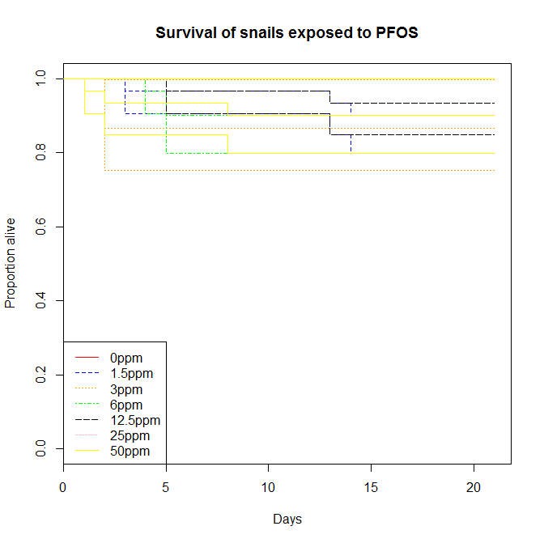

Figure IV‑1. Kaplan-meier curves for survival of 0-3 week-old snails exposed to PFOS. Each concentration is represented by three colored lines. The middle line represents the number of snails alive on each day of the study, and the upper and lower lines are the 95% confidence limits.

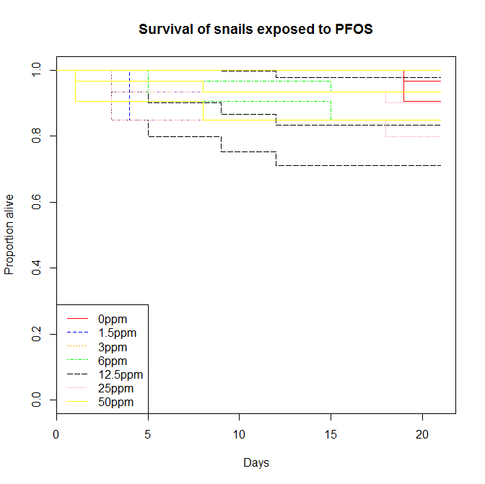

Figure IV‑2. Kaplan-meier curves for survival of 3-6 week-old snails exposed to PFOS. Each concentration is represented by three colored lines. The middle line represents the number of snails alive on each day of the study, and the upper and lower lines are the 95% confidence limits.

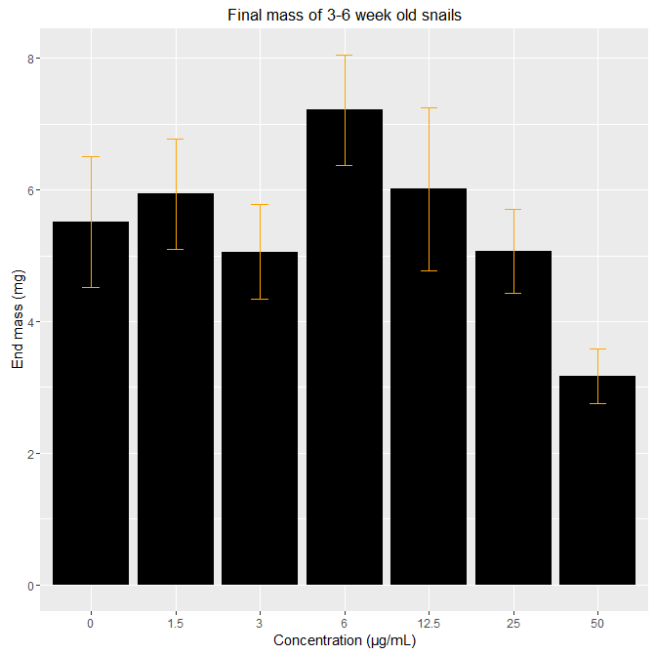

Figure IV‑3. Average final mass of 3-6 week snails exposed to PFOS. Snails exposed to 50 µg/mL PFOS had a lower final mass than any of the other concentrations. Error bars are representative of one standard error from the mean.

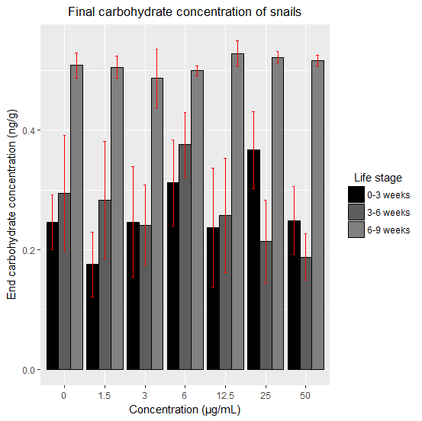

Figure IV‑4. The average carbohydrate concentration in the 0-3 week-old, 3-6 week-old, and 6-9 week-old snail age-classes at the conclusion of 21-day trials. A significant trend of decreasing carbohydrates with an increase in PFOS exposure was seen in 3-6 week-olds but no individual treatment concentration was significantly different from the controls. No significant trends were observed in either of the two other age classes. Error bars represent one standard error from the mean.

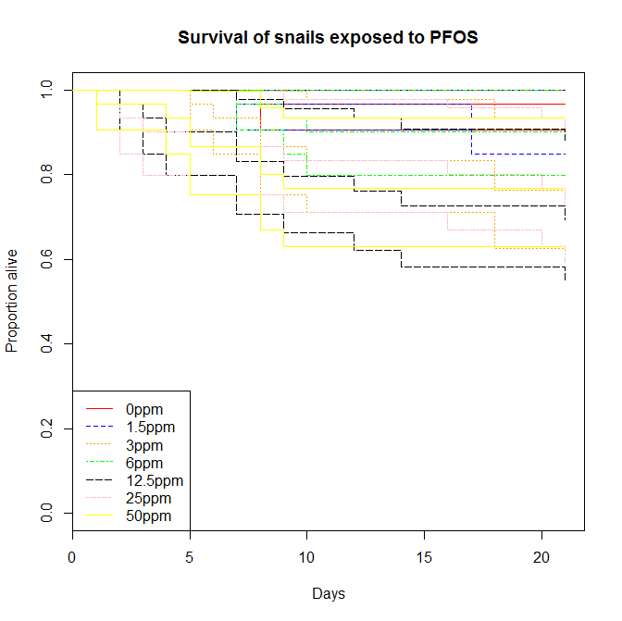

Figure IV‑5. Kaplan-meier curves for survival of 6-9 week-old snails exposed to PFOS. Each concentration is represented by three colored lines. The middle line represents the number of snails alive on each day of the study, and the upper and lower lines are the 95% confidence limits.

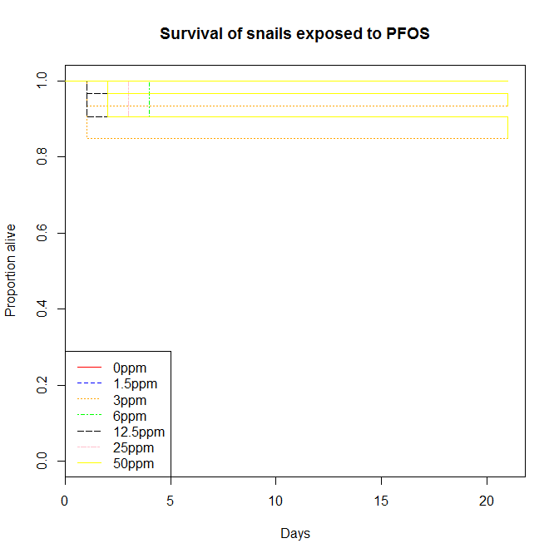

Figure IV‑6. Kaplan-meier curves for survival of 9-12 week-old snails exposed to PFOS. Each concentration is represented by three colored lines. The middle line represents the number of snails alive on each day of the study, and the upper and lower lines are the 95% confidence limits.

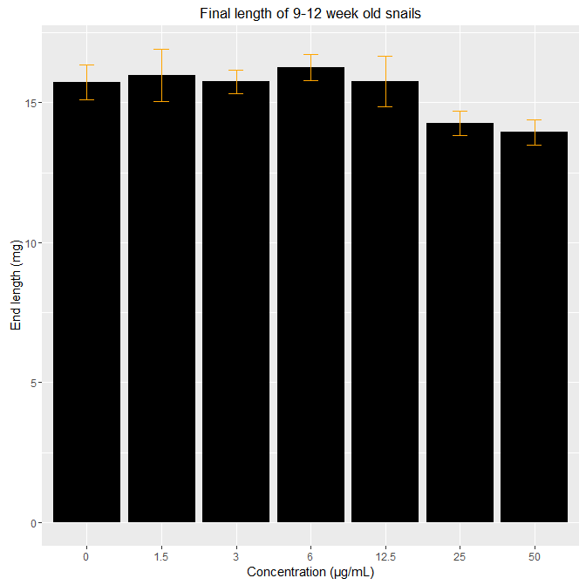

Figure IV‑7. Average final length of 9-12 week snails exposed to PFOS. Error bars are representative of one standard error from the mean.

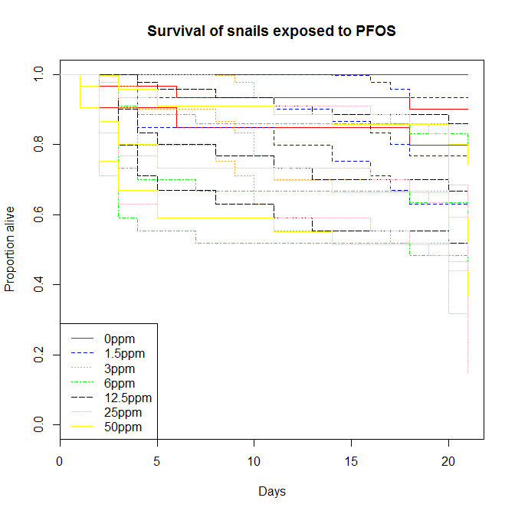

Figure IV‑8. Kaplan-meier curves for survival of adult snails exposed to PFOS. Each concentration is represented by three colored lines. The middle line represents the number of snails alive on each day of the study, and the upper and lower lines are the 95% confidence limits.

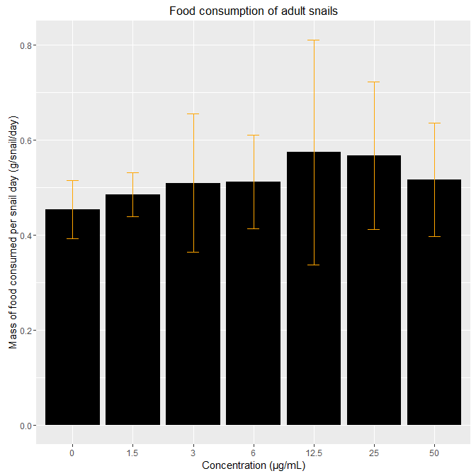

Figure IV‑9. Mass of raw organic lettuce consumed by adult snails. The mean of the bar graph represents the amount consumed per adult snail per day during a 21-day experiment. No significant differences were observed due to PFOS exposure. Error bars represent one standard error from the mean.

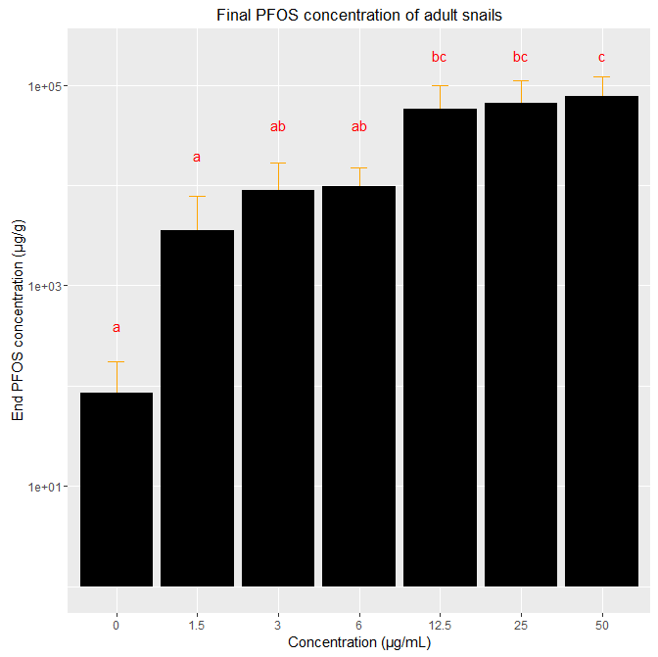

Figure IV‑10. Final body burden of adult *L. stagnalis* exposed to different concentrations of PFOS for 21 days. The vertical axis is logarithmic, and error bars represent a single standard error from the mean. The three highest concentrations are significantly greater than the controls. Letters on the figure designate significant differences.

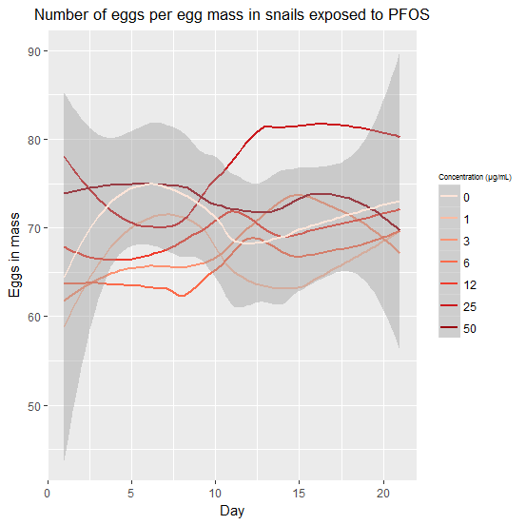

Figure IV‑11. The average number of eggs laid per egg mass per day by snails exposed to PFOS. Lines are smoothed to increase the legibility of the figure. The darkened area represents the 95% confidence interval around the mean of the control treatment. No significant trends were seen temporally, either per day overall or when separated exposure concentration.

**CHAPTER V**

# THE TOXICITY OF TWO PERFLUORINATED ALKYL SUBSTANCES TO A POTENTIALLY SENSITIVE INVERTEBRATE, THE YELLOW FEVER MOSQUITO (*AEDES AEGYPTI*)

**ABSTRACT**

Perfluorooctane sulfonate (PFOS) has recently been listed as a contaminant of emerging concern. Due to this classification, the chemical has been the focus of toxicological research, including efforts to determine the sensitivity of aquatic species to the chemical. Currently, the most sensitive organism to PFOS is a dipteran, *Chironomus tentans*. To further our understanding of PFOS ecotoxicity, I evaluated a species from the same Order, the yellow fever mosquito *Aedes aegypti*. Four-hundred and twenty newly hatched (first instar) mosquitoes were exposed to PFOS continuously until emergence at one of seven concentrations ranging from 0 to 2000 µg/L. There were no significant effects for any endpoints at the lowest exposure level, 50 µg/L, but many significant effects at the next highest concentration, 125 µg/L. For instance, 125 µg/L PFOS or greater significantly reduced survival compared to the control (0 µg/L). Perfluorooctane sulfonate also significantly decreased time to emergence at and above 125 µg/L. Mosquito mass at emergence for all PFOS concentrations was positively correlated with time to emergence. Mosquito mass at emergence is positively correlated with adult fecundity; therefore, mosquito fecundity should be reduced following exposure to PFOS concentrations at or above 125 µg/L. Importantly, field sampling has shown that PFOS often occurs within a mixture of PFASs. One of those, perfluorohexane sulfonate (PFHxS), was measured at concentrations up to 5000 µg/L in mixtures with other PFASs, including PFOS. To better understand potential risks of PFASs, it is important to test the toxicity of PFHxS to sensitive organisms such as *A. aegypti* with and without the inclusion of PFOS and other PFASs. I discovered that chronic toxicity was significantly increased when PFOS and PFHxS were combined, with a LOAEC for mortality of 15 µg/L PFOS: 67.5 µg/L PFHxS. Overall, although not as sensitive to PFOS as *C. tentans*, *A. aegypti* is among the more sensitive aquatic species evaluated, providing additional evidence that insects may be particularly sensitive to PFOS. Further, this study suggests that mixture toxicity may be of paramount importance when testing PFASs.

**INTRODUCTION**

Per- and poly-fluorinated alkyl substances (PFASs) are a class of chemicals historically used for their anti-stick and flame-resistant properties (Roos, et al. 2008). However, many of these chemicals are persistent and bioaccumulative in contaminated environments (Conder, et al. 2008). For this reason, and because of concerns for potential effects of these chemicals, the manufacturer voluntarily canceled their production. Perfluorooctane sulfonate (PFOS) and perfluorooctanoic acid (PFOA) are two examples of chemicals of this class that have been partially or completely phased out of production (Lindstrom, et al. 2011). However, both chemicals continue to be measured in environmental and biological samples (Giesy and Kannan 2001, Boulanger, et al. 2004), despite the cessation of production in 2002.

The persistence of these chemicals in surface waters worldwide indicates that they may pose a continued risk to human and ecological receptors (Boulanger, et al. 2004, Loos, et al. 2007). Although the concentrations measured in environmental samples are typically below the chronic no-observed effect concentration (NOEC) for the most sensitive aquatic organism evaluated to date (MacDonald, et al. 2004), the possibility remains that more sensitive organisms may exist. Furthermore, research has shown that these chemicals generally appear as part of a mixture of toxicants in the environment, particularly with other PFASs (Loos, et al. 2007, 2009). For example, surface water samples from Barksdale Air Force Base (BAFB), Shreveport, LA, a site at which PFAS-containing aqueous film forming foams (AFFFs) were historically used, yielded detectable or measurable concentrations of six PFAS (PFBS, PFOS, PFHxS, PFOA, PFNA, and PFHpA, Cochran 2015). Little research has been completed evaluating the toxicity of PFASs other than PFOS and PFOA, such as perfluorohexane sulfonate (PFHxS). Therefore, it is important to better understand the toxicity of less common PFASs and to begin to research the impact of mixtures in order to better identify the potential for adverse effects from exposures to PFASs at environmentally realistic concentrations.

In order to better estimate the potential of a chemical to cause adverse effects, it is important to classify the toxicity of the chemical to a variety of species. Testing in this manner should yield a range of toxicity values that can be arranged into a species sensitivity distribution (SSD, Suter 2006). Species sensitivity distributions provide risk managers with a means by which they can estimate the concentration at which a certain percentage of organisms will be adversely effected by exposure, and also a degree of confidence in their estimate (Maltby, et al. 2005). The confidence, determined by the error inherent in SSDs, may be increased by adding more data to the SSD (Forbes and Calow 2002). Particularly helpful for risk analysis is when a SSD contains information about the toxicity for some of the most sensitive species (Wheeler, et al. 2002). This is because risk managers are generally concerned with protecting the majority of species and therefore would be concerned with estimating risk for the more sensitive range of the SSD (Posthuma, et al. 2002).

The most sensitive organism to PFOS evaluated thus far is the Dipteran, *Chironomus tentans* (MacDonald, et al. 2004). Unlike many toxicants, PFOS binds to proteins in blood serum. *Chironomus tentans* are a unique aquatic invertebrate in that they have hemoglobin and therefore may have increased binding sites for PFOS upon exposure (Panis, et al. 1995). This particular organismal trait may explain the sensitivity of *C. tentans* to PFOS. Alternatively, there may be other traits possessed by *C. tentans* that explains its sensitivity to PFOS. Testing other species closely related to *C tentans* may be a promising way to develop additional toxicity data for potentially sensitive species and/or for identifying traits that may contribute to the sensitivity of *C. tentans* to PFOS. For example, the Yellow fever mosquito, *Aedes aegypti*, may be similarly sensitive to PFOS exposure despite not having hemoglobin.

The traditional method for testing the toxicity of chemicals are single-species, single-chemical toxicity tests (Suter 2006). These tests are limited in their environmental applicability because chemicals are rarely present in the environment in isolation. Mixture toxicity testing has recently become a greater focus in the scientific community, including efforts to develop models for predicting mixture effects based on the mode of action of toxicants or through synergistic effects (Belden, et al. 2007, Gonzalez-Pleiter, et al. 2013). These tests often focus on chemicals of the same class that are often found co-occurring in environmental samples, such as pharmaceuticals (e.g., Watanabe, et al. 2016, Cleuvers 2004). Perfluorinated compounds are also commonly found in mixtures, particularly those present in AFFFs (Moody and Field 2000, Baduel, et al. 2015, Munoz, et al. 2017). For example, multiple PFASs were detected in all of the 49 water samples at BAFB which had quantifiable concentrations. Of these, all had quantifiable amounts of either PFOS or PFHxS and, of these, only five samples had only one of those compounds (Cochran 2015). The synergistic potential for chemical mixtures to cause greater toxicity than each chemical could have caused individually means that chemical toxicity tests should be done with commonly co-occuring chemicals when possible (e.g., Cleuvers 2003).

The objectives of this research were to increase the scientific knowledge of PFAS toxicity to aquatic organisms. This was accomplished by the use of both single-chemical and chemical-mixture toxicity tests using PFASs commonly found at elevated concentrations in the environment to a representative dipteran, *A. aegypti*. Multiple endpoints including fecundity, emergence, and body size were observed after organisms were exposed to the chemical(s) for the duration of the aquatic phase of their life-cycle. This information is used to assess the toxicity of these chemicals to another potentially sensitive species, including one of the first toxicity studies of PFHxS, and to potentially reduce confidence intervals associated with current PFAS SSDs.

**METHODS**

*Mosquito Culture*

The use of two *A. aegypti* strains were necessary to complete the experiment to ensure availability between the experimental sections. Using different strains can introduce some uncertainty as there can be different toxicant responses among strains (Boyer, et al. 2007). As a way to capture some of this potential uncertainty, I replicated some treatments with both strains to verify that the strains had similar responses. The strain used for the testing with only PFOS were of the Liverpool Strain started by the Liverpool School of Medicine in 1936. The initial eggs for the colony were donated by Texas A&M and the colony had been maintained in the laboratory at Texas Tech University since summer 2013. The other strain was obtained from BEI resources and is called the Black-eye Liverpool strain. While maintained in the colony, adults were subjected to the following conditions: 25º Celsius (C) temperature, 60% relative humidity, and a light regime that ranged from 12-12 to 14-10 light-dark cycle. Adult mosquitoes had continuous access to a 10% sucrose solution.

*Experimental Procedure*

Perfluoroalkyl chemical solutions (PFOS and PFHxS) were prepared by dissolving soluble amounts of powdered chemical in moderately hard laboratory water (3 g CaSO4, 3 g MgSO4, 0.2 g KCl, and 4.8 g NaHCO3 per 50-L deionized water, as in US EPA (2002)) in 1-L HDPE bottles. Diluted stock concentrations were determined by the test concentrations for the experiment and were chosen to simplify the dilution calculations. In general, the stock dilution concentration was equal to the maximum test concentration. Each bottle was mixed on a shaker table at 125 rpm for at least 18 hours before being added to exposure containers.

Cultured females were fed bovine blood in 50% Alsever’s solution using a membrane feeding system to induce the production of eggs as in Mishra et al.(2005). The evening before the initiation of the experiment at approximately 1700 hours, the cards on which eggs were laid were collected and transferred to a 25º C water bath.

Approximately 12-18 hours later, during the first instar life stage, individuals were randomly removed from the water bath using a blunt plastic transfer pipette and added to 50 mL HDPE plastic beakers containing moderately hard water also warmed to 25º C. Once each experimental container contained 10 mosquitoes, the appropriate amount of PFOS stock solution was added to each exposure container. Mosquitoes in each container were also fed 0.15 mg brewer’s yeast/larvae from a solution containing 0.15 mg yeast/50 mL deionized water (DI) at experiment initiation. The containers were then randomly placed in a 25º C incubator and covered with plexiglass to limit evaporation.

The experiment was monitored every 24 hours and development (life stage) and mortality were observed and recorded. Individuals that did not respond to stimuli were marked as dead and removed from the experiment. Mosquitoes within containers were fed an amount of food each day commensurate with the life stage of the majority of the larvae in that container. The feeding amount for first instars is given in the previous paragraph, while second instars received 0.2 mg yeast/larvae from a solution containing 0.2 mg yeast/50 mL DI and third and fourth instars received 0.25 mg yeast/larvae from a solution containing 0.25 mg yeast/50 mL DI. Exposure media was 100% changed every 72 hours by transferring the mosquitoes to freshly prepared exposure chambers.

Upon pupation, individuals by replicate within treatment were transferred to a new exposure container that was placed inside an emergence container meant to prevent adults from escaping. Pupae did not need to be fed while in this container and the exposure media was 100% changed every 72 hours as before. Any adults noted during the daily monitoring were sacrificed by freezing. After the termination of the experiment, the adults were ashed at 50º C for 48 hours. They were then weighed using a balance accurate to the ten-thousandth of a gram. Mass, determined by this method, was used as a predictor for fecundity as in Steinwascher (1984).

*PFOS-Only Experiments*

I initially conducted a range-finding experiment to determine the 48 hour and 96 hour LC50 values for PFOS and obtained the exposure concentrations used for the life-cycle experiment using the exposure concentrations from MacDonald et al. (2004), which were 50, 100, 150, and 200 mg/L and also 50, 100, 150, and 200 µg/L. Hence, the following concentrations were chosen for the current life-cycle study on *A. aegypti*: 50, 125, 250, 500, 1000, and 2000 µg/L.

*PFHxS-Only Experiment*

As with PFOS, I conducted a range-finding study with PFHxS using concentrations of 20, 50, 75, 100, 125, and 150 mg/L, similar to MacDonald et al. (2004), to determine the concentrations appropriate for a life-cycle study. However, there was no evidence of toxicity at the evaluated concentrations so a longer duration study at lower concentrations was not conducted.

*Mixture Experiments*

As mentioned previously, data from surface water near former fire training areas at BAFB indicated that PFOS and PFHxS are the two most prevalent co-occuring PFASs. To generate a ratio between the chemicals representative of that seen in the environment, I determined an average and standard deviation of the ratio for each sampling site from the August sampling event at BAFB in Cochran (2015) and used these values to determine the upper 95% confidence limit for the ratio between concentrations to be 4.5:1 PFHxS:PFOS. Therefore, this ratio was used to inform the concentrations for my experiments. The exposure concentrations for these mixture experiments were chosen based on those from my previous studies: 50 : 225, 125 : 662.5, 250 : 1125, 500 : 2250, 1000 : 4500, and 2000 : 10000 µg/L PFOS : PFHxS. No adults from this study survived to 24-hours post-emergence so I subsequently completed another full life-cycle experiment using lower concentrations of 0.5 : 2.25, 2.5 : 11.25, 7.5 : 33.75, 15 : 67.5, and 30 : 135 µg/L PFOS: PFHxS. Additionally, for this experiment, mosquito wing size was included as an endpoint that relates strongly to body size and fecundity in females (Briegel 1990).

*Verification Experiment*

The preceding experiments were conducted at separate times due to a limitation in both laboratory space and the number of containers designed to collect emergent adults. This temporal variation in experiments also meant that the experiments ended up being completed with different strains of *A. aegypti*. To verify that my results were comparable despite being completed at different times and with different strains of the species, I conducted a final experiment during which I repeated the 30 µg/L and 125 µg/L PFOS-only concentration, the 15 µg/L : 67.5 µg/L and 30 µg/L : 135 µg/L PFOS : PFHxS concentrations, and the 135 µg/L PFHxS-only concentration to compare these results to previous studies.

*Statistics*

Survival was compared using a Kaplan-Meier estimator test (Kaplan and Meier 1958). The mass of mosquitoes at emergence was compared using both an ANOVA, to compare mass at emergence to concentration, and an ANCOVA, to compare mass at emergence to concentration by date of emergence. All statistical analyses were completed using the R software package (R Core Team 2016) for Windows with significance set to *p* = 0.05.

**RESULTS**

*PFOS-Only Experiments*

The LC50 for the 48-hour exposure to PFOS was 1.18 mg/L with lower and upper 95% confidence intervals of 0.95 and 1.41 mg/L, respectively. All mosquitoes from the three highest concentrations (those above 250 µg/L) died before pupation when exposed for the longer duration. Significant differences were determined for survival of mosquitoes in all concentrations above 50 µg/L when compared with controls (Figure V-1).

A significant effect was not determined for mass at emergence of mosquitoes between concentrations, however there was a general increasing trend for mass over time. Further, the mass of those mosquitoes that emerged later in the study (days 14, 15, and 17-21) was significantly greater than those that emerged earlier in the study (days 9, 10, and 11, Figure V-2, *p* <<< 0.01).

Exposure to PFOS significantly decreased the average time to emergence for those mosquitoes that survived to emergence (Figure V-3). For this endpoint, mosquitoes at the lowest exposure concentration were not significantly different from the controls, however, the other two exposure concentrations for which mosquitoes emerged (125 and 250 µg/L) had significantly earlier emergence (*p* <<< 0.01). Body mass at emergence did not significantly differ between concentrations (*p* = 0.43).

*PFHxS Experiments*

The LC50s for 48- and 96-hour exposures to PFHxS only were 89.0 mg/L with 95% confidence intervals of 78.9 and 99.1 mg/L and 46.4 mg/L with 95% confidence intervals of 40.1 and 52.7 mg/L, respectively.

*PFHxS + PFOS Mixture Experiments*

All mosquitoes from the four highest concentrations of the initial mixture experiment (those above 125 µg/L PFOS : 562.5 µg/L PfHxS) died before pupation in the chronic study (Figure V-4). As before, survival to emergence was not significantly decreased for all concentrations above 50 µg/L PFOS : 225 µg/L PFHxS. However, all exposed mosquitoes in this experiment died within the first 24 hours after emergence. Body mass at emergence did not significantly differ between concentrations.

When the study was repeated with lower concentrations, significantly decreased survival was observed for all concentrations above 7.5 µg/L PFOS : 33.75 µg/L PFHxS. Again, some mosquitoes in each exposure concentration died within 24 hours of emergence, however this effect was mainly restricted to concentrations of 15 µg/L PFOS : 67.5 µg/L PFHxS and above. Wing size was not significantly different between concentrations or sexes.

*Verification Experiment*

Total mortality was similar in the replicated experiment to the initial experiments (Figure V-5), indicating that the methods and species responses were consistent across time.

**DISCUSSION**

The LC50 for PFOS determined in this study (1.18 mg/L) was the second-most sensitive value determined to date (Qi, et al. 2011), but not as sensitive as the most sensitive organism, *Chironomus tentans* in which the 10-d LC50 was 45.2 µg/L (MacDonald, et al. 2004). This study also presents one of the first calculated LC50s for PFHxS, which was much higher (89 mg/L) than the LC50 for PFOS. From these values, it appears that PFHxS is approximately 90 times less toxic to mosquitoes than PFOS alone. However, the toxicity of the mixture of the compounds combined at an environmentally relevant ratio is greater than for that of either chemical individually (Figure V-6), although still below measured environmental concentrations. Nonetheless, the higher toxicity of the PFAS mixtures suggests that researchers conducting future PFAS toxicity studies should consider testing relevant mixtures, particularly since PFASs generally co-occur in the environment (Baduel, et al. 2015). Further, ecological risk assessments of individual PFASs may prove to not be the most appropriate methodology if additional toxicity studies reveal further synergistic effects of PFAS mixtures.

A greater emphasis on evaluating the toxicity of PFAS mixtures has been a recent trend within the scientific community (Ding, et al. 2013, Rodea-Palomares, et al. 2012, Wei 2009). These studies have shown that the effect of PFAS mixtures on toxicity is not always consistent between mixture ratio formulations nor species. The results in the current study suggested a synergistic response of PFHxS with PFOS. However, Ding, et al. (2013) evaluated mixtures of PFOS and PFOA and found that some ratios had additive interactions, some had synergistic interactions, and some had antagonistic interactions. Further, the results of Ding, et al. (2013) were not consistent within a mixture at different time points in the study. Therefore, it is possible that mixtures of PFOS and PFHxS at different ratios or over a different duration may yield different interactive effects, further altering the toxicity of the mixture and decreasing the ability of risk managers to make informed predictions about the potential for adverse effects resulting from exposure to PFASs.

Several studies have shown that PFASs also behave in an unpredictable manner when combined with other commonly occurring anthropogenic chemicals in the environment (Rosal 2010, Gonzalez-Naranjo and Boltes 2014). For example, Gonzalez-Naranjo and Boltes (2014) completed a risk assessment for both PFOA and ibuprofen individually and within a mixture. They calculated ECx values (the threshold at which X percent of species are likely to experience toxic effects) and found that for lower ECx values, the mixture concentration was greater than for an individual chemical alone (suggesting antagonistic effects) while at higher ECx values, the mixture concentration was less than for an individual chemical (suggesting additive or synergistic effects). Alternately, Rodea-Palomares et al. (2012) found that PFOA and PFOS acted antagonistically together and with many heavy metals to a cyanobacteria. The varied effects found by mixture tests in the literature and the current study indicate that the risk estimates for real-world scenarios where PFASs occur with a multitude of other chemicals may be significantly inaccurate if the current method of using single-chemical risk quotients is applied.

In this study, the lowest-observed effect concentration (LOEC) was 15 µg/L PFOS : 67.5 µg/L PFHxS, and therefore the NOEC was 7.5 µg/L : 33.75 µg/L PFHxS. The true threshold at which toxicity occurs for a mixture of this ratio, therefore, occurs between these two values. Although the amount of PFOS present in the NOEC ratio is similar to that observed in the field, of 7.07 µg/L PFOS, the amount of PFHxS in the ratio is still much higher than what was observed concurrent with PFOS in the field by Cochran (maximum of 4.43 µg/L, 2015). Therefore, although this study is among the first to present toxic effects that are clearly relevant at the population level at a concentration of PFOS and with a ratio of PFOS:PFHxS that can be found maintained in the environment, the amount of PFHxS necessary to cause those effects is unlikely to be present in the environment. However, the species used in this study is not the most sensitive species to acute exposure. It is possible to predict the toxicity of a chemical when an exact threshold is not known by using an acute-chronic ratio (ACR, Kenaga 1982). The confidence in predictions using this method is increased if the species are closely related (Ahlers, et al. 2006). Although the acute exposure duration for *A. aegypti* exposed to PFOS in this study (at least 24 days, up to 45 days) and *C. tentans* exposed to PFOS in MacDonald, et al. (2004, duration of 20 days) are not the same and therefore complicate the use of an ACR, it is still possible to apply the theory behind the use of ACRs. For this purpose, the chronic NOEC of exposure to PFOS and the PFAS mixture with *A. aegypti* will be compared to generate a ratio to predict the NOEC for *C. tentans* exposed to the PFAS mixture. In application, this leads to the prediction of a NOEC of 0.345 µg/L PFOS : 1.55 µg/L PFHxS. These values are well within those observed in environmental surface water samples, as seen by Cochran (2015) and others. Therefore, this study indicates that even low concentrations of PFASs, including those currently present in the environment, may cause adverse effects when organisms are exposed in tandem with other chemicals.

The predominant effects of the PFASs tested were on mosquito survival and although no significant differences were observed for the mass at emergence when comparing exposed concentrations to the controls, two important significant trends were observed that could signal a potential for mass at emergence to be affected by exposure to PFOS. The first trend was that the mass of all mosquitoes at emergence increased significantly over time. The second was that PFOS exposure significantly decreased the time to emergence of mosquitoes. Decreased gestational periods and altered thyroid hormones have been noted in studies with mammals and fish exposed to PFOS (Luebker, et al. 2005, Shi, et al. 2009). Interestingly, PFOS has also been shown to alter the insect thyroid hormone analogue ecdysteroid, which plays an important role in regulating molting behavior (Mommaerts, et al. 2011). Taken together, it is reasonable to assume that with a larger sample size of emerged mosquitoes, the trends of decreased time to molt and increased mass at emergence for longer molts would combine to result in a significantly decreased mass at emergence of mosquitoes exposed to PFOS, perhaps explained by a modulation of ecdysteroid. This decreased mass at emergence correlates with decreased fecundity (Steinwascher 1984) and therefore adverse effects of exposure to PFOS at the population level that could potentially translate to increased risk of decline.

The lowest concentrations in this study for which an adverse effect was observed were greater than environmentally relevant concentrations, as is true for the vast majority of studies involving PFASs. However, the concentrations in this study, especially those involving mixtures of PFASs, are at levels approaching environmental relevance. For this reason, researchers should give particular consideration to evaluating mixtures of PFASs when completing toxicity experiments in the future. Furthermore, many PFAS-contaminated sites are exposed to more chemicals than just PFASs, and the interaction between these chemicals as it relates to toxicity is still largely unknown in the scientific community. Additionally, to best ascertain the risk posed by these persistent chemicals, chronic studies should be a focus for the scientific community. With these guidelines in mind, the knowledge of the toxicity of these chemicals will be greatly improved.

**REFERENCES**

Ahlers, J., C. Riedhammer, M. Vogliano, R.-U. Ebert, R. Kuhne, and G. Schuurmann. 2006. Acute to chronic ratios in aquatic toxicity - variation across trophic levels and relationship with chemical structure. *Environmental Toxicology and Chemistry* 25: 2937-2945.

Baduel, C., C.J. Paxman, and J.F. Mueller. 2015. Perfluoroalkyl substances in a firefighting training ground (FTG), distribution and potential future release. *Journal of Hazardous Materials* 296: 46-53.

Belden, J.B., R.J. Gilliom, and M.J. Lydy. 2007. How well can we predict the toxicity of pesticide mixtures to aquatic life? *Integrated Environmental Assessment and Management* 3: 364-372.

Boulanger, B, J Vargo, J.L. Schnoor, and K.C. Hornbuckle. 2004. Detection of perfluorooctane surfactants in Great Lakes water. *Environmental Science and Technology* 38: 4064-4070.

Boyer, S., M. Tilquin, and P. Ravanel. 2007. Differential sensitivity to *Bacillus thuringiensis* *var.* *israelensis* and temephos in field mosquito populations of *Ochlerotatus cataphylla* (Diptera: Culicidae): toward resistance? *Environmental Toxicology and Chemistry* 26: 157-162.

Briegel, H. 1990. Metabolic relationship between female body size, reserves, and fecundity of *Aedes aegypti*. *Journal of Insect Physiology* 36: 165-172.

Cleuvers, M. 2003. Aquatic ecotoxicity of pharmaceuticals including the assessment of combination effects. *Toxicology Letters* 142: 185-194.

Cleuvers, M. 2004. Mixture toxicity of the anti-inflammatory drugs diclofenac, ibuprofen, naproxen, and acetylsalicylic acid. *Ecotoxicology and Environmental Safety* 59: 309-315.

Cochran, R.S. 2015. *Evaluation of perfluorinated compounds in the sediment, water, and passive samplers collected from the Barksdale Air Force Base.* Master’s Thesis, Lubbock, TX: Texas Tech University.

Conder, J.M., R.A. Hoke, W.D. Wolf, M.H. Russell, and R.C. Buck. 2008. Are PFCAs bioaccumulative? A critical review and comparison with regulatory criteria and persistent lipophilic compounds. *Environmental Science and Technology* 42: 995-1003.

Ding, G, J Zhang, Y Chen, L Wang, M Wang, D Xiong, and Y Sun. 2013. Combined effects of PFOS and PFOA on Zebrafish (*Danio rerio*) embryos. *Archives of Environmental Contamination and Toxicology* 64: 668-675.

Forbes, V.E., and P. Calow. 2002. Species sensitivity distributions revisited: a critical appraisal. *Human and Ecological Risk Assessment* 8: 473-492.

Giesy, J.P., and K. Kannan. 2001. Global distribution of perfluorooctane sulfonate in wildlife. *Environmental Science & Techonology* 35: 1339-1342.

Gonzalez-Naranjo, V., and K. Boltes. 2014. Toxicity of ibuprofen and perfluorooctanoic acid for risk assessment of mixtures in aquatic and terrestrial environments. *International Journal of Environmental Science and Technology* 11: 1743-1750.

Gonzalez-Pleiter, M., S. Gonzalo, I. Rodea-Paomares, F. Leganes, R. Rosal, K. Boltes, E. Marco, and F. Fernandez-Pinas. 2013. Toxicity of five antibiotics and their mixtures towards photosynthetic aquatic organisms: implications for environmental risk assessment. *Water Research* 47: 2050-2064.

Kenaga, E.E. 1982. Predictability of chronic toxicity from acute toxicity of chemicals in fish and aquatic invertebrates. *Environmental Toxicology and Chemistry* 1: 347-358.

Lindstrom, A.B., M.J. Strynar, and E.L. Libelo. 2011. Polyfluorinated compounds: past, present, and future. *Environmental Science and Technology* 45: 7954-7961.

Loos, R., J. Wollgast, T. Huber, and G. Hanke. 2007. Polar herbicides, pharmaceutical products, perfluorooctane sulfonate (PFOS), perfluorooctanoate (PFOA), and nonylphenol and its carboxylates and ethoxylates in surface and tap waters around Lake Maggiore in Northern Italy. *Analytical and Bioanalytical Chemistry* 387: 1469-1478.

Loos, R., B.M. Gawlik, G. Locoro, E. Rimaviciute, S. Contini, and G. Bidoglio. 2009. EU-wide survey of polar organic persistent pollutants in European river waters. *Environmental Pollution* 157: 561-568.

Luebker, D.J., R.G. York, K.J. Hansen, J.A. Moore, and J.L. Butenhoff. 2005. Neonatal mortality from in utero exposure to perfluorooctanesulfonate (PFOS) in Sprague-Dawley rats: Dose-response, and biochemical and pharamacokinetic parameters. *Toxicology* 215: 149-169.

Kaplan, E.L. and P. Meier. 1958. Nonparametric estimation from incomplete observations. *Journal of the American Statistical Association*. 53: 457-481.

MacDonald, M M, A L Warne, N L Stock, S A Mabury, K R Solomon, and P K Sibley. 2004. Toxicity of perfluorooctane sulfonic acid and perfluorooctanoic acid to *Chironomus tentans*. *Environmental Toxicology and Chemistry* 23: 2116-2123.

Maltby, L., N. Blake, T.C.M. Brock, and P.J. Van den Brink. 2005. Insecticide species sensitivity distributions: importance of test species selection and relevance to aquatic ecosystems. *Environmental Toxicology and Chemistry* 24: 379-388.

Mishra, K., D. Kumar Raj, R.K. Hazra, and A.P. Dash. 2005. A simple, artificial-membrane feeding method for the radio-isotope labelling of *Aedes aegypti* polypeptides in vivo. *Annals of Tropical Medicine & Parasitology* 99 (8): 803-806.

Mommaerts, V., A. Hagenaars, J. Meyer, W. De Coen, L. Swevers, H. Mosallanejad, and G. Smagghe. 2011. Impact of a perfluorinated organic compound PFOS on the terrestrial pollinator *Bombus terrestris* (Insecta, Hymenoptera). *Ecotoxicology* 20: 447-456.

Moody, C.A., and J.A. Field. 2000. Perfluorinated surfactants and the environmental implications of their use in fire-fighting foams. *Environmental Science and Technology* 34: 3864-3870.

Munoz, G., M. Desrosiers, S.V. Duy, P. Labadie, H. Budzinski, J. Liu, and S. Sauve. 2017. Environmental occurrence of perfluoroalkyl acids and novel fluorotelomer surfactants in the freshwater fish *Catostomus commersonii* and sediments following firefighting foam deployment at the Lac-Megantic railway accident. *Environmental Science and Technology* 51: 1231-1240.

Panis, Luc Int, Boudewijn Goddeeris, and Rudolf Verheyen. 1995. The hemoglobin concentration of *Chironomus cf. Plumosus* . (Diptera: Chironomidae) larvae from two lentic habitats. *Netherland Journal of Aquatic Ecology* 29 (1): 1-4.

Posthuma, L., G.W. Suter II, and T.P. Traas. 2002. *Species Sensitivity Distributions in Ecotoxicology.* Boca Raton, FL: CRC Press LLC.

Qi, P, Y Wang, Jingli Mu, and J Wang. 2011. Aquatic predicted no-effect-concentration derivation for perfluorooctane sulfonic acid. *Environmental Toxicology and Chemistry* 30: 836-842.

R Core Team. 2016. R: A language and environment for statistical computing. Vienna, Austria: R Foundation for Statistical Computing. https://www.R-project.org.

Rodea-Palomares, I, F Leganes, R Rosal, and F Fernandez-Pinas. 2012. Toxicological interactions of perfluorooctane sulfonic acid (PFOS) and perfluorooctanoic acid (PFOA) with selected pollutants. *Journal of Hazardous Materials* 201-202: 209-218.

Roos, P.H., J. Angerer, H. Dieter, M. Wilhelm, D. Wolfe, and J.G. Hengstler. 2008. Perfluorinated compounds (PFC) hit the headlines. *Archives of Toxicology* 82: 57-59.

Rosal, R., I Rodea-Palomares, K. Boltes, F. Fernandez-Pinas, F. Leganes, and A. Petre. 2010. Ecotoxicological assessment of surfactants in the aquatic environment: combined toxicity of docusate sodium with chlorinated pollutants. *Chemosphere* 81: 288-293.

Shi, X., C. Liu, G. Wu, and B. Zhou. 2009. Waterborne exposure to PFOS causes disruption of the hypothalamus-pituitary-thyroid axis in zebrafish larvae. *Chemosphere* 77: 1010-1018.

Steinwascher, Kurt. 1984. Egg size variation in *Aedes aegypti*: relationship to body size and other variables. *The American Midland Naturalist* 112 (1): 76-84.

Stockwell, D.R.B., and A.T. Peterson. 2002. Effects of sample size on accuracy of species distribution models. *Ecological Modelling* 148: 1-13.

Suter, G.W. 2006. *Ecological Risk Assessment, Second Edition.* Boca Raton, FL: CRC Press.

US EPA 2002. *Methods for measuring the acute toxicity of effluents and receiving waters to freshwater and marine organisms, fifth edition.* Washington, D.C.: U.S. Environmental Protection Agency Office of Water.

Watanabe, H., I. Tamura, R. Abe, H. Takanobu, A. Nakamura, T. Suzuki, A. Hirose, T. Nishimura, and N. Tatarazako. 2016. Chronic toxicity of an environmentally relevant mixture of pharmaceuticals to three aquatic organisms (alga, daphnia, and fish). *Environmental Toxicology and Chemistry* 35: 996-1006.

Wei, Y., X. Shi, H. Zhang, J. Wang, B. Zhou, and J. Dai. 2009. Combined effects of polyfluorinated and perfluorinated compounds on primary cultured hepatocytes from rare minnow (*Gobiocypris rarus*) using toxicogenomic analysis. *Aquatic Toxicology* 95: 27-36.

Wheeler, J.R., E.P.M. Grist, K.M.Y. Leung, D. Morritt, and M. Crane. 2002. Species sensitivity distributions: data and model choice. *Marine Pollution Bulletin* 45: 192-202.

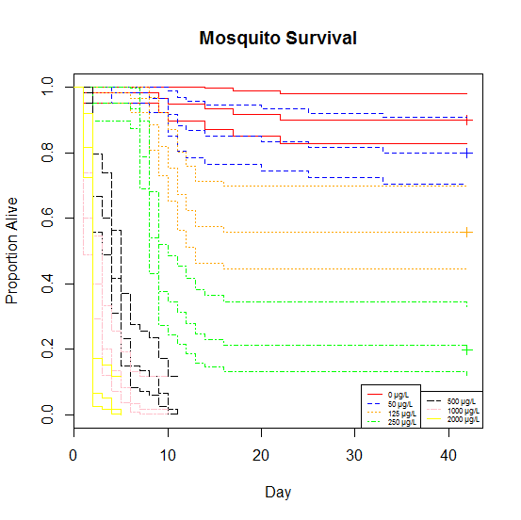

Figure V‑1. Survival of mosquitoes across one life-stage when exposed to PFOS. Each concentration is represented by a color, for which the middle line shows the number alive on that day and the upper and lower lines represent the upper and lower 95% confidence intervals from a Kaplan-Meier estimator, respectively. The plus symbol at the end of each line represents the total number emerged at the end of the study.

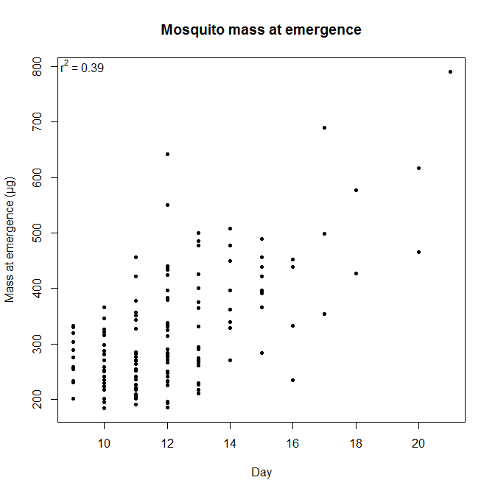

Figure V‑2. Mass of emerged mosquitoes as a function of time to emergence. Mosquitoes were either exposed to 0, 50, 125, or 250 µg/L PFOS from first-instar through adulthood but all data were combined for this analysis.

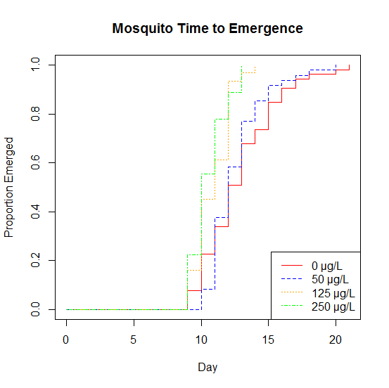

Figure V‑3. Time to emergence for mosquitoes exposed to PFOS. All treatments are scaled to 100% emergence, meaning that all mosquitoes in the treatment have either emerged or died when the line reaches the top of the graph. The mosquitoes exposed to 125 and 250 µg/L PFOS emerged significantly earlier than those exposed to 0 and 50 µg/L PFOS (*p* <<< 0.01).

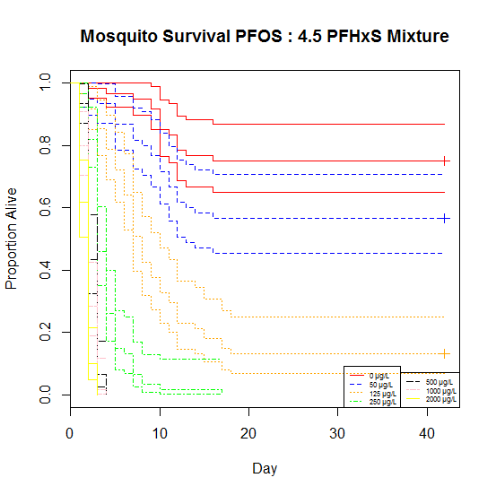

Figure V‑4. Survival of mosquitoes through development when exposed to a mixture of 1 part PFOS to 4.5 parts PFHxS. Each concentration is represented by a color, for which the middle line shows the number alive on that day and the upper and lower lines represent the upper and lower 95% confidence intervals in a Kaplan-Meier estimator. The plus symbol at the end of each line represents the total number emerged at the end of the study.

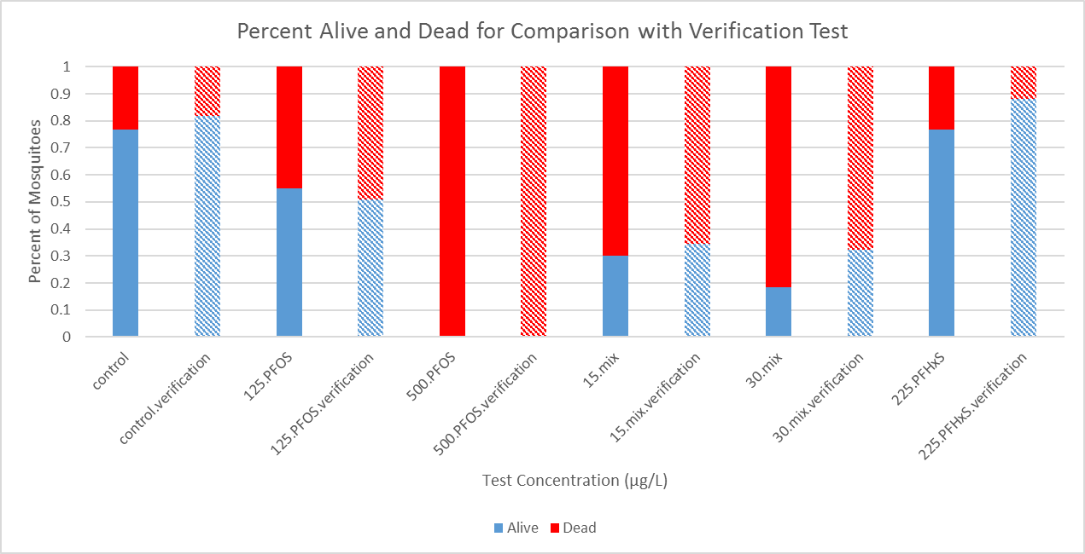

Figure V‑5. Comparison of the results of multiple mortality studies conducted at different times. The solid bars show the results of studies conducted at different times, while the dashed bars show the results of a study conducted simultaneously, to ensure that the original studies were comparable despite being conducted across a period of several months.

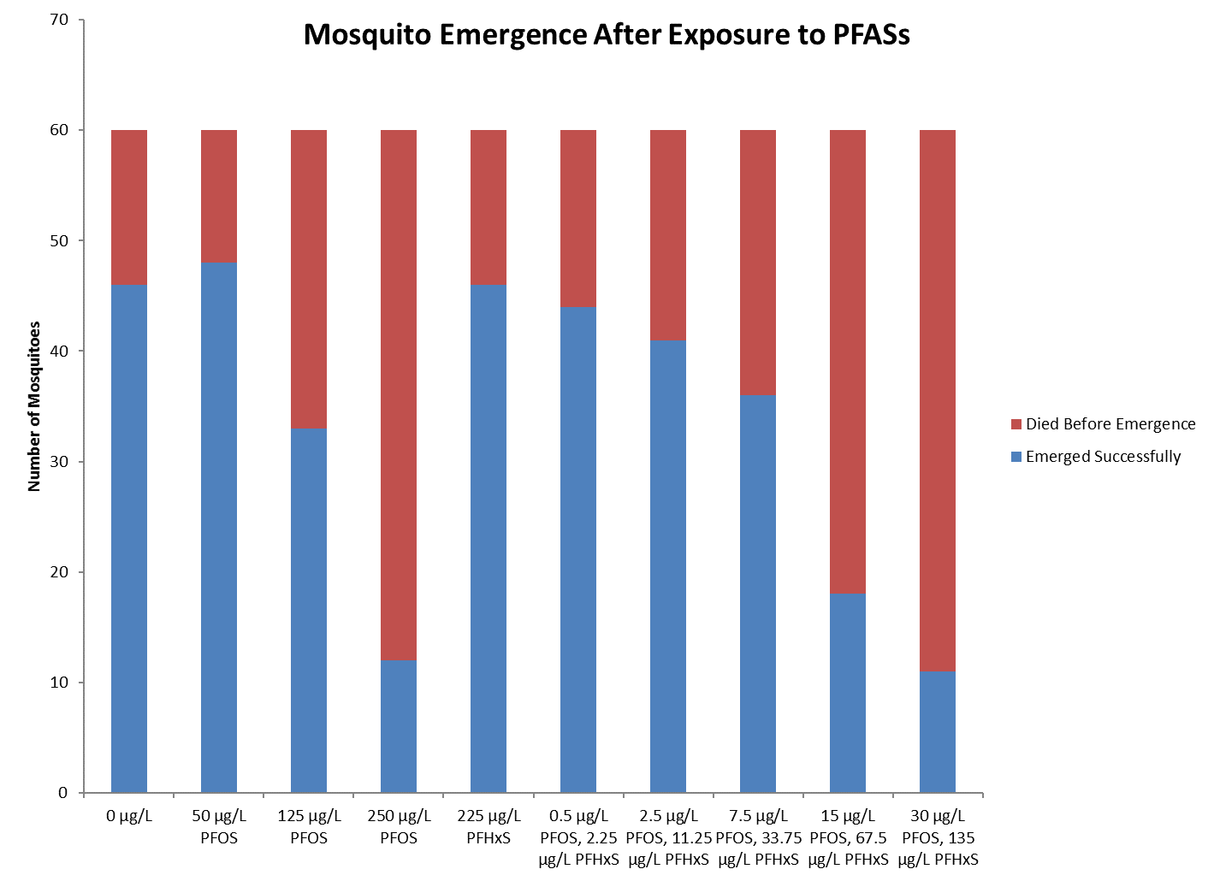

Figure V‑6. An important subset of the toxic results of *A. aegypti* after exposure to only PFOS, only PFHxS, or a mixture of those two chemicals. Similar toxicity, as indicated by the number of individuals that did not survive to emergence, was seen at a much lower concentration for PFOS than for PFHxS, and for the mixture than either chemical individually. This indicates that these chemicals are significantly more toxic when combined in an aquatic mixture.

**CHAPTER VI**

# REVISITING PERFLUOROOCTANE SULFONATE (PFOS) CONCENTRATION IN THE EASTERN OYSTER, *CRASSOTREA VIRGINICA*, IN THE GULF OF MEXICO EIGHTEEN YEARS LATER

**ABSTRACT**

Per- and polyfluoroalkyl substances (PFASs) such as perfluorooctane sulfonate (PFOS) are surfactants, which led to their use in stick- and flame-resistant products and in fire-fighting foams. However, due to their bioaccumulative potential and long half-life, they were voluntarily phased out by the North American manufacturer in the early 2000s. Perfluorooctane sulfonate has a hydrolytic half-life of greater than 40 years and a large KOC, meaning that long-term studies of PFOS body burdens in benthic organisms will be particularly instructive in predicting the fate of PFOS. This project revisits sites along the Texas coastline from a study completed between 1997 and 1998 in which PFOS was measured in eastern oysters, *Crassostrea virginica*. The goal of the study was to characterize the change of PFOS concentration in *C. virginica* as a way to determine if the phase-out of PFOS has had an impact. Perfluorooctane sulfonate was found in oysters at all six sites sampled, ranging from 5.09 to 8.17 ng/g, and in the sediment at the four sampled sites, ranging from 0.21 to 0.35 ng/g. However, all values were between 12 and 70 times less than what was detected in the study from the late 90’s. These results indicate that the risk of chronic exposure to PFOS in locations that did not receive direct exposure may be decreasing as a result of the phase-out. Additionally, these results appear to indicate a best-case scenario for chemical phase-out and provide a framework for future work with other perfluorinated compounds.

**INTRODUCTION**

A variety of factors influence the potential toxicity of a chemical in the environment. One critically important factor, the environmental fate of the chemical, determines the exposure which may result in toxicity (Zhuang, et al. 2015). In ecotoxicology, the chemical fate describes both the environmental compartment where the chemical accumulates and how long it is present before it is broken down or bound in a way that decreases its bioavailability (Klassen 2007). For example, chemicals that are easily volatilized or quickly degraded may not be present for enough time for organisms to receive a high level of exposure (Wilson 2013). Alternatively, compounds with a long half-life may express toxic effects over a period of years or even generations, and may do so at concentrations much lower than those that cause toxicity at acute exposure durations (Brennan, et al. 2006). The fate of a compound may be further altered by other properties including its organic carbon-water partitioning coefficient (KOC), solubility, or Henry’s law constant (Mackay, et al. 1997). These properties result in a large decrease of the bioavailability of a compound if it becomes strongly bound to a particular environmental compartment (such as sediment, see Ahrens, et al. 2009). Therefore, understanding the chemical fate of a potentially toxic compound is critical for accurately estimating ecological risk.

Per- and polyfluroalkyl substances (PFASs) are chemicals that are persistent in the environment (Beach, et al. 2006). They are characterized by carbon backbones with strong fluorine bonds, making them resistant to degradation (Torres, et al. 2009). This is one reason that background environmental concentrations remain generally steady despite the manufacturer ending production in 2002 (Lindstrom, et al. 2011). Other factors influencing the persistence of PFASs include their high KOC, indicating that they sorb to organic carbon within the environment and then may remain bound there, dependent on other abiotic factors such as salinity, pH, or the presence of other surfactants (You, et al. 2010, Pan, et al. 2009, Higgins and Luthy 2006). This environmental fate profile for PFASs indicates that exposure may be highest for sediment-dwelling aquatic organisms (Van de Vijver, et al. 2003, Hoff, et al. 2003), and therefore these may be most susceptible to long-term toxic effects.

In many locations where PFASs were heavily used, they entered the groundwater (Moody, et al. 2003) and may been slowly leaching into surface water (Miller 1980). However, the contamination of these chemicals has not been restricted to the locations at which they were used, as they have been found worldwide in freshwater (Hansen, et al. 2002, Kunacheva, et al. 2012) and marine environments (Ahrens, et al. 2010, Yamashita, et al. 2008). Troublingly, PFASs have even been found in the Arctic (Zhao, et al. 2012), an ecosystem that may be particularly affected by a combination of contaminant exposure and climate change (Letcher, et al. 2010, Macdonald 2005). Since PFASs have been found throughout the world, assessing the concentration of these chemicals in wildlife can provide important insight into the temporal and spatial trends of PFASs in the environment since the phase-out. Many published studies have collected samples of PFASs in wildlife throughout the world (Kannan, et al. 2002, Giesy and Kannan 2001, Senthilkumar, et al. 2007, Van de Vijver, et al. 2003, Hoff, et al. 2003, among many others). These studies can serve as benchmarks for PFAS concentrations and allow researchers to assess the bioaccumulation and spatial and temporal movement of the chemicals throughout the environment through revisiting and resampling previously studied systems or organisms. This is especially important for PFOS, which is one of the PFASs most commonly observed in environmental samples (Kunacheva, et al. 2012). Further, measuring the concentration of a chemical within an organism is a means of measuring the bioavailable fraction of that chemical to that receptor within the environment (Pascoe, et al. 1994).

To aid in the ease of assessing contaminant exposure and risk over a large area, selecting a study organism that is ubiquitous across that area is of tantamount importance.   
Bivalves have a history of being used as sentinel organisms for monitoring pollution in coastal marine ecosystems (O'Connor 1996). Further, these organisms may live in directly or indirectly exposed sediment, because transported sediment typically accumulates where the movement of a water body slows. Extreme examples of this happen where one flowing body meets another, especially at the mouth of rivers. Here, large amounts of potentially contaminated sediments are deposited when flowing water meets the slower-moving ocean (Bates, 1953). These environments tend to be nutrient-rich, turbid, and a quality habitat for marine life (Glenn, et al. 1992). Extensive and biodiverse communities often form in these shallow waters (Ramberg, et al. 2006, Wang, et al. 2009) that may be particularly vulnerable to the introduction of toxic chemicals via contaminated sediments.

For PFOS, toxic effects, such as decreased reproduction or mortality, may be most pronounced for sediment-dwelling filter feeders such as oysters. Living entirely within potentially PFOS-contaminated sediment can lead to these organisms receiving relatively high chronic exposures that may then translate to important toxicological effects. A marine bivalve that lives throughout a large area of potentially exposed near-shore ocean, the Eastern oyster (*Crassostrea virginica*), can serve as a sentinel species for PFOS exposure due to its presence in this location. This species is also a good indicator for PFOS exposure because it is long-lived and therefore may receive chronic exposure over a period of decades (Buroker 1983). Oysters will receive exposure via two main routes, water-filtration and through PFOS sorbed to organic carbon in the sediment (Bergquist, et al. 2006). Additionally, they preferentially ingest suspended organic material and therefore will be exposed to contaminants, particularly those like PFOS with a large KOC (Newell and Jordan 1983). Importantly, a previous study reported the body burdens of *C. virginica* to PFOS and therefore serves as a good point of comparison for the change of exposure over time (Kannan, et al. 2002).

Kannan, et al. (2002) serves as a benchmark for PFOS exposure in oysters before the cessation of production. Crucially, they measured PFOS concentrations in oysters collected in locations that are relatively easy to access along the Texas coastline but also collected oysters in nearby locations in which PFOS concentrations were below the detection limit. These locations can serve as “exposed” and “reference” sites, respectively, for future research and comparison. The purpose of this study was to assess PFOS concentrations in *C. virginica* collected at a subset of the same locations as Kannan, et al. (2002) to discover if the phase-out of PFOS production and use has decreased detectable concentrations of the chemicals approximately 18 years later. Additionally, the analytical method included an attempt to detect four other PFASs, PFHpA (Perfluoroheptanoic acid), PFOA (Perfluorooctanoic acid), PFNA (Perfluorononanoic acid), and PFHxS (Perfluorohexane sulfonate), which are also considered contaminants of emerging concern (Glassmeyer, et al. 2017) and appear in the Third Unregulated Contaminant Monitoring Rule list (EPA 2012). I hypothesize that PFOS levels will have decreased in oyster samples since the sampling effort of Kannan, et al. (2002) due to the cessation of use in Texas and the greater United States, but that detectable concentrations of the chemical will remain. I then discuss my findings with respect to surveys of PFOS in other parts of the world including current use patterns and the implications of the phase out.

**METHODS**

A subset of sites were chosen from those visited by Kannan, et al. (2002). Those sites located on the Texas coast were visited in June of 2015 in order to determine whether they were easily accessible by wading from the shore. The presence of *C. virginica* was additionally observed at each site at this time. Those sites that were both accessible and at which oysters could be found were noted in preparation for a sampling event later in the year (Table VI-1).

*Sample Collection*

Sample sites were re-visited in October, 2015 for collection of oysters. This date was chosen for a number of reasons: it was after peak reproduction season, to prevent drastically altering population by removing gravid females; it was before open harvest season, to avoid competition with local fishermen; and the chosen sampling week allowed all the sites to be visited at or near low tide during daylight hours. Furthermore, and most importantly, it was at a similar time of year as Kannan, et al. (2002), who visited the same sites in December of 1996. Although I did not sample sites during the same month as Kannan, et al. (2002), I expected river flows, and therefore PFOS transport and dilution rates, to be similar as winter tends to be the season of least precipitation along the Texas coast (Shepherd and Burian 2003). Unfortunately, a red tide event shortly before the sampling event made collection at both Corpus Christi sites impossible (Sikes 2015). Further, oysters could not be found at the Houston Yacht Club, Carancahua Bay, or Gallinipper Point sites. At each site, a similar procedure to that of Kannan, et al. (2002) was followed. All oysters were collected by hand as the depth of the water column at all sites was not enough to require tongs or dredge. Ten *C. virginica* were collected at each site, shucked, and immediately put onto ice. Although Kannan, et al. (2002) collected twenty oysters at each site, pre-collection testing in the laboratory revealed that ten collected oysters would provide enough mass for the extraction and analytical method. Shells were returned to the water. Sediment was also collected where possible in the immediate vicinity of collected oysters by submerging a sample jar into the sediment, removing the cap, and dredging the jar through the sediment. These sample jars were also immediately put on ice after collection. Additionally, all samples were kept on ice while in the field. Upon returning to the lab, samples were placed in a -5 ºC freezer overnight. Processing of the samples began the next day.

*Sample Analysis*

To prepare for analysis, samples were initially weighed. They were then dried for 48 hours at room temperature in a laboratory hood. Their dry weight was obtained and oysters from each sample site were randomly combined into three samples of approximately equal mass. The same procedure was followed to obtain three sediment samples from each field site. Oyster samples ranged from 1.5 to 6.6 g and sediment samples were approximately 40 – 60 g. All samples were then processed via the QuEChERS method. Briefly, the dried and homogenized samples were added to a tube containing 4 g anhydrous magnesium sulfate and 1 g sodium chloride. Ten mL of acetonitrile and 2 mL of milliQ water were each added to the tube which was then closed, vortexed, and left on a shake table overnight. The tubes were then vortexed before being centrifuged at 0º C for 15 minutes. The supernatant was collected and transferred to a second tube containing 900 mg anhydrous magnesium sulfate, 300 mg PSA, and 150 mg C18. These new tubes were vortexed and centrifuged for 15 minutes. They were then placed in a -20º C freezer for at least three hours and the supernatant was filtered into a new tube through a 0.2 µm cellulose acetate syringe filter. Recovered volumes were recorded and the samples were evaporated to dryness. They were then reconstituted to 0.5 mL using methanol before being transferred to microcentrifuge tubes containing 0.2 µm cellulose acetate filters. These were spun for 2 minutes at 4500 rpm and the remaining liquid was transferred to polypropylene LC vials.

Each vial was also spiked with a 100 µg/L mixture of two internal standards (13C2-PFOA and 13C4-PFOS) to determine instrumental ion suppression. These were used as the standards for the five PFASs for which the instrumental procedure was setup to detect, PFHpA/PFOA/PFNA and PFHxS/PFOS, respectively. A Thermo Fisher Scientific Triple Stage Quadrupole Quantum liquid chromatography tandem mass spectrometer (LC-MS/MS) was used to quantify PFAS residues. Separation was accomplished using a Gemini-NX C18 column (150 mm x 2.0 mm, 3 µm; Phenomenex), with gradient elution. The mobile phase consisted of methanol and 20 mM ammonium acetate in water, with a flow rate of 0.3 mL/min. Blanks of milliQ water and QC samples were run after half of the samples were complete and at the end of the run to check for instrumental error and matrix effects. The lowest calibration standard, 10 µg/L, was used to determine the limit of detection (LOD).

Pearson’s correlation coefficient was calculated to test for a correlation between the sampled concentrations in Kannan, et al. (2002) and this study. This was performed using program R (R Core Team 2016) and alpha was set to 0.05.

**RESULTS**

The amount of PFOS in oyster samples ranged from 5.09 to 8.17 ng/g-dw across the six sites sampled, with an overall mean of 6.73 ng/g-dw. Sediment concentrations of PFOS were also relatively consistent, ranging from 0.21 to 0.35 ng/g-dw across the four sites at which sediment was collected, with a mean of 0.26 ng/g-dw (Table VI-2 and Figure VI-1). Other PFASs ( PFHpA, PFHxS, PFOA, and PFNA) were not detected by instrumental analysis in either sediment or oyster samples. No obvious spatial trend existed nor did the concentrations observed by Kannan, et al. (2002) correlate with those calculated in the current study (*p* = 0.6073). Furthermore, the sediment concentrations did not correlate with the observed oyster concentrations (*p* = 0.8003).

**DISCUSSION**

Perfluorooctane sulfonate was detected in oysters at all six sampled locations. This is in contrast to the results of Kannan, et al. (2002), who found detectable concentrations at five of the re-sampled sites: Eagle Point, Freeport, Brownsville, Port Lavaca, and Galveston. However, the limit of detection (LOD) for the current study was much lower than that of the Kannan, et al. (2002) study. In fact, the values for PFOS determined by this study all appear to be below the LOD in the previous study, where the lowest LOD for any sample appears to have been <42 ng/g. A comparison between the concentrations of other PFASs may not be made, as Kannan, et al. (2002) did not test for PFASs other than PFOS. Overall, the results suggest a decrease in PFOS concentrations in the sentinel oyster species, further suggesting that the voluntary phase-out of PFASs may be causing lower environmental exposures.

At locations where PFOS concentrations were detected both by this study and Kannan, et al. (2002), the current measured concentrations were between approximately 60 to 70 times lower than they were during the previous sampling event. Further, all concentrations measured in this study were of approximately the same amount, between approximately 5 and 8 ng/g-dw. Although the ability to directly compare oyster concentrations between those collected in the current study and those collected in Kannan, et al. (2002) may be slightly limited by the minor difference between sampling time during the year, it is highly unlikely that the potential difference in PFOS water and sediment concentrations caused by the seasonal variations in flow rate and precipitation could account for the large PFOS oyster burden differences observed. Previous work has shown that although PFOS water concentrations vary between wet and dry seasons (Hu, et al. 2011), the magnitude of that difference (less than 5-fold at most locations) is not nearly large enough to explain the 60-70-fold difference observed in this study, when compared to Kannan, et al. (2002). Furthermore, both the sampling from the current study and that by Kannan, et al. (2002) occurred during the same season, when large amounts of precipitation that could drastically change the concentration of PFOS in the environment are not common (Shepherd and Burian 2003).

The concentrations of PFOS in oysters found by Kannan, et al. (2002) in their study was similar to the concentrations found by a number of studies around that time. In the collections of Kannan, et al. (2002), the observed concentrations were from <42 to 1225 ng/g-dw with a median value of 387 ng/g-dw. Many other studies were published in the early 2000s in which bivalves were collected and analyzed for PFOS concentrations. For comparison, the Mediterranean mussel, *Mytilus galloprovincialis*, was reported to have concentrations ranging from 37.04 to 125.93 ng/g-ww in a 2005 collection (Cunha, et al. 2005). Wet weights and dry weights require modification in order for direct comparisons to be made, which were done by Cunha, et al. (2005), who concluded that their reported values were similar to Kannan, et al. (2002), which would have been expected to range from 10 to 92 ng/g-ww. A collection of the Pacific oyster, *Crassotrea gigas*, by Tseng, et al. (2006), reported concentrations of 250 and 330 ng/g-dw. Bivalves are not the only benthic species that were sampled to determine PFOS concentrations in wildlife around the time of the phase-out. Van de Vijver, et al. (2003) sampled the Common shrimp, *Crangon crangon*, the Green crab, *Carcinus maenas*, and the Common starfish, *Asterias rubens*, and found mean concentrations ranging from 16 to 319 ng/g-ww, with a maximum single concentration of 877 ng/g-ww in *C. maenas*. Therefore, it appears that all collections of lower trophic-level benthic macroorganisms that occurred around the time of the phase-out of PFOS are similar and comparable to the burdens observed by Kannan, et al. (2002), suggesting that those values are accurate and representative of worldwide concentrations at the time.

Other studies have been published recently in which oysters were collected and then analyzed for PFOS burdens. Yoo, et al. (2009) found oysters in an anthropogenically impounded salt-water lake in Korea to have a mean PFOS concentration of 1.1 ng/g-ww. A collection of *C. gigas* that was completed by 2009 did not detect PFOS in any of 18 samples despite a limit of detection of between 0.07 and 0.22 ng/g-ww (Fernandez-Sanjuan, et al. 2010). Another study collected oysters and mussels in Hong Kong (Zhao, et al. 2014) and found PFOS concentrations ranging from 0.25 to 0.83 ng/g-ww and 0.41 to 1.47 ng/g-ww, respectively. Although all these values are given in ng/g-ww instead of ng/g-dw, using the comparison ratio as conducted by Cunha, et al. (2005) indicates that the values detected by Yoo, et al. (2009), Fernandez-Sanjuan, et al. (2010), and Zhao, et al. (2014) are comparable to the values detected in *C. virginica* in the current study. These data provide important evidence that the values observed in the current study are accurate and representative of the burdens observed in bivalves throughout the world currently. It is important to note, however, that the bivalve studies mentioned would generally represent “background” exposures to PFASs and not direct exposure resulting from a contamination event (e.g., Moody, et al. 2002), historical outdoor use (e.g., Cochran 2015), or an old manufacturing plant (e.g., D'Hollander, et al. 2014).

Comparing the observed PFOS concentrations between studies that occurred around the time of the phase out and more recently, after concentrations would have been expected to begin to decrease, can provide important insight into trends of PFAS concentrations within wildlife over time. This is particularly informative when comparing between two studies that occurred around the same time of year and collected the same species of organisms using similar methods such as the current study and the one by Kannan, et al. (2002). This comparison indicates that background PFOS concentrations may be decreasing along the Texas Gulf Coast. Further comparisons may be made between bivalve collections in similar locations, such as between Cunha, et al. (2005) and Fernandez-Sanjuan, et al. (2010), which both collected their samples in the Iberian Peninsula or Tseng, et al. (2006) and Zhao, et al. (2014), which both collected their samples in south-east Asia. Although a direct comparison as made between the current study and Kannan, et al. (2002) is not possible, both of these comparisons show that the concentration of PFOS in bivalves may have decreased significantly in the time since the first study.

Bivalves have been shown to depurate PFASs, including PFOS, at a rate that is particularly rapid when compared to other organisms (Jeon, et al. 2010). Therefore, they are likely show a comparatively rapid return to a non-detectable amount of PFOS after the cessation of exposure compared to other organisms. However, several recent studies, including the current one, have found detectable amounts of PFOS in bivalves. The implication of this is that although PFOS may no longer be used upstream to the same extent or in the local areas of the sample sites, it remains present in the groundwater, surface water, and/or sediment and is slowly being transported downstream into nearshore benthic ecosystems. However, it would be expected that over time these concentrations would continue to decrease as PFOS continues to be degraded in the environment and as source concentrations continue to presumably decrease.

The implication of the observed PFOS concentrations, present in the environment over a decade after the cessation of production of the chemical, seems to be positive as it relates to toxicity. Although chronic toxicity data for PFOS are scarce, what research has been conducted indicates that the concentrations of PFOS to which oysters were found to be exposed in this study are less than those found to cause toxic effects in the most sensitive organism evaluated to date (MacDonald, et al. 2004), and therefore are not at a level high enough to cause long-term toxic effects. If this trend were to be repeated elsewhere globally, it would indicate that the phase-out of PFOS may have been successful in reducing chronic exposure to the chemical before environmental concentrations reached levels that would cause adverse effects over the long-term. However, more research is necessary to confirm this hypothesis, especially in areas where historic concentration data exists. Recent research indicates that PFOS may not behave as expected of a non-volatile compound, as shown by detection in the Arctic, far removed from where it was used (Martin, et al. 2004). Further work could also be completed using study species with livers, as this has been shown to be the organ with the highest concentration of PFOS accumulation (Martin, et al. 2003).

**REFERENCES**

Ahrens, L., N. Yamashita, L.W.Y. Yeung, S. Taniyasu, Y. Horii, P.K.S. Lam, and R. Ebinghaus. 2009. Partitioning behavior of per- and polyfluoroalkyl compounds between pore water and sediment in two sediment cores from Tokyo Bay, Japan. *Environmental Science and Technology* 43: 6969-6975.

Ahrens, L., Z. Xie, and R. Ebinghaus. 2010. Distribution of perfluoroalkyl compounds in seawater from Northern Europe, Atlantic Ocean, and Southern Ocean. *Chemosphere* 78: 1011-1016.

Bates, C.C. 1953. Rational theory of delta formation. *AAPG Bulletin* 37: 2119-2162.

Beach, S.A., J.L. Newsted, K. Coady, and J.P. Giesy. 2006. Ecotoxicological evaluation of perfluorooctanesulfonate (PFOS). *Reviews of Environmental Contamination and Toxicology* 186: 133-174.

Bergquist, D. C., J. A. Hale, P. Baker, and S. M. Baker. 2006. Development of ecosystem indicators for the Suwanee River estuary: oyster reef habitat quality along a salinity gradient. *Estuaries and Coasts* 29: 353-360.

Brennan, S.J, C.A. Brougham, J.J. Roche, and A.M. Fogarty. 2006. Multi-generational effects of four selected environmental oestrogens on *Daphnia magna*. *Chemosphere* 64: 49-55.

Buroker, N.E. 1983. Population genetics of the American oyster *Crassostrea virginica* along the Atlantic coast and Gulf of Mexico. *Marine Biology* 77: 99-112.

Cochran, R.S. 2015. *Evaluation of perfluorinated compounds in the sediment, water, and passive samplers collected from the Barksdale Air Force Base.* Ph.D. Dissertation, Lubbock, TX: Texas Tech University.

Cunha, I., P. Hoff, K. Van de Vijver, L. Guilhermino, E. Esmans, and W. De Coen. 2005. Baseline study of perfluorooctane sulfonate occurrence in mussels, *Mytilus galloprovincialis*, from north-central portugese estuaries. *Marine Pollution Bulletin* 50: 1128-1132.

D'Hollander, W., L. De Bruyn, A. Hagenaars, P. de Voogt, and L. Bervoets. 2014. Characterisation of perfluorooctane sulfonate (PFOS) in a terrestrial ecosystem near a fluorochemical plant in Flanders, Belgium. *Environmental Science and Pollution Research* 21: 11856-11866.

Fernandez-Sanjuan, M., J. Meyer, J. Damasio, M. Faria, C. Barata, and S. Lacorte. 2010. Screening of perfluorinated chemicals (PFCs) in various aquatic organisms. *Analytical and Bioanalytical Chemistry* 398: 1447-1456.

Giesy, J.P., and K. Kannan. 2001. Global distribution of perfluorooctane sulfonate in wildlife. *Environmental Science & Technology* 35: 1339-1342.

Glassmeyer, S.T., E.T. Furlong, D.W. Kolpin, A.L. Batt, R. Benson, J.S. Boone, O. Conerly, M.J. Donohue, D.N. King, M.S. Kostich, H.E. Mash, S.L. PFaller, K.M. Schenck, J.E. Simmons, E.A. Varughese, S.J. Vesper, E.N. Villegas, and V.S. Wilson. 2017. Nationwide reconnaissance of contaminants of emerging concern in source and treated drinking water of United States. *Science of the Total Environment* 581-582: 909-922.

Glenn, E. P., R. S. Felger, A. Burquez, and D.S. Turner. 1992. Cienega de Santa Clara: endangered wetland in the Colorado River Delta, Sonora, Mexico. *Natural Resources Journal* 817-824.

Hansen, K.J., H.O. Johnson, J.S. Eldridge, J.L. Butenhoff, and L.A. Dick. 2002. Quantitative characterization of trace levels of PFOS and PFOA in the Tennessee River. *Environmental Science and Technology* 36: 1681-1685.

Higgins, C.P., and R.G. Luthy. 2006. Sorption of perfluorinated surfactants on sediments. *Environmental Science and Technology* 40: 7251-7256.

Hoff, P.T., K. Van de Vijver, W. Van Dongen, E.L. Esmans, R. Blust, and W.M. De Coen. 2003. Perfluorooctane sulfonic acid in bib (*Trisopterus luscus*) and plaice (*Pleuronectes platessa*) from the Western Scheldt and the Begian North Sea: distribution and biochemical effects. *Environmental Toxicology and Chemistry* 22: 608-614.

Hu, J., J. Yu, S. Tanaka, and S. Fujii. 2011. Perfluorooctane sulfonate (PFOS) and perfluorooctanoic acid (PFOA) in water environment of Singapore. *Water, Air, and Soil Pollution* 216: 179-191.

Jeon, J., K. Kannan, H.K. Lim, H.B. Moon, J.S. Ra, and S.D. Kim. 2010. Bioaccumulation of perfluorochemicals in Pacific Oyster under different salinity gradients. *Environmental Science and Technology* 44: 2695-2701.

Kannan, K., K.J. Hansen, T.L. Wade, and J.P. Giesy. 2002. Perfluorooctane sulfonate in oysters, *Crassostrea virginica*, from the Gulf of Mexico and the Chesapeake Bay, USA. *Archives of Environmental Contamination and Toxiology* 313-318.

Klassen, C.D. 2007. *Casarett & Doull's Toxicology: The Basic Science of Poisons, Seventh Edition.* McGraw-Hill Professional.

Kunacheva, C., S. Fujii, S. Tanaka, S.T.M.L.D. Seneviratne, N.P.H. Lien, M. Nozoe, K. Kimura, B.R. Shivacoti, and H. Harada. 2012. Worldwide surveys of perfluorooctane sulfonate (PFOS) and perfluorooctonoic acid (PFOA) in water environment in recent years. *Water Science and Technology* 66: 2764-2771.

Letcher, R.J., J.O. Bustnes, R. Dietz, B.M. Jenssen, E.H. Jorgensen, C. Sonne, J. Verreault, M.M. Vijayan, and G.W. Gabrielsen. 2010. Exposure and effects assessment of persistent organohalogen contaminants in arctic wildlife and fish. *Science of the Total Environment* 408: 2995-3043.

Lindstrom, A.B., M.J. Strynar, and E.L. Libelo. 2011. Polyfluorinated compounds: past, present, and future. *Environmental Science and Technology* 45: 7954-7961.

MacDonald, M.M., A.L. Warne, N.L. Stock, S.A. Mabury, K.R. Solomon, and P.K. Sibley. 2004. Toxicity of perfluorooctane sulfonic acid and perfluorooctanoic acid to *Chironomus tentans*. *Environmental Toxicology and Chemistry* 23: 2116-2123.

Macdonald, R.W. 2005. Climate change, risk and contaminants: a perspective from studying the Arctic. *Human and Ecological Risk Assessment: An International Journal* 11: 1099-1104.

Mackay, D., W.-Y. Shiu, and K.-C. Ma. 1997. *Illustrated handbook of physical-chemical properties of environmental fate for organic chemicals.* Vol. 5. Boca Raton, FL: CRC Press.

Martin, J.W., S.A. Mabury, K.R. Solomon, and D.C.G. Muir. 2003. Bioconcentration and tissue distribution of perfluorinated acids in rainbow trout (*Oncorhynchus mykiss*). *Environmental Toxicology and Chemistry* 22: 196-204.

Martin, J.W., M.M. Smithwick, B.M. Braune, P.F. Hoekstra, D.C.G. Muir, and S.A. Mabury. 2004. Identification of long-chain perfluroinated acids in biota from the Canadian Arctic. *Environmental Science and Technology* 38: 373-380.

Miller, D.W. 1980. *Waste disposal effects on groundwater: a comprehensive survey of the occurrence and control of groundwater contamination.* Berkeley, CA: Premier Press.

Moody, C.A., J.W. Martin, W.C. Kwan, D.C.G. Muir, and S.A. Mabury. 2002. Monitoring perfluorinated surfactants in biota and surface water samples following an accidental release of fire-fighting foam in Etobicoke Creek. *Envionmental Science & Technology* 36: 545-551.

Moody, C.A., G.N. Hebert, S.H. Strauss, and J.A. Field. 2003. Occurrence and persistence of perfluorooctanesulfonate and other perfluorinated surfactants in groundwater at a fire-training area at Wurtsmith Air Force Base, Michigan, USA. *Journal of Environmental Monitoring* 5: 341-345.

Newell, R.I.E., and S.J. Jordan. 1983. Preferential ingestion of organic material by the American oyster *Crassostrea virginica*. *Marine Ecology Progress Series* 13: 47-53.

O'Connor, T.P. 1996. Trends in chemical concentrations in mussels and oysters collected along the US coast from 1986 to 1993. *Marine Environmental Research* 41: 183-200.

Pan, G., C. Jia, D. Zhao, C. You, H. Chen, and G. Jiang. 2009. Effect of cationic and anionic surfactants on the sorption and desorption of perfluorooctane sulfonate (PFOS) on natural sediments. *Environmental Pollution* 157: 325-330.

Pascoe, G.A., R.J. Blanchet, and G. Linder. 1994. Bioavailability of metals and arsenic to small mammals at a mining waste-contaminated wetland. *Archives of Environmental Contamination and Toxicology* 27: 44-50.

R Core Team. 2016. R: A language and environment for statistical computing. Vienna, Austria: R Foundation for Statistical Computing. https://www.R-project.org.

Ramberg, L., P. Hancock, M. Lindholm, T. Meyer, S. Ringrose, J. Sliva, J. Van As, and C. Vander Post. 2006. Species diversity of the Okavango Delta, Botswana. *Aquatic Sciences* 68: 310-337.

Senthilkumar, K., E. Ohi, K. Sajwan, T. Takasuga, and K. Kannan. 2007. Perfluorinated compounds in river water, river sediment, market fish, and wildlife samples from Japan. *Bulletin of Environmental Contamination and Toxicology* 79: 427-431.

Shepherd, J.M., and S.J. Burian. 2003. Detection of urban-induced rainfall anomalies in a major coastal city. *Earth Interactions* 7: 1-17.

Sikes, D. 2015. Toxic levels of red tide linger in the Coastal Bend. *Corpus Christi Caller Times*, October 1.

Torres, F.J., V. Ochoa-Herrera, P. Blowers, and R. Sierra-Alvarez. 2009. *Ab initio* study of the structural, electronic, and thermodynamic properties of linear perfluorooctane sulfonate (PFOS) and its branched isomers. *Chemosphere* 76: 1143-1149.

Tseng, C.-L., L.-L. Liu, C.-M. Chen, and W.-H. Ding. 2006. Analysis of perfluorooctanesulfonate and related fluorochemicals in water and biological tissue samples by liquid chromatography-ion trap mass spectrometry. *Journal of Chromatography A* 1105: 119-126.

U.S. EPA. 2012. *Fact Sheets about the Third Unregulated Contaminant Monitoring Rule (UCMR 3).* EPA 815-F-12-002, Washington, D.C.: U.S. Environmental Protection Agency.

Van de Vijver, K.I., P.T. Hoff, W. Van Dongen, E.L. Esmans, R. Blust, and W.M. De Coen. 2003. Exposure patterns of perfluorooctane sulfonate in aquatic invertebrates from the Wester Scheldt estuary and the Southern North Sea. *Environmental Toxicology and Chemistry* 22: 2037-2041.

Wang, L., Z. Yang, J. Niu, and J. Wang. 2009. Characterization, ecological risk assessment and source diagnostics of polycyclic aromatic hydrocarbons in water column of the Yellow River Delta, one of the most plenty biodiversity zones in the world. *Journal of Hazardous Materials* 169: 460-465.

Wilson, C. 2013. *Aquatic Toxicology Notes: Predicting the Fate and Effects of Aquatic and Ditchbank Herbicides.* Fact Sheet SL236, Gainesville, FL: Soil and Water Science Department, UF/IFAS Extension.

Yamashita, N., S. Taniyasu, G. Petrick, S. Wei, T. Gamo, P.K.S. Lam, and K. Kannan. 2008. Perfluorinated acids as novel chemical tracers of global circulation of ocean waters. *Chemosphere* 70: 1247-1255.

Yoo, H., N. Yamashita, S. Taniyasu, K.T. Lee, P.D. Jones, J.L. Newsted, J.W. Khim, and J.P. Giesy. 2009. Perfluoroalkyl acids in marine organisms from Lake Shihwa, Korea. *Archives of Environmental Contamination and Toxicology* 57: 552-560.

You, C., C. Jia, and G. Pan. 2010. Effect of salinity and sediment characteristics on the sorption and desorption of perfluorooctane sulfonate at sediment-water interface. *Environmental Pollution* 158: 1343-1347.

Zhao, Y.G., H.T. Wan, M.H. Wong, and C.K.C. Wong. 2014. Partitioning behavior of perfluorinated compounds between sediment and biota in the Pearl River Delta of South China. *Marine Pollution Bulletin* 83: 148-154.

Zhao, Z., Z. Xie, A. Moller, R. Sturm, J. Tang, G. Zhang, and R. Ebinghaus. 2012. Distribution and long-range transport of polyfluoroalkyl substances in the Arctic, Atlantic Ocean and Antartic coast. *Environmental Pollution* 170: 71-77.

Zhuang, J., H.-Q. Yu, T. B. Henry, and G. S. Sayler. 2015. Fate and toxic effects of environmental stressors: environmental control. *Ecotoxicology* 24: 2043-2048.

Table VI‑1. Site names and latitude and longitude coordinates for potential Texas coast oyster sampling sites.

|  |  |  |  |  |
| --- | --- | --- | --- | --- |
| Site name | Latitude (N) | Longitude (W) | Detectable PFOS in Kannan, et al. (2002)? | Corresponding location number in Kannan, et al. (2002) |
| Port Arthur | 29º 47’ 27” | 93º 54’ 23” | No | 30 |
| Houston Yacht Club | 29º 37’ 19” | 94º 59’ 45” | Yes | 11 |
| Eagle Point | 29º 29’ 45” | 94º 54’ 33” | Yes | 15 |
| Galveston | 29º 17’ 2” | 94º 50’ 10” | Yes | 10 |
| Freeport | 28º 55’ 16” | 95º 20’ 22” | Yes | 7 |
| Carancahua Bay | 28º 39’ 54” | 96º 22’ 59” | No | 19 |
| Port Lavaca | 28º 39’ 37” | 96º 35’ 4” | Yes | 5 |
| Gallinipper Point | 28º 34’ 44” | 96º 33’ 47” | No | 16 |
| Corpus Christi East | 27º 51’ 8” | 97º 21’ 35” | Yes | 12 |
| Corpus Christi West | 27º 50’ 10” | 97º 22’ 49” | Yes | 4 |
| Brownsville | 26º 5’ 6” | 97º 10’ 12” | Yes | 2 |

Table VI‑2. Concentration of PFOS in *Crassotrea virginica* and sediment at field sites along the Texas coast where oysters could be collected by hand in this study.

|  |  |  |  |
| --- | --- | --- | --- |
| Site Name | Concentration in *C. virginica* (mean ± sd, ng/g) | Concentration in sediment(mean ± sd, ng/g) | Concentration in *C. virginica* from Kannan, et al. (2002)(mean ± sd, ng/g) |
| Eagle Point | 8.17 ± 2.45 | 0.21 ± 0.03 | 549 ± 67 |
| Freeport | 8.01 ± 0.27 | Not sampled | 480 ± 60 |
| Brownsville | 7.63 ± 2.24 | 0.35 ± 0.04 | 540 ± 71 |
| Port Lavaca | 5.43 ± 1.70 | 0.25 ± 0.01 | 1225 |
| Port Arthur | 5.09 ± 1.23 | 0.24 ± 0.01 | <63 (i.e., <LOD) |
| Galveston | 6.02 ± 1.41 | Not sampled | 430 ± 71 |

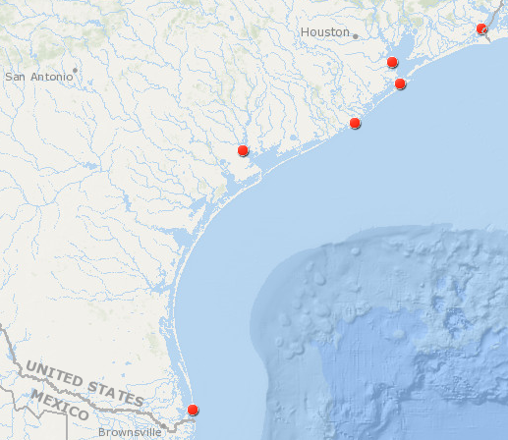

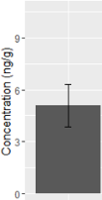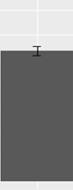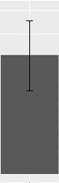

8.17,

549

5.43,

1225

8.01,

480

6.02,

430

5.09,

<63

7.63,

540

Figure VI‑1. Means and standard deviations of PFOS concentrations in *C. virginica* collected on the Texas coast. From right to left, locations are: Port Arthur, Galveston, Eagle Point, Freeport, Port Lavaca, and Brownsville. For reference, the mean oyster burden determined by this study followed by the value from Kannan, et al. (2002), in µg/g, is presented next to a bar graph of concentrations. Each bar graph is on the same scale, with the largest number on the y-axis being 9 µg/g.

**CHAPTER VII**

# An assessment of chronic ecological risk from exposure to perfluorooctane sulfonate (PFOS) at Mack’s Bayou, Barksdale Air Force Base, Shreveport, LA

**ABSTRACT**

In this chapter, chronic risk estimates are presented for aquatic communities in bayous contaminated with perfluorooctane sulfonate (PFOS) at Barksdale Air Force Base, Shreveport, LA. The risk estimates were further characterized by comparing chronic effect thresholds to PFAS exposure estimates obtained from studies in the literature. The potential for a chemical to have adverse effects on ecological resources depends on a number of factors, of which the two primary are the amount and duration of exposure. However, exposure at a minimal dose, even over a long term, may not cause adverse effects to ecological receptors. Ecological Risk Assessment is the process used to determine the likelihood and magnitude of potential adverse effects. Risk estimates may be as simple as comparing an exposure concentration to a threshold of effects to generate hazard or risk quotient, or may involve probabilistic modeling. The most refined probabilistic risk assessments involve comparing a range of exposure estimates to a range of effect estimates to determine the chance that a set percentage of organisms may receive enough exposure to cause adverse effects and allows risk managers to make informed decisions. For aquatic receptors at BAFB, cumulative distribution functions (CDFs) were developed for PFOS water concentrations in addition to a species sensitivity distribution for chronic exposures to thirteen species. The result of these assessments was the quantification of the probability of exceeding the HC5 or HC10 – the concentration at which 5 or 10 percent of species, respectively, would exhibit an adverse effect – due to maintained PFOS concentrations. For assessments based on mean exposures, these probabilities were minimal, 0.079 and 0.024, respectively, for BAFB, and 0.07 and 0.012, respectively, for concentrations from the literature. These results indicate that the risk and the potential for adverse effects due to exposure to PFOS at BAFB and in surface waters throughout the world are of minimal concern. However, a number of uncertainties exist in these assessments and the confidence associated with the risk predicted here could be increased with additional knowledge of both water concentrations and chronic toxicity thresholds.

**INTRODUCTION**

Perfluoroalkyl substances (PFASs) are an example of a persistent class of chemicals for which toxicity thresholds based on chronic studies best represent the nature of exposure in the field (Loos, et al. 2009). These chemicals were a main component of Aqueous Film Forming Foams (AFFFs) due to their surfactant nature. As a consequence of use in fire training activities, many of these chemicals contaminated the soil and eventually the groundwater (Moody, et al. 2003), which then acted as a source for continuous releases to surface water (Miller 1980). One particular chemical of this class, perfluorooctane sulfonate (PFOS), has been found worldwide in surface water samples (Boulanger, et al. 2004, Loos, et al. 2007) despite a phase-out in 2002. Frequent detection of PFOS is due to its stability, with a hydrolytic half-life greater than 40 years (Beach, et al. 2006). However, the vast majority of toxicity data for PFOS is of an acute or sub-chronic duration (Giesy, et al. 2010). Based on the persistence of PFOS, assessments based on acute toxicity data may underestimate the risk of PFOS for aquatic organisms by overestimating the threshold at which toxicity occurs (Oakes, et al. 2005).

The toxicity of PFOS to different ecological receptors has been investigated in a number of studies but much uncertainty remains. To date, the most sensitive species evaluated has been the midge, *Chironomus tentans*, for which an EC50 for growth of 87 µg/L and a NOEC of 2.3 µg/L were determined (MacDonald, et al. 2004). A pair of review studies (Beach, et al. 2006, Giesy, et al. 2010) have collected available toxicity data and shown that the toxicity of PFOS is relatively low for the majority of species, including fish (Drottar and Krueger 2000a) and amphibians (Palmer and Krueger 2001). These authors additionally calculated benchmark protective chronic exposure concentrations of 1.2 µg/L and 5.1 µg/L, respectively. Although these values are similar to the NOEC for the most sensitive species, studies with additional taxa are necessary to further improve the understanding of the potential toxicity of the chemical. However, without measures or estimates of water concentrations present in the environment, toxicity thresholds do not provide adequate information regarding the potential for a chemical to cause adverse ecological effects.

Ecological risk assessment (ERA) is the fundamental method by which ecotoxicological data is incorporated into decision making to support environmental management. Ecological risk assessments require a synthesis of exposure and effect data to estimate risk to ecological receptors (Suter 2006). Ideally, ERAs provide a quantitative estimate of the likelihood and magnitude of adverse effects to assessment endpoints. At the most basic level, this estimate of risk is achieved by comparing a single exposure concentration to a single effect benchmark, and results in a hazard or risk quotient (HQ or RQ, respectively) (Brix, et al. 2001). However, regardless of how robust the data, the HQ may dramatically over- or under-estimate risk and is generally fraught with uncertainty (Lemly 1996). Alternatively, using a probabilistic approach to risk assessments, that explicitly considers variability and multiple data points into the distribution of potential exposure and effects, can provide a much more defensible estimate of risk than an HQ (Brix, et al. 2001). Probabilistic risk assessments that include species sensitivity distributions (SSDs) increase the robustness and defensibility of a risk assessment by providing a range of potential effect thresholds for a variety of species (Wheeler, et al. 2002, Newman, et al. 2000). To date, few ERAs have been completed for PFOS (but see, Yu-Chen Lin, et al. 2010). Therefore, it is important to continue to refine risk estimates to further our understanding of the risk posed by PFOS.

The most basic measures of effects in risk assessments come from standardized toxicity tests, which are currently required as part of the regulatory process for a number of chemical classes and uses (Sanderson, et al. 2003). Additionally, effects can be determined from other laboratory or field testing, observational field work, or environmental modeling (Suter 2006). However, for some chemicals, especially those for which chronic exposure is possible, these tests likely do not accurately represent the potential for adverse effects (van der Oost, et al. 2003). Chronic effects are often reported with the use of no-observed effect concentrations (NOECs), which remain a point of contention within the scientific community due to the arbitrary nature by which they may be determined (Laskowski 1995, Warne and van Dam 2008). However, the use of these endpoints has not been eliminated within the literature and often still provides important information about the potential for chemicals to cause toxicity (Green, et al. 2013).

When chronic exposure data are not available for a particular chemical or species type, a variety of methods may be used to develop an SSD for use in probabilistic risk assessments. These methods include applying safety factors to estimate thresholds between species (Kooijman 1987), applying statistical methods to build a more robust SSD (Wang, et al. 2008), using quantitative structure-activity relationships (QSARs) (McCarty, et al. 1985), or using an acute-chronic ratio (ACR) (Kenaga 1982). Ultimately, although these approaches can help build a range of effects for use in probabilistic assessments, the best assessments will draw from a large database of scientifically sound experiments (Van den Brink, et al. 2006, Forbes and Calow 2002), and utilize endpoints that relate to a response that may have an effect at the population level (i.e., not physiological or histological changes) (Suter 2006).

In addition to developing an SSD based on chronic effects data, a probabilistic risk assessment for PFOS will require developing a distribution of potential exposure values. For this work, these data will come from a site, Barksdale Air Force Base (BAFB), in Shreveport, LA, where PFASs were historically used in AFFFs. Two locations at this site were historically utilized as firefighting training areas. These training areas are near moving water bodies, Cooper’s and Mack’s Bayous, and the site also has a stationary groundwater aquifer. Concentrations of PFASs in the Bayous measured during sampling periods from 2013-2014 (Cochran 2015) will be used as a case-study risk assessment. Further, a large dataset of exposure concentrations will be developed using modeling techniques developed in this dissertation to demonstrate how this method can be utilized to predict risk. Finally, the SSD generated in this study will be compared to distributions generated from surface water concentrations in the literature as a way to further characterize the relative risk estimated at BAFB.

The objectives of this work are three-fold: 1) to develop a chronic SSD for aquatic organisms exposed to PFOS, 2) to complete an aquatic risk assessment for BAFB, and 3) to further characterize risk estimates at BAFB using a preliminary probabilistic chronic risk assessment for aquatic systems for PFOS exposure data from the literature.

**METHODS**

*Case Study ERA: BAFB*

Barksdale Air Force Base is an active military airbase located in Shreveport, in northwest Louisiana. Two locations on this base were historically used as fire training areas at which PFAS-containing AFFFs were used. The use of AFFFs led to the contamination of the surface water of Mack’s and Cooper’s Bayous, which surround the training areas on the north, east, and south sides. Groundwater contamination has also been detected at this site, and it is likely that contaminated groundwater has served as a source for the continued contamination of the surface water after the cessation of fire training with PFAS-containing AFFFs (Cochran 2015). Flowing water eventually exits the base to the south via the Flat River. Collections of fish from the bayous during multiple sampling events in 2013-2014 found detectable levels of several PFASs (Lanza, et al. In press), indicating that organismal exposure to PFASs may pose a risk to ecological receptors in the aquatic environment.

*Overview of Risk Assessment Approach*

Chronic exposure species sensitivity distributions were generated using data located in the literature and from previous experiments (Chapters IV, V). An effort was made to find toxicity values for each of the groups necessary for a Tier I threshold as established by the Great Lakes Initiative (GLI, US EPA. 1985). These families are: the family *Salmonidae*; a second family in *Osteichthyes*, preferably *Cyprinidae*; a third family in *Chordata*; a planktonic crustacean; a benthic crustacean; an aquatic insect; a family in a phylum other than *Arthropoda* or *Chordata*; and a family in any order of insect or phylum not already represented. Chronic toxicity data for all of these families were found in the literature or were already discussed in this dissertation with the exception of the family *Salmonidae*, for which a chronic endpoint was estimated using an ACR, discussed in greater detail below.

Environmental exposure concentration datasets were developed using data from BAFB and from studies in which measured means and standard deviations were published. A further distribution of exposure was developed using the NetLogo model for fish exposure (Chapter III) for a fish in each exposed reach of BAFB. To estimate risk, the probabilities of exceeding several commonly recognized thresholds were calculated. The procedure for this involved identifying the point on the SSD that corresponded to 5% of species affected (the HC5) and the point on the SSD that corresponded to 10% of species affected (the HC10). These points were then used to determine the probability that a water concentration would exceed that value, from the water concentration cumulative distribution function (CDF, Posthuma, et al. 2002). This procedure was completed for water concentrations in the exposed reaches of BAFB as collected by Cochran (2015) and the distributions generated using the NetLogo exposure model (Chapter III), and for concentrations of water worldwide and resulted in estimates of the probability of exceeding water concentrations that would protect 90 (HC10) and 95 (HC5) percent of species. The exposure distributions were also compared to previously calculated benchmarks for aquatic effects (Table VII-1).

*Species Sensitivity Distributions for Effects*

Effect metrics were collected by searching the literature for chronic effects to aquatic organisms. Only studies that reported endpoints that represented the potential for adverse effects on a community or population level were utilized to build the SSDs, i.e., growth, reproductive, or survival effects. When multiple endpoints of these types were reported for the same species, the geometric mean of the NOECs was calculated and this single value was utilized in the SSDs (as in Brix, et al. 2001). Two SSDs were developed for the purposes of this study, one containing data from all aquatic organisms and one only containing data from studies with fish. To increase the number of effect endpoints in the SSDs, chronic values were calculated for Tier I GLI species lacking chronic endpoints using the most conservative published ACR of 21 developed in Qi, et al. (2011). The final SSDs were generated by fitting the toxicity data with logistic regression following procedures outlined by the EPA (2005).

Previously calculated benchmarks for aquatic effects were also located in the literature. For example, Qi, et al. (2011) derived a predicted lowest no-effect concentration of 0.61 µg/L based on the mode of action of PFOS with the use of an ACR. Beach, et al. (2006) calculated that a water value of 1.2 µg/L would be protective for aquatic organisms using Great Lakes Initiative methods (US EPA 1985). The Criterion Continuous Concentration, the highest concentration that an organism can be exposed to without resulting in an adverse effect, was later calculated by Giesy, et al. (2010) to be 5.1 µg/L. The probability of water concentrations exceeding these thresholds were calculated to provide an esimate of risk.

*Exposure at BAFB*

Fish were sampled at eleven locations along the bayous by Cochran (2015). For the purposes of this ERA, the locations were clustered into three discrete, spatially separated, areas. One of these, the Weapon’s Bridge site, was located at a large riffle area, which is a potential barrier to fish movement (see Warren and Pardew 1998). Therefore, I compiled the water concentration values from Cochran (2015) into three reaches: (1) Upstream (containing the Extreme Upstream, West of Upstream, and Upstream sites), (2) Weapon’s Bridge, and (3) Downstream (containing the Fire Training Area-1, Upper Tributary, South Upper Tributary, Upper Tributary at South Mack’s Bayou, South Cooper’s Bayou, South Mack’s Bayou, Confluence, and Lower Confluence sites). Although the sizes of each of these reaches are not equal, no obvious barriers to fish movement existed during the period of sampling within each reach. Furthermore, the closest sampling locations from each of these reaches were at least 1 km distant from each other, which may represent a greater distance than the species of fish collected at BAFB are likely to travel (Rodriguez 2002, Funk 1957). Therefore, it is possible that an individual organism in each reach could have traveled throughout the reach during the sampling period but would have been unlikely to travel between reaches. Non-detect samples were set equal to one-half of the limit of detection (as in Munoz, et al. 2015). All reported concentrations from Cochran (2015) for relevant reaches were included in the data sets as individual data points. This resulted in an *n* of 10, 9, and 37 for the Upstream, Weapon’s Bridge, and Downstream reaches. The data for each reach were then combined into individual CDFs that could be compared to the SSDs for aquatic organisms at the HC5 and HC10 and the benchmark values of Beach, et al. (2006), Giesy, et al. (2010), and Qi, et al. (2011) (Table VII-1). In addition to making CDFs around the mean, the 75th and 95th percentile values for exposure were calculated and compared to the SSD for aquatic organisms at the HC5.

The NetLogo model for uptake (Chapter III) was modified in two ways for use in this assessment. The first involved including a variable so that the maximum exposure concentration for fish could be recorded at each time step. The mean and standard deviation of the sample concentrations from Cochran (2015) for the reach downstream of Weapon’s Bridge from the August 2013 sampling event were then used to determine the concentration of the water “patches”. To provide a greater potential range of exposure values, the “river” of patches was modified to be 100 patches by 100 patches (10,000 total patches). Ten fish were then spawned into random patches and allowed to travel through the river with no limit to the total distance from each’s home patch for 10,000 time steps (one time step = one hour). The maximum concentration of the water patches occupied by the fish at the end of each time-step was recorded and this distribution was used to create a CDF for modeled exposure. This methodology was utilized to calculate a conservative (e.g., high-end) risk estimate. This CDF was compared to the SSD for fish at the HC5 and HC10 and the benchmark values of Beach, et al. (2006), Giesy, et al. (2010), and Qi, et al. (2011) (Table VII-1). The second way the model was modified was via the inclusion of a total exposure variable for each fish so that average exposure per fish could be observed. The average exposure per fish over a 47-day period was modeled and compared to the benchmarks for *Pimephales promelas* from Drottar and Kreuger (2000a). The exposure period was chosen because it was the longest duration for which a toxicity study involving fish was found in the literature (Table VII-2).

*Characterizing PFOS Exposure Estimates Using Published Sample Data*

In order to provide additional perspective on any potential risk identified at BAFB, the literature was queried for manuscripts that reported PFOS concentrations in water. Specifically, I looked for manuscripts that reported surface-water concentration means and standard deviations. The goal was to develop a dataset of PFOS water concentrations that could be used to generate predicted distributions at the mean, 75th, and 95th percentile values. Mean values were transformed to the 75th and 95th percentile by multiplying the standard deviation of the mean by 1.349 and 1.96, respectively, and adding these values to the mean. Non-detect means were excluded from the 75th and 95th percentile analysis due to the lack of a standard deviation for those values. Water concentration distributions for each of these percentiles of exposure were created as CDFs by fitting a log-probit curve to each data set. The probability of water concentrations on each CDF were determined for the threshold values of the HC5 and HC10 from the SSD for aquatic species created in the current study and the benchmark values of Beach, et al. (2006), Giesy, et al. (2010), and Qi, et al. (2011) (Table VII-1).

All calculations were completed and distributions developed using program R (R Core Team 2016).

**RESULTS**

*Species Sensitivity Distributions for Effects*

Published studies in which survival, growth, and/or reproduction were evaluated for a chronic duration were found for a variety of aquatic animals (Zhang, et al. 2014, Boudreau, et al. 2003, Li 2010, Jeong, et al. 2016, MacDonald, et al. 2004, Drottar and Krueger 2000a,b, Cui, et al. 2016, Wang, et al. 2011, Du, et al. 2009, Ankley, et al. 2004, Bots, et al. 2010, Sharpe, et al. 2010, Palmer, et al. 2002a,b, Palmer and Kreuger 2001). These endpoints related directly to survival, reproduction, and growth, and the species evaluated included frogs, fish, and invertebrates (Table VII-2). However, chronic toxicity data for the family *Salmonidae* were not readily available in the literature, so acute toxicity data for this family were modified using the most conservative ACR for PFOS (i.e., the largest ACR, which would provide the lowest chronic values; Qi, et al. 2011). The smallest no-observed effect concentration from these studies was for *Chironomus tentans*, of 2300 ng/L (MacDonald, et al. 2004). The chronic studies in this dissertation, involving *Lymnaea stagnalis* and *Aedes aegypti*, were also added to the data set to increase *n*, to increase representation of Tier I groups not covered by published endpoints, and to decrease the uncertainty in the species sensitivity distribution (Figure VII-1). The HC5 and HC10 determined from the SSD for all taxa were approximately 4750 and 10350 ng/L, respectively. The HC5 and HC10 determined from the SSD for only fish were approximately 17500 and 29400 ng/L, respectively. The probabilities of water concentrations exceeding these values and the benchmarks of Beach, et al. (2006), Giesy, et al. (2010), and Qi, et al. (2011) for each of the three BAFB reaches and for published water concentrations are presented in Table VII-3.

*Case Study ERA: BAFB*

Cumulative distribution functions were generated for each reach of BAFB. Means and standard deviations for each reach were as follows: upstream, 536 ± 1110 ng/L; Weapon’s Bridge, 326 ± 393 ng/L; and downstream, 938 ± 1424 ng/L (i.e., Figure VII-2). The probability of the 75th and 95th percentile concentrations exceeding the HC5 were less than 0.2 for all reaches, indicating a low probability of adverse effects (Table VII-4). The maximum probabilities were observed for the downstream reach, of 0.117 and 0.181 for exceedances of the 75th and 95th percentile, respectively. The mean and standard deviation used to populate the patches in the NetLogo model was 145 ± 45 ng/L. The mean and standard deviation of the modeled maximum exposure concentration from the model was 258 ± 19 ng/L. A CDF was developed using the modeled exposure concentrations (Figure VII-3). The probability of the modeled water concentrations for BAFB downstream of Weapon’s Bridge from August 2013 exceeding any protective values were all <0.0001. The probability of the average water concentration exceeding the NOEC of Drottar and Kreuger (2000a) was <0.0001 (mean = 0.145 µg/L, stdev = 0.0012 µg/L, max = 0.148 µg/L).

*Characterizing PFOS Exposure Estimates Using Published Sample Data*

Nine manuscripts were discovered in a literature search for studies containing water concentration values for sites representing background concentrations or located near a point source of PFOS release (Jin, et al. 2009, Ahrens, et al. 2010, Hansen, et al. 2002, Harada, et al. 2003, Pan and You 2010, Orata, et al. 2009, Flores, et al. 2013, B. Boulanger, et al. 2004). When combined into one dataset, values representing the mean concentration at sites ranged from 0.42 ng/L to 703 ng/L. The range of the 75th percentile and the 95th percentile were 0.46 ng/L to 2860 ng/L and 0.47 ng/L to 3730 ng/L, respectively. These data were combined with those representative of each reach sampled by Cochran to increase the robustness of the set. A CDF was generated for each of the three datasets (Figure VII-4). The maximum exceedance probabilities, of 0.118, were predicted for the 95th percentile of water concentrations to the benchmark of Qi, et al. (2011). However, the overwhelming majority of exceedance risk predictions were less than 0.073 (Table VII-4).

**DISCUSSION**

This work indicates a low potential for adverse effect to aquatic organisms resulting from chronic PFOS exposure. The HC5 determined by this study for all aquatic species was very similar to the protective continuous exposure concentration developed in the most recent review paper (Giesy, et al. 2010). This congruence provides some confidence in the toxicity threshold for aquatic systems exposed to PFOS. In the case-study for BAFB, the probability of mean water concentrations exceeding the HC5 and HC10 values was 8.4% or lower (Table VII-3). However, the probability of exceeding the older threshold from Beach, et al. (2006), the most conservative threshold of Qi, et al. (2011), or the upper bounded water concentrations at BAFB was greater than 0.1 in many cases, with a maximum probability of 0.336 for downstream BAFB mean concentrations of exceeding the values of Qi, et al. (2011) (Tables VII-3 and VII-4). These results indicate a clear potential for adverse effects, although this potential is generally minor. Further, I developed a dataset of water concentrations from samples collected and published in the literature, and used this to develop a distribution of samples for probabilistic analyses as a way to further characterize risk at BAFB. When compared to a distribution of chronic toxic endpoints, the overlap in curves was minimal, indicating that background concentrations of PFOS maintained in water bodies do not pose a great risk to aquatic communities. Hence, it would not seem that risk estimates for aquatic species are significantly greater at BAFB than from other PFOS-contaminated areas but that risk may exist for the most sensitive species in some cases.

The risk assessment for BAFB suggested a relatively low, but plausible, risk to the majority of species comprising the aquatic community in all three reaches of Mack’s Bayou. The downstream reach had the greatest water concentrations and therefore the greatest predicted risk. Over 33% of water concentrations in this reach exceeded the predicted lowest NOEC calculated by Qi, et al. (2011). Additionally, approximately 23% of water concentrations exceeded the protective threshold value of Beach, et al. (2006) but only 8% to exceed a similarly derived value by Giesy, et al. (2010). The use of NOECs in risk assessments remains a point of scientific debate due to a variety of problems inherent in the calculation of these values, including that they vary based on exposure duration, experimental setup including the choice of exposure concentrations, they cannot always be determined, and that statements of precision and uncertainty are not possible when using these thresholds (Fox 2009, Jager, et al. 2006). Furthermore, the effect to the aquatic community of simply exceeding the most sensitive estimated NOEC is of questionable meaning (i.e., see Klepper, et al. 2009). Of greater potential relevance is the probability of exceeding other benchmark values such as those calculated by Beach, et al. (2006) and Giesy, et al. (2010). These benchmarks were derived using similar methods, with the value derived by Giesy, et al. (2010) obtained from a greater set of toxicity data. Therefore, the relatively high probability of exceedance of the threshold from Beach, et al. (2006) likely represents an older assessment and is less representative of actual toxicity thresholds than the minimal risk predicted by a comparison to the benchmark of Giesy, et al. (2010) or to the HC5 developed by this assessment (Table VII-1).

Very minimal risk was predicted for all fish species using modeled potential exposure concentrations at BAFB. This was, in part, due to the relatively high chronic toxicity endpoints determined for fish (Table VII-2). Some of these thresholds were not published in the literature and instead required derivation from aquatic values with an ACR. This was conducted with the most conservative ACR (i.e., the one that would yield the lowest chronic toxicity thresholds after transformation and therefore the largest prediction of risk), as I hypothesized that the risk predicted would not be large and therefore wanted to be overly protective in the assessment. However, the prediction of risk using this modeling method is limited in its use, for example, in this case it could only be concluded that there was no risk to fish from PFOS exposure in the reach of Mack’s Bayou downstream of Weapon’s Bridge in August, 2013. Indeed, the true utility of the model is that risk assessors may use it to predict risk for individual reaches of exposed rivers by collecting water samples in the field and then building a robust distribution of potential exposure that can be compared to appropriate benchmarks of effect. Additionally, it must be considered that although these results indicate that fish are less sensitive to PFOS than many other aquatic species, this may be due to the duration of the studies used to derive these thresholds. For example, a 47-day exposure to *P. promelas* represents a much smaller fraction of the life cycle of that species than does a 21-day exposure for *D. magna*. Therefore, it is possible that chronic exposures of a longer duration would decrease the threshold at which adverse effects are observed in fish.

These results are of particular importance because BAFB was a location at which AFFFs were used heavily in close proximity to the sites at which the water used in this assessment was collected. Further, the water concentration values from these collections represented most of the higher concentrations in the literature. Mack’s Bayou is a flowing water body with the ability to carry dissolved and suspended PFOS downstream and out of the system. Therefore, the elevated concentrations observed at this site are likely due to contaminated groundwater acting as a source for continued exposure. In a system with less flow and therefore less ability to remove PFOS, such as an oxbow lake or catchment pond, maintained PFOS concentrations, and therefore risk of threshold exceedance, would likely be even higher than at BAFB.

The risk assessment for water concentrations in the literature indicated minimal risk to the vast majority of species. Only 6.3% of mean water concentrations exceeded the most sensitive endpoint, the predicted NOEC for all species (Qi, et al. 2011). Furthermore, endpoints more commonly recognized as protective of communities in risk assessments, such as the HC5, were only predicted to be exceeded by 1.2% of mean water concentrations. The probabilities of exceedances were greater for the 75th and 95th percentile but below 3% for the HC5, HC10, and the benchmark of Giesy, et al. (2010). The risk interpretation of these results is that there is a low probability (75th and 95th percentile of water concentrations) of low effects (exceedance of HC5). In general, these results are a promising sign that the phase-out of PFOS may have been successful in preventing the concentration of these chemicals from reaching a point, despite their persistence, where they would remain a threat for a long period of time.

However, much uncertainty exists within this assessment, both with the creation of exposure distributions and the selection of chronic toxicity endpoints. Many manuscripts in the literature only report a range and measure of central tendency for PFOS concentration. Several manuscripts reported on concentrations after a spill but these were not deemed relevant to this assessment because high concentrations are not maintained for a chronic duration. The reports identified as relevant spanned a wide variety of collection locations, providing a reasonable estimate of background concentrations in surface waters throughout the world. However, additional collections would increase the robustness of the data set and decrease the confidence interval associated with the CDF. Collecting water concentration data at locations near historical point sources of PFOS usage would also aid in improving the data set. Furthermore, these collections would allow for risk assessments to be completed for the areas of greatest concern.

The inclusion of more toxicity test results of a chronic duration for PFOS would also further improve the reliability of these assessments. Despite being of a chronic duration, many of the study endpoints used in the current assessment represent a period of exposure that is much shorter than what an organism would experience in the environment. Therefore, the inclusion of tests of a longer duration would aid in the development of more a more accurate SSD. Furthermore, the chronic toxicity thresholds for several taxa required estimation with an ACR (Kenaga 1982). To increase the conservativism of the assessment, the largest ACR was used, which decreased the value of the predicted chronic toxicity threshold. Determining the actual value of these thresholds would increase confidence in the risk assessment process. The addition of more data points to the SSD will decrease the width of the error bars and increase the confidence in risk predictions (Wheeler, et al. 2002). Increasing the scientific knowledge of chronic toxicological thresholds with a greater range of species, particularly to expand the distribution with other taxa and to determine if a more sensitive species exists, would also increase the confidence of risk assessments for the chemical. Additionally, as the use of NOECs has been a source of much debate within the scientific community, generating more of these values and refining those currently in the literature will also increase the confidence in risk estimates (Aldenberg and Jaworska 2000). Thresholds observed in toxicity testing for the same species may also vary based on experimental setup (Elphick, et al. 2011), duration (see the guidelines of US EPA 2015), and endpoint. Particular care must be taken that the endpoint in a selected chronic test is ecologically relevant (Forbes and Calow 2002). However, the protective threshold calculated by Giesy, et al. (2010) was very similar to the HC5 for all species calculated by this assessment. This similarity indicates that toxicity testing in the years since the review of Giesy, et al. (2010) has not identified additional sensitive species that have dramatically affected the most sensitive part of the SSD. Therefore, it is possible that further testing for sensitive species will not significantly alter the results of risk assessments.

Another set of data that would improve the risk assessment of PFASs would be those involving mixture concentrations and toxicity. As seen in Cochran (2015), PFOS is generally present concurrent with other chemicals, as multiple PFAS were included in AFFFs, and degradation can yield multiple PFAS (Liu and Avendano 2013). My work with *A. aegypti* (Chapter V) showed that the presence of multiple PFASs in a mixture may dramatically decrease the threshold at which toxicity occurs from the value for a single chemical. This observation implies that the risk assessments presented within this chapter may also be underestimating risk, since these assessments only simulate risk for PFOS alone. To build an understanding of the risk of PFAS mixtures would require developing knowledge of both the toxicological effects and range of concentrations at which these mixtures are present in the environment (Borgert, et al. 2004, Relyea 2009). This would, understandably, be a large undertaking, but would certainly aid in the development of more appropriate risk models for this class of chemicals.

Ultimately, more work is necessary in order to improve the confidence associated with risk assessments for PFOS. The persistence of the chemical and its relative lack of toxicity for acute exposures means that chronic toxicity tests are a better measure of the threshold at which toxic effects may been observed. Unfortunately, little research is available in the literature that investigates exposures of this duration. Further, studies are only available for a few taxa, primarily those used in standard toxicity tests. It is of crucial importance to consider the toxicity of PFASs in terms of long-term exposures to a wide variety of species, since the chemical can be detected in water samples throughout the world. Furthermore, the increased toxic effects that mixtures of PFASs alone and PFASs with other chemicals can have should not be ignored moving forward. It is possible that more refined risk assessments, including factors that are more representative of the reality of environmental exposure, would predict significantly more risk than was observed in these preliminary assessments. Therefore, the results of this preliminary assessment should be viewed as an important first step in characterizing the risk of PFOS to aquatic communities that may be built upon for further refined assessments that can even more accurately estimate risk.

**REFERENCES**

Ahrens, L., Z. Xie, and R. Ebinghaus. 2010. Distribution of perfluoroalkyl compounds in seawater from Northern Europe, Atlantic Ocean, and Southern Ocean. *Chemosphere* 78: 1011-1016.

Aldenberg, T., and J.S. Jaworska. 2000. Uncertainty of the hazardous concentration and fraction affected for normal species sensitivity distributions. *Ecotoxicology and Environmental Safety* 46: 1-18.

Ankley, G.T., D.W. Kuehl, M.D. Kahl, K.M. Jensen, B.C. Butterworth, and J.W. Nichols. 2004. Partial life-cycle toxicity and bioconcentration modeling of perfluorooctanesulfonate in the northern leopard frog (*Rana pipiens*). *Environmental Toxicology and Chemistry* 23: 2745-2755.

Beach, S.A., J.L. Newsted, K. Coady, and J.P. Giesy. 2006. Ecotoxicological evaluation of perfluorooctanesulfonate (PFOS). *Reviews of Environmental Contamination and Toxicology* 186: 133-174.

Bots, J., L. De Bruyn, T. Snijkers, B. Van den Branden, and H. Van Gossum. 2010. Exposure to perfluorooctane sulfonic acid (PFOS) adversely affects the life-cycle of the damselfly *Enallagma cyathigerum*. *Environmental Pollution* 158: 901-905.

Borgert, C.J., T.F. Quill, L.S. McCarty, and A.M. Mason. 2004. Can mode of action predict mixture toxicity for risk assessment? *Toxicology and Applied Pharmacology* 201: 85-96.

Bots, J., L. De Bruyn, T. Snijkers, B. Van den Branden, and H. Van Gossum. 2010. Exposure to perfluorooctane sulfonic acid (PFOS) adversely affects the life-cycle of the damselfly *Enallagma cyathigerum*. *Environmental Pollution* 158: 901-905.

Boudreau, T.M., P.K. Sibley, S.A. Mabury, D.C.G. Muir, and K.R. Solomon. 2003. Laboratory evaluation of the toxicity of perfluorooctane sulfonate (PFOS) on *Selenastrum capricornutum*, *Chlorella vulgaris*, *Lemna gibba*, *Daphnia magna*, and *Daphnia pulicaria*. *Archives of Environmental Contamination and Toxicology* 44: 307-313.

Boulanger, B., J. Vargo, J.L. Schnoor, and K.C. Hornbuckle. 2004. Detection of perfluorooctane surfactants in Great Lakes water. *Environmental Science and Technology* 38: 4064-4070.

Brix, K.V., D.K. DeForest, and W.J. Adams. 2001. Assessing acute and chronic copper risks to freshwater aquatic life using species sensitivity distributions for different taxonomic groups. *Environmental Toxicology and Chemistry* 20: 1846-1856.

Cochran, R.S. 2015. *Evaluation of perfluorinated compounds in the sediment, water, and passive samplers collected from the Barksdale Air Force Base.* Ph.D. Dissertation, Lubbock, TX: Texas Tech University.

Cui, Y., S. Lv, J. Liu, S. Nie, J. Chen, Q. Dong, C. Huang, and D. Yan. 2016. Chronic perfluorooctanesulfonic acid exposure disrupts lipid metabolism in zebrafish. *Human and Experimental Toxicology* 1-11.

Drottar, K.R., and H.O. Krueger. 2000a. *PFOS: A 96-hr static acute toxicity test with the fathead minnow (Pimephales promelas).* Easton, MD: Wildlife International, Ltd.

Drottar, K.R., and H.O. Krueger. 2000b. *PFOS: A flow through life-cycle toxicity test with the saltwater mysid (Mysidopsis bahia).* Easton, MD: Wildlife International, Ltd.

Du, Y., X. Shi, C. Liu, K. Yu, and B. Zhou. 2009. Chronic effects of water-borne PFOS exposure on growth, survival and hepatotoxicity in zebrafish: a partial life-cycle test. *Chemosphere* 74: 723-729.

Elphick, J.R.F., K.D. Bergh, and H.C. Bailey. 2011. Chronic toxicity of chloride to freshwater species: effects of hardness and implications for water quality guidelines. *Environmental Toxicology and Chemistry* 30: 239-246.

Flores, C, F. Ventura, J. Martin-Alonso, and J. Caixach. 2013. Occurrence of perfluorooctane sulfonate (PFOS) and perfluorooctanoate (PFOA) in N.E. Spanish surface waters and their removal in a drinking water treatment plant that combines conventional and advanced treatments in parallel lines. *Science of the Total Environment* 461-462: 618-626.

Forbes, V.E., and P. Calow. 2002. Species sensitivity distributions revisited: a critical appraisal. *Human and Ecological Risk Assessment* 8: 473-492.

Fox, D.R. 2009. Is the ECx a legitimate surrogate for a NOEC? *Integrated Environmental Assessment and Management* 5: 351-353.

Funk, J.L. 1957. Movement of stream fishes in Missouri. *Transactions of the American Fisheries Society* 85: 39-57.

Giesy, J.P., J.E. Naile, J.S. Khim, P.D. Jones, and J.L. Newsted. 2010. Aquatic toxicology of perfluorinated chemicals. In *Reviews of Environmental Contamination and Toxicology*, 1-52. Springer Science.

Green, J.W., T.A. Springer, and J.P. Staveley. 2013. The drive to ban the NOEC/LOEC in favor of ECx is misguided and misinformed. *Integrated Environmental Assessment and Management* 9: 12-16.

Hansen, K.J., H.O. Johnson, J.S. Eldridge, J.L. Butenhoff, and L.A. Dick. 2002. Quantitative characterization of trace levels of PFOS and PFOA in the Tennessee River. *Environmental Science and Technology* 36: 1681-1685.

Harada, K., N. Saito, K. Sasaki, K. Inoue, and A. Koizumi. 2003. Perfluorooctane sulfonate contamination of drinking water in the Tama River, Japan: estimated effects on resident serum levels. *Bulletin of Environmental Contamination and Toxicology* 71: 31-36.

Jager, T., E.H.W. Heugens, and S.A.L.M. Kooijman. 2006. Making sense of ecotoxicological test results: towards application of process-based models. *Ecotoxicology* 15: 305-314.

Jeong, T.-Y., M.-S. Yuk, J. Jeon, and S.D. Kim. 2016. Multigenerational effect of perfluorooctane sulfonate (PFOS) on the individual fitness and population growth of *Daphnia magna*. *Science of the Total Environment* 569-570: 1553-1560.

Jin, Y.H., W. Liu, I. Sato, S.F. Nakayama, K. Sasaki, N. Saito, and S. Tsuda. 2009. PFOS and PFOA in environmental and tap water in China. *Chemosphere* 77: 605-611.

Kenaga, E.E. 1982. Predictability of chronic toxicity from acute toxicity of chemicals in fish and aquatic invertebrates. *Environmental Toxicology and Chemistry* 1: 347-358.

Klepper, O., T.P. Traas, A.J. Schouten, G.W. Korthals, and D. De Zwart. 2009. Estimating the effect on soil organisms of exceeding no-observed effect concentrations (NOECs) of persistent toxicants. *Ecotoxicology* 8: 9-21.

Kooijman, S.A.L.M. 1987. A safety factor for LC50 values allowing for differences in sensitivity among species. *Water Research* 21: 269-276.

Lanza, H.A., R.S. Cochran, J.F. Mudge, A.D. Olson, B.R. Blackwell, J.D. Maul, C.J. Salice, and T.A. Anderson. In press. Temporal monitoring of PFOS accumulation in aquatic biota downstream of historical aqueous film forming foam use area. *Environmental Toxicology and Chemistry.* doi:10.1002/etc.3726.

Laskowski, R. 1995. Some good reasons to ban the use of NOEC, LOEC and related concepts in ecotoxicology. *Oikos* 73: 140-144.

Lemly, A.D. 1996. Evaluation of the hazard quotient method for risk assessment of selenium. *Ecotoxicology and Environmental Safety* 35: 156-162.

Li, H. 2010. Chronic effects of perfluorooctane sulfonate and ammonium perfluorooctanoate on biochemical parameters, survival and reproduction of *Daphnia magna*. *Journal of Health Science* 56: 104-111.

Lien, N.P.H., S. Fujii, S. Tanaka, M. Nozoe, W. Wirojanagud, and A. Anton. 2006. Occurrences of perfluorooctane sulfonate (PFOS) and perfluorooctane acid (PFOA) in surface waters of Southeast Asian countries. *Science of the Total Environment* 461: 681-626.

Loos, R., J. Wollgast, T. Huber, and G. Hanke. 2007. Polar herbicides, pharmaceutical products, perfluorooctane sulfonate (PFOS), perfluorooctanoate (PFOA), and nonylphenol and its carboxylates and ethoxylates in surface and tap waters around Lake Maggiore in Northern Italy. *Analytical and Bioanalytical Chemistry* 387: 1469-1478.

Loos, R., B.M. Gawlik, G. Locoro, E. Rimaviciute, S. Contini, and G. Bidoglio. 2009. EU-wide survey of polar organic persistent pollutants in European river waters. *Environmental Pollution* 157: 561-568.

MacDonald, M.M., A.L. Warne, N.L. Stock, S.A. Mabury, K.R. Solomon, and P.K. Sibley. 2004. Toxicity of perfluorooctane sulfonic acid and perfluorooctanoic acid to *Chironomus tentans*. *Environmental Toxicology and Chemistry* 23: 2116-2123.

McCarty, L.S., P.V. Hodson, G.R. Craig, and K.L.E. Kaiser. 1985. The use of quantitative structure-activity relationships to predict the acute and chronic toxicities of organic chemicals to fish. *Environmental Toxicology and Chemistry* 4: 595-606.

Miller, D.W. 1980. *Waste disposal effects on groundwater: a comprehensive survey of the occurrence and control of groundwater contamination.* Berkeley, CA: Premier Press.

Moody, C.A., G.N. Hebert, S.H. Strauss, and J.A. Field. 2003. Occurrence and persistence of perfluorooctanesulfonate and other perfluorinated surfactants in groundwater at a fire-training area at Wurtsmith Air Force Base, Michigan, USA. *Journal of Environmental Monitoring* 5: 341-345.

Munoz, G., J.-L. Giraudel, F. Botta, F. Lestremau, M.-H. Devier, H. Budzinski, and P. Labadie. 2015. Spatial distribution and partitioning behavior of selected poly- and perfluoroalkyl substances in freshwater ecosystems: a French nationwide survey. *Science of the Total Environment* 517: 48-56.

Newman, M.C., D.R. Ownby, L.C.A. Mezin, D.C. Powell, T.R.L. Christensen, S.B. Lerberg, and B.-A. Anderson. 2000. Applying species-sensitivity distributions in ecological risk assessment: assumptions of distribution type and sufficient numbers of species. *Environmental Toxicology and Chemistry* 19: 508-515.

Oakes, K.D., P.K. Sibley, J.W. Martin, D.D. MacLean, K.R. Solomon, S.A. Mabury, and G.J. Van der Kraak. 2005. Short-term exposures of fish to perfluorooctane sulfonate: acute effects on fatty acyl-coa oxidase activity, oxidative stress, and circulating sex steroids. *Environmental Toxicology and Chemistry* 24: 1172-1181.

Orata, F., N. Quinete, F. Werres, and R.-D. Wilken. 2009. Determination of perfluorooctanoic acid and perfluorooctane sulfonate in Lake Victoria gulf water. *Bulletin of Environmental Contamination and Toxicology* 82: 218-222.

Palmer, S.J., and H.O. Krueger. 2001. *A frog embryo teratogenesis assay- Xenopus (FETAX).* Easton, MD: Wildlife International, Ltd.

Palmer, S.J., R.L. van Hoven, and H.O. Krueger. 2002a. *Perfluorooctanesulfonate, potassium salt (PFOS): A 96-hr static acute toxicity test with the rainbow trout (Oncorhynchus mykiss).* Easton, MD: Wildlife International, Ltd.

Palmer, S.J., R.L. van Hoven, and H.O. Krueger. 2002b*.* Perfluorooctanesulfonate, potassium salt (PFOS): A 96-hr static renewal acute toxicity test with the sheepshead minnow (*Cyprinodon variegatus*). Easton, MD: Wildlife International, Ltd.

Pan, G., and C. You. 2010. Sediment-water distribution of perfluorooctane sulfonate (PFOS) in Yangtze River Estuary. *Environmental Pollution* 158: 1363-1367.

Posthuma, L., G.W. Suter II, and T.P. Traas. 2002. *Species Sensitivity Distributions in Ecotoxicology.* Boca Raton, FL: CRC Press LLC.

Qi, P., Y. Wang, J. Mu, and J. Wang. 2011. Aquatic predicted no-effect-concentration derivation for perfluorooctane sulfonic acid. *Environmental Toxicology and Chemistry* 30: 836-842.

R Core Team. 2016. R: A language and environment for statistical computing. Vienna, Austria: R Foundation for Statistical Computing. https://www.R-project.org.

Relyea, R.A. 2009. A cocktail of contaminants: how mixtures of pesticides at low concentrations affect aquatic communities. *Oecologia* 159: 363-376.

Rodriguez, M.A. 2002. Restricted movement in stream fish: the paradigm is incomplete, not lost. *Ecology* 83: 1-13.

Sanderson, H., D.J. Johnson, C.J. Wilson, R.A. Brain, and K.R. Solomon. 2003. Probabilistic hazard assessment of environmentally occurring pharmaceuticals toxicity to fish, daphnids and algae by ECOSAR screening. *Toxicology Letters* 144: 383-395.

Sharpe, R.L., J.P. Bensjkin, A.H. Laarman, S.L. MacLeod, J.W. Martin, C.S. Wong, and G.G. Goss. 2010. Perfluorooctane sulfonate toxicity, isomer-specific accumulation, and maternal transfer in zebrafish (*Danio rerio*) and rainbow trout (*Oncorhynchus mykiss*). *Enviornmental Toxicology and Chemistry* 29: 1957-1966.

Suter, G.W. 2006. *Ecological Risk Assessment, Second Edition.* Boca Raton, FL: CRC Press.

US EPA. 1985. *Guidelines for deriving numerical national water quality criteria for the protection of aquatic organisms and their uses.* PB-85-227049, Springfield, VA: U.S. Environmental Protection Agency NTIS.

US EPA. 2005. *Methods/indicators for determining when metals are the cause of biological impairments of rivers and streams: species sensitivity distributions and chronic exposure-response relationships from laboratory data.* EPA/600/X-05-027, Cincinnati, OH: U.S. Environmental Protection Agency, Office of Research and Development, National Center for Environmental Assessment.

Van den Brink, P.J., N. Blake, T.C.M. Brock, and L. Maltby. 2006. Predictive value of species sensitivity distributions for effects of herbicides in freshwater ecosystems. *Human and Ecological Risk Assessment* 12: 645-674.

van der Oost, R., J. Beyer, and N.P.E. Vermeulen. 2003. Fish bioaccumulation and biomarkers in environmental risk assessment: a review. *Environmental Toxicology and Pharmacology* 13: 57-149.

Wang, B., G. Yu, J. Huang, and H. Hu. 2008. Development of species sensitivity distributions and estimation of HC5 of organochlorine pesticides with five statistical approaches. *Ecotoxicoloy* 17: 716-724.

Wang, M., J. Chen, K. Lin, Y. Chen, W. Hu, R.L. Tanguay, C. Huang, and Q. Dong. 2011. Chronic zebrafish PFOS exposure alters sex ratio and maternal related effects in F1 offspring. *Environmental Toxicology and Chemistry* 30: 2073-2080.

Warne, M.S.J., and R. van Dam. 2008. NOEC and LOEC data should no longer be generated or used. *Australasian Journal of Ecotoxicology* 14: 1-5.

Warren, M.L., and M.G. Pardew. 1998. Road crossings as barriers to small-stream fish movement. *Transactions of the American Fisheries Society* 127: 637-644.

Wheeler, J.R., E.P.M. Grist, K.M.Y. Leung, D. Morritt, and M. Crane. 2002. Species sensitivity distributions: data and model choice. *Marine Pollution Bulletin* 45: 192-202.

Yu-Chen Lin, A., S.C. Panchangam, and P.-S. Ciou. 2010. High levels of perfluorochemicals in Taiwan's wastewater treatment plants and downstream rivers pose great risk to local aquatic ecosystems. *Chemosphere* 80: 1167-1174.

Zhang, L., J. Niu, Y. Wang, J. Shi, and Q. Huang. 2014. Chronic effects of PFOA and PFOS on sexual reproduction of freshwater rotifer *Brachionus calyciflorus*. *Chemosphere* 114: 114-120.

Table VII-1. Benchmarks from the literature and calculated HC5 and HC10 values for chronic exposure to organisms. Separate HC5 and HC10 values were determined for fish and all aquatic animals.

|  |  |  |  |  |  |  |
| --- | --- | --- | --- | --- | --- | --- |
| Benchmark (µg/L) | | | | | | |
| HC5 | | HC10 | | Predicted NOEC  (Qi, et al. 2011) | Secondary Chronic Value  (Beach, et al. 2006) | Continuous exposure (Giesy, et al. 2010) |
| Fish only | All aquatic species | Fish only | All aquatic species |
| 17.5 | 4.75 | 29.4 | 10.3 | 0.61 | 1.2 | 5.1 |

Table VII-2. Chronic endpoints used for creating a species sensitivity distribution for PFOS exposure. Calculated geometric means for species with more than one endpoint are presented in parentheses within the NOEC column.

|  |  |  |  |  |
| --- | --- | --- | --- | --- |
| Scientific name | Duration | Endpoint | NOEC (µg/L) | Citation |
| *Brachionus calyciflorus* | 4-d | Reproduction | 125 | (Zhang, et al. 2014) |
| *Daphnia magna* | 21-d,  25-d | Survival, Reproduction | (642) | (Boudreau, et al. 2003, H. Li, 2010, Jeong, et al. 2016) |
| *Chironomus tentans* | 10-d | Survival, Growth | 2.3 | (MacDonald, et al. 2004) |
| *Pimephales promelas* | 47-d | Survival | 290 | (Drottar and Krueger 2000a) |
| *Enallagma cyathigerum* | >300-d | Growth | 10 | (Bots, et al. 2010) |
| *Mysidopsis bahia* | 35-d | Growth, Reproduction | 240 | (Drottar and Krueger 2000b) |
| *Oncorhynchus mykiss* | 4-da | Survival | (189) | (Sharpe, et al. 2010, Palmer, et al. 2002a) |
| *Danio rerio* | 70-d,  157-d, 180-d | Survival, Reproduction | (29) | (Du, et al. 2009, Wang, et al. 2011, Cui, et al. 2016) |
| *Cyprinodon variegatus* | 4-da | Survival | 714 | (Palmer, et al. 2002b) |
| *Rana pipiens* | 35-d | Survival | 3000 | (Ankley, et al. 2004) |
| *Xenopus laevis* | 4-da | Development | 230 | (Palmer and Krueger 2001) |
| *Aedes aegypti* | 44-d | Survival | 50 | Chapter IV |
| *Lymnaea stagnalis* | 21-d | Survival | 3000 | Chapter V |
| aAcute toxicity endpoint modified to chronic with ACR (Qi, et al. 2011) | | | | |

Table VII-3. The probabilities of PFOS water concentrations from Mack’s and Cooper’s Bayou, BAFB, exceeding protective benchmarks. The HC5 and HC10 were derived from species sensitivity distributions of a variety of aquatic taxa.

|  |  |  |  |  |  |  |
| --- | --- | --- | --- | --- | --- | --- |
| Location of water body | | Benchmark | | | | |
| HC5 | HC10 | Predicted NOEC  (Qi, et al. 2011) | Secondary Chronic Value  (Beach, et al. 2006) | Continuous exposure (Giesy, et al. 2010) |
| Toxicity threshold (µg/L) | | 4.75 | 10.3 | 0.61 | 1.2 | 5.1 |
| Upstream BAFB | | 0.043 | 0.025 | 0.177 | 0.116 | 0.041 |
| Weapon’s Bridge BAFB | | 0.044 | 0.023 | 0.208 | 0.136 | 0.042 |
| Downstream BAFB | | 0.084 | 0.043 | 0.336 | 0.229 | 0.079 |
| Worldwide, from the literature | Mean | 0.012 | 0.007 | 0.063 | 0.041 | 0.010 |
| 75th percentile | 0.022 | 0.009 | 0.102 | 0.063 | 0.020 |
| 95th percentile | 0.026 | 0.010 | 0.118 | 0.073 | 0.025 |

Table VII-4. The probabilities of the 75th and 95th percentile PFOS water concentrations from Mack’s and Cooper’s Bayou, BAFB, exceeding the calculated HC5 for aquatic organisms, of 4750 ng/L.

|  |  |  |
| --- | --- | --- |
| Location of water body | Percentile | Probability of exceedance |
| Upstream BAFB | 75th | 0.069 |
| 95th | 0.134 |
| Weapon’s Bridge BAFB | 75th | 0.077 |
| 95th | 0.162 |
| Downstream BAFB | 75th | 0.117 |
| 95th | 0.181 |

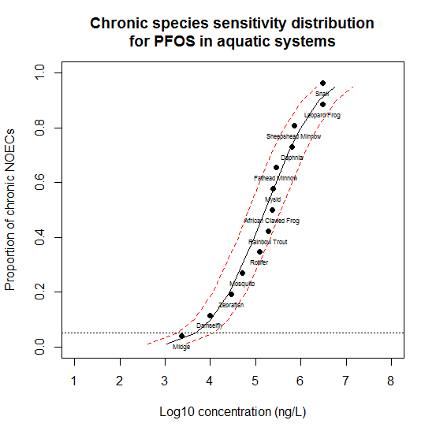

Figure VII-1. Species-sensitivity distribution generated from no-observed effect concentrations (NOECs) for chronic exposure of aquatic species to perfluorooctane sulfonate (PFOS). Chronic endpoints were chosen because PFOS is persistent in aquatic systems. Additionally, endpoints chosen were only those that would directly and obviously cause population-level effects, such as survival, growth, and reproduction. The place where the horizontal dashed line crosses the curve shows the concentration at which 5% of species are likely to be adversely affected by exposure to PFOS. The red dashed lines represent the 95% confidence interval of the curve.

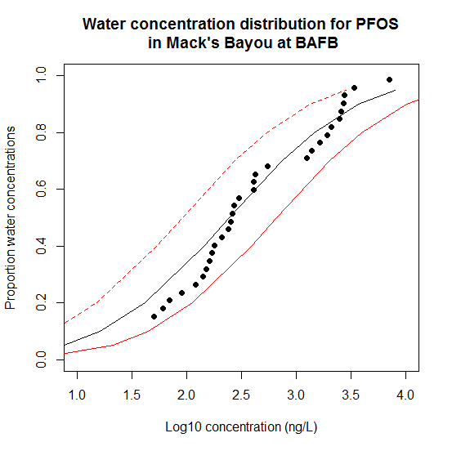Figure VII-2. A cumulative distribution function for water concentrations of perfluorooctane sulfonate (PFOS) in the downstream reach of Mack’s Bayou, Barksdale Air Force Base (BAFB), Shreveport, LA, as collected by Cochran (2015). This Bayou is located near two fire-training areas at which aqueous film forming foams containing PFOS were historically used. The red dashed lines represent the 95% confidence interval of the curve.

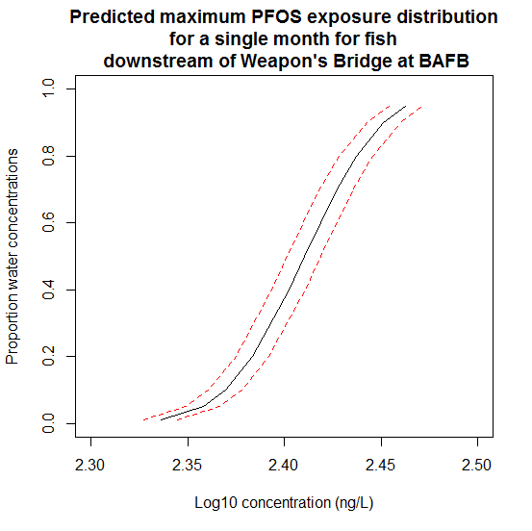

Figure VII-3. The modeled maximum exposure concentration for fish downstream of the Weapon’s Bridge site at BAFB for August, 2013 (data from Cochran, 2015). Exposure was calculated using the NetLogo model presented in Chapter III of this dissertation, modified so that the output parameter was maximum exposure concentration at each time-step. The red dashed lines represent the 95% confidence interval of the curve.

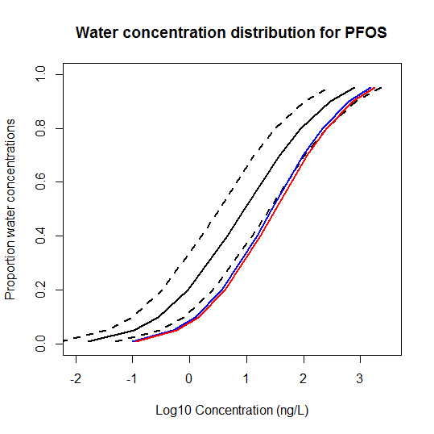

Figure VII-4. Cumulative distribution functions for water concentrations of perfluorooctane sulfonate (PFOS). The water concentrations in this figure were taken from a literature search for concentrations that are maintained in the environment rather than those present in the immediate aftermath of a spill event. The black solid and black dashed lines represent the curve generated by the mean of the values and the 95% confidence interval of that curve, respectively. The blue and red lines represent the 75th and 95th percentile curves, respectively, generated from the means and standard deviations of the reported concentrations.

**CHAPTER VIII**

# CONCLUSION

This work provides important information regarding the toxicity and potential ecological risk of perfluorooctane sulfonate (PFOS) to aquatic organisms, as well as a brief investigation into the toxicity of perfluorohexane sulfonate (PFHxS) and the potential for synergistic effects of mixtures of per- and polyfluorinated substances (PFASs). In Chapter II, a methodology for completing laboratory testing with PFAS compounds was presented, which involved the use of pipette tip aeration, biweekly water changes, and polyethylene exposure tanks. A bioaccumulation model was presented in Chapter III that can be used to predict PFOS concentration in three fish tissues from surface water concentrations. When compared to actual field data, the models provided reasonable estimates of fish tissue concentrations, generally within an order of magnitude of measured tissue concentrations. Also, a demonstration of the utility of the model included simulating fish movement in a stream with heterogeneously distributed PFOS concentrations, which provided a range of exposure potentials and outcomes. Toxicity testing with the snail, *Lymnaea stagnalis*, was presented in Chapter IV, wherein five different life stages were exposed to equal concentrations of PFOS for 21 days and endpoints related to survival, growth, and reproduction were observed. The most sensitive endpoint and life stage evaluated was for survival of adults, suggesting that more sensitive un-evaluated sub-lethal endpoints that would have an effect at the population level may exist. However, adults were not the most sensitive life stage for each endpoint, indicating the need to complete toxicity testing for a variety of life stages to determine threshold concentrations. A potentially PFAS-sensitive organism, the mosquito *Aedes aegypti*, was exposed to PFOS, PFHxS, and a mixture of the two chemicals for the duration of its aquatic life-cycle and these results were given in Chapter V. Although *A. aegypti* was not found to be the most sensitive organism to PFOS, a significant increase in toxicity was observed when organisms were exposed to a mixture of PFASs rather than an individual chemical. The difference was of a large enough magnitude to suggest that adverse effects could be observed due to environmental mixtures of PFASs to the most sensitive organism evaluated, *Chironomus tentans* (MacDonald, et al. 2004).The results of a field collection of the oyster *Crassotrea virginica* were reported in Chapter VI. The concentration of PFOS in the oysters collected were compared to those observed in a previous study (Kannan, et al. 2002), which indicated that the burden of PFOS in environmental samples is likely on the decline, providing some evidence that the voluntary phase-out implemented in 2003 may be having the desired effect. Finally, a probabilistic risk assessment for aquatic species at a heavily PFAS-exposed site, Barksdale Air Force Base, Shreveport, LA, was completed and these results were presented in Chapter VII. The assessment indicated that the risk due to PFOS exposure is minimal for the vast majority of species but that the most sensitive organisms may be at risk, particularly at highly contaminated locations. Furthermore, the potential additional toxicity of PFAS mixtures could increase the risk of exposure when compared to PFOS alone.

The work presented herein remains relevant despite the phase-out of several PFASs in North America for a number of reasons, including 1) Although production of many potentially harmful PFASs has stopped in North America, stockpiles of these chemicals still exist and may be used; 2) PFOS and PFOA are still produced and used in China, thereby increasing the total amount of these chemicals in the environment (Liu, et al. 2017); 3) PFOS may be the ultimate degradation product of several perfluorinated chemicals in the environment (Beach, et al. 2006); 4) The historical use and persistence of PFASs suggest that environmental exposures are likely to continue for many years to come; 5) PFOS has recently been detected in samples collected in the Arctic, suggesting a global transport mechanism (Martin, et al. 2004). Therefore, the methods, models, and toxicity data presented within this work will aid researchers to better assess and predict the risk of PFOS and similar chemicals in the environment.

However, although this work provides important information about PFOS and PFHxS, much more research is needed for the scientific community to better understand PFASs and the potential for risk to ecological systems. Chronic toxicity testing with these long-lived chemicals is crucial and under-represented in the literature. Furthermore, because PFASs rarely occur individually in the environment, toxicity tests must be carried out with environmentally relevant mixtures of these chemicals, and for chemicals for which synergy would be predicted. Care must be taken to ensure that potentially sensitive species, life stages, and endpoints are being evaluated, particularly since this work has shown that adverse effects are not always observed as predicted. The detection of PFASs in the Arctic (Martin, et al. 2004) further indicate the need for novel testing to provide an extensive understand of the behavior and risk of these chemicals in the environment, as this biome may be rapidly and dramatically altered in the near future due to a variety of anthropogenic stressors including toxicants and global climate change (Jenssen 2006).

To summarize, this research presents important toxicity testing and a means of assessing individual exposure, burden, and community-level risk. Chronic toxicity tests with PFOS have been shown to have toxic effects at concentrations much lower than those that cause effects at an acute duration and therefore it is crucial that further work with PFASs use test durations that more accurately represent the potential of these chemicals to be maintained in the environment. Further, this work highlights the necessity of testing the potential toxicity of a chemical along with commonly co-occurring chemicals including other PFASs. With this information, a better understanding of the risk posed to aquatic systems by PFASs will be gained.

**REFERENCES**

Beach, S.A., J.L. Newsted, K. Coady, and J.P. Giesy. 2006. Ecotoxicological evaluation of perfluorooctanesulfonate (PFOS). *Reviews of Environmental Contamination and Toxicology* 186: 133-174.

Jenssen, B.M. 2006. Endocrine-disrupting chemicals and climate change: a worst-case combination for arctic marine mammals and seabirds? *Environmental Health Perspectives* 114: 76.

Kannan, K., K.J. Hansen, T.L. Wade, and J.P. Giesy. 2002. Perfluorooctane sulfonate in oysters, *Crassostrea virginica*, from the Gulf of Mexico and the Chesapeake Bay, USA. *Archives of Environmental Contamination and Toxiology* 313-318.

Liu, Z., Y. Lu, P. Wang, T. Wang, S. Liu, A.C. Johnson, A.J. Sweetman, and Y. Baninla. 2017. Pollution pathways and release estimation of perfluorooctane sulfonate (PFOS) and perfluorooctanoic acid (PFOA) in central and eastern China. *Science of The Total Environment* 580: 1247-1256.

MacDonald, M.M., A.L. Warne, N.L. Stock, S.A. Mabury, K.R. Solomon, and P.K. Sibley. 2004. Toxicity of perfluorooctane sulfonic acid and perfluorooctanoic acid to *Chironomus tentans*. *Environmental Toxicology and Chemistry* 23: 2116-2123.

Martin, J.W., M.M. Smithwick, B.M. Braune, P.F. Hoekstra, D.C.G. Muir, and S.A. Mabury. 2004. Identification of long-chain perfluroinated acids in biota from the Canadian Arctic. *Environmental Science and Technology* 38: 373-380.

**APPENDIX A**

# CODE TO PRODUCE THE BIOACCUMULATION MODELS FOR UPTAKE AND DEPURATION IN PROGRAM R

The code presented below uses data from Martin, et al. (2003) for uptake and depuration into and out of the carcass of rainbow trout, *Oncorhynchus mykiss*. Pound signs (#) and the text that follows on a line may be ignored when importing into R (R Core Team, 2016).

*To parameterize the model from Newman (2012):*

t=0:1080 #This is the number of total hours of the experiment

Cw = .00035 #This is the concentration in water, in µg/mL

Cf = 0 #This is the concentration in food, in µg/mL

C0 = 0.00000 #This is the initial concentration of PFOS in the fish, in µg/mL

U.w=10.833333333 #This is the rate of uptake of PFOS from water, in this case a

modified version of the value found in Martin, converted to mL/g*hr

D.w=.0020833333 #This is the rate of depuration of PFOS from water inputs, in this case

a value found in Martin

W.d=(D.w+D.f)/2 #This is the average depuration value from food and water

U.t=288 #This is the amount of time for which Martin ran their uptake part of the

experiment

H.l=15*24 #This is the half-life of PFOS according to Martin, in hours

output=

ifelse(t<=U.t,((U.w*Cw)/D.w)*(1-(exp(-D.w*t)))+(C0*(exp(-D.w*t))),

(((((U.w*Cw)/D.w)*(1-(exp(-D.w*U.t)))+

(C0*(exp(-D.w*U.t))))*(.5^((t-U.t)/H.l)))))

output

*To parameterize the model from Liu, et al. (2011):*

t.l=0:1080 #This is the number of total hours of the experiment

BAF=1100 #The calculated bioaccumulation factor in the tissue, L/kg

Cw.l=.00035 #The initial concentration in water, in µg/mL

Ku=53/24 #The uptake rate in the tissue, in L/kg/hr

Ke=0.048/24 #The elimination rate in the tissue, in hr-1

U.l=288 #This is the amount of time for which Martin ran their uptake

H.d=15*24 #This is the half-life of PFOS in the tissue according to Martin, in hours

output.x=

ifelse(t.l<=U.l,BAF*Cw.l*(1-exp(-(Ku*Cw.l+Ke)*t.l)),

(BAF*Cw.l*(1-exp(-(Ku*Cw.l+Ke)*U.l)))*.5^((t.l-U.l)/H.d))

output.x

**REFERENCES**

Liu, C., K.Y.H. Gin, V.W.C. Change, B.P.L. Goh, and M. Reinhard. 2011. Novel perspectives on the bioaccumulation of PFCs - the concentration dependency. *Environmental Science & Technology* 45: 9758-9764.

Martin, J.W., S.A. Mabury, K.R. Solomon, and D.C.G. Muir. 2003. Bioconcentration and tissue distribution of perfluorinated acids in rainbow trout (*Oncorhynchus* *mykiss*). *Environmental Toxicology and Chemistry* 22: 196-204.

Newman, M.C. 2012. *Quantitative Ecotoxicology.* Second Edition. CRC Press.

R Core Team. 2016. R: A language and environment for statistical computing. Vienna, Austria: R Foundation for Statistical Computing. https://www.R-project.org.

**APPENDIX B**

# CODE TO PRODUCE THE SPATIALLY-EXPLICIT BIOCONCENTRATION MODEL IN NETLOGO

The following code is color-coded as it would appear within NetLogo. Sliders must be made on the “Interface” tab to set water concentration values for one.mean, one.sd, four.mean, four.sd, three.mean, three.sd, two.mean, two.sd, five.mean, five.sd, BAF, Ku, and Kd. Alternatively, those values can be used to replace the variables within the code. However, this model is set to expect exposure concentrations in ng/mL, and will provide outputs with the same units. Plots must be made on the Interface tab for Average fish burden and Maximum fish burden. Additionally, an output window must be initialized on the same tab. The code here is built to predict fish liver exposure using the uptake and depuration values from Martin, et al. (2003). Double semicolons (;;) and the text that follows on a line may be ignored when importing into NetLogo.

breed[fish]

patches-own [PFOS]

fish-own [concentration conc-last home-x home-y]

to setup

resize-world -1 10 -20 30 ;;changing this changes the size of the world. If changed, the

;;size of the river sections will need to be changed as well

clear-all

set-default-shape fish "fish"

create-fish 100 [ ;;the number of fish is alterable here

setxy random-xcor random-ycor

set conc-last 0

set home-x pxcor

set home-y pycor

set size 2 ;;changing this value changes the size of the fish in the figure

set color 26 ;;changing this value chances the color of the fish in the figure

;;output-print home-x ;;this line to make sure home-x is working

;;output-show home-y ;;this line to make sure home-y is working

]

reset-ticks

ask patches[

;;set PFOS 1 ;;This line can be turned on to make sure that uptake is working as it

;;should be.

ifelse pycor > 20 [set PFOS random-normal one.mean one.sd] [

ifelse pycor > 10 [set PFOS random-normal two.mean two.sd] [

ifelse pycor > 0 [set PFOS random-normal three.mean three.sd] [

ifelse pycor > -10 [set PFOS random-normal four.mean four.sd] [

set PFOS random-normal five.mean five.sd]]]]

if PFOS < 0 [set PFOS 0]

]

;;diffuse PFOS 0.9 ;;This line can be turned on to diffuse the PFOS to make less

;;dramatic differences between each patch

ask patches[

set pcolor scale-color blue PFOS 2 0 ;;for concentrations higher than 2, the larger value

;;will need to be altered here

]

ask fish[

set concentration 0

]

end

to go

ask fish [ move-fish

]

dose

tick

if ticks > 249[output-show mean [concentration] of fish output-show max

[concentration] of fish stop] ;;this should appear all on one line in NetLogo. Ticks ;;may be changed based on the duration of the exposure desired

end

to move-fish

ask fish [

ifelse ((distancexy home-x home-y) > 10) ;;changing this value alters the home

;;range

[facexy home-x home-y

forward 1]

[right random 360

forward 1]

]

if not can-move? 1 [ rt 180 ]

end

to dose

ask fish[

set conc-last concentration

if [PFOS] of patch-here > 0 [ set concentration BAF * ([PFOS] of patch-here / 1000) *

( 1 - e ^ (-1 * (( (Ku) * ([PFOS] of patch-here / 1000) ) + Kd)))) + (conc-last * e ^ (-Kd)))]

;;these values may be changed depending on the species and tissue

if [PFOS] of patch-here = 0 [set concentration (conc-last * e ^ (-.002))]

if concentration < 0 [set concentration 0]

]

end

**REFERENCES**

Liu, C., K.Y.H. Gin, V.W.C. Change, B.P.L. Goh, and M. Reinhard. 2011. Novel perspectives on the bioaccumulation of PFCs - the concentration dependency. *Environmental Science & Technology* 45: 9758-9764.