Northern Bobwhite Reproduction in the Rolling Plains of Texas
by
Derek S. Wiley, B.S.
A Thesis
In
Wildlife, Aquatic, and Wildlands Science and Management
Submitted to the Graduate Faculty
of Texas Tech University in
Partial Fulfillment of
the Requirements for
the Degree of

MASTER OF SCIENCE

Approved by

Dr. Brad Dabbert
Chairperson

Dr. Robert Cox
Dr. Blake Grisham
Mark Sheridan
Dean of the Graduate School

December 2017

Copyright 2017, Derek S. Wiley

ACKNOWLEDGEMENTS
I would like to thank my family for allowing me to pursue my dreams of becoming a wildlife biologist. I would like to thank Dr. Dabbert for the opportunity to work with him on this project. I would like to thank the many people on the Four Sixes who helped me while doing my field work. I would especially like to thank Mrs. Beverly Hollar for the excellent food and Mr. and Mrs. Joe Leathers for their hospitality. I would like to thank Boots for his conversation and tales. I would also like to thank the other students at Quail Tech for their help with this project. I would particularly like to thank Mr. John McLaughlin and Mr. Byron Buckley for their help in setting up this project, without them I would not have accomplished this task. Thank you all very much.

Table of Contents
Abstract: vi
List of Tables viii
List of Figures ix
Chapter I 1
Literature Review 1
Bobwhite Decline 1
Bobwhite Life History 1
Bobwhite Habitat 2
Bobwhite Decline- Drought 6
Population Augmentation- Bobwhite Release 7
Population Augmentation- Supplemental Feed 10
Reproduction 13
Nest Success 14
Brood Success 16
Research Justification 17
Research Hypothesis and Prediction 17
Literature Cited 19
Chapter II 27
Broadcast Supplemental Feed Effects on Northern Bobwhite Reproduction 27
Abstract: 27
Introduction 28
Study Site 31
Study Design 32
Supplemental Feeding 33
Capture 33
Reproduction 34
Statistical Analysis 35
Results 36
Discussion 38
Management Implications 41
Figures 42
Literature Cited 51
Chapter III 54
Vegetation and Temperature Impacts on Bobwhite Nesting 54
Abstract: 54
Introduction 54
Study Site 58
Study Design 58
Capture and Nest Detection 59
Temperature Sensors 60
Methods 60
Statistical Analysis 61
Results 62
Discussion 64
Management Implications 66
Tables 68
Figures 71
Literature Cited 77
Chapter IV 80
Management Implications 80

Abstract:
Bobwhites have declined across their range in the past few decades. Much research has gone into slowing, stopping, and reversing this decline. Broadcast supplemental feed is a technique that has worked in the southeast to bolster bobwhite populations. When first tested in the Rolling Plains, broadcast feeding had a positive impact on nesting and annual survival. My goals were to determine if reducing the amount of feed provided similar benefits. We used three treatments, full feed (~69.1 kg/km), half feed (~34.6 kg/km), and control (no feed) using milo on two separate pastures on the Four Sixes Ranch in Guthrie, TX. I evaluated nest survival in Program MARK using the nest survival model. To evaluate bobwhite reproduction I radiomarked 350 bobwhite hens during October 2013 – March 2014 and October 2014 - March 2015. The top models for nest survival were quadratic time, quadratic time + attempt, and quadratic time + treatment. The quadratic time variable was determined to be the most important and carried 51% of the model weight. The remaining two variables, attempt and treatment carried 21% and 20% of the model weight respectively. Nest site selection was not influenced by feeding treatment. Brood success was not affected by feeding treatment. Clutch size was influenced by feeding treatment in 2014 with the full feed treatment having larger clutch sizes than half feed or control treatments. This was the fourth year of supplemental feed data that indicated there was no influence of supplemental feed on nest success, but that broadcast supplemental feed could potentially increase nesting season length and increase clutch size. Additionally, we evaluated nest vegetation, and temperature and their influences on nest survival. We evaluated 214 nests for vegetation characteristics based on nesting substrate and vegetation height. We found that the overall habitat patch associated with a nest had an impact on nest survival. Specifically a nest that was located in a habitat patch of at least 42 cm of height had a greater chance of survival then a nest located in a shorter habitat patch. In areas where that was not available increased visual obstruction at the nest improved nest survival. No nest evaluated for temperature approached a lethal threshold during this study and nests closely matched the temperature of the incubating hen.
KEYWORDS: Northern bobwhite, broadcast supplemental feed, daily nest survival, Program MARK, Rolling Plains.

List of Tables
Table 2.1 Model ranking bobwhite nesting with timing of nest, nest attempt number and treatment. 48
Table 2.2 Treatment influence on measured reproductive variables 2014. 49
Table 2.3 Treatment Influence on measured reproductive variables 2015. 50
Table 3.1. Model ranking northern bobwhite nesting models 2014-2015. 68
Table 3.2 Robel measurements of successful and unsuccessful nests from 2014 in meters. 68
Table 3.3 Robel measurements of successful and unsuccessful nests from 2015 in meters. 69
Table 3.4 Temperature Sensor Analysis from 2014 and 2015. 69
Table 3.5 2014 Vegetation characteristics, nest bowl and random points. 70
Table 3.6 2015 Vegetation characteristics, nest bowl and random points 70

List of Figures
Figure 2.1 Southwest Pasture Four Sixes Ranch Guthrie, Texas. Rolling Plains. 42
Figure 2.2 Hackberry Pasture Four Sixes Ranch Guthrie, Texas. Rolling Plains. 43
Figure 2.3 Southwest Pasture Four Sixes Ranch Guthrie, Texas treatment layout 2014. 44
Figure 2.4 Hackberry Pasture Four Sixes Ranch Guthrie, Texas treatment layout 2014. 45
Figure 2.6 Hackberry Pasture Four Sixes Ranch Guthrie, Texas treatment layout 2015. 47
Figure 3.1 Robel cover heights in meters of successful nests and an average of cover heights from 4 random points around the nests (2014). 70
Figure 3.2 Robel cover heights in meters of unsuccessful nests and an average of cover heights from 4 random points around the nest (2014). 70
Figure 3.3 Robel cover heights in meters of successful nests and an average of cover heights from 4 random points around the nests (2015). 71
Figure 3.4 Robel cover heights in meters of unsuccessful nests and an average of cover heights from 4 random points around the nest (2015). 71
Figure 3.5 Average of random robel cover heights in meters from 2014 and 2015. 72
Figure 3.6 Nest robel cover heights in meters from 2014 and 2015. 72
Figure 3.7 Average temperature (Celsius) from the three nest sensors placed at each nest site 2014. 73
Figure 3.8 Average temperature (Celsius) from the three nest sensors placed at each nest site 2014. 73
Figure 3.9 Comparing the random point temperature (Celsius) from nest locations in 2014 and 2015. 74
Figure 3.10 Comparing the beside nest sensor average temperature (Celsius) from nest locations in 2014 and 2015. 74
Figure 3.11 Comparing the average temperature (Celsius) of the in nest sensors from 2014 and 2015. 75

Chapter I

Literature Review

Bobwhite Decline
Northern Bobwhites (Colinus virginianus), hereafter bobwhites, have been declining across their historic range for the past five decades (Brennan 1991, Collins et al. 2009, Sauer et al. 2014). Bobwhites are an important species due to their economic and ecological value (Brennan 1991). Maintaining or bolstering populations is desirable among land managers, either for economic gain or aesthetic value (Brennan 1991). Several factors are believed to contribute to the decline including but not limited to: habitat loss and degradation, fragmentation, and drought (Brennan 1991, Wilkins 2000, Scott et al. 2013). Common practices used when attempting to mitigate bobwhite population losses include avoiding excessive harvest, altering habitat conditions, and providing supplemental feed (Guthery et al. 2004, Haines 2004). Directly augmenting wild populations has been tried as well with the use of the following techniques: releasing pen-raised bobwhites, translocation of wild bobwhites, and release of parent-reared bobwhites (Buechner 1950, Roseberry et al. 1987, Tall Timbers 2011). This chapter will review efforts and evaluate the pros and cons of each.

Bobwhite Life History
Bobwhite populations exhibit a “boom and bust” life history cycle typical of animals with low annual survival and high reproductive potential (Jackson 1969, Payne and Bryant 1994:270, Hernandez et al. 2005). Low mortality and high hatch rates that lead to high brood success and/or dispersal during annual shuffles are two ways that populations can increase quickly (Jackson 1969, Silvy 2007, Scott et al. 2013). Bobwhites shift their methods of maintaining high populations in relation to the latitude they inhabit, northern latitude bobwhites focus more on reproduction and southern latitude bobwhites focus on adult survival more than reproduction (Guthery et al. 2000), particularly during times of drought (Buckley 2013). However, across their range when conditions are right bobwhite populations can increase dramatically. These fluctuations are predicated upon the availability of good bobwhite habitat that is maintained through active management (Tall Timbers 2009).

Bobwhite Habitat
Bobwhite habitat is different across their broad range. However, bobwhites, no matter their geographic location, are shrub obligates. That is one constant across their range. Bobwhite habitat is different in a pine savannah, primarily used for timber production, of the eastern portion of their range than the western portion of their range that is mostly composed of native rangeland that is primarily used for grazing. However, there are indicators of good habitat that can be noticed across the bobwhites range. Cover is the most important aspect of bobwhite habitat for two reasons, escape from predators, and temperature regulation. Cover can be brush, woody component, cover can be tall forbs or grasses but cover is essential for bobwhite survival. A brush component of 20% is recommended for the Rolling Plains of Texas. An obvious second habitat requirement is nesting structure. Bobwhites utilize bunchgrasses for their nests. Native warm season bunchgrasses such as little bluestem are generally best, however, bobwhites will nest in nonnative bunchgrasses such as weeping lovegrass (Eragrostis curvula) in the absence of native grasses. A third requirement for bobwhites are forbs. Forbs are required for brood rearing habitat and food sources throughout an annual cycle. The last requirement is a bare ground component. Bare ground allows for ease of movement through cover and ease of feeding. At different times of the year different requirements for a bobwhite’s life cycle are needed, there is no one group of these three things that can be managed for exclusively to provide optimum bobwhite habitat. A diverse landscape is needed to promote bobwhites. Bobwhites also need large patches of contiguous habitat. To sustain a stable bobwhite population approximately 5000 acres of prime habitat is required (Guthery 1997). This poses a problem due to increasing human encroachment into rural areas.
Texas loses more agricultural land to urbanization purposes, such as subdivisions, than any other state (Wilkins et al. 2000). Large family ranches are also being converted to smaller plots to accommodate small recreational usage “ranchettes” as the demand for land and land prices skyrocket (Wilkins et al. 2000). Rangeland is being converted to improved pastures, and seeded with nonnative forage such as bermudagrass (Cynodon dactylon), for hay and cattle grazing, a process that fragments native habitat into smaller areas (Wilkins et al. 2000). Fragmentation leads to smaller areas of suitable habitat, and possibly longer distances between areas of suitable habitat. Longer distances between suitable habitat means that a bobwhite population could be cut off from other population sources (Scott et al. 2012). This isolation can lead to an increased risk of extirpation. Once extirpated from an area, bringing back bobwhites is not an easy task.
Beyond fragmentation, other changes in land use are causing large areas of land to be unsuitable for bobwhites. Historically, wildfires frequently traversed the Rolling Plains to restore nutrients and promote plant succession. However, with European arrival fire was suppressed and grazing is now the primary driver of habitat management for bobwhites in the Rolling Plains (Rollins 2007). Grazing animal density and timing must be carefully managed or too much biomass may be removed (Rollins 2007). This overgrazing causes the herbaceous vegetation in an area to become too short and thin to conceal bobwhites and their nests. Bobwhites leave areas where vegetation does not sufficiently protect them or they suffer increased rates of predation (Arredondo et al. 2007). Overgrazing of rangeland is also leading to woody species encroachment, particularly juniper and mesquite in the Rolling Plains (Rollins 2007, Silvy 2007). Woody species encroachment causes the woody cover component of an area to exceed the percentage that is suitable for bobwhites, becoming almost closed canopies in some instances. This type of landscape provides poor habitat for nesting and brood rearing bobwhites due to lack of cover underneath the canopy (Jackson 1969, Osborne et al. 2012). Overgrazing causes a multitude of short and long-term problems that cause reduction in bobwhite populations and even local absence. Proper grazing management to maintain sufficient herbaceous vegetative cover for concealing bobwhites and their nests is the foundational component of habitat management.
Overgrazing and brush encroachment problems can be reversed to restore habitat for bobwhites. The combination of grazing deferment and timely precipitation can restore the herbaceous vegetation component of habitat within a few months (Arredondo et al. 2007). Though more expensive and labor intensive than grazing deferment, brush encroachment can be reversed as well with the use of mechanical or chemical brush removal methods and/or prescribed burning (Rollins 2007). The advantage of mechanical brush removal techniques is that they can be easily limited to precise areas, they allow the manager to leave some brush species while removing others, and they do not leave standing dead tree skeletons which are not aesthetically pleasing and can be hazardous for other management activities such as herding cattle. The disadvantage of mechanical brush removal techniques is that they are expensive, cause the most soil disturbance, and leave behind brush piles which should be burned at some point. Chemical brush removal techniques have the advantage of allowing rapid treatment of large acreages using aerial spraying and they are cheaper than mechanical means. However, they generally do not allow the manager to discriminate between woody species, the treatment area can be imprecise, and they do leave tree skeletons that must be dealt with at some point in the future.
One possible way to deal with skeletons is prescribed fire. Fire is the cheapest of all habitat treatments (Brennan 1991). Fire stimulates early successional plants (forbs) whose seeds are excellent food sources for bobwhites and other game bird species. Fire also stimulates insect populations that are necessary for reproductive success (Hartley et al. 2007) because insects are an excellent source of protein for laying hens and growing chicks (Jackson 1969, Andes 2013). A problem with fire is that it must be used under the correct prescription to effect the desired changes in the plant community, such as a mosaic, patch-burn or low temperature burn. Burning too much could cause more harm than good, because too much of the available food and cover is removed (Stoddard 1931, Jackson 1969, Brennan 1991). Burning under correct conditions is an excellent management tool. However, a change in the public view of fire in Texas would be needed to use fire to return large tracts to proper habitat (Silvy 2007, Krueter et al. 2008).

Bobwhite Decline- Drought
Even with suitable habitat, timely rainfall is required to maintain or increase bobwhite populations (Jackson 1969). Precipitation is one of the greatest factors influencing land based ecosystems (Bridges et al. 2001). Bobwhite population growth is directly related to rainfall and severely affected by drought. Long term population trends have shown that bobwhite populations mirror rainfall amounts on a year to year basis (Jackson 1969). The benefits of precipitation are an increased carrying capacity because of an increase in the amount of food and cover available to bobwhites. This production provides an increase in the amount of suitable cover and increased production of seeds and insects necessary for bobwhite survival and growth (Jackson 1969, Rollins 2007, Tri et al. 2013). In the semi-arid rolling plains of Texas, bobwhite populations have been more strongly linked to weather influences than in more mesic environments (Rice et al. 1993). In the Rolling Plains there are 8 months out of a year that precipitation and bobwhite populations are highly correlated, according to the Palmer Drought Index (Bridges et al. 2001). Three of those months fall in the breeding season: April, June, and September. As mentioned earlier this relationship is most likely related to insect production and brood success. Chicks require insects for the first two weeks following hatch, due to high protein availability and digestibility (Savory 1989, Lusk et al. 2005, Andes 2013). However, the strongest correlation was during November, a relationship likely caused by the influence of precipitation on the plant communities during the subsequent growing season and the resulting bobwhite populations (Bridges et al. 2001).
Steps can be taken to help mitigate the effects of drought on bobwhite populations. Reduced stocking rates or deferred grazing during drought will conserve pockets of suitable habitat (Rollins 2007). Buckley (2013) reported that broadcasting supplemental feed increased bobwhite survival during drought. Reducing or eliminating harvest during drought is another way to conserve bobwhite populations. Taking steps to manage habitat and making the proper conservation decisions during drought can mitigate losses of bobwhites during these periods of stress.

Population Augmentation- Bobwhite Release
Augmenting bobwhite populations through the release of pen-raised bobwhites (Buechener 1950, Roseberry et al. 1987), translocation of wild bobwhites (Roseberry et al. 1987, Scott et al. 2013) and, release of parent-reared bobwhites (Tall Timbers 2007, Thomas 2015) has been attempted throughout the country in hopes of bolstering bobwhite populations. The principle of these methods is to add bobwhites into an area where populations have been sparse or extirpated. The success of these methods has been generally related to the relative ability of the released birds to survive and reproduce at the release site.
Releasing pen-raised birds does not increase bobwhite populations (Buechner 1950, Klimstra 1975, Roseberry et al. 1987, Hernandez and Perez 2007). Pen-raised bobwhites simply do not survive when released into the wild. In a review of band recovery studies Buechner (1950) found a recovery rate of about 1% of pen-raised bobwhites. Herenandez and Perez (2007) stated that releasing pen-raised bobwhites to augment a wild population did not work due to high cost and low success of restocking programs. Two factors seem to reduce pen-raised bobwhite survival: lack of natural behavior and poor flight characteristics (Klimstra 1975). In addition, release of pen-raised bobwhites raises concerns that disease and genetic pollution could harm wild populations (Pough 1948, Fidel and Hernandez 2007). For instance, Landers (1991) reported an outbreak of avian pox in a wild population that may have come from pen-raised bobwhites. However, disease events stemming from pen-raised bobwhite releases have not appeared to have a large influence on wild bobwhite populations, likely due to low survival rates of pen-raised birds in the wild. Genetic pollution was addressed by Ellsworth et al. (1988). They reported that though there were differences in wild bobwhites and pen-raised bobwhites, wild bobwhites were not consistently more variable across all loci. This result is once again likely due to low survival of pen-raised bobwhites and limited breeding interaction. Consequently, current evidence suggests that disease and genetic issues with pen-raised populations may not have a large impact on wild populations. A greater concern is evidence that release of pen-raised bobwhites can increase the predation rate of wild bobwhites already at the release site. Some studies suggest the absence of anti-predator behavior in the naïve pen-raised bobwhites released into the wild can encourage local predators to seek all bobwhites because they can easily catch the released birds (Brennan 1991). This problem, along with the long-term evidence of failure make release of pen-raised birds a poor choice for attempting to augment bobwhite populations.
To attempt to correct the issue of lack of natural behavior in pen-raised bobwhites, a new release technique was devised to increase survival of pen-raised birds. Parent-reared propagation of bobwhites involves imprinting a brood on an adult bird, which adopts the chicks and raises them in pens containing natural habitat. This process attempts to have the adult convey appropriate parenting and survival skills onto the brood, mimicking how a wild bird would do with their own broods. This method has worked at the Tall Timbers Research Station. During the fall of 2006 they estimated up to a 36% survival rate of parent-reared chicks versus a 0.2% survival rate of brooder chicks (Tall Timbers 2007). However, release of parent-reared bobwhites was not successful in the Rolling Plains of Texas (Thomas 2015). Lack of woody cover at release sites in Texas as compared to those in Florida was proposed as a reason the method did not work in Texas. Specifically, Thomas (2015) suggested that the parent-rearing process does not sufficiently convey anti-predator behaviors to the chicks and the lower availability of woody cover in Texas as compared to Florida habitats did not provide released birds sufficient time to learn these behaviors in the wild. Though an apparent improvement over pen-raised birds, the parent-rearing process appears to be deficient in conveying anti-predator behavior to bobwhites raised in captivity. The present restricted success of releasing parent-reared birds limits the usefulness of this technique.
Since release of pen-raised and parent-reared bobwhites are not effective, moving bobwhites from areas of high density to areas of low density, termed translocation, has been proposed as a method increase wild populations. Translocation involves trapping bobwhites from a high density population and releasing them in an area where a bobwhite population is desired. In the southeastern portion of bobwhites’ range, translocation has had success. Translocation of bobwhites has produced huntable properties that did not previously have populations sufficient to allow harvest (Tall Timbers 2009, Terhune et al. 2010). Sites that have been the beneficiaries of translocated wild bobwhites have even become donor sites for wild quail in one of their translocation studies (Tall Timbers 2011). These studies involved extensive habitat restoration prior to the translocation showing that given suitable habitat wild bobwhites can successfully colonize a new area. Relatively short distance movements (≤ 200 miles) of bobwhites into restored habitats have not been successful in Texas (Abbott et al. 2012, Scott et al. 2013). Translocation of wild bobwhites into habitat already occupied by wild bobwhites was also unsuccessful (Yancey and Dabbert 2014). Yancey and Dabbert (2014) hypothesized that this failure was the result of differences in vegetation and climate between the donor and recipient sites because of the almost 600-mile distance between them. Consequently, the efforts of translocating wild bobwhites in the Rolling Plains of Texas have been largely unsuccessful. Rather than raising bobwhites for release or moving bobwhites into new areas, building up existing populations to expand their range seems to be a better option. Increasing survival would be the best way to accommodate that task (Sandercock et al. 2008).

Population Augmentation- Supplemental Feed
Providing supplemental feed has long been attempted to increase survival of bobwhites. Methods to provide supplemental feed include stationary feeders (Townsend et al. 1999, Guthery 2000), road baiting (Haines et al. 2004), and broadcasting feed into roadside vegetation (broadcast feeding) (Tall Timbers 2009, Andes 2013, Buckley 2013). Several hypotheses have been offered as to why supplemental feeding would provide a boost to bobwhite populations. Increased overwinter survival, increased breeding season fitness, and meeting maintenance requirements for bobwhites during times of stress such as drought and extreme cold (Guthery et al. 2004) are all valid reasons for supplemental feed. Guthery (1997) suggested that food supplementation is at best a neutral management practice due to the amount of food available in quail use days, the amount of food consumed by one quail in one day, following winter. He argued that food is not a limiting factor for bobwhite survival. However, this argument seems incorrect given the simple fact that food can be completely restricted from bobwhites for several days during snowfall events in many portions of their range. Studies have demonstrated that supplemental feed benefits bobwhite populations (Tall Timbers 2009, Buckley 2013, McLaughlin 2016). However, contradictory studies have demonstrated that supplemental feeding is not beneficial (Guthery 2004, Henson et. al 2012). Several studies have shown that the concentration of coveys could influence harvest allowing for easier hunts (Townsend et al. 1999, Henson et al. 2012). However, supplemental feeding cannot be considered as on topic, but based upon the method in which the supplement is provided.
A common technique is to use stationary supplemental feeders to distribute feed among bobwhites. However, no studies have consistently shown any benefits of providing supplemental feed to bobwhites using stationary feeders (DeMaso et al. 2002, Guthery 2004). There are several potential problems with this technique such as potential disease transmission among birds, nonuse by the target species, and reduced home range size of bobwhites that could render the technique harmful (Guthery et al. 2004, Henson et al. 2012). Disease in stationary feeders from infected feed has been a proposed hypothesis that could negatively influence bobwhite survival (Lehmann 1984, Guthery 1986). Others have hypothesized that the probability of spreading of parasites from covey to covey could be increased by coveys using the same feeder (Guthery 1997, Peterson 2007). Henson et al. (2012) addressed an issue in stationary feeders with aflatoxin contamination and reported that the issue was not significant. Oberheu and Dabbert (2001) found that aflatoxin concentration could be as high or higher in wild forbs that bobwhites use as a food source and alleviated some concern about mycotoxins. Use of stationary feeders by bobwhites has been limited, with one study showing only 7% of feeder visits were from bobwhites, the primary species to use the feeders were raccoons, Procyon lotor (Henson et al. 2012). A separate study found that nontarget species comprised 99.6% of visits at stationary feeders (Guthery et al. 2004). Given no consistent benefit to bobwhites and this long list of potential problems, stationary supplemental feeders do not appear to be a suitable method of providing feed to bobwhites.
Biologists attempted to address some of the problems of using stationary supplemental feeders using a technique termed road baiting. Road baiting is the process of distributing supplemental feed directly onto the road surface. Haines et al. (2004) tested road-baiting and reported that it did not increase the survival rate of bobwhites. They suggested that road baiting altered bobwhite home range, but this study was not replicated and one year of data is not enough to make a sound management decision.
One technique has been shown to have no impact on home range size, increase survival, and positively impact reproduction. That method is broadcast feeding (Sisson 2000, Whitelaw et al. 2007, Tall Timbers 2009, Buckley 2013). Broadcast feeding is the process by which feed is broadcast directly into the vegetation within habitat. Tall Timbers (2011) demonstrated that broadcast feeding increased yearly survival rates by 7%. Broadcasting supplemental feed was particularly important during times of stress to improve survival, drought being the main stressor during their study. Whitelaw et al. (2007) reported that foraging times for bobwhites using supplemental feed was 3 to 4 times less than control bobwhites. This data led to the conclusion that risk of predation was lessened due to less time spent foraging. Whitelaw et al. (2007) did report smaller home range sizes with supplemental feed in the southeast, but did not report adverse effects, such as higher predation or disease resulting from smaller home range sizes. Buckley (2013) found that broadcast feeding into roadside vegetation in the rolling plains had no impact on home range size and reduced the chance of predation on feeding bobwhite. This study focused on the use of milo, Sorghum bicolor, as the supplement broadcast at a rate of 69.6 kg/km on treatment sites. Annual survival was increased by up to 20% for bobwhites on treatment areas as compared to controls that did not receive supplemental feed in the two years of study. Buckley (2013) also reported that this supplemental feeding technique had a positive impact on reproduction. Hens were 5 times more likely to nest in experimental units versus control units. There were also six times as many renesting attempts on experimental units versus control units (Buckley 2013). Tall Timbers began a study that reduced the amount of feed available to determine if the same benefits could be observed with less cost incurred by the manager (Tall Timbers 2009). They reported that a quarter feeding rate had similar effects on survival and reproduction as the full feeding rate. Nest rates per hen were 0.74 and 0.6 respectively for the full and reduced rates of feed and only 0.46 nests per hen on control sites. Less feed could impact body condition leading into the breeding season. However, to save money, the quarter rate of feed could be a viable option in the southeast to improve bobwhite survival and production.

Reproduction
Body condition going into the breeding season has long been acknowledged as important for breeding success in avian species (Nestler 1944, Krapu 1981, Meathral et al. 1993). Body condition can be related to fat reserves prior to the breeding season. Egg production is initiated earlier in females with better body condition (Breitenbach et al. 1963, Krapu 1981). For instance, female pheasants will initiate egg laying earlier, nest longer, and produce larger eggs and larger clutch sizes (Breitenbach et al. 1963). Tall Timbers researchers demonstrated that bobwhites had increased nesting rates, longer nesting seasons, and increased breeding season survival when supplementally fed using the broadcast feeding method (Tall Timbers 2009). Buckley (2013) reported that bobwhites nested 17 and 39 days longer, respectively, then bobwhites on control sites during two years of drought conditions. The difference in the two years was one of the worst drought years in history, 2011, and a more normal precipitation year, 2012. This finding matches with what Tall Timbers (2009) reported, that nesting season lasted up to a month longer on units provided with supplemental feed. Buckley (2013) reported that clutch sizes among bobwhites with access to supplemental feed and control bobwhites were equal, however, egg size was larger and hens nested later into the breeding season than control hens. Excellent bobwhite habitat with the addition of supplemental feed can increase productivity (Tall Timbers 2009). Tall Timbers (2011) reported reducing the feeding rate to one quarter of the full rate did impact reproduction, but the reduced rate of feed was still higher than control units. Providing supplemental feed using the broadcast method positively influences bobwhite reproduction. However, factors other than food availability also impact reproductive potential of bobwhites.

Nest Success
Cover, precipitation, and temperature are important factors influencing nest success of bobwhites. The most important biotic factor governing nest success is vegetative cover. The risk of predation of a nest decreases as the amount of cover increases (Taylor et al. 1999, Rader et al. 2007). Predation is the major cause of nest mortality and visual obscurity greatly reduces the risk of predation (Martin 1993). Taylor et al. (1999) reported that bobwhites selected nest sites with less bare ground, higher amounts of litter and grass cover, and taller vegetation than random sites within the study area. Visual obscurity measured above 3.5dm on a Robel Pole has been shown to increase bobwhite nest success in south Texas (Rader et al. 2007). Predation is generally attributed to mammals or snakes and classified as such depending upon sign left by the predator at the nest bowl, such as egg shells left at a nest in the case of mesomammal predation (Staller et al. 2005). In the rolling plains 82% of nest predation has been attributed to raccoons (Hernandez et. al 1997). Protection of nests through proper habitat management, proper stocking rates in the Rolling Plains, should be a manager’s priority.
Temperature and precipitation are the two most important abiotic factors influencing nest success (Rader et al. 2007). Rader (2007) reported that nest success increased with increasing mean temperature. However, there was a threshold of 39°C. Temperature >39°C can cause a nest to be abandoned due to hyperthermia (Forrester et al. 1998, Guthery et al. 2001).
Tall Timbers (2009) found that nest success on units with access to supplemental feed was higher than control units. The differences seemed to correlate with dry years, times of stress, and years of higher than average predation. The hypothesis that supplemental feed reduces foraging time and thus exposure to predation seems to have influenced nest success in that study. A second hypothesis was that supplemental feeding increased availability of alternative prey and reduced a predator’s desire for quail nests. Tall Timbers (2009) did observe higher renesting rates compared to control renesting rates. However, Buckley (2013) reported that nest success did not differ among treatment groups in the rolling plains, but that greater renesting opportunities provided for the potential production of more clutches. Broadcast supplemental feed has had a positive impact on nest success in the two geographical regions that it has been studied, but for a bobwhite to have a successful reproductive season having a brood reach maturity from hatch is key.

Brood Success
Brood success is defined as a bobwhite chick surviving to three weeks of age (Taylor et al. 1999). Brood success is influenced by cover, food availability, and weather (Taylor et al. 1999). Ideal brood habitat (cover) is comprised of three components: shade, broadleaf herbaceous cover, and green, growing vegetation (Hernandez and Peterson 2007). These criteria are necessary for the fact that small chicks must be able to maneuver freely underneath vegetation that attracts protein rich insects that are necessary for their rapid growth rates. Average production per adult bobwhite in the Rolling Plains is 3.9 juveniles/adult (Jackson 1969). Tall Timbers (2009) reported that chick survival was higher on broadcast fed units with 5 juveniles produced per hen on fed units versus 3.4 juveniles produced per hen on control units. Possibly due to increased prey availability due to food available for prey (rats). An alternate reason could be that larger eggs produced by hens in superior body condition generally lead to healthier chicks upon hatch (Breitenbach et al. 1963). Tall Timbers also reported that reducing the feeding rate to one quarter the full rate produced more chicks than unfed sites but did not equal full feed site chick production. Tall Timbers attributed higher chick survival to lower predation rates on quail, due to higher availability of other prey. Andes (2013) reported that brood success did not differ among treatments in relation to supplemental feed in the rolling plains. To have an impact on fall recruitment, and thus a larger bobwhite population, brood success along with nest success are the measuring sticks used to evaluate reproductive success. Broadcast supplemental feed has been shown to positively benefit both reproductive processes in portions of bobwhite range.

Research Justification
My research is focused on reducing the amount of milo broadcast into roadside vegetation to reduce cost incurred by managers attempting to bolster their bobwhite populations. Cost is the primary concern voiced by many managers when they consider broadcasting supplemental feed for bobwhites. My research builds upon the work done by Buckley (2013) and Andes (2013). They reported that broadcast supplemental feed at 69.1 kg/km bimonthly improved overwinter survival and improved reproductive output. It is important to determine if halving the rate of broadcasting supplemental feed (34.6 kg/km) can provide the same survival and reproductive benefits in the Rolling Plains of Texas as the full feed rate. If successful, the half feed rate would provide the same benefits while reducing the economic cost of broadcast feeding. Tall Timbers (2009) reported that using a quarter of the amount of feed had an impact on reducing the reproductive output, perhaps using the half rate of feed will mitigate those negative effects and allow the manager to halve the feeding costs incurred.

Research Hypothesis and Prediction
Based on previous research from Tall Timbers (2009) and Buckley (2013) by reducing the feeding rate I will be able to reduce the cost of feed while maintaining the benefits of increased nesting season length, and improved adult survival. I hypothesize that egg size will be larger and more eggs per clutch on full and half feed units due to better hen body condition leading into the breeding season. I hypothesize that brood success on full and half feed treatments will be higher than controls due to improved chick health from larger eggs (Meathral et al. 1993). Nest site selection is a large part of bobwhite nest success, I intend to record nesting substrate, nest substrate height, and vegetative composition of 1m² around a nest bowl and compare it to what is randomly available around the nest site (Rader et al. 2007). I anticipate that nest survival will be greatly influenced by vegetation height (Arredondo et al. 2007, Collins et al. 2009). I hypothesize that the vegetative composition, such as grass cover, forb cover, and amount of bare ground, will influence nest survival. I hypothesize that vegetation around a nest site will influence nest survival. I will be placing temperature sensors in and around nests to record microclimate characteristics at nest sites. I hypothesize that temperatures above 39 Celsius will negatively impact nest survival due to extreme temperature causing stress for the hen and 39 degrees Celsius is the lethal threshold for embryos (Guthery et al. 2005).

Literature Cited
Abbott, C., Dabbert, C., Lucia, D., Mitchell, R., Andes, A. 2012. Nest-site characteristics of northern bobwhites translocated into weeping lovegrass CRP. Proceedings of the 7th National Quail Symposium 7:59-62.
Andes, A. 2013. Use of a thermal camera to evaluate the influence of broadcasted supplemental feed on northern bobwhite quail chicks in the Texas Rolling Plains. Thesis, Texas Tech University, Lubbock, Texas, USA.
Arredondo, J., Hernandez, F., Bryant, F., C., Bingham, R., Howard, R. 2007. Habitat- Suitability bounds for nesting cover of northern bobwhites on semiarid rangelands. Journal of Wildlife Management 71:2592-2599.
Boyd, C., Rollins, D., and Engle, D. 1997. Is good range management for livestock really good management for wildlife? A Review of An SRM Symposium. Rangelands 19:19-21.
Brennan, L. 1991. How can we reverse the northern bobwhite population decline? Wildlife Society Bulletin 19:544-555.
Breitenbach, R., Nagra, C., Nagra, L., and Meyer, R. 1963. Effect of limited food intake on cyclic annual changes in ring-necked pheasant hens. Journal of Wildlife Management 27:24-36.
Bridges, A., Peterson, M., Silvy, N., Smeins, F., and Wu, B. 2001. Differential influence of weather on regional quail abundance in Texas. Journal of Wildlife Management 65:10-18.

Buckley, B. 2013. Evaluation of distributing supplemental feed into roadside vegetation for northern bobwhite (Colinus virginianus) in the Texas Rolling Plains ecoregion. Thesis, Texas Tech University, Lubbock, Texas, USA.
Buechner, H. An evaluation of restocking with pen-reared bobwhite. 1950. Journal of Wildlife Management. 14:363-377.
Case, R., and Robel, R. Bioenergetics of the bobwhite. 1974. Journal of Wildlife Management 38:638-625.
Collins, B., Williams, C., Castelli, P. 2009. Reproduction and microhabitat selection in a sharply declining northern bobwhite population. Wilson Journal of Ornithology 121:688-695.
DeMaso, S., Townsend, D., Cox, S., Parry, E., Lochmiller, R., Peoples, A. 2002. The effect of quail feeders on northern bobwhite density in western Oklahoma. Proceedings of the Fifth National Quail Symposium 241-244.
Fidel, H., Peterson, M. 2007. Northern bobwhite ecology and life history. Pages 40-64 in L.A. Brennan, editor. Texas Quails: Ecology and Management. Texas A&M Press, College Station, Texas, USA.
Forrester, N., Guthery, F., Kopp, S., and Cohen, W. 1998. Operative temperature reduces habitat space for northern bobwhites. Journal of Wildlife Management 62:1506- 1511.
Guthery, F. 1986. Beef, brush, and bobwhites: quail management in cattle country. Caesar Kleberg Wildlife Research Institute Press, Kingsville, Texas, USA.
Guthery, F. A philosophy of habitat management for northern bobwhites. 1997. Journal of Wildlife Management 61:291.301.
Guthery, F., Peterson, M., George, R. 2000. Viability of northern bobwhite populations. Journal of Wildlife Management 64:646-662.
Guthery, F., Land, C., Hall, B. 2001. Heat loads on reproducing bobwhites in the semiarid subtropics. Journal of Wildlife Management 65:111-117.
Guthery, F., Hiller, T., Puckett, W., Baker, R., Smith, S., Rybak, A. 2004. Effects of feeders on dispersion and mortality of bobwhites. Wildlife Society Bulletin 32:1248-1254.
Haines, A., Hernandez, F., Henke, S., and Bingham, R. 2004. Effects of road baiting on home range and survival of northern bobwhites in southern Texas. Wildlife Society Bulletin 32:401-411.
Hartley, M., Rogers, W., Siemann, E., Grace, J. 2007. Responses of prairie arthropod communities to fire and fertilizer: balancing plant and arthropod conservation. American Midland Naturalist 157:92-105.
Henson, K., Rollins, D., Lyons, E., Ransom, D. 2012. Species vistitation at free-choice quail feeders in west Texas. Wildlife Society Bulletin 36:735-740.
Hernandez, F., Rollins, D., Cantu, R. 1997. Evaluating evidence to identify ground- nest predators in west Texas. Wildlife Society Bulletin 25:826-831.
Hernandez, F., Hernandez, F., Arredondo, J., Bryant, F., Brennan, L., Bingham, R. 2005. Influence of precipitation on demographics of northern bobwhites in southern Texas. Wildlife Society Bulletin 33:1071-1079.
Hernandez, F., Perez, R. 2007. Managing and releasing pen-raised bobwhites. Pages 327-335 in L.A. Brennan, editor. Texas Quails: Ecology and Management. Texas A&M Press, College Station, Texas, USA.
Jackson, A. 1969. A handbook for bobwhite quail management in the West Texas Rolling Plains. Bulletin no. 48. Austin: Texas Parks and Wildlife Department.
Klimstra, W. 1975. Harvest returns of pen-reared bobwhite quail. Transactions Illinois State Academy 63:278-284.
Krapu, G. 1981. The role of nutrient reserves in mallard reproduction. Auk 98:29-38.
Kreuter, U., Woodard, B., Taylor, C., Teague, R. 2008. Perceptions of Texas landowners regarding fire and its use. Rangeland Ecology and Management 61:456-464.
Landers, J., Simoneaux, L., Sisson, D., editors. 1991. The effects of released, pen-raised bobwhites on wild bird populations. Tall Timbers, Inc. and Southeast. Coop. Wildl. Disease Study, Tallahassee, Fla. 36pp.
Lehmann, V. 1984. The bobwhite in the Rio Grande Plains of Texas. Texas A&M University Press, College Station, USA.
Lusk, J., Guthery, F., Cox, S., Demaso, S., and Peoples, A. 2005. Survival and growth of northern bobwhite chicks in western Oklahoma. American Midland Naturalist 153:389-395.
Martin, T. 1993. Nest predation and nest sites. Bioscience 43:523-532.
Meathrel, C., Bradley, J., Wooler, R., Skira, I. 1993. The effect of parental condition on egg-size and reproductive success in short-tailed shearwaters Puffinus tenuirostris. Oecologia 93:162-164.
Nestler, R., Bailey, W., Rensberger, M., Benner, M. 1944. Protein requirements of breeding bobwhite quail. Journal of Wildlife Management 8:284-289.
Oberheu, D., Dabbert, C. 2001. Aflatoxin contamination in supplemental and wild foods of northern bobwhite. Ecotoxicology 10:125-129.
Osborne, D., Sparling, D., Hopkins, R. 2012. Influence of conservation reserve program mid-contract management and landscape composition on northern bobwhite in tall fescue monocultures. Journal of Wildlife Management 76:566-574.
Payne, N., Bryant, F. 1994. Techniques for wildlife habitat management of uplands. McGraw-Hill. New York, New York, USA.
Peterson, M. 2007. Diseases and parasites of quail. Pages 89-114 in L.A. Brennan, editor. Texas Quails: Ecology and Management. Texas A&M Press, College Station, Texas, USA.
Pough, R. 1948. The arguments against the annual stocking of already inhabited coverts with artificially reared game birds. Transactions North American Wildlife Conference 13:228-235.
Rader, M., Brennan, L., Hernandez, F., Silvy, N., and Wu, B. 2007. Nest-site selection and nest survival of northern bobwhite in southern Texas. Wilson Journal of Ornithology 119:392-399.
Rice, S., Guthery, F., Spears, S., DeMaso, S., and Koerth, B. 1993. A precipitation- habitat model for northern bobwhites on semiarid rangeland. Journal of Wildlife Management 57:92-102.
Rollins, D. 2007. Quails on the Rolling Plains. Pages 117-141 in L.A. Brennan, editor. Texas Quails: Ecology and Management. Texas A&M University Press, College Station, Texas, USA.
Roseberry, J., Ellsworth, D., and Klimstra, W. 1987. Comparative post-release behavior and survival of wild, semi-wild, and game farm bobwhites. Wildlife Society Bulletin 15:449-455.
Sandercock, B., Jensen, W., Williams, C., Applegate, R. 2008. Demographic sensitivity of population change in northern bobwhite. Journal of Wildlife Management 72:970-982.
Sauer, J., Hines, J., Fallon, J. 2014. The North American breeding bird survey, results and analysis 1966-2007, version 5.15.2008. U.S. Geological Survey, Patuxent Wildlife Research Center, Laurel, Maryland, USA.
Savory, C. 1989. The importance of invertebrate food to chicks of gallinaceous species. Proceedings of the Nutrition Society 48:113-133.
Scott, J., Hernandez, F., Brennan, L., Ballard, B., Janis, M., Forrester, D. 2013. Population demographics of translocated northern bobwhites on fragmented habitat. Wildlife Society Bulletin 37:168-176.
Silvy, N. 2007. Bobwhites on the post oak savannah. Pages 248-259 in L.A. Brennan, editor. Texas Quails: Ecology and Management. Texas A&M Press, College Station, Texas, USA.
Sisson, D., Stribling, H., Speake, D. 2000. Effects of supplemental feeding on home range size and survival of northern bobwhites in South Georgia. Pp. 128-131. Proceedings of the fourth national quail symposium, L.A. Brennan, W.E. Palmer, L.W. Burger, and T.L. Pruden (eds). Tall Timbers Research Station, Tallahassee.
Staller, E., Palmer, W., Carroll, J., Thornton, R., and Sisson, C. 2005. Identifying predators at northern bobwhite nests. Journal of Wildlife Management 69:124- 132.
Stoddard, H. 1931. The bobwhite quail: its habits, preservation, and increase. Charles Scribner and Sons, New York, New York, USA.
Tall Timbers. 2007. Quail research report. Quail call 1:1-6.
Tall Timbers. 2009. Quail research report. Quail call 1:1-12.
Tall Timbers. 2011. Quail research report. Quail Call 1:1-16.
Taylor, S., Church, K., Rusch, D. 1999. Microhabitat selection by nesting and brood- rearing northern bobwhite in Kansas. Journal of Wildlife Management 63:686- 694.
Terhune, T., Sisson, C., Palmer, W., Faircloth, B., Stribling, L., Carroll, J. 2010. Translocation to a fragmented landscape: survival, movement, and site fidelity of northern bobwhites. Ecological Applications 20:1040-1052.
Thomas, Mark. 2015.
Tri, A., Sands, J., Buelow, M., Williford, D., Wehland, E., Larson, J., Brazil, K., Hardin, J., Hernandez, F., Brennan, L. 2013. Impacts of weather on northern bobwhite sex ratios, body mass, and annual production in south Texas. Journal of Wildlife Management 77:579-586.
Townsend, D., Lochmiller, R., DeMaso, S., Leslie, D., Peoples, A., Cox, S., and Parry, E. 1999. Using supplemental food and its influence on survival of northern bobwhite (Colinus virginanus). Wildlife Society Bulletin 27:1074-1081.
Townsend, D., Masters, R., Lochmiller, R., Leslie, D., DeMaso, S., Peoples, A. 2001. Characteristics of nest sites of northern bobwhites in western Oklahoma. Journal of Wildlife Management 54:260-264.
Whitelaw, R., Palmer, W., Wellendorf, S., and Carroll, J. 2007. Effect of supplemental feeding on winter diet and body mass of northern bobwhites. Proceedings of the National Quail Symposium 6.
Wilkins, N., Brown, R., Conner, R., Engle, J., Gilliland, C., Hays, A., Slack, R., Steinbach, D. 2000. Fragmented lands: changing land ownership in Texas. Texas Cooperative Extension Publication MKT 3443, College Station, Texas, USA.
Yancey, S., Dabbert, C. 2014. Survival, movements, habitat use, and reproductive success of northern bobwhites and scaled quail translocated from the South Texas Plains to the Rolling Plains of Texas. Quail Tech Newsletter 13: 14-15.

Chapter II

Broadcast Supplemental Feed Effects on Northern Bobwhite Reproduction
Abstract: Broadcast supplemental feeding has been shown to lengthen northern bobwhite (Colinus virginianus) nesting seasons and provide opportunity for more nesting attempts. Goals of this study were to assess the efficacy of reduced rate supplemental feeding (from ~69.1 kg/km – 34.1 kg/km) to determine if the same benefits, such as increased nesting season length and more renesting attempts, of a full rate of feed could be obtained with a half rate of feed to reduce cost of a broadcast feeding program. Supplemental feed sites were rotated each year to test for differences among treatments. There were three treatments, full feed 69.1 kg/km of milo, a half rate of 34.1 kg/km, and control units with no supplement provided. There were 12 units of ~404.6 hectares split among two different study sites. Bobwhites were trapped from October 15th - March 31st 2013/2014 and 2014/2015. I evaluated 214 total nests evaluated in respect to treatment availability. I recorded 71 full feed nests, 73 half feed nests, and 70 control nests. I analyzed nest survival in program MARK. The top model was based on quadratic time indicating that nest initiation date influenced nest survival not feeding treatment. Nesting season length was evenly distributed over years and treatments (2014: 132, 120, 134 2015: 119, 121, 103) for full feed, half feed and control units respectively. Number of nest attempts/hen were also evenly distributed 2014 43.18%, 44.67% and 48.88% 2015 25.93%, 42.32%, 32%. Clutch size during 2014 was influenced by feeding treatment with full feed having the largest clutch size (n= 117, df= 116, p= .019).

Introduction
Northern bobwhites (Colinus virginanus), hereafter bobwhites, have been declining across their range for at least the last 60 years (Sauer et al. 2014). Several issues have led to their decline such as habitat loss, degredation, fragmentation, and drought (Brennan 1991). Common practices to mitigate population losses are avoiding excessive harvest, altering habitat conditions, and providing supplemental feed (Guthery et al. 2004, Haines 2004,).
Providing supplemental feed by several methods has been attempted increase survival of bobwhites (Townsend et al. 1999, Guthery 2004, Haines et al. 2004, Tall Timbers 2009, Andes 2013, Buckley 2013). Methods to provide supplemental feed include stationary feeders (Townsend et al. 1999, Guthery 2004), road baiting (Haines et al. 2004), and broadcasting feed into roadside vegetation (broadcast feeding) (Tall Timbers 2009, Andes 2013, Buckley 2013). Several hypotheses have been offered as to why supplemental feeding would provide a boost to bobwhite populations. Increased overwinter survival, increased productivity, and meeting maintenance requirements for bobwhites during times of stress such as drought and extreme cold (Guthery et al. 2004) are all valid reasons for supplemental feed. Guthery (1997) suggested that food supplementation is at best a neutral management practice due to the amount of food available in bobwhite use days, the amount of food an average bobwhite consumes in one day, following winter. He argued that food is not a limiting factor for bobwhite survival. However, this argument seems incorrect given the simple fact that food can be completely restricted from bobwhites for several days during snowfall events in many portions of their range. Studies have frequently contradicted themselves on the subject of supplemental feed, both that supplemental feed benefits bobwhite populations (Tall Timbers 2009, Buckley 2013, McLaughlin 2016) and that supplemental feeding is not beneficial (Guthery 2004, Henson et. al 2012). Several studies have shown that the concentration of coveys could influence harvest allowing for easier hunts (Townsed et al. 1999, Henson et al. 2012). However, supplemental feeding cannot be considered as only one method, but based upon the method in which the supplement is provided.
A common technique is to use stationary supplemental feeders to distribute feed among bobwhites. However, no studies have consistently shown any benefits of providing supplemental feed to bobwhites using stationary feeders (DeMaso et al. 2002, Guthery 2004). There are several potential problems with this technique such as potential disease transmission among birds, nonuse by the target species, and reduced home range size of bobwhites that could render the technique harmful (Guthery et al. 2004, Henson et al. 2012). Bobwhite use of stationary feeders is reported to be low, with one study showing only 7% of feeder visits were from bobwhites. The primary species to use the feeders were raccoons, Procyon lotor (Henson et al. 2012). A separate study found that nontarget species comprised 99.6% of time spent at feeders (Guthery et al. 2004). Given no consistent benefit to bobwhites and this long list of potential problems, stationary supplemental feeders do not appear to be a suitable method of providing feed to bobwhites.
Biologists attempted to address some of the problems of using stationary supplemental feeders using a technique termed road baiting. Road baiting is the process of distributing supplemental feed directly onto the road surface. Haines et al. (2004) tested road-baiting and reported that it did not increase the survival rate of bobwhites. Only studies using technique of broadcasting supplemental feed consistently report benefits for bobwhites (Sisson 2000, Whitelaw et al. 2007, Tall Timbers 2009, Buckley 2013). Broadcast feeding is the process by which feed is broadcast directly into the vegetation within habitat. Tall Timbers (2011) demonstrated that broadcast feeding increased yearly survival rates by 7%. Broadcasting supplemental feed was particularly important during times of stress to improve survival, drought being the main stressor during their study. Whitelaw et al. (2007) reported that foraging times for bobwhites using supplemental feed was 3 to 4 times less than control bobwhites. This data led to the conclusion that risk of predation was lessened due to less time spent foraging. Whitelaw et al. (2007) did report smaller home range sizes with supplemental feed in the southeast, but did not report adverse effects, such as higher predation or disease resulting from smaller home range sizes. Similarly, Buckley (2013) broadcast milo into roadside vegetation in the rolling plains at a rate of 69.1 kg/km on treatment sites. This feeding treatment increased annual survival by up to 20% for bobwhites on treatment areas as compared to controls that did not receive supplemental feed during the two years of study. Buckley (2013) also reported that this supplemental feeding technique had a positive impact on reproduction. Hens in supplemental feed areas were 5 times more likely to establish at least one nest and six times more likely to attempt to renest as compared to hens in control units (Buckley 2013). Broadcasting supplemental feed has proven to be a beneficial technique for bobwhites.
Despite the benefit, a large concern for managers in Texas before establishing a broadcast feeding program is the cost of such a program. The most likely avenue for reducing the cost of the feeding program would be to reduce the rate at which feed is provided to birds, which would reduce the cost of feed. However, reducing the rate or amount of feed provided to bobwhites could also reduce the benefits. Tall Timbers began a study that reduced the amount of feed available to determine if the same benefits could be observed with less cost incurred by the manager (Tall Timbers 2009). They reported that a quarter feeding rate had similar effects on survival and reproduction as the full feeding rate. Nest rates per hen were 0.74 and 0.6 respectively for the full and reduced rates of feed and only 0.46 nests per hen on control sites. But, it is intuitive that the daily energy requirements of a wintering bobwhite are much greater in the Rolling Plains of Texas as compared to the Red Hills Region of Georgia and Florida. Less feed could reduce body condition leading into the breeding season, especially during a relatively cold winter in the Rolling Plains of Texas. Managers might reduce feed expenses, but lose the reproductive benefits that broadcasting supplemental feed provides; an earlier and longer nesting season and an increased likelihood of renesting attempts. Consequently, my objective was to determine if I could reduce the feeding rate by half from 69.1 kg/km to 34.6 kg/km and still maintain the reproductive benefits of a full feed rate. Additionally, some have hypothesized that providing supplemental feed along roads would result in higher nest depredation rates because hens might nest closer to roads making their nests easier to find then hens nesting farther from roads. I examined this hypothesis during my study as well by comparing the average distances of nests from roads between hens receiving supplemental feed and control hens not receiving feed.

Study Site
This study was conducted in King County, Texas on the Four Sixes Ranch in Guthrie, Texas. The ranch is primarily a cow-calf operation with intermittent stocker grazing when the ranch has reduced grazing pressure due to frequent drought. Two pastures of the ranch were used for this study, the Southwest pasture and the Hackberry Pasture. The approximate stocking rate for both pastures were 20.23 hectares/animal unit. Average annual temperature 16.72°C (U.S. Climate Data accessed 5/20/17). Annual precipitation is 64.9 cm with 8 cm being snowfall (U.S. Climate Data accessed 9/10/16). Much of the precipitation falls in late spring or early summer. Soils of the area are loam, fine sandy loam, very fine sandy loam with level to steep slopes (Ressel 1997). Dominant vegetation includes, blue grama (Bouteloua gracilis), little bluestem (Schizachyrium scoparium var. frequens), sand dropseed (Sporobolus cryptandrus), sideoats grama (Bouteloua curtipendula), silver bluestem (Bothriocloa laguroides), tobosa (Hilaria mutica), broom snakeweed (Gutierrezia sarothrae), honey mesqutite (Prosopis glandulosa), pricklypear (Opuntia spp.), red berry juniper (Juniperus pinchotii), sand plum (Prunus augustifolia), sand sagebrush (Artemisia filifolia), yucca (Yucca glauca), common broomweed (Amphiachyris dracunculoides), sagewort (Artemesia ludoviciana), and western ragweed (Ambrosia psilostachya).

Study Design
I tested the influence of three different supplemental feeding rates using an experiment that compared the reproductive success of bobwhites in relation to the feeding rate received: full feed (69.1 Kg/km), half feed (34.6 Kg/km), and control (no supplement). I used nest success, hatch rate, clutch size, egg volume, egg mass, percentage of hens renesting, nesting season length, and brood survival as metrics of reproductive success for comparison among treatment and control sites. The average amount of road per treatment was approximately 11km. The two pastures were subdivided into 12 units of ~ 404 hectares as noted in Figures 1 and 2. The units were delineated with signs at all entrance points to designate feeding rate, full feed, half feed, or control. There were 9 units in Southwest Pasture and 3 units in Hackberry Pasture. Units consisted of A-I in Southwest and J-L in Hackberry. There were equal amounts of each treatment in the two designated pastures, 3 units of each treatment in Southwest, and one unit of each treatment in Hackberry. Treatment placement was determined by a random number generator for both years of research to remove bias of having the feeding treatment in the same locations. My research was conducted from the 1st of January 2014 to the 1st of September 2015.

Supplemental Feeding
Milo (Sorghum bicolor) was distributed at feeding treatment sites at ~69.1 Kg/km (full feed) and ~34.6 Kg/km (half feed) year-round on a two-week interval. Control sites were not to be supplemented at all during this study. Milo was chosen due to its high energy content and because bobwhites will readily select for milo above other domestic grains (Michael and Beckwith 1955). Similar to Buckley (2013), feed was broadcast into roadside vegetation. At the end of May in both study years feeding was halted due to a manpower shortage which was unavoidable. Figures (3 – 6) demonstrate treatment layout for each year. In February of 2014 control birds were fed during one particularly harsh weather week when the ranch manager feared there would be a large die off event due to heavy snow cover.

Capture
I estimated nest success of bobwhite hens on supplemental feed and control units by radio marking hens and monitoring them throughout the breeding season. Bobwhite hens were trapped beginning October 15th and ending March 31st during 2014 and 2015 using a walk in funnel trap (Stoddard 1931). Bobwhites were trapped along the same roads that were fed by the wildlife manager. Bobwhites captured with a mass ≥150 grams were fitted with a necklace style radio transmitter weighing approximately 7 grams (American Wildlife Enterprises, Monticello, FL). Hens were located once per week from October 15th to March 31st each year.

Reproduction
Following March 31st, hens were tracked 2-3 times per week to facilitate early nest detection (Rader et al. 2007). When hens repeatedly used the same location that appeared to be suitable nest habitat, I circled the area to pinpoint the hen location within a square meter area and searched for a nest when the hen was absent (Buckley 2013). The geographic location of the nest was recorded using a Garmin eTrex 20 GPS unit (Garmin, Olathe, Kansas) and the nest was marked with a natural indicator such as down woody material. Once I determined that a full clutch of eggs had been laid and the hen was incubating, indicated by two successive locations in the same position, I returned to the nest when the hen was absent and counted the number of eggs in the clutch (Buckley 2013). Eggs were measured to determine egg length and width, measured to the nearest hundredth millimeter using a Westward © digital caliper (Westward Tools; Edmonton, Alberta, Canada). Egg volume was determined using the formula 0.51(egg length*egg width²) (Westerkov 1950). Egg mass was determined using a scale set to the nearest gram (Dymo, Atlanta, Georgia). I estimated hatch date by candling the eggs using a Mini MagLite (Mag-Lite, Ontario, California) with the lens removed (Hanson 1954). Nesting substrate, the vegetation a nest was concealed in, was recorded (Arredondo et al. 2007). Nests were monitored by locating the hen location with radio telemetry every 2-3 days following initial nest assessment.
Hatch rate was determined by counting the number of either whole eggs remaining in the nest (unhatched) or number of egg shells left in the nest out of the total number of eggs counted when a nest was located. Nest distance to feed was determined using ArcGIS 10.3 for desktop (Esri, Redlands, California) using the Near tool and measuring the Euclidean distance from the nest to the nearest road was measured for all nests (Esri, Redlands, California). Once a nest had successfully hatched the hen and brood were monitored 2-3 times per week to determine brood success. Broods were accounted for by chicks flushing with the hen when located. A brood was considered successful when at least one chick from the brood was three weeks old (Taylor et al. 1999). I did not count the number of chicks in the broods at three weeks of age, due to brood amalgamations and dense cover.

Statistical Analysis
Nest success was analyzed in program MARK (White and Burnham 1999) using the logit-link function in the nest survival model (Dinsmore et al. 2002). My data met the assumptions of this model based on the use of radio telemetry to track hens and locate nests. When the hen was located at the same spot for two consecutive telemetry locations the hen was considered to be incubating and a nesting attempt begun. The date of incubation was considered (i), the last location date before nest hatched or failed as (j), and the date of nest hatch or failure as the last day the nest was checked as (k) (Dinsmore et al. 2002). Nests were active from April 13 – August 31 resulting in 140 estimates of daily nest survival. I used the mean incubation period of 24 days to estimate survival across nest incubation (Rotella 2012, Buckley 2013).
There were 2 variables that were chosen a-priori to be included in analysis: treatment, and attempt. Attempt was the nesting attempt of an individual hen, important to measure renesting attempts in comparison to treatment. All models were based on a quadratic nest survival function rather than a linear function. This approach allowed for nest success to change throughout the nesting season and not have the same survival function for every day of the nesting season (Dinsmore et al. 2002).
Egg volume was compared across treatments using the formula V= Kv * (L * B)² where Kv represents the volume coefficient, L is the length of egg in mm and B is the width of the egg in mm. I used 0.51 as the volume coefficient (Westerkov 1950). I used an ANOVA (SPSS, IBM Corporation, Armonk, New York) to compare egg volume among treatments. Average volume per nest was used as the measure for eggs, rather than each individual egg to account for non-independence among eggs.
I then analyzed the distance from a nest, in meters, to the nearest road, feeding transect, and analyzed the results in SPSS (IBM Corporation, Armonk, New York) using a one-way ANOVA.

Results
I radiomarked a total of 350 bobwhite hens, 198 in October 2013 – March 2014, and 152 October 2014 – March 2015. There were 83 hens alive as of 1 April 2014: 28 full feed, 32 half feed, and 23 control. Sixty-seven hens were alive as of 1 April 2015: 24 full feed, 22 half feed, and 21 control. Fewer hens were alive during 2015 due to a severe weather event in early March (McLaughlin 2016). Across the duration of my study I monitored 214 nest attempts. During the 2014 nesting season 63 of 136 total nests were renesting attempts by hens, many of the first attempts were depredated. Renesting attempts were evenly distributed among treatments with 43.18% of full feed nests being renesting attempts, 44.67% of half feed nests being renesting attempts, and 48.88% of control nests being renests. During the 2015 nesting season only 25 of 78 total nests were renesting attempts due to the much higher nest success rate across all treatments. Thus 2015 resulted in 25.93% of full feed nests being renesting attempts, 42.32% of half feed nests being renesting attempts, and 32% of control nests being renesting attempts.
I used the nest survival model in program MARK to estimate daily nest survival rate. I based all models on the quadratic daily survival rate and then added in other variables that are listed below. The models with treatment variables showed almost no support. The highest rated model, the model based on quadratic daily survival rate, had an AICc value of 0. The lowest rated model, quadratic DSR + treatment + attempt, was 3.86 (Table 2.1).
During two years of research I measured a total of 2,399 eggs from 214 nests (Table 2.2). Egg volume was not different among treatments during either year (2014; n=119, Df= 118, p= 0.354; 2015; n=69, Df=68, p=0.083). Egg volume was not different between years either (n=188, Df=187, p=.262). Likewise, egg mass was not different among treatments for either year or between years (2014; n=120, Df: 119, p=.274; 2015; n=70, Df=69, p=.393; Table 2.2) (n=190, Df=189, p=0.947).
Average clutch size was 2 eggs greater in 2015 as compared to 2014 (Table 2.2). Clutch size was different among treatments only in 2014 (n=117, Df=116, p=0.019). A Bonferroni post hoc test in SPSS was used to determine where the differences among treatments lie, full feed was different from the control (p=0.03), half feed was not statistically significantly different from the control or the full feed (p=0.07; p=1.00).
Nest distance to feed was analyzed for both years looking for a difference in the distance from the feed that a hen chose to nest from. There was no impact on nest distance to feed for either year (2014; n=131, Df: 130, p=0.127; 2015; n=78, Df: 77, p=0.401; Table 2.2). Feeding treatment did not affect brood success in either year (2014; n=136, Df=2, p=.107; 2015; n=78, Df=2, p=.689) (Table 2.2). During 2014 17/136 nests produced a successful brood, during 2015 26/78 nests produced a successful brood. Thus, brood success was 20% greater during 2015 as compared to 2014.

Discussion
Increased clutch size during 2014 for hens provided a full rate of feed indicated that supplemental feed can positively affect bobwhite reproduction in other ways than increased nesting season length and increased renesting attempts. These studies provided supplemental feed every two weeks throughout the year. Due to unavoidable circumstances my study cannot be directly compared to previous broadcast supplemental feed studies due to a gap in supplement availability from May until after nesting had ceased in both years. My study design reflects a feed provision technique that increases hen survival during winter (October to March; McLaughlin 2016), but ends supplemental feed provision two months into the breeding season. Nevertheless, my study provides important data concerning the influence of food limitation on bird clutch size. Investigators have hypothesized that providing supplemental feed to birds can increase their body condition and this improved condition results in increased reproductive effort if food is a limiting factor (Tall Timbers 2009). One metric of my study, clutch size, supports this hypothesis during the first year of my study. Clutch size was 1 egg per clutch greater in birds receiving supplemental feed during 2014 as compared to controls. The influence of feed on clutch size disappeared during 2015, and was replaced by the influence of increased rainfall throughout the breeding season. This increased rainfall provided more nutrients throughout the summer to birds in all areas causing all birds to have two eggs more per clutch as compared to 2014. Taken together, these data indicate that food can be limiting for breeding bobwhites in the Rolling Plains of Texas even in years of average rainfall (Buckley 2013). However, at the rainfall levels that occurred during 2015, food was evidently not a limiting factor for reproductive effort (Guthery et al. 2004). Buckley (2013) showed that food limitation during drought could be sufficient to cause 85% of bobwhite hens to completely forego any nesting attempts. My data suggest that food available at different levels in the environment can influence not only the number of nesting attempts but also clutch size during each attempt.
Because it is primarily a function of habitat conditions in an area (Chapter 3), providing supplemental feed should not influence nest depredation rates. However, some have suggested that providing supplemental feed along roads might increase the probability of nest depredation (Haines et al. 2004), because hens might nest closer to roads that can be high traffic areas for nest predators. Based on the models from my dataset treatment, or supplemental feeding, did not influence nest success. Supplemental feeding did not influence hen’s nest site selection indicated by no difference in distance to roads among treatments. Previous research by Buckley (2013) also indicated that supplemental feed had no impact on nest success. Together, the study of Buckley (2013) and my own comprise 4 years of experiments providing supplemental feed broadcast along roadsides with no negative influence on nest success.
Early nests and late nests were not as successful as peak nesting season nests during both years. Most likely do to the number of nests throughout the study area at the beginning and end of nesting season, or lack thereof. Interestingly, attempt number did not influence nest success either. Timing of the nesting attempt had a greater impact on nest success than did attempt number.
Some have hypothesized that supplemental feed might increase egg mass or volume producing a larger chick that has increased survival characteristics related to its larger initial body mass (Guiliano et al. 1996, Parsons 1970). Buckley (2013) did report a slightly larger egg volume during his study, which used feed supplementation throughout the summer. My supplemental feed treatments did not influence egg mass, egg volume, or, influence brood success. However, the 20% increase in brood success from 2014 to 2015 is striking. This increase was most likely related to the improvement in habitat quality (random robel cover) across the study area between years (Chapter 3). During the month of May in 2015 Guthrie received 8.28 cm of precipitation (West Texas Mesonet), however, personal observation of the study site indicated much more precipitation than that. Provided more cover during 2015 with this additional rainfall, brood success increased considerably one year over the other.

Management Implications
Providing supplemental feed to improve bobwhite reproduction can be beneficial, particularly in times of food limitation. A one egg per clutch increase from supplemental feed is demographically significant. Assuming 1,000 laying hens, a 50% nest success and 30% chick survival to 3 weeks of age, a 12 egg clutch would produce 9% more chicks at 3 weeks of age then an 11 egg clutch. Based on the results of this study and McLaughlin (2016) the half rate of feed will provide ~ the same benefits as the full rate of feed when supplemental feeding is stopped the last day of May. However, feeding year-round may not be necessary when precipitation patterns allow for large quantities of available food and bobwhites are not having to drastically alter feeding patterns to maintain high fitness levels required for breeding. The possible benefits of supplemental feed outweigh the costs of such a program, particularly if the feeding rate has been reduced to maintain positive benefits without breaking the bank.

Figures

Figure 2.1 Southwest Pasture Four Sixes Ranch Guthrie, Texas. Rolling Plains.
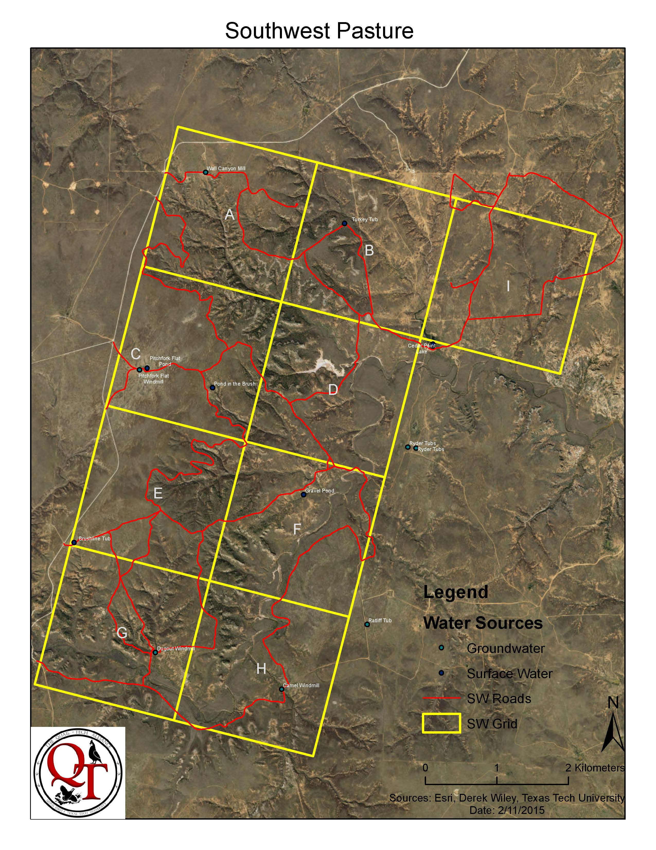

Figure 2.2 Hackberry Pasture Four Sixes Ranch Guthrie, Texas. Rolling Plains.
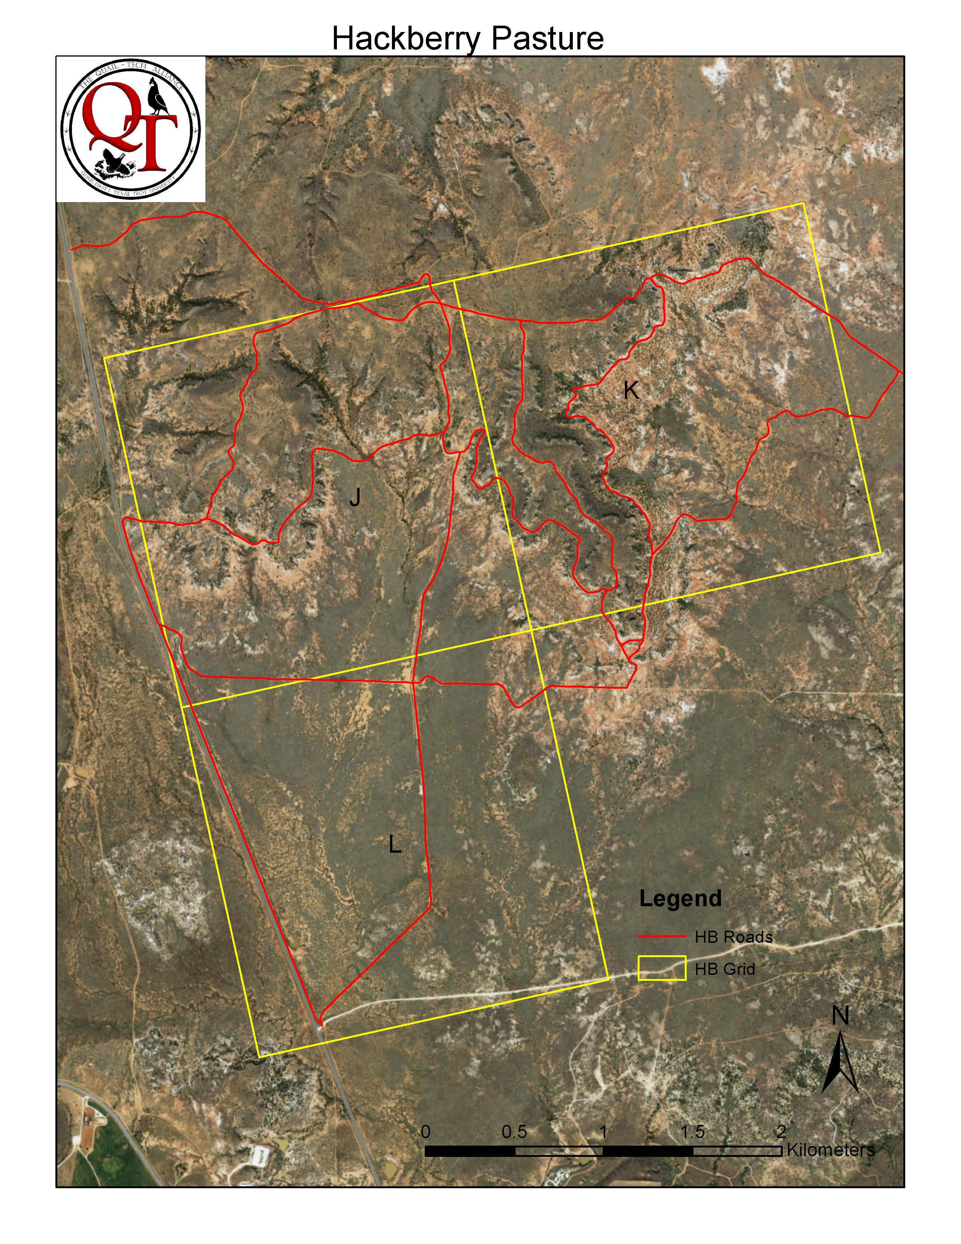

Figure 2.3 Southwest Pasture Four Sixes Ranch Guthrie, Texas treatment layout 2014.
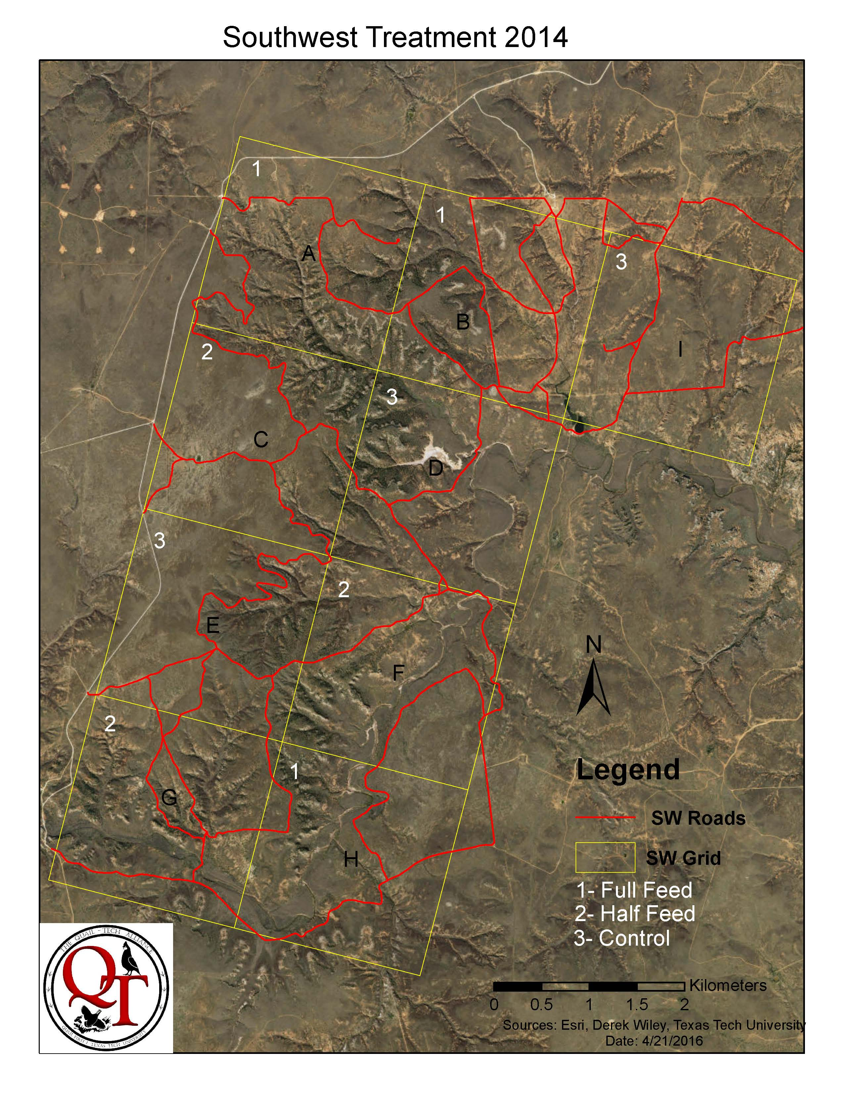

Figure 2.4 Hackberry Pasture Four Sixes Ranch Guthrie, Texas treatment layout 2014.
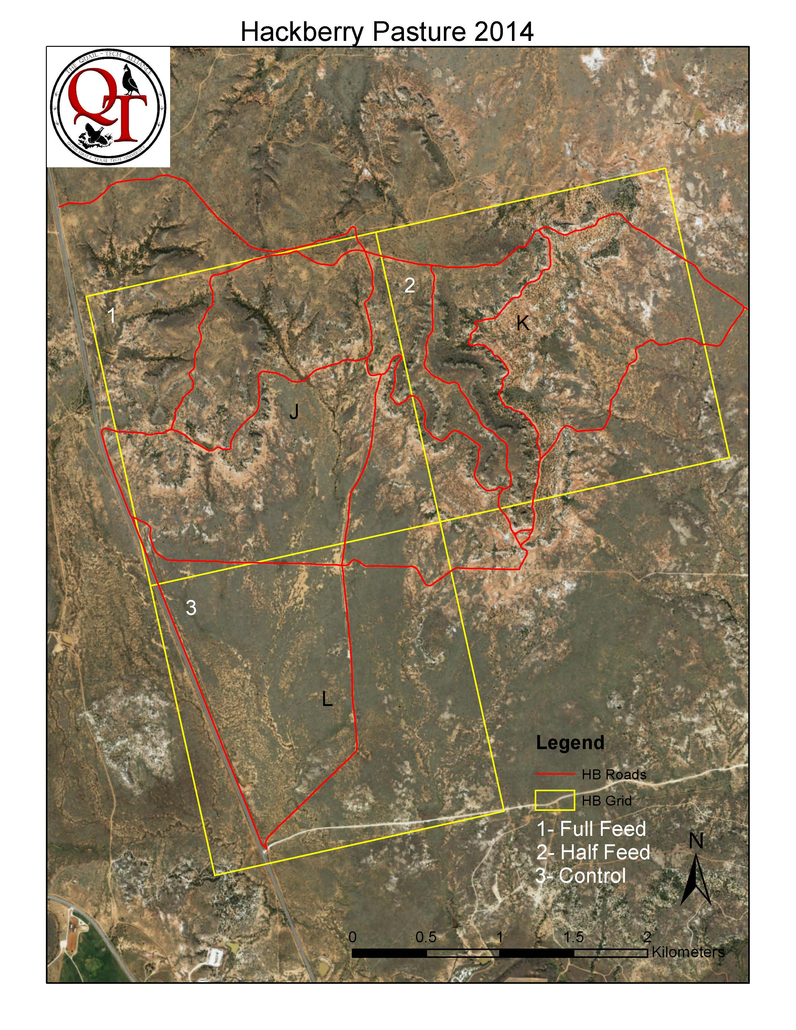

Figure 2.5 Southwest Pasture Four Sixes Ranch Guthrie, Texas treatment layout 2015.
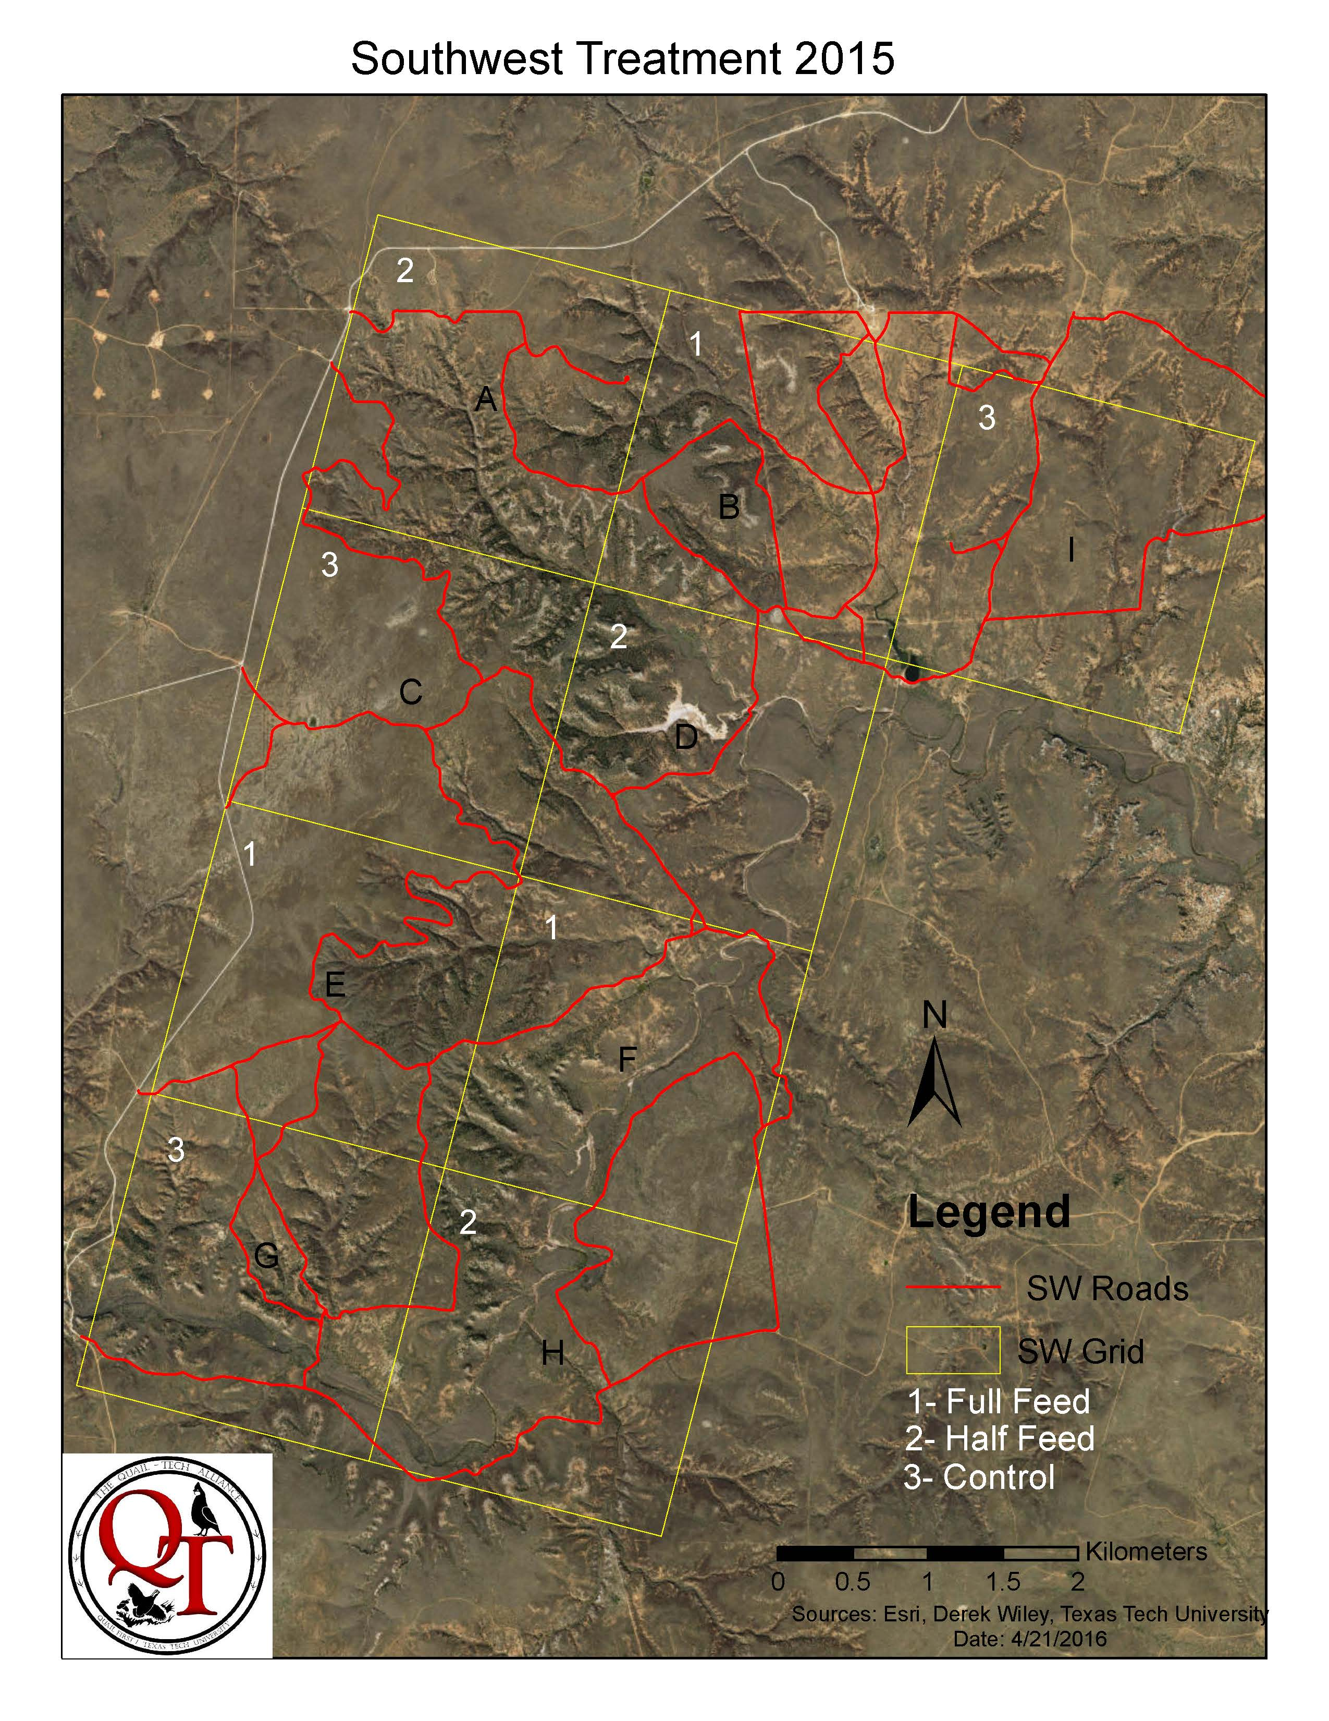

Figure 2.6 Hackberry Pasture Four Sixes Ranch Guthrie, Texas treatment layout 2015.
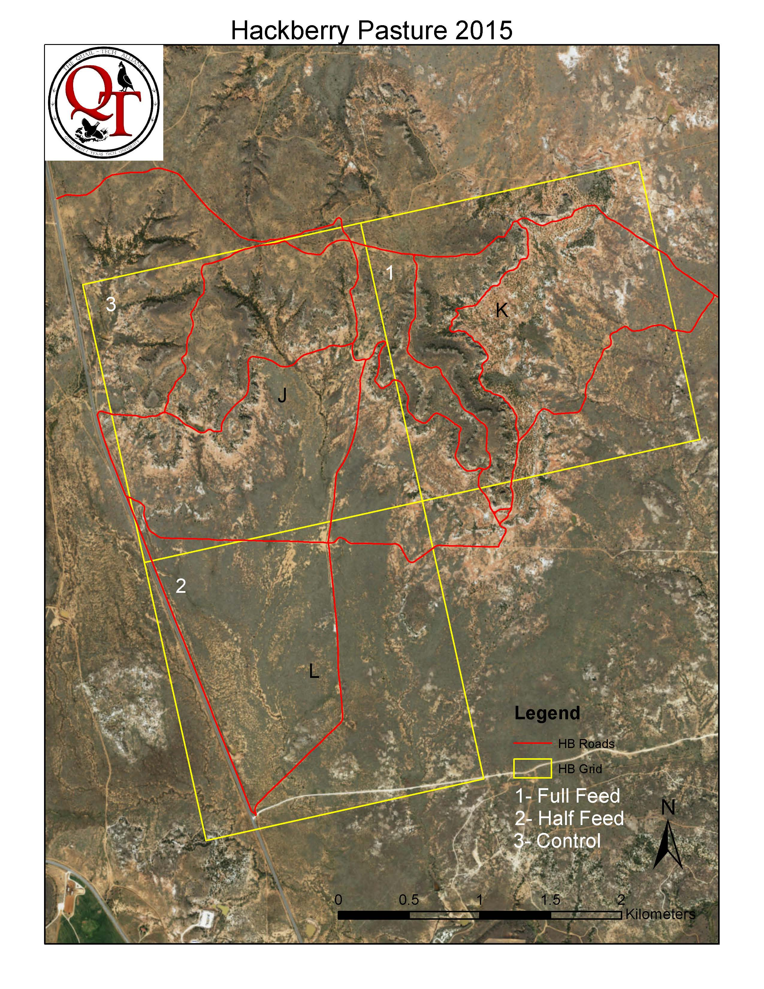

Tables

Table 2.1 Model ranking bobwhite nesting with timing of nest, nest attempt number and treatment.
Model | AICc | ΔAICc | w_{i} | Model Likelihood | k | Deviance
Quadratic Time | 589.55 | 0 | 0.51 | 1 | 3 | 583.54
Quadratic Time+attempt | 591.37 | 1.82 | 0.21 | 0.4 | 4 | 583.35
Quadratic Time+treatment | 591.41 | 1.86 | 0.2 | 0.39 | 4 | 583.39
Quadratic Time+attempt+treatment | 593.23 | 3.86 | 0.08 | 0.16 | 5 | 583.20

Δ= delta
w_{i}= AICc weight
k= number of parameters

Table 2.2 Treatment influence on measured reproductive variables 2014.
 | 2014 | n | SE | 95% Confidence Interval
Full Feed Hens | 28 | *** | *** | ***
# of Nests | 44 | *** | *** | ***
Clutch Size | 12.37 | 38 | 0.344 | 11.70 - 13.04
Egg Volume (millimeters³) | 90.97 | 39 | 1.02 | 88.98 - 92.96
Egg Mass (grams) | 8.91 | 40 | 0.13 | 8.65 - 9.17
# of Renesting Attempts | 19 | *** | *** | ***
Successful Broods | 6 | *** | *** | ***
Nesting Season Length (days) | 132 | *** | *** | ***
Nest Distance to Feed (meters) | 141.92 | 44 | 19.36 | 103.97 - 179.87
Half Feed Hens | 32 | *** | *** | ***
# of Nests | 47 | *** | *** | ***
Clutch Size | 12.18 | 40 | 0.38 | 11.43 - 12.93
Egg Volume (millimeters³) | 89.94 | 39 | 0.93 | 88.12 - 91.76
Egg Mass (grams) | 8.65 | 40 | 0.14 | 8.38 - 8.92
# of Renesting Attempts | 22 | *** | *** | ***
Successful Broods | 9 | *** | *** | ***
Nesting Season Length (days) | 120 | *** | *** | ***
Nest Distance to Feed (meters) | 194.05 | 47 | 19.4 | 156.03 - 232.07
Control Hens | 23 | *** | *** | ***
# of Nests | 45 | *** | *** | ***
Clutch Size | 10.92 | 39 | 0.43 | 10.08 - 11.76
Egg Volume (millimeters³) | 92.13 | 40 | 0.95 | 90.27 - 93.99
Egg Mass (grams) | 8.92 | 40 | 0.13 | 8.66 - 9.18
# of Renesting Attempts | 22 | *** | *** | ***
Successful Broods | 2 | *** | *** | ***
Nesting Season Length (days) | 134 | *** | *** | ***
Nest Distance to Feed (meters) | 165.62 | 40 | 10.95 | 144.16 - 187.08
Total Nests | 136
Total Hens | 83

n= Sample Size, SE= standard error, ***= not applicable

Table 2.3 Treatment Influence on measured reproductive variables 2015.
 | 2015 | n | SE | 95% Confidence Interval
Full Feed Hens | 24 | *** | *** | ***
# of Nests | 27 | 27 | *** | ***
Clutch Size | 14.26 | 23 | 0.59 | 13.10 - 15.42
Egg Volume (millimeters³) | 88.20 | 22 | 1.45 | 85.36 - 91.04
Egg Mass (grams) | 8.66 | 23 | 0.17 | 8.33 - 8.99
# of Renesting Attempts | 7 | *** | *** | ***
Successful Broods | 8 | *** | *** | ***
Nesting Season Length (days) | 119 | *** | *** | ***
Nest Distance to Feed (meters) | 150.06 | 27 | 18.42 | 113.96 - 186.16
Half Feed Hens | 22 | *** | *** | ***
# of Nests | 26 | 26 | *** | ***
Clutch Size | 14.29 | 24 | 0.55 | 13.21 - 15.37
Egg Volume (millimeters³) | 92.06 | 24 | 1.15 | 89.81 - 94.31
Egg Mass (grams) | 8.93 | 24 | 0.13 | 8.67 - 9.19
# of Renesting Attempts | 11 | *** | *** | ***
Successful Broods | 8 | *** | *** | ***
Nesting Season Length (days) | 121 | *** | *** | ***
Nest Distance to Feed (meters) | 157.48 | 26 | 20.31 | 117.67 - 197.29
Control Hens | 21 | *** | *** | ***
# of Nests | 25 | 25 | *** | ***
Clutch Size | 13.61 | 23 | 0.60 | 12.43 - 14.79
Egg Volume (millimeters³) | 89.51 | 23 | 1.08 | 87.39 - 91.63
Egg Mass (grams) | 8.87 | 23 | 0.14 | 8.60 - 9.14
# of Renesting Attempts | 8 | *** | *** | ***
Successful Broods | 10 | *** | *** | ***
Nesting Season Length (days) | 103 | *** | *** | ***
Nest Distance to Feed (meters) | 188.44 | 25 | 24.34 | 140.73 - 236.15
Total Nests | 78
Total Hens | 67

n= Sample Size, SE= Standard error, ***= not applicable

Literature Cited
Arredondo, J., Hernandez, F., Bryant, F., Bingham, R., Howard, R. 2007. Habitat- Suitability bounds for nesting cover of northern bobwhites on semiarid rangelands. Journal of Wildlife Management 71:2592-2599.
Brennan, L. 1991. How can we reverse the northern bobwhite population decline? Wildlife Society Bulletin 19:544-555.
Buckley, B. 2013. Evaluation of distributing supplemental feed into roadside vegetation for northern bobwhite (Colinus virginianus) in the Texas Rolling
Plains ecoregion. Thesis, Texas Tech University, Lubbock, Texas, USA.
Buechner, H. 1950. An evaluation of restocking with pen-reared bobwhite. Journal of Wildlife Management. 14:363-377.
Collins, B., Williams, C., Castelli, P. 2009. Reproduction and microhabitat selection in a sharply declining northern bobwhite population. Wilson Journal of Ornithology 121:688-695.
Daubenmine, R. 1959. A canopy-coverage method of vegetational analysis. Northwest Science 33:43-64.
Dinsmore, S., White, G., Knopf, F. 2002. Advanced techniques for modeling avian nest survival. Ecology 83: 3476-3488.
Giuliano, W., Lutz, S., Patino, R. 1996. Reproductive responses of adult female northern bobwhite and scaled quail to nutritional stress. Journal of Wildlife Management 60:302-309.
Guthery, F., Hiller, T., Puckett, W., Baker, R., Smith, S., Rybak, A. 2004. Effects of feeders on dispersion and mortality of bobwhites. Wildlife Society Bulletin 32:1248-1254.
Haines, A., Hernandez, F., Henke, S., and Bingham, R. 2004. Effects of road baiting on home range and survival of northern bobwhites in southern Texas. Wildlife Society Bulletin 32:401-411.
Hanson, H. 1954. Criteria of age of incubated mallard, wood duck, and bob-white quail eggs. Auk 71:267-272.
McLaughlin, John. 2016.
Micheal, V., Beckwith, S. 1955. Quail preference for seed of farm crops. Journal of Wildlife Management 19:281-296.
Parsons, J. 1970. Relationship between egg size and post-hatching chick mortality in the herring gull (Larus argentatus). Nature 228:1221-1222.
Rader, M., Brennan, L., Hernandez, F., Silvy, N., and Wu, B. 2007. Nest-site selection and nest survival of northern bobwhite in southern Texas. Wilson Journal of Ornithology 119:392-399.
Ressel, D. Soil survey of King County, Texas. United States department of Agriculture, Natural Resources Conservation Service.
Robel, R., Briggs, J., Dayton, A., Hulbert, L. 1970. Relationships between visual obstruction measurements and weight of grassland vegetation. Journal of Range Management 23:295-297.
Roseberry, J., Ellsworth, D., Klimstra, W. 1987. Comparative post- release behavior and survival of wild, semi-wild, and game farm bobwhites. Wildlife Society Bulletin 15:449-455.
Rotella, Ray. 2012. MARK book.
Sauer, J., Hines, J., Fallon, J. 2014. The North American breeding bird survey,
results and analysis 1966-2007, version 5.15.2008. U.S. Geological Suvey, Patuxent Wildlife Research Center, Laurel, Maryland, USA.
Scott, J., Hernandez, F., Brennan, L., Ballard, B., Janis, M., and Forrester, D. 2013. Population demographics of translocated northern bobwhites on fragmented habitat. Wildlife Society Bulletin 37:168-176.
Tall Timbers. 2011. Quail research report. Quail Call 1:1-16.
Taylor, S., Church, K., Rusch, D. 1999. Microhabitat selection by nesting and brood- rearing northern bobwhite in Kansas. Journal of Wildlife Management 3:686-694.
US Climate Data.
Westerkov, K. 1950. Methods for determining the age of game bird eggs. Journal of
Wildlife Mangement 14:55-67.
White, G., Burnham, K. 1999. Program MARK: survival estimation from populations of marked animals. Bird Study 46 Supplement, 120-138.
Wilkins, N., Brown, R., Conner, R., Engle, J., Gilliland, C., Hays, A., Slack, R., Steinbach, D. 2000. Fragmented lands: changing land ownership in Texas. Texas Cooperative Extension Publication MKT 3443, College Station, Texas, USA.

Chapter III

Vegetation and Temperature Impacts on Bobwhite Nesting
Abstract: Northern bobwhite, Colinus virginianus, have been declining across their range. The optimum vegetative characteristics for the Rolling Plains of Texas have never been adequately quantified. We attempt to accurately quantify vegetative characteristics that promote nest success. We evaluated 214 nests during two years (2014, 2015) of research to determine a threshold in vegetative structure at a nest and around a nest that increased nest success. Bobwhites selected nesting substrates at least .40 m in height across both years. However, we found that when a habitat patch within 200 m of a nest averaged ~.40 m in height brood success increased 20%. We determined that islands of suitable vegetative cover were not as successful as homogenous vegetative cover. Managing for the proper vegetative structure is crucial for successful bobwhite reproduction. Finally we monitored temperature at nest sites using three sensor, an in nest sensor, beside the nest sensor and a random sensor. Nests remained cooler than random locations and no nest ever reached a lethal threshold for embryos.

Introduction
Northern bobwhite, hereafter bobwhite, has been declining across their range. Several factors have been attributed to this decline such as habitat fragmentation, degredation, and loss, as well as drought (Brennan 1991). In an effort to better understand this decline over the years, bobwhites have become one of the most studied gamebirds in North America (Brennan 1991). Despite this intense focus, there are still significant questions concerning what constitutes optimal bobwhite habitat. More specifically, at what point do we see reductions in bobwhite population demographics such as nest success when habitat components are degraded? Managers must use land for multiple purposes. They need specific prescriptions for bobwhite habitat so that they can make decisions and adjustments to land use when that use conflicts with bobwhite habitat management.
Most usable space for bobwhites in the Rolling Plains of Texas is also suitable grazing land (Rollins 2007). Consequently, abuse of these rangelands can have a significant influence on bobwhite habitat and population growth. Herbaceous vegetation provides bobwhites with thermal protection, obstruction from predators, nesting substrates, and brood rearing structure (Townsend et al. 2001). Improper grazing practices can cause an excessive amount of herbaceous vegetation to be removed. What is unclear is at what herbaceous vegetation height threshold does the probability of depredation of bobwhites and their nests start to increase. An answer to this question would provide grazing managers a target for maintaining vegetation height for bobwhites on grazing lands.
Vegetation height is a key component governing bird use of an area. Martin and Possingham (2005) used vegetation height to predict bird use of areas grazed by livestock. Dabbert and Abercrombie (2009) suggested that correlations between bobwhite whistle counts in the High Plains of Texas and vegetation height indicated that herbaceous vegetation height needed to be at least 40 cm tall for suitable bobwhite habitat. Similar data are not available for the Rolling Plains of Texas. Vegetation height prescriptions would best be made based upon influences on nest success, because stationary nests are more vulnerable to depredation than adults and nest success is a key component of bobwhite population growth (Sandercock et al. 2008).
Bobwhite nests have been evaluated since the 1940s (Lehman 1946). Studies have described the type and size of bobwhite nests, clutch sizes, hatch rates, and brood success (Klimstra and Roseberry 1975). There are few studies, however, that have successfully identified habitat characteristics, such as vegetation height, that govern nest success (Lusk et al. 2006). Bobwhites nest in a variety of substrates, but native bunchgrasses, such as little bluestem (Schizachrium scoparium) and sideoats grama (Bouteloua curtipendula), have long been judged to be the preferred nesting substrate for bobwhite hens (Lehman 1946). In the Rolling Plains, the most common nesting substrate is little bluestem (Rollins 2007). It is likely that characteristics of the nest site such as nesting substrate type, height, and density govern nest success. Additionally, characteristics of the habitat patch within which a nest resides may be equally important (Fletcher and Koford 2002). For instance, small island patches of suitable vegetation for nest sites may be easily searched by predators, as compared to large patches of suitable vegetation which may decrease the search efficiency of predators. In wild turkeys (Meleagris gallopavo), Lehman et al. (2008) concluded that the visual obstruction of large patches of habitat dictated nest success more than the individual nest site quality. However, Fuller et al. (2013) concluded that characteristics at the individual nest site influenced nest success more than the characteristics of the habitat patch. Information concerning nest site and habitat patch characteristics that increase the likelihood of nest success of bobwhites in the Rolling Plains of Texas is not available.
Assuming nest site quality influences bobwhite nest survival the most, then the ability of bobwhite hens to select quality nest sites is of paramount importance. Rader et al. (2007) reported that bobwhites selected nests with greater visual obstruction (3.50 dm. vs. 2.60 dm.), increased vegetation height (64 cm. vs. 47 cm.) and less bare ground (11% vs. 25%) than what was randomly available. They concluded, however, that nest predation was a random event independent of nest site characteristics. Lusk et al. (2006) reported that bobwhites selected nest sites with vegetation heights exceeding 40 cm and shrub cover greater than 25%, but could not differentiate between successful and unsuccessful nests using nest site characteristics. Thus, there is significant evidence that bobwhites select nest sites for specific habitat characteristics, but little evidence this selection helps them avoid nest depredation.
Besides avoiding nest depredation, nest site selection may be beneficial for protecting the incubating hen and her developing embryos from lethal ground temperatures that can occur during the breeding season in the Rolling Plains of Texas. Bare ground temperatures without shading vegetative canopy can regularly exceed 57 degrees Celsius during summer. When temperature reaches ~39 degrees Celsius, thermal stress in adult bobwhites occurs (Guthery et al. 2001). Temperatures above 39 degrees Celsius are lethal for bobwhite embryos (Reyna and Burggren 2012). Consequently, it is imperative that bobwhites select nest sites that will protect their developing embryos from thermal damage. It is intuitive that nest sites that are generally shaded by vegetation will be cooler than bare ground, but differences between the ability of randomly available vegetation sites and nest sites selected by bobwhites to provide a cooler microclimate than bare ground have not been evaluated. Therefore, my objective was to evaluate the ability of hens to select nest sites by comparing the vegetative and thermal characteristics of nest sites to random sites available in the habitat patch. Additionally, I tested the influence of the vegetative and thermal characteristics of nest sites as well as the average vegetative and thermal characteristics of habitat patches on the survival rate of nests.

Study Site
This study was conducted in King County Texas on the Four Sixes ranch in Guthrie, TX. The Southwest and Hackberry Pastures were the primary areas used. Pastures were all rangeland utilized for grazing by cattle, and is primarily a cow-calf operation. The approximate stocking rate for both pastures is 20.23 hectares/animal unit. Fully stocked the Southwest Pasture contains ~ 220 animal units. Average annual temperature is 16.72 degrees Celsius (U.S. Climate Data). Annual precipitation is 64.9 cm with 8 cm being snowfall (U.S. Climate Data). Much of the total precipitation falls in late spring or early summer. Soils of the area are loam, fine sandy loam, very fine sandy loam with level to steep slopes (Ressel 1997). Dominant vegetation includes blue grama (Bouteloua gracilis), little bluestem (Schizachyrium scoparium var. frequens), sand dropseed (Sporobolus cryptandrus), sideoats grama (Bouteloua curtipendula), silver bluestem (Bothriocloa laguroides), tobosa (Hilaria mutica), broom snakeweed (Gutierrezia sarothrae), honey mesqutite (Prosopis glandulosa), pricklypear (Opuntia spp.), red berry juniper (Juniperus pinchotii), sand plum (Prunus augustifolia), sand sagebrush (Artemisia filifolia), yucca (Yucca glauca), common broomweed (Amphiachyris dracunculoides), sagewort (Artemesia ludoviciana), and western ragweed (Ambrosia psilostachya).

Study Design
I evaluated the ability of radiomarked hens to select nest sites by comparing the vegetative and thermal characteristics of nest sites to random sites available in the habitat patch. Additionally, I tested the influence of the vegetative and thermal characteristics of nest sites as well as the average vegetative and thermal characteristics of habitat patches on the survival rate of nests. I did not construct the study to ensure there were equal numbers of nests of each vegetation type, but used nests as they became available. I placed sensors at every nest possible. I did not evaluate this based on feeding treatment due to feeding treatment having no impact on nest success, based on previous research by Buckley (2013) and Wiley (2017). I also used an experiment to test for differences between random vegetation and nest sites to evaluate what bobwhites in the Rolling Plains selected for.

Capture and Nest Detection
Bobwhite hens were trapped beginning on October 15th and ending March 31st during 2014 and 2015. Bobwhites were trapped along the same roads that were fed by the wildlife manager (Chapter 2). Bobwhites captured with a mass ≥150 were fitted with a necklace style radio transmitter weighing approximately 7 grams (American Wildlife Enterprises, Monticello, FL). Hens were located once per week from October 15th to March 31st each year. Following March 31st, hens were tracked 2-3 times per week to facilitate early nest detection (Rader et al. 2007). When hens repeatedly used the same location that appeared to be suitable nest habitat, I circled the area to pinpoint the hen location within a square meter area and searched for a nest when the hen was absent (Buckley 2013). The geographic location of the nest was recorded using a Garmin eTrex 20 GPS unit (Garmin, Olathe, Kansas).

Temperature Sensors
I used HOBO (Onset, Bourne, Massachusetts) model number UTBI-001 for the in nest monitoring and a UA-002-08 sensor for the temperature beside the nest. A second UA-002-08 sensor was placed 5m from the nest to record temperature in a random direction, determined by spinning a pencil. This design was chosen to monitor differences in nest site and the microclimate around the nest.

Methods
Sensors were placed in the nest and beside the nest to monitor lumens and temperature. A HOBO model UTBI-001 sensor that logs temperature in degrees Celsius every 15 minutes was placed in the nest (A). This sensor was wrapped in camouflage Gorilla Tape (Gorilla Glue, Cincinnati, Ohio) and placed in a small depression created in the bottom of the nest to reduce the chance of nesting hens kicking the sensor out of the nest. The tape did not have a significant impact on temperature sensing ability of the device. Eggs were placed over the sensor and the nest was left alone for the hen to return and continue incubation. A second HOBO model UA-002-08 sensor was placed beside the nest to measure lumens and temperature every 15 minutes (B). This sensor was also wrapped in Gorilla Tape to conceal it from predators. A second HOBO model UA-002-08 sensor was placed 5 meters away in a random direction (C), determined by spinning a pencil. This sensor was placed in an open area to capture all available light, not placed in a shaded area. The top of the light intensity sensor was not covered to allow light to pass through. The blinking light of the sensor was covered from inside the sensor to reduce visibility by bobwhites or predators. Temperature and lumen recordings were taken every 15 minutes.
When a nest either hatched, was depredated, or abandoned, vegetative characteristics of the nest site were evaluated using a 1m² Daubenmire frame and Robel poles (Robel 1970). Percentages of grass, litter, bare ground, forbs, and woody material were estimated to the nearest 5% (Daubenmire 1959). If a percentage was <5% it was given a rating <5% and the vegetation with the largest amount was adjusted to fit the 100% scale (Daubenmire 1959). Robel poles, with 10 decimeter divisions equaling 1m in length, were used to determine vegetation height over the nest bowl. If a division on the pole was ≥50% obstructed it was considered covered (Robel 1970).
All of these vegetation measurements were repeated at 4 random locations around each nest. Random points were chosen from each of the 4 cardinal directions, N, E, S and W. The distance from the nest bowl for the point in each of the 4 cardinal directions was determined by a random number chart split into 25m increments. The nearest distance to the nest bowl allowed was 25m and 200m was the farthest distance from the nest allowed. The vegetation characteristics of the 4 random plots were averaged to provide an assessment of the habitat characteristics available in the habitat patch surrounding a nest.

Statistical Analysis
To determine the variable with the largest impact on nest success, nests were evaluated in program MARK (White and Burnham 1999) using the logit-link function in the nest survival model (Dinsmore et al. 2002). My data met the assumptions of this model based on the use of radio telemetry to track hens, and locate nests. When the hen was located at the same spot for two consecutive telemetry locations the hen was considered to be incubating and a nesting attempt begun. The date of incubation was considered (i), the last location date before nest hatched or failed as (j), and the date of nest hatch or failure as the last day the nest was checked as (k) (Dinsmore et al. 2002). Nests were active from April 13 – August 31 resulting in 140 estimates of daily nest survival. I used the mean incubation period of 24 days to estimate survival across nest incubation (Rotella 2012, Buckley 2013).
There were 14 variables that were chosen a-priori to be included in analysis: robel, temperature, bare ground, forb, grass, litter, wood, random robel, random bare ground, random forb, random grass, random litter, and random wood. Except for temperature these were all vegetative, or habitat characteristics to be used to evaluate nest success in relation to habitat. Temperature was included to determine if higher or lower temperature influenced nest success.
Vegetation measurements were also analyzed in SPSS (IBM corporation, Armonk, New York) with one-way ANOVA to determine if there was a difference among nest site versus random sites, nest sites in relation to year, and random sites in relation to year. Temperature was evaluated using SPSS in the same manner.

Results
I radiomarked a total of 350 bobwhite hens, 198 during 2013/2014 and 152 during 2014/2015. There were 83 hens alive as of April 1 2014 that produced 136 nest attempts. There were 67 hens alive as of April 1 2015 that produced 78 nest attempts. Five models from the MARK analysis of these 214 nests showed the greatest support. The variables included in the top models were: robel, random robel, grass, random grass, and temperature. The top three models had an AICc value <2 and the other two models were <4. The top five models were averaged to derive the final model equation: logit y= 0.97 (intercept) + 0.02 (linear function) - 0.0001 (quadratic function) + 1.51 (robel) + .00005 (temperature) + 1.26 (grass) + 1.33 (random robel) + 0.06 (random grass) - 0.03 (treatment) (Table 3.1). During 2014 daily survival rate or DSR was .96, during 2015 DSR was .97.
Nest robel cover height at nest sites was 10 cm greater than mean robel cover height at random sites in 2014 for both successful and unsuccessful nests (n=118, Df: 117, p = < 0.001), (n = 154, Df = 153, p = < 0.001) (Figures 3.1 and 3.2). Nest robel cover height was not different between successful and unsuccessful nests in 2014 (p=136, Df=135, p=0.396). Nest robel cover was not different from random sites at either successful or unsuccessful nests during 2015 (n=78, Df= 77, p=0.127) (Figures 3.3 - 3.4). Random robel cover height of the area surrounding nests was 7 cm greater for successful as compared to unsuccessful nests when both years are combined (n=214, Df=213, p=0.011) (Figure 3.5). Nest robel heights of all nests was not different between years (n=214, Df: 213, p=0.078) (Figure 3.6) (Table 3.2). Nest sites had greater grass cover (n=214, Df: 213, p= <.001), less bare ground (n=214, Df: 213, p=<.001), and less forb cover (n=214, Df: 213, p=0.01) than the randomly available vegetation.
Temperature was measured in three different locations around and in nests. Temperature was analyzed for differences among in nest sensors, beside nest sensors and random point sensors. In both years, sensor B was lower than A or C (Figures 3.7 and 3.8). There were no differences between sensor A and C. There were no differences between years for temperature on any of the sensors (Figures 3.9, 3.10, 3.11) (Table 3.4).

Discussion
My data represent some of the first specific habitat recommendations available for bobwhite nesting habitat that are validated with demographic data that show an improved outcome. My data support the hypothesis that bobwhites select nest sites for increased vegetative cover height and density. This finding is intuitive and consistent with other studies of bobwhite nest site selection (Townsend et al. 2001, Hernandez et al. 2003, Lusk et al. 2006, Rader et al. 2007). The vegetation height at nests was relatively stable between years ranging from 42-45 cm even though average available vegetation height was significantly shorter during 2014. This vegetation height at the nest is remarkably consistent with nest site selection descriptions from other studies. Klimstra and Roseberry (1975) reported a mean nest substrate height of 49 cm in Illinois. Lusk et al. (2006) in Oklahoma indicated a threshold for suitable nest sites was a vegetation height >40 cm. Average bobwhite nest substrate height in southern Texas was 64 cm with an average available vegetation height of 47 cm (Rader et al. 2006). Taken as a whole these data indicate that bobwhites select for nest vegetation height of at least 40 cm. Similar to Rader et al. (2007) my data indicated that bobwhites selected for greater grass cover and less bare ground than what was randomly available for nest sites. In addition, I also found reduced forb cover at nest sites. However, that means that in the random area around nest sites (200 m buffer) there was increased forb presence, key for brood survival and success. During the 2015 breeding season particularly there was increased forb production, likely linked to the increased brood survival observed.
Previous comparisons of successful and depredated nests have been unable to differentiate nest fate based upon nest site and habitat patch characteristics (Lusk et al. 2006, Rader et al. 2006). Lusk et al. (2006) suggested that successful nests had better visual obstruction than depredated nests, but could not validate this assertion with analysis. Rader et al. (2006) modeled bobwhite nest survival and nest site habitat and thermal characteristics, but detected no influence of habitat characteristics on nest fate. They suggested that predation was a random event not governed by attributes associated with habitat characteristics. In contrast, my models indicated that visual obstruction at the nest site and of the overall habitat patch were important regulators of nest survival rate. Consideration of the models and differences in habitat structure between surviving and depredated nests indicates that visual obstruction at the nest site most influenced nest survival during 2014 when nest survival was relatively lower as compared to 2015. Overall vegetation height appeared to be the most important influence during 2015 when nest survival rate was greater than during 2014. Large patches of contiguous nesting habitat with a vegetation height > 40 cm provide bobwhite nests better protection from nest predators than smaller patches. But, in the case where smaller patches were available in my study, more visual obstruction at the nest site itself resulted in improved nest success. More isolated patches of suitable nesting cover during 2014 was likely due to less rainfall than 2015. The increased rainfall of 2015 provided optimum nesting conditions with homogenous vegetation height to decrease predator efficiency.
The factors governing nest success of bobwhites are complex and include both the influences of nest sites as well as the influence of predator species and density (Arredondo et al. 2007, Rollins and Carroll 2001). I did not monitor possible changes in predator density on my study area which could influence my results concerning changes in nest success between years. However, the increased rainfall and corresponding increases in overall vegetation height that accompanied increased nest success suggest that improvements in habitat quality played a significant role in the improved demographics that I measured.
My models indicate that temperature, in mild to average conditions for the Rolling Plains, does not significantly influence bobwhite nest success. It is intuitive that the vegetation that bobwhites select to hide their nests provides a shading effect that causes nest temperatures to remain below those of bare ground exposed directly to the sun. Temperatures of the shaded nest substrate in my study remained well below the temperature of bare ground outside the nest. No nests approached a lethal temperature for bobwhite embryos and I did not find any nests where embryos were killed by excessive nest temperature. In fact, nest interior temperatures corresponded with the body temperature of the incubating hen. Rader et al. (2006) reported that their models suggested that mean maximum nest temperature was 0.6 degrees Celsius lower for depredated nests as compared to successful nests, but could not identify a biological basis for this relationship. I suggest that increasing temperature during the bobwhite reproductive season is correlated with increasing rate of plant growth. Thus, evaluation of the influence of temperature on depredation rate of nests as an independent metric may be somewhat confounded by the effects of temperature on habitat quality.

Management Implications
My data provide bobwhite managers with specific targets for vegetation height that are tied to improved bobwhite demographics. Managers should maintain large habitat patches at > 40 cm in height. Conceding that variations in nest predator density will influence the range of impacts that changes in vegetation height can have, managers should expect to suffer an increased rate of nest depredation when vegetation height falls below 40 cm. A 20% change in nest success can have a significant impact on bobwhite populations. Combined with the vegetation height influence of brood success identified in chapter 2, vegetation height can be the limiting factor for bobwhite population growth in the Rolling Plains of Texas.

Tables

Table 3.1. Model ranking northern bobwhite nesting models 2014-2015.
Model | ΔAIC_{c}ª | W_{i} | Model Likelihood | K | Deviance
Robel+Temp+Grass+Rrobel | 0.00 | 0.42 | 1.00 | 7.00 | 561.21
Robel+Temp+Grass+Rrobel+Treatment | 1.52 | 0.20 | 0.47 | 8.00 | 560.72
Robel+Temp+Grass+Rrobel+Rgrass | 1.92 | 0.16 | 0.38 | 8.00 | 561.12
Robel+Temp+Grass | 2.39 | 0.13 | 0.30 | 6.00 | 565.61
Robel+Temp+Grass+Rrobel+Rgrass+Treatment | 3.43 | 0.08 | 0.18 | 9.00 | 560.61

ªLowest AIC_{c} value = 560.61, ΔAIC_{c}= differences in AIC_{c}, w_{i}= model weights, K= number of parameters

Table 3.2 Robel measurements of successful and unsuccessful nests from 2014 in meters.
 | 2014 | n | SE | 95% Confidence Interval
Successful Nest Robel Height | 0.42 | 59 | 0.02 | 0.38 - 0.46
Successful Random Robel Height | 0.3 | 59 | 0.02 | 0.26 - 0.34
Unsuccessful Robel Height | 0.39 | 77 | 0.02 | 0.35 - 0.43
Unsuccessful Random Robel Height | 0.29 | 77 | 0.01 | 0.27 - 0.31

Table 3.3 Robel measurements of successful and unsuccessful nests from 2015 in meters.
 | 2015 | n | SE | 95 % Confidence Interval
Successful Nest Robel Height | 0.47 | 47 | 0.02 | 0.43 - 0.51
Successful Random Robel Height | 0.43 | 47 | 0.02 | 0.39 - 0.47
Unsuccessful Robel Height | 0.42 | 31 | 0.03 | 0.36 - 0.48
Unsuccessful Random Robel Height | 0.37 | 31 | 0.02 | 0.33 - 0.41

Table 3.4 Temperature Sensor Analysis from 2014 and 2015.
 | 2014 | n | SE | 2015 | n | SE
In Nest Sensors | 31.29 | 60 | 0.27 | 31.53 | 48 | 0.44
Beside Nest Sensors | 27.21 | 69 | 0.32 | 28.29 | 40 | 0.62
Random Sensors | 30.78 | 70 | 0.37 | 32.14 | 19 | 1.12

Table 3.5 2014 Vegetation characteristics, nest bowl and random points.
 |  | Nest |  |  | Random
2014 | n | Mean | 95% C.I. | S.E. | Mean | 95% C.I. | S.E. | p-value
Bare Ground | 136 | 5.6 | 3.80 - 7.42 | 0.92 | 28.05 | 26.25 - 29.86 | 0.92 | <.001
Forb | 136 | 7.55 | 5.73 - 9.37 | 0.93 | 10.11 | 8.29 - 11.94 | 0.93 | 0.001
Grass | 136 | 60.76 | 57.66 - 63.85 | 1.58 | 49.39 | 46.28 - 52.49 | 1.58 | 0.003
Litter | 136 | 10.31 | 8.34 - 12.28 | 1 | 8.41 | 6.44 - 10.37 | 1 | 0.039
Woody | 136 | 17.48 | 14.99 - 19.96 | 1.27 | 6.03 | 3.55 - 8.52 | 1.27 | 0.029

Table 3.6 2015 Vegetation characteristics, nest bowl and random points.
 |  | Nest |  |  | Random
2015 | n | Mean | 95% C.I. | S.E. | Mean | 95% C.I. | S.E. | p-value
Bare Ground | 78 | 7.69 | 5.31 - 10.08 | 1.22 | 17.84 | 15.46 - 20.23 | 1.22 | <.001
Forb | 78 | 13.28 | 10.87 - 15.69 | 1.23 | 16.48 | 14.07 - 18.89 | 1.23 | <.001
Grass | 78 | 52.54 | 48.44 - 56.63 | 2.09 | 45.87 | 41.77 - 49.97 | 2.09 | <.001
Litter | 78 | 16.15 | 13.56 - 18.75 | 1.32 | 13.47 | 10.87 - 16.06 | 1.32 | 0.039
Woody | 78 | 11.23 | 7.95 - 14.51 | 1.67 | 7.31 | 4.03 - 10.59 | 1.67 | 0.779

Figures

Figure 3.1 Robel cover heights in meters of successful nests and an average of cover heights from 4 random points around the nests (2014).
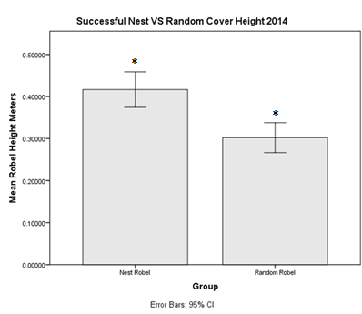

Figure 3.2 Robel cover heights in meters of unsuccessful nests and an average of cover heights from 4 random points around the nest (2014).
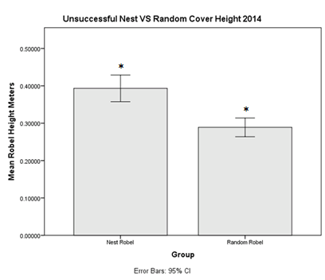

Figure 3.3 Robel cover heights in meters of successful nests and an average of cover heights from 4 random points around the nests (2015).
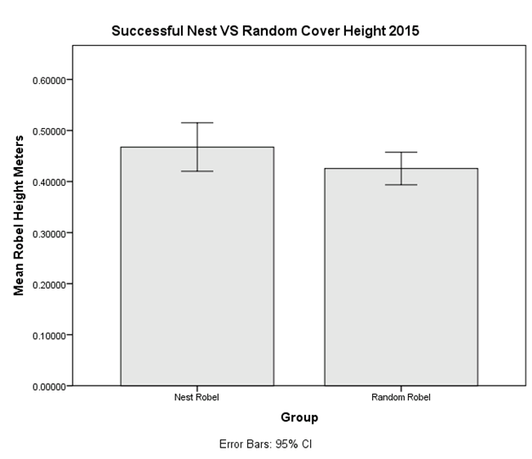

Figure 3.4 Robel cover heights in meters of unsuccessful nests and an average of cover heights from 4 random points around the nest (2015).
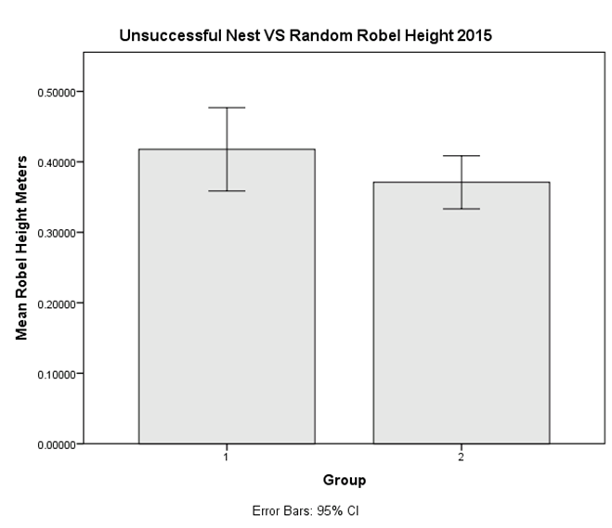

Figure 3.5 Average of random robel cover heights in meters from 2014 and 2015.
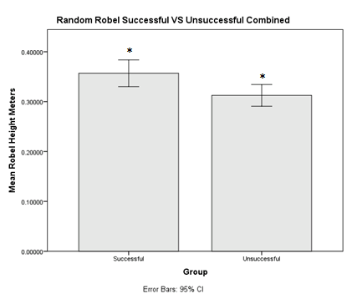

Figure 3.6 Nest robel cover heights in meters from 2014 and 2015.
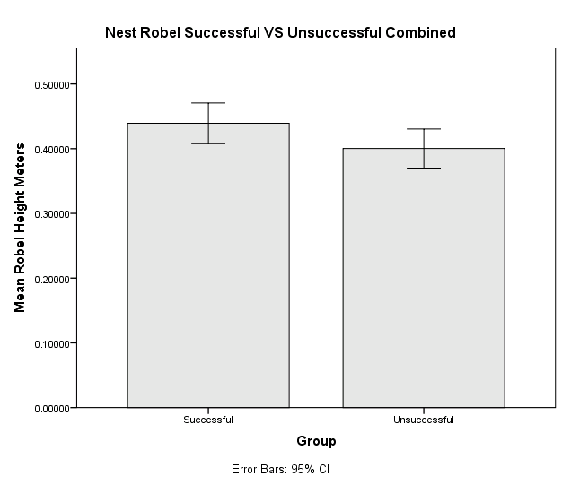

Figure 3.7 Average temperature (Celsius) from the three nest sensors placed at each nest site 2014.
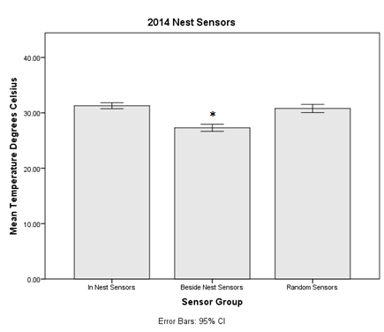

Figure 3.8 Average temperature (Celsius) from the three nest sensors placed at each nest site 2014.
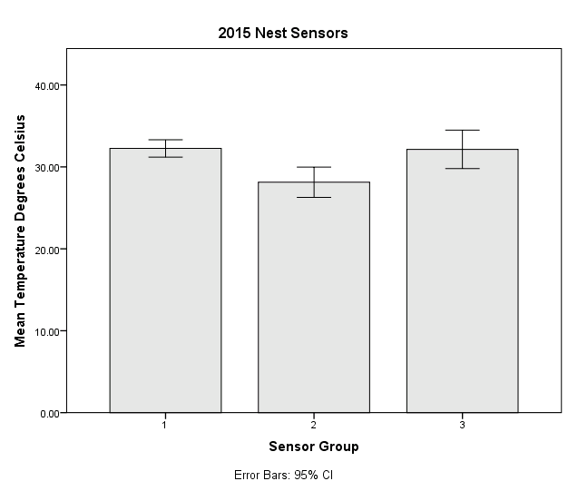

Figure 3.9 Comparing the random point temperature (Celsius) from nest locations in 2014 and 2015.
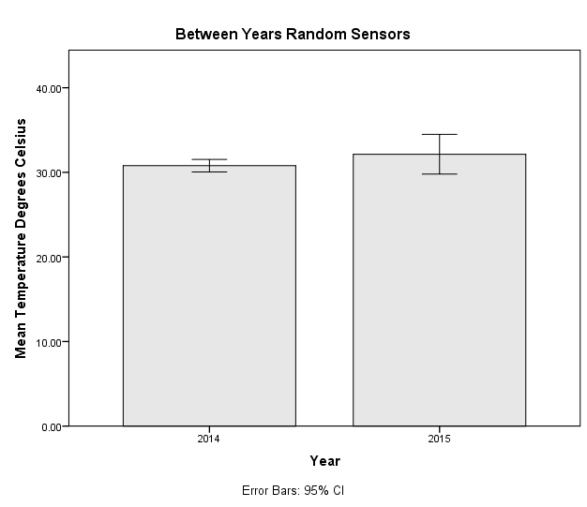

Figure 3.10 Comparing the beside nest sensor average temperature (Celsius) from nest locations in 2014 and 2015.
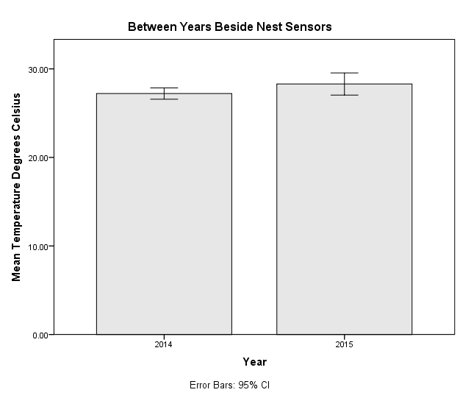

Figure 3.11 Comparing the average temperature (Celsius) of the in nest sensors from 2014 and 2015.
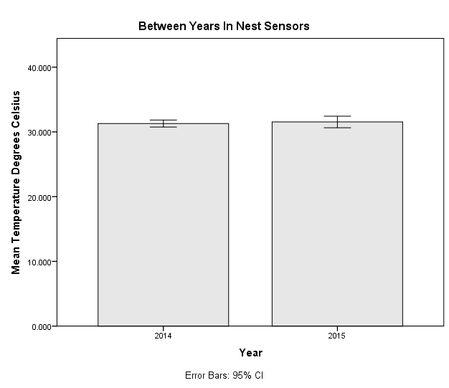

Literature Cited
Arredondo, J., Hernandez, F., Bryant, F., Bingham, R., Howard, R. 2007. Habitat- Suitability bounds for nesting cover of northern bobwhites on semiarid rangelands. Journal of Wildlife Management 71:2592-2599.
Brennan, L. 1991. How can we reverse the northern bobwhite population decline? Wildlife Society Bulletin 19:544-555.
Buckley, B. 2013. Evaluation of distributing supplemental feed into roadside vegetation for northern bobwhite (Colinus virginianus) in the Texas Rolling Plains ecoregion. Thesis, Texas Tech University, Lubbock, Texas, USA.
Dabbert, C., Abercrombie, E. 2009. Bobwhite response to Environmental Quality Incentives Program (EQIP) Practices in the High Plains Ecological region of Texas. In Burger, Jr., L. W. and K. O. Evans, eds. Managing Working Lands for Bobwhite Quail: The USDA-NRCS Bobwhite Restoration Project. USDA-NRCS.
Daubenmine, R. 1959. A canopy-coverage method of vegetational analysis. Northwest Science 33:43-64.
Dinsmore, S., White, G., Knopf, F. 2002. Advanced techniques for modeling avian nest survival. Ecology 83: 3476-3488.
Fletcher, R., Koford, R. 2002. Habitat and landscape associations of breeding birds in native and restored grasslands. Journal of Wildlife Management 66:1011-1022.
Fuller, A., Spohr, S., Harrison, D., Servello, F. 2013. Nest survival of wild turkeys Meleagris gallopavo silvestris in a mixed-use landscape: influences at nest site and patch scales. Wildlife Biology 19:138–146
Lehman, V. 1946. Mobility of bobwhite quail in southwestern Texas. Journal of Wildlife Management 10:124-136.
Guthery, F., Land, C., Hall B. 2001. Heat loads on reproducing bobwhites in the semiarid subtropics. Journal of Wildlife Management 65:111-117.
Klimstra, W., Roseberry, J. 1975. Nesting ecology of the bobwhite in Southern Illinios. Wildlife Monographs 3-37.
Lehman C., Rumble M., Flake L., Thompson, D. 2008. Merriam’s turkey nest survival and factors affecting nest predation by mammals. Journal Wildlife Management 72:1765–1774
Lusk, J., Smith, S., Fuhlendorf, S., Guthery, F. 2006. Factors influencing northern bobwhite nest-site selection and fate. Journal of Wildlife Management 70:564-571.
Martin, T., Possingham, H. 2005. Predicting the impact of livestock grazing on birds using foraging height data. Journal of Animal Ecology 42:400-408.
Rader, M., Brennan, L., Hernandez, F., Silvy, N., Wu, B. 2007. Nest-site selection and nest survival of northern bobwhite in southern Texas. Wilson Journal of Ornithology 119:392-399.
Ressel, D. Soil survey of King County, Texas. United States department of Agriculture, Natural Resources Conservation Service.
Reyna, K., Burggren, W. 2012. Upper lethal temperatures of northern bobwhite embryos and the thermal properties of their eggs. Poultry Science 91:41-46.
Robel, R., Briggs, J., Dayton, A., Hulbert, L. 1970. Relationships between visual obstruction measurements and weight of grassland vegetation. Journal of Range Management 23:295-297.
Rollins, D. 2007. Quail on the Rolling Plains. Pages 117-141 in L.A. Brennan, editor. Texas Quails: Ecology and Management. Texas A&M University Press, College Station, Texas, USA.
Rollins, D., Carroll, J. 2001. Impacts of predation on northern bobwhite and scaled quail. Wildlife Society Bulletin 29:39-51.
Rotella, Ray. 2012. MARK book.
U.S. Climate Data.

Chapter IV

Management Implications
The results of this study indicate several management goals that can be actively managed for from a bobwhite perspective in the Rolling Plains. The first management goal is to maintain an average vegetation height of at least 40 cm. Providing cover at that height increases nest survival and provided an increase in brood success. The primary way to achieve the first goal is through proper grazing management, range management principle number one. The proper stocking rate is key to maintaining or creating ideal bobwhite habitat in the Rolling Plains. Monitoring grazing on a property from year to year closely to ensure that there is enough residual cover remaining for the following nesting season should be one of a bobwhite managers primary concerns. The second goal is to provide supplemental feed, in the form of milo broadcast into roadside vegetation, at a rate of ~36.1 kg/km of road throughout the property being managed. Reducing the rate of feed from 69.1 kg/km to 36.1 kg/km provides similar winter survival benefits while simultaneously reducing feeding costs. Providing supplemental feed at this rate has increased overwinter survival, particularly during times of stress such as drought and severe winter storms, and provided reproductive benefits in the form of increased brood survival and increased egg size. Remember that providing supplemental feed can only help a bobwhite population if there is adequate usable space available. Supplemental feeding is not a replacement for land stewardship. Managing for heterogeneity across your property will be the best way to maintain bobwhite populations, and usable space, on a property in the Rolling Plains. Using the tools available for habitat manipulation by grazing, mechanical treatments such as discing, and prescribed fire will set a land manager on the path to success for bobwhite management.

